Lab 3 — Broken Access Control and Command Injection
503M · Software Security
Zakaria Labban
GitHub repository (fixed code): [ add your repo link here after pushing ]
The repository above contains the full application with the access-control and command-injection fixes applied.

Overview
The target is Meridian, an internal service desk running locally at http://127.0.0.1:5001. I signed in as the support agent rmasri, whose account is scoped to the Customer Support queue only. The lab has two halves. Part A is about who is allowed to do what — three controls each have a hole. Part B is about what the server runs — the ticket export builds a shell command from a value I supply. The finale chains them. Every flaw lives in src/helpdesk/views/staff.py.
- GET /tickets/<id>/ — opens any ticket by id with no queue check (IDOR).
- GET /admin-tools/promote/ — grants superuser but only checks for staff (privilege escalation).
- POST /profile/email/ — accepts a state change with no CSRF token (CSRF).
- GET /tickets/<id>/export/ — builds a shell command from the label (command injection), and has no queue check.
Every request below was driven from Burp Suite's Repeater against 127.0.0.1:5001.

A1 — IDOR across the queue boundary
As rmasri I can see my own Customer Support tickets. Ticket 4 is a Billing ticket, outside my queue. The detail view fetches the ticket by id with only a staff check — it never asks whether the ticket's queue is one I may access — so requesting it directly opens it.
GET /tickets/4/
It opens as billing-4, “Invoice 4471 charged twice”, including the private internal note from the billing agent. The id is the only thing guarding the record, and ids are sequential.
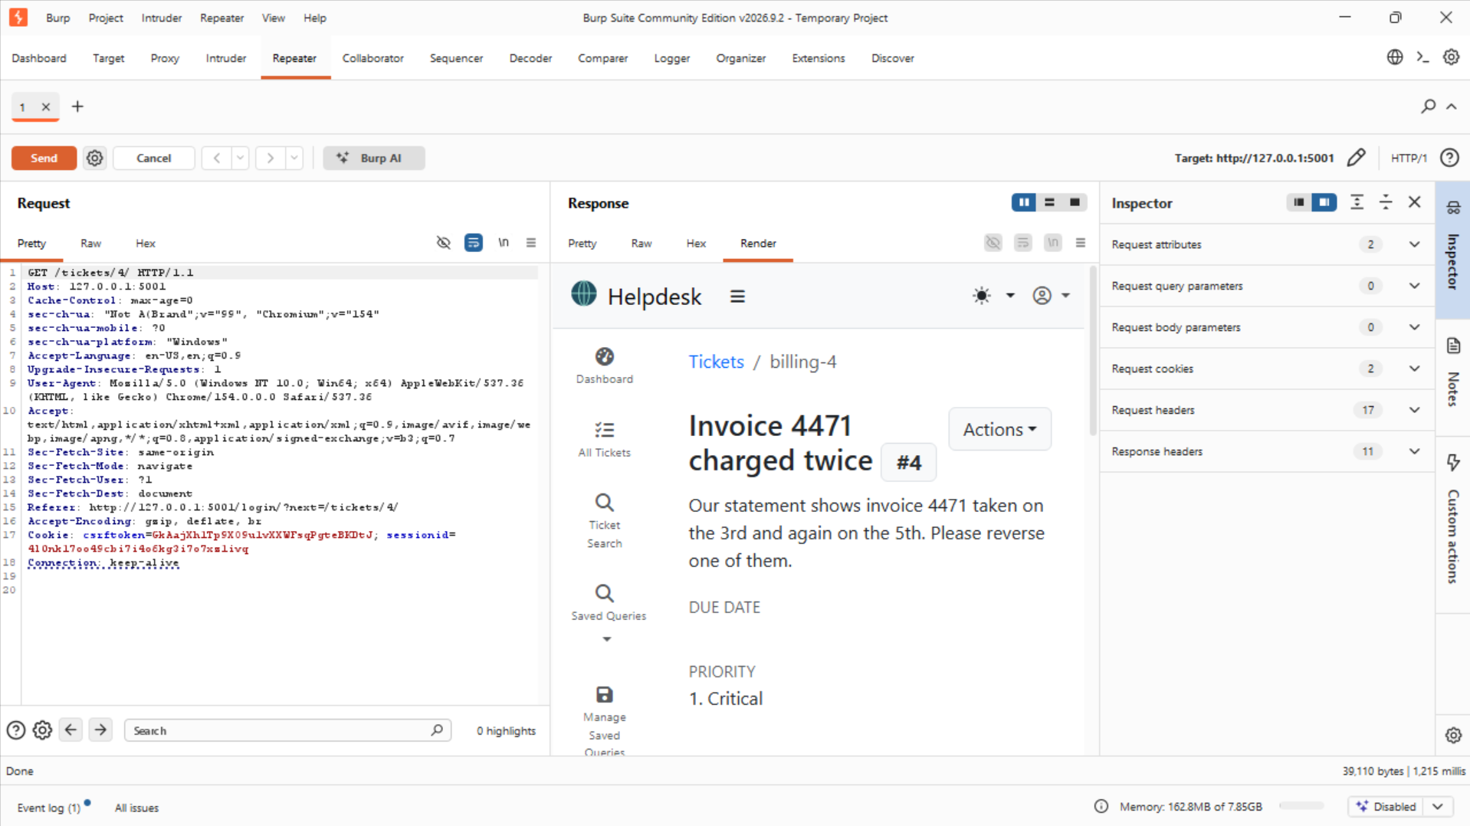
Ticket 4 (Billing) opened by rmasri — “Invoice 4471 charged twice”, a queue I have no rights to.
Walking a neighbouring id shows it is systematic. Ticket 6 is in the Infrastructure queue — another queue I cannot access — and it opens the same way.
GET /tickets/6/
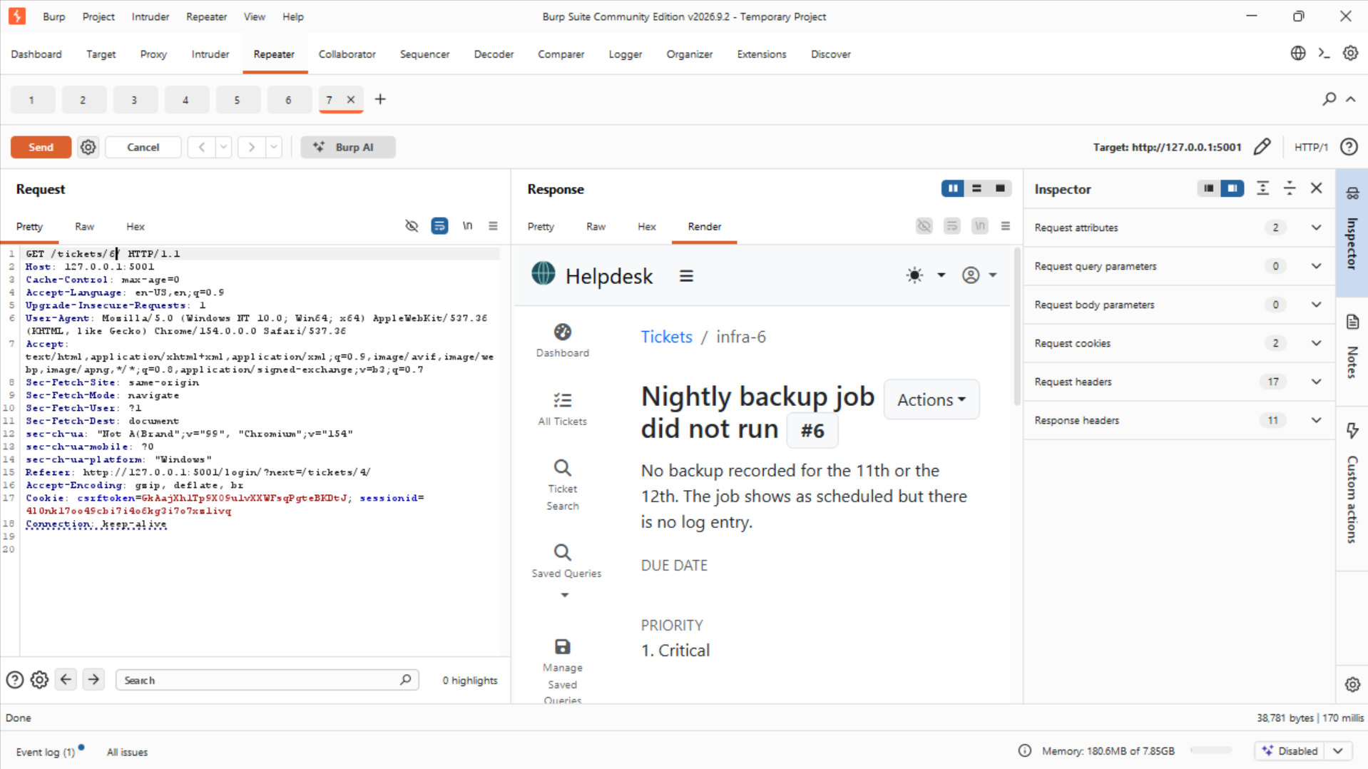
Ticket 6 (Infrastructure) also opens for rmasri — “Nightly backup job did not run”.

A2 — Vertical privilege escalation
The admin tool at /admin-tools/promote/ sets a user's is_superuser flag. It checks the caller is staff, but not that the caller is an administrator, so any agent can call it. Still as the plain agent rmasri:
GET /admin-tools/promote/?user=tokafor
The response confirms tokafor is now a superuser. Pointing the same call at my own username would hand me administrator rights.
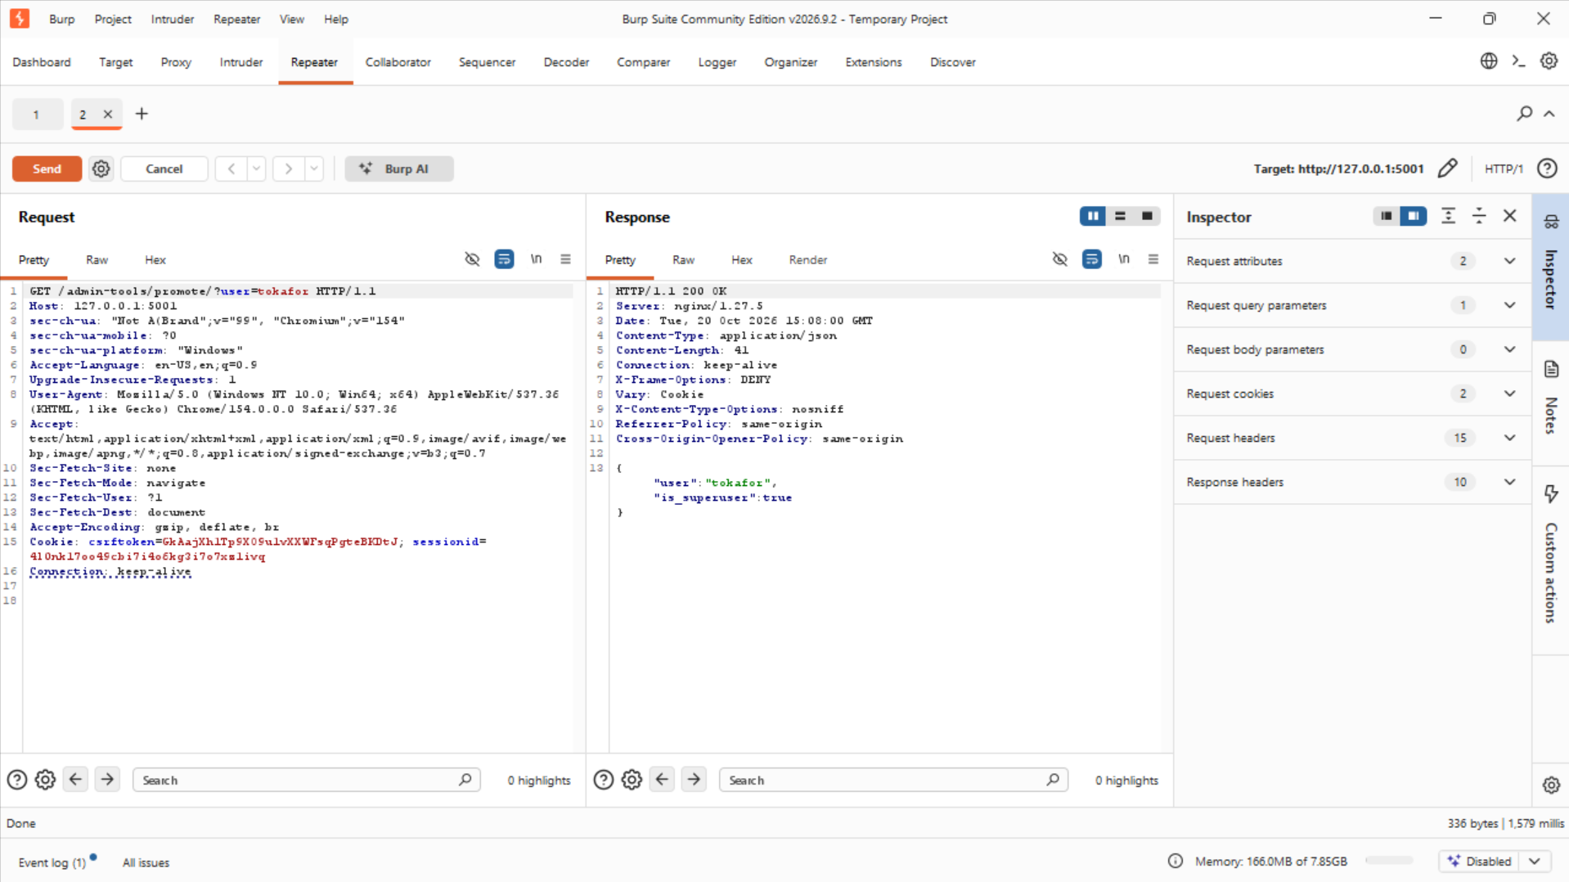
rmasri, a plain agent, promotes tokafor: {"user": "tokafor", "is_superuser": true}.

A3 — Cross-site request forgery (CSRF)
The “change my e-mail” action is a POST marked @csrf_exempt, so Django's CSRF protection is switched off for it. I crafted the POST in Repeater with no CSRF token and no Referer / Origin headers:
POST /profile/email/
email=attacker@evil.invalid
It is accepted with HTTP 200 and my e-mail is changed. Because no token is required, any page a logged-in agent visits could submit this in their session.
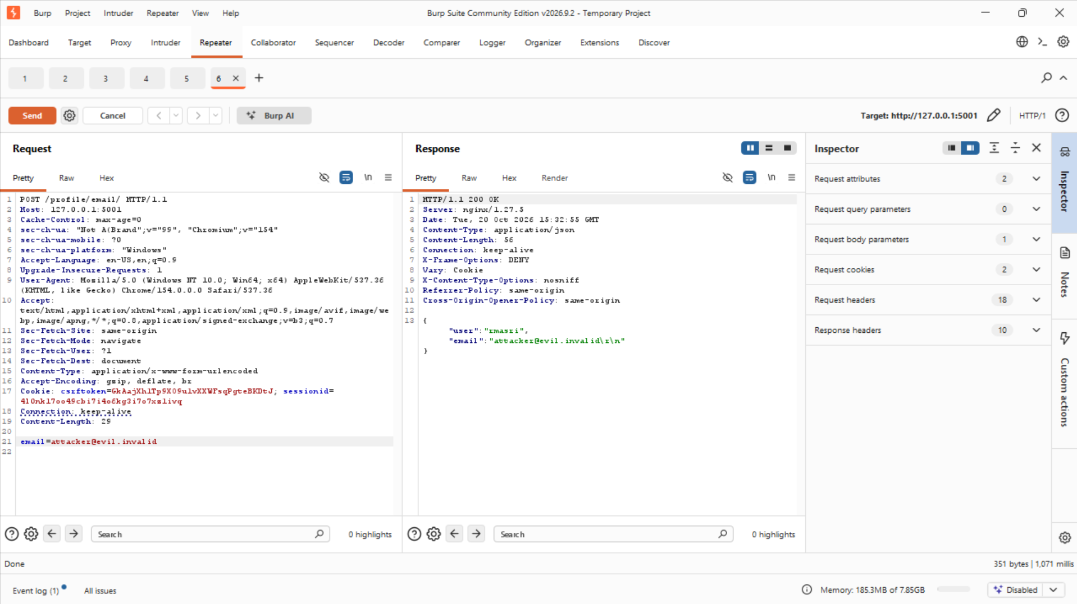
The tokenless POST accepted — HTTP 200, {"user": "rmasri", "email": "attacker@evil.invalid"}.

B5 — Command injection: chain a command
The export at /tickets/<id>/export/ builds a shell command around the label and runs it, so shell metacharacters in the label run as commands. The shell treats ; as “then run this”. The export appends .txt after the label, so the trailing # comments it out. In Repeater I selected the label and pressed Ctrl+U to URL-encode it before sending.
GET /tickets/2/export/?label=x; id #
The response is no longer the ticket — it is the output of id, and the server runs as root:
uid=0(root) gid=0(root) groups=0(root)
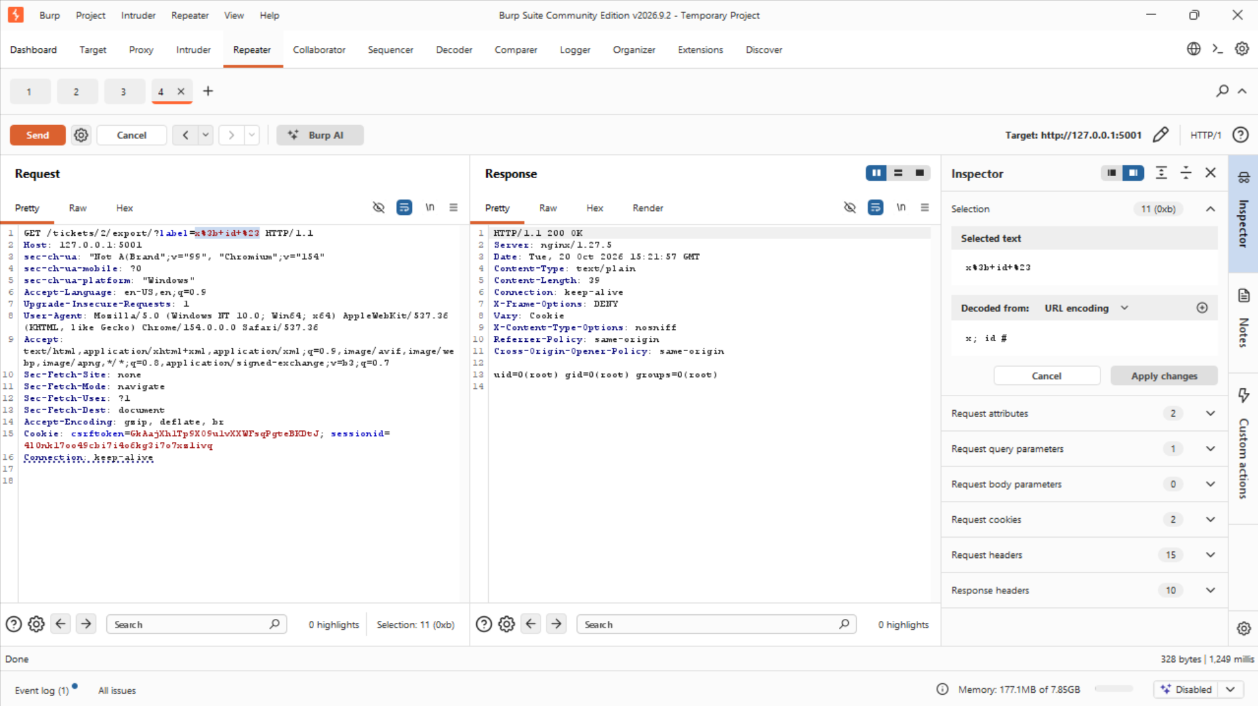
label=x; id # returns uid=0(root) — a command executed on the server as root.

B6 — Confirm with another separator
The same result comes back with && (“run if the first succeeds”), confirming it is real and not a quirk of one operator.
GET /tickets/2/export/?label=x && id #
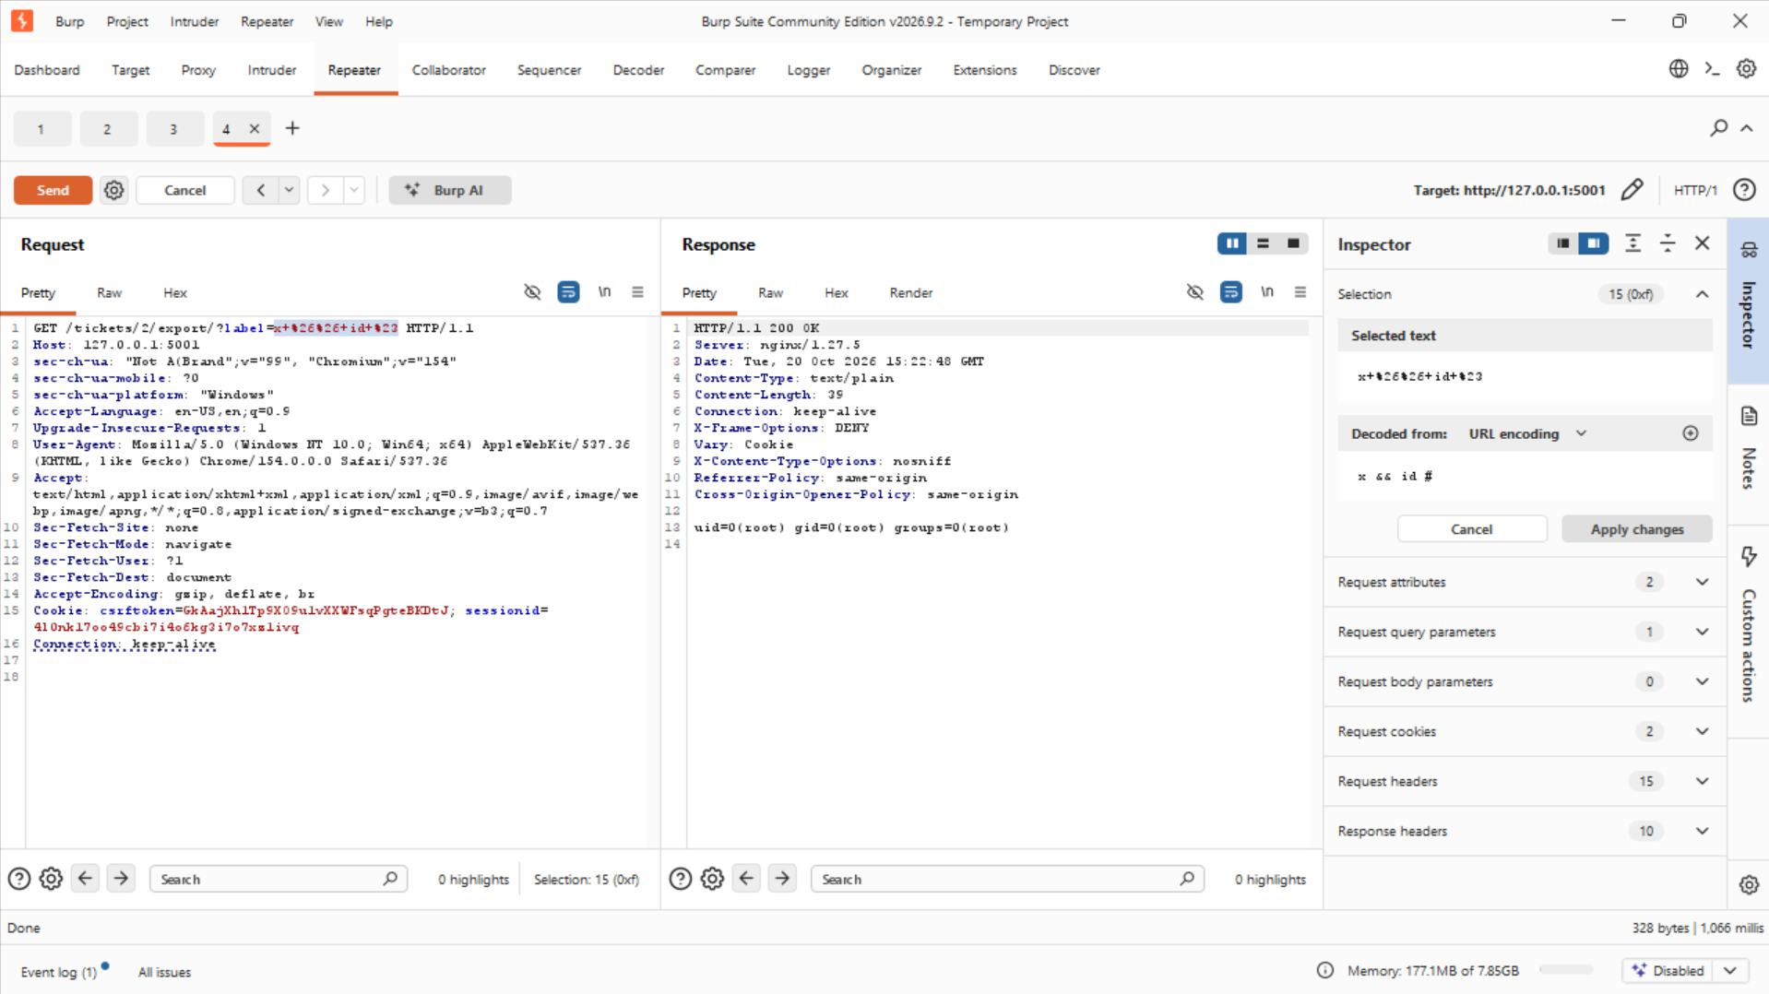
label=x && id # returns the same uid=0(root) — a second separator confirms execution.

B7 — Show impact: read a file
A command can read anything the server can. Reading /etc/passwd proves file access beyond the application (reads only; nothing was changed).
GET /tickets/2/export/?label=x; cat /etc/passwd #
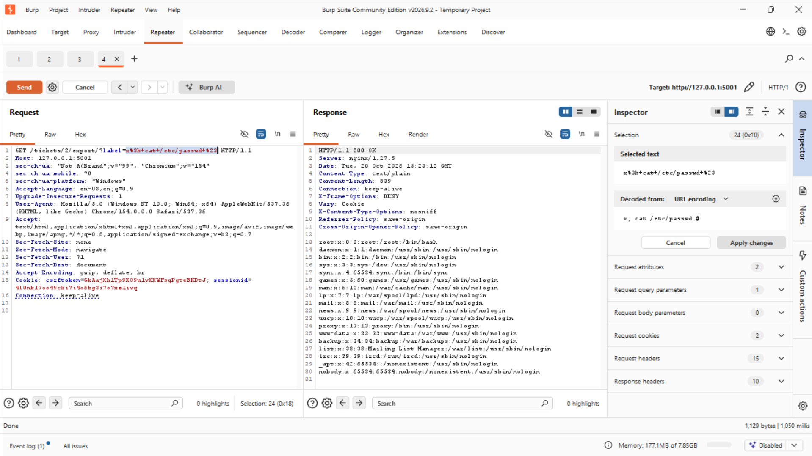
label=x; cat /etc/passwd # returns the server's account list.

Finale — Chain the two
A support agent has no business exporting a Billing ticket, let alone running a command through it — but A1 showed the export has no object check, and Part B showed the label is a shell. As rmasri I aim the export at ticket 4 (Billing, outside my queue) and inject in the same request:
GET /tickets/4/export/?label=x; id #
It returns uid=0(root): I crossed the queue boundary and executed a command behind it in one request. One weak control let me reach the surface; the other let me abuse it.
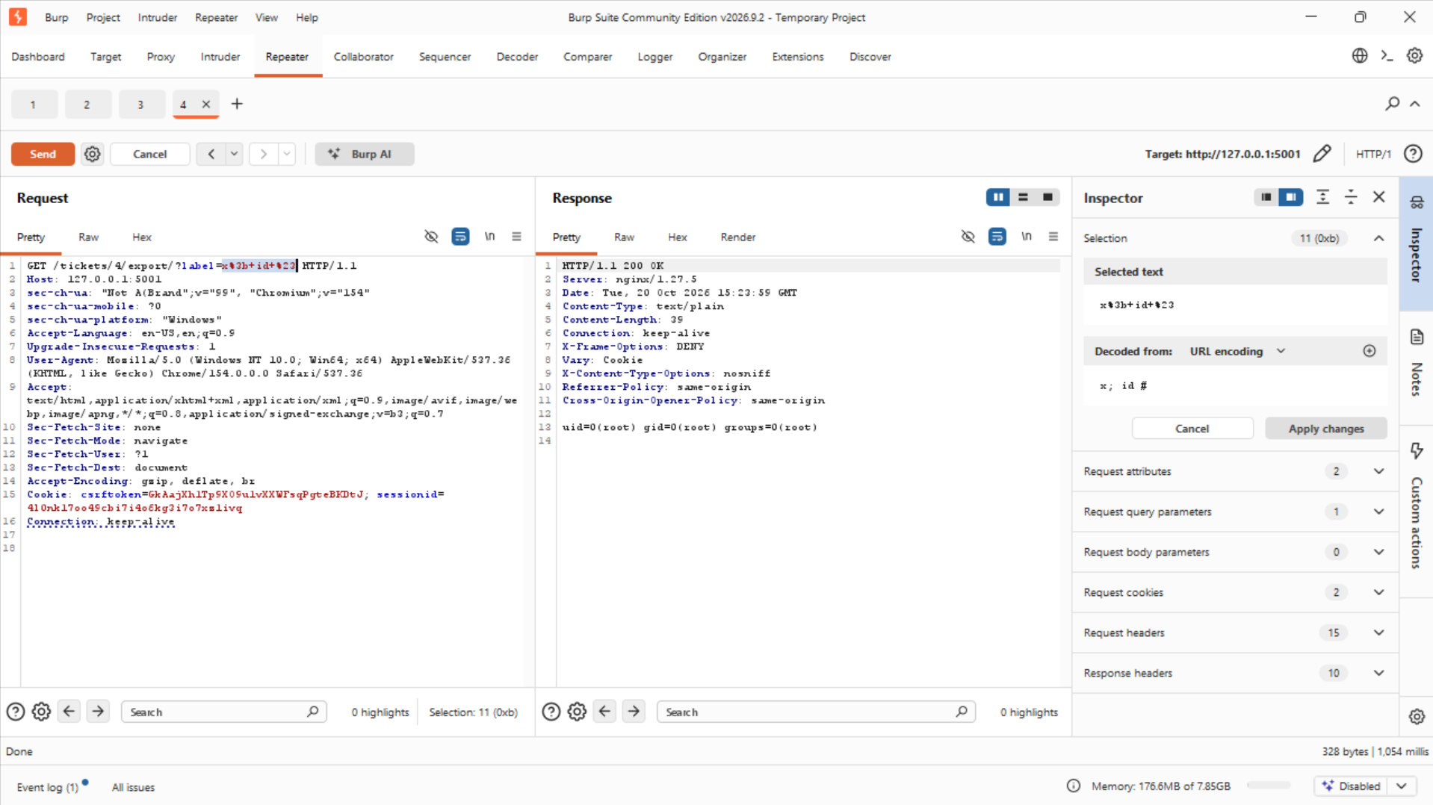
GET /tickets/4/export/?label=x; id # against a foreign Billing ticket returns uid=0(root) — access-control bypass and command execution together.

Remediation
I fixed each hole in src/helpdesk/views/staff.py, then re-ran every attack and confirmed each now fails. The application already ships the right helpers (ticket_perm_check / can_access_ticket); the planted flaws simply skipped them.
IDOR and the export's object check — add the existing queue check after the ticket is fetched, in both view_ticket and export_ticket.
Before:
ticket = get_object_or_404(Ticket, id=ticket_id)
After:
ticket = get_object_or_404(Ticket, id=ticket_id)
ticket_perm_check(request, ticket) # 403 unless the agent may access this queue
Privilege escalation — require administrator rights, not merely staff.
Before:
@helpdesk_staff_member_required
def promote_user(request):
After:
@helpdesk_superuser_required
def promote_user(request):
CSRF — remove the exemption so Django's CsrfViewMiddleware enforces the token again.
Before:
@csrf_exempt
@helpdesk_staff_member_required
def change_email(request):
After:
@helpdesk_staff_member_required
def change_email(request):
Command injection — do not build a shell string from the label. Remove the shell entirely and write/read the file in Python, so the label can only ever be part of a filename.
Before:
command = f"... printf %s {json.dumps(body)} > /tmp/exports/{name}.txt && cat ..."
output = subprocess.check_output(command, shell=True)
After:
path = os.path.join("/tmp/exports", os.path.basename(f"{name}.txt"))
with open(path, "w") as h: h.write(body)
with open(path) as h: output = h.read()
After applying the four fixes I re-ran every attack. Each now fails:
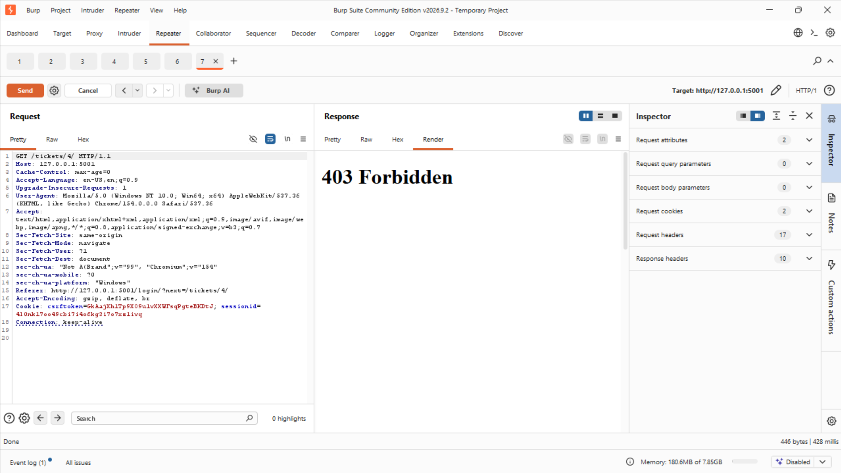
A1 — GET /tickets/4/ now returns HTTP 403 Forbidden.
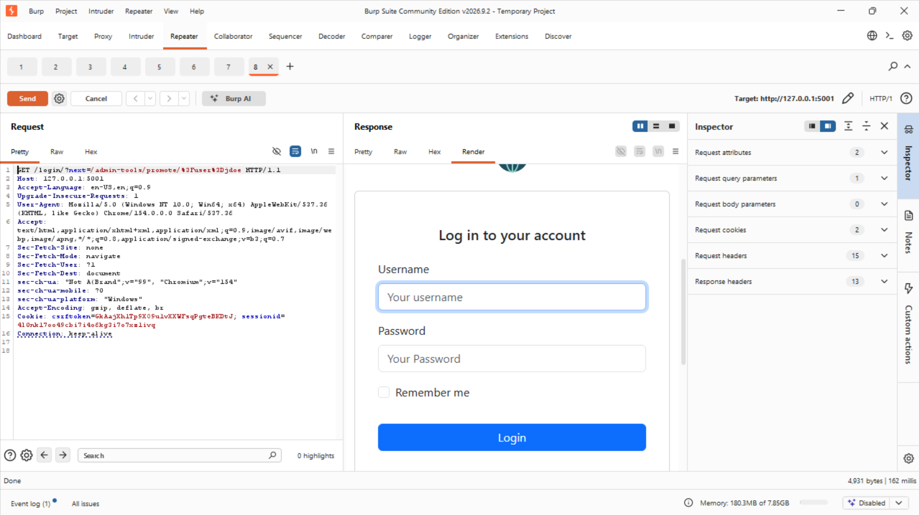
A2 — promote as rmasri is refused and redirected to the login page; the target is not promoted.
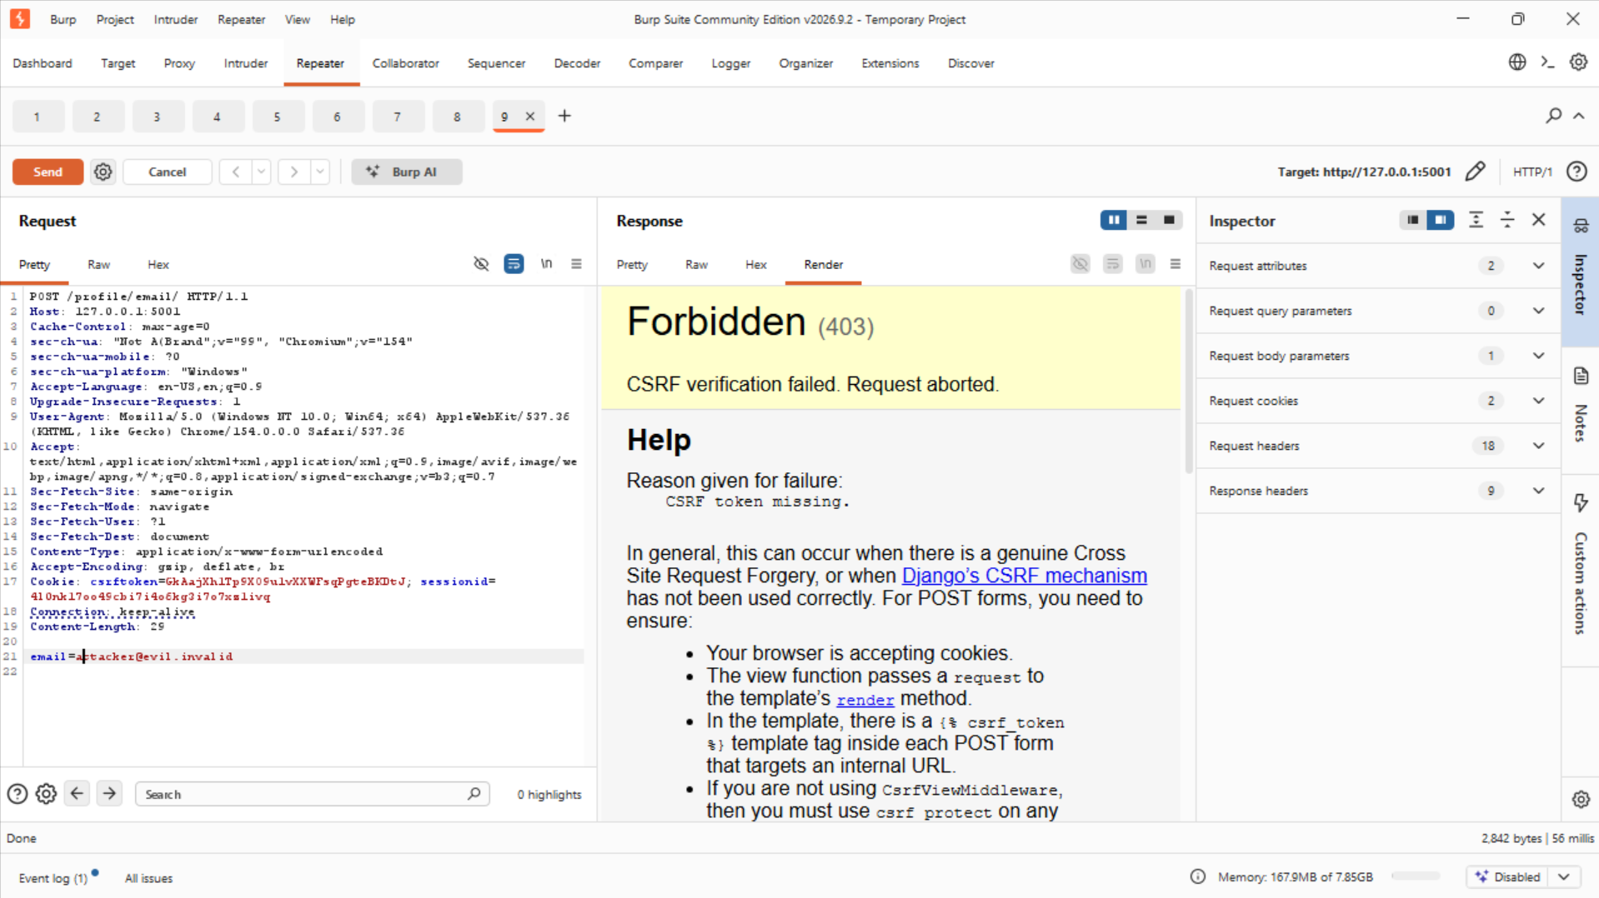
A3 — the tokenless POST now returns HTTP 403, “CSRF verification failed”.
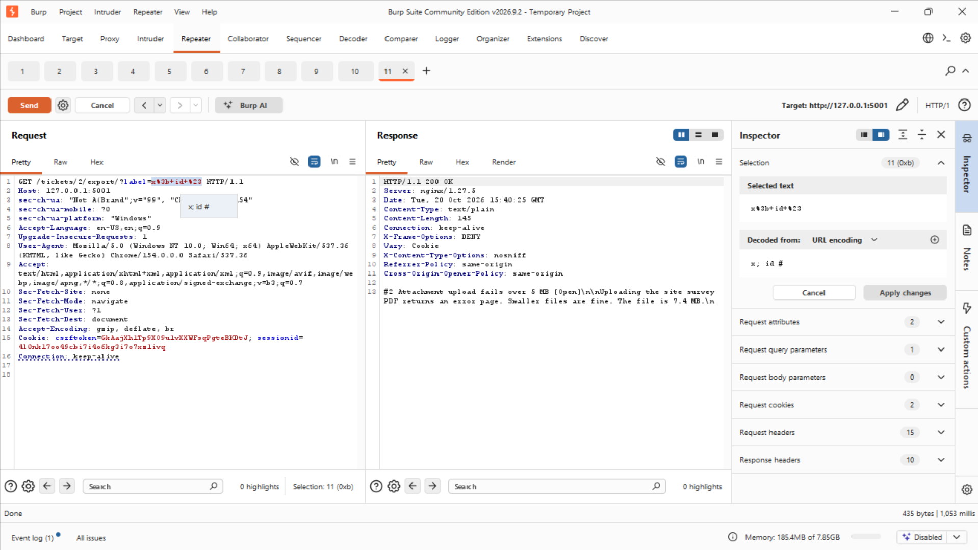
B — label=x; id # now returns the plain ticket text file, never the output of id.
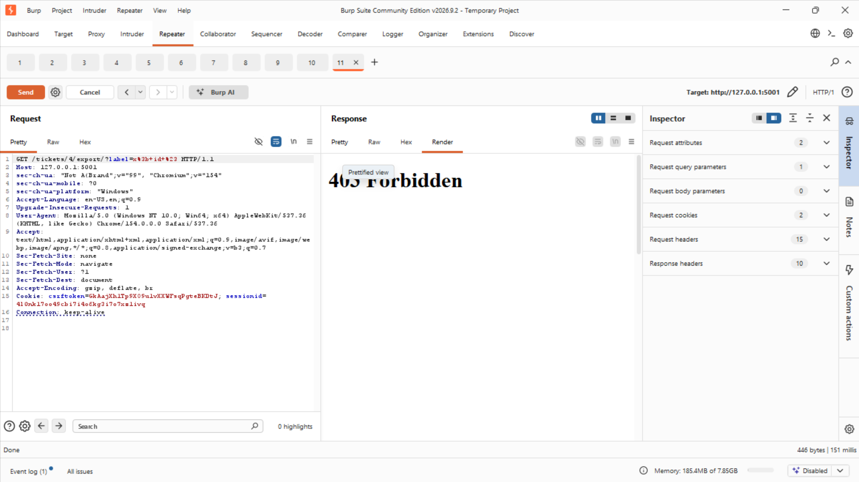
Finale — GET /tickets/4/export/?label=x; id # now returns HTTP 403 Forbidden.

