




ERTIFICATE
C
of completíon

P R O U D L Y P R E S E N T E D T O
M.Muzammil Bashir
has successfully completed the Web Development Intern Internship of 3 Months,
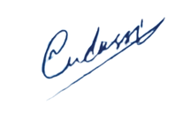
conducted by
DevRolin

Mudassir Hussain
CEO Dev Rolin

