REF NO : DEVR897
DATE : 2025-08-30 Offer Letter
Dear M.Muzammil Bashir,
We are pleased to extend to you an offer for the position of Business Development Intern at Devrolin for a period of 3 Months months, commencing on 2025-09-07.
You will be supervised by Mr. Mudassir Hussain and will support our business growth initiatives through tasks such as Frontend, Backend Integrations, Coding and Implementation. . This internship aims to provide practical industry exposure and enhance your communication, analytical, and strategic thinking skills in a real-world business environment.
Details of the Internship:


- Position: Web Development Intern
support@devrolin.com
+971 52 234 7966
Al Abraj Streets Dubai , UAE

- Department: Web Development
- Duration: September 07, 2025 to December 07, 2025
- Type: Onsit
- Location: Oric Pak Korea Building, Arid Agriculture University, Rawalpindi
- Supervisor: Mr. Mudassir Hussain
You are expected to maintain a professional attitude, observe company policies, and uphold strict confidentiality regarding internal projects and materials.
Please confirm your acceptance of this offer by signing and returning a copy of this letter by {{RESPONSEDATE}}. Should you have any questions, feel free to reach out to Mr. zohaibejaz@devrolin.com
We are excited about the opportunity to work with you and look forward to your positive impact at Devrolin.
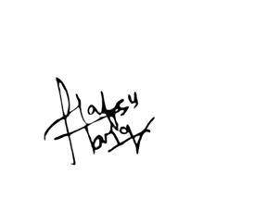
Sincerely,
HR Manager

