




ERTIFICATE
C
of completíon

P R O U D L Y P R E S E N T E D T O
{{NAME}}
has successfully completed the {{POSITION}} Internship of {{DURATION}},
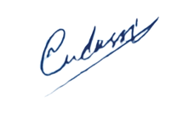
conducted by
DevRolin

Mudassir Hussain
CEO Dev Rolin

