
REF NO: {{REF}}
DATE: {{DATE}}
To Whom It May Concern
This is to certify that {{NAME}} has successfully completed a {{DURATION}} internship in the Graphic Designing Department of DevRolin, from {{STARTDATE}} to {{ENDDATE}}.

During this period, {{NAME}} actively contributed to our creative design projects, demonstrating strong visual sense, technical proficiency, and a genuine passion for graphic design. Key contributions include:
- Branding & Identity Design: Assisted in creating and refining brand assets, including logos, typography, and color palettes, ensuring consistency across client deliverables.
- Social Media Creatives: Designed engaging posts, banners, and promotional graphics that increased audience interaction and brand visibility.

- Print & Marketing Materials: Contributed to the design of brochures, posters, and presentation decks, aligning visuals with brand guidelines and campaign goals.
- Collaboration & Communication: Worked closely with the design and marketing teams, participated in brainstorming sessions, and presented weekly progress updates with clarity and professionalism.

Throughout the internship, {{NAME}} exhibited diligence, adaptability, and an eagerness to learn.
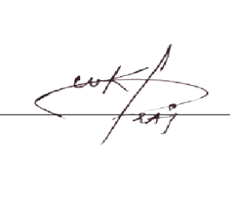
We appreciate {{NAME}} dedication during their tenure with DevRolin and wish them every success in their future academic and professional endeavors.
Sincerely,

Muhammad Bilal
Director, Devrolin

