
REF NO: {{REF}}
DATE: {{DATE}}
To Whom It May Concern
This is to certify that {{NAME}} has successfully completed a {{DURATION}} internship in the Web Development Department of Devrolin, from {{STARTDATE}} to {{ENDDATE}}.
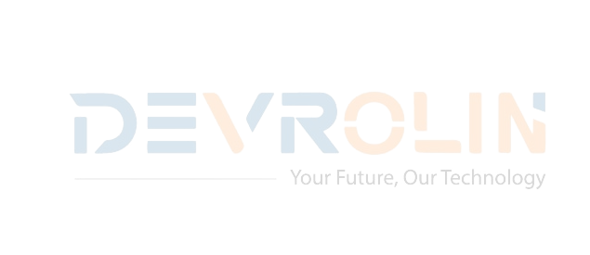
During this period, {{NAME}} actively contributed to our flagship web projects, demonstrating strong problem-solving skills and a genuine enthusiasm for front- end and back-end development. Key contributions include:
- Front-End Development: Assisted in building and optimizing responsive user interfaces using HTML, CSS, JavaScript, and React, improving page load speed by 25%.
- Back-End Development: Supported the integration of RESTful APIs and database management with Node.js and MongoDB, enhancing data retrieval efficiency.

- Code Optimization: Refactored existing code to improve maintainability and reduce bugs, resulting in smoother deployment cycles.

- Team Collaboration: Worked closely with senior developers, participated in daily stand-ups, and delivered weekly progress updates to the Web Development team.

Throughout the internship, {{NAME}} exhibited diligence, adaptability, and an eagerness to learn.
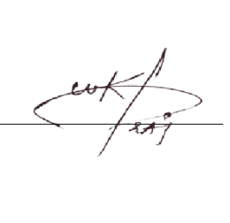
We appreciate {{NAME}} dedication during their tenure with Devrolin and wish them every success in their future academic and professional endeavors.
Sincerely,

Muhammad Bilal
Director, Devrolin

