
REF NO: {{REF}}
DATE: {{DATE}}
To Whom It May Concern
This is to certify that {{NAME}} has successfully completed a {{DURATION}} internship in the Artificial Intelligence Department of DevRolin, from {{STARTDATE}} to {{ENDDATE}}.
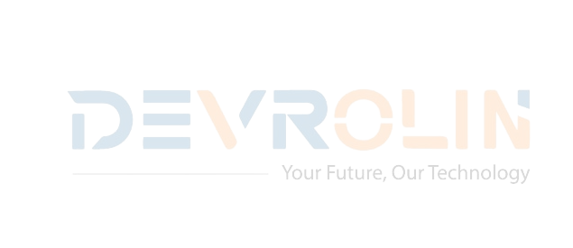
During this period, {{NAME}} actively participated in our flagship Al projects, demonstrating strong analytical skills and a genuine enthusiasm for machine learning and data science. Key contributions include:
- Model Development: Assisted in developing and fine-tuning a convolutional neural network for image classification, achieving a 92% validation accuracy.
- Data Preprocessing: Designed and implemented data-cleaning pipelines that reduced feature-engineering time by 30%

- Research & Documentation: Conducted literature reviews on Transformer architectures and prepared concise technical reports that informed our experimental design

- Team Collaboration: Collaborated effectively with senior engineers, attended daily stand-ups, and presented weekly progress updates to the Al team.

Throughout the internship, {{NAME}} exhibited diligence, adaptability, and an eagerness to learn.
We appreciate {{NAME}} dedication during their tenure with DevRolin and wish them every success in their future academic and professional endeavors.
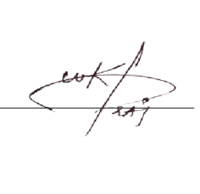
Sincerely,

Muhammad Bilal
Director, Devrolin

