REF NO : {{REF}}
DATE : {{DATE}} Offer Letter
Dear {{NAME}},
We are pleased to extend to you an offer for the position of Business Development Intern at Devrolin for a period of {{DURATION}} months, commencing on {{STARTDATE}}.
You will be supervised by {{SUPNAME}} and will support our business growth initiatives through tasks such as {{TASKS}}. This internship aims to provide practical industry exposure and enhance your communication, analytical, and strategic thinking skills in a real-world business environment.
Details of the Internship:


- Position: {{POSITION}}
support@devrolin.com
+971 52 234 7966
Al Abraj Streets Dubai , UAE

- Department: {{DEPARTMENT}}
- Duration: {{FROMANDTODATE}}
- Type: {{TYPE}}
- Location: Oric Pak Korea Building, Arid Agriculture University, Rawalpindi
- Supervisor: {{SUPNAME}}
You are expected to maintain a professional attitude, observe company policies, and uphold strict confidentiality regarding internal projects and materials.
Please confirm your acceptance of this offer by signing and returning a copy of this letter by {{RESPONSEDATE}}. Should you have any questions, feel free to reach out to Mr. zohaibejaz@devrolin.com
We are excited about the opportunity to work with you and look forward to your positive impact at Devrolin.
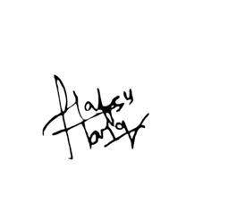
Sincerely,
HR Manager

