REF NO : 659232
DATE : 2026-02-25 Offer Letter
Dear Zakawat Ali,
We are pleased to extend to you an offer for the position of Business Development Intern at Devrolin for a period of 2 month months, commencing on 2026-02-01.
You will be supervised by shahid and will support our business growth initiatives through tasks such as kjshuidh. This internship aims to provide practical industry exposure and enhance your communication, analytical, and strategic thinking skills in a real-world business environment.
Details of the Internship:


- Position: Developer
support@devrolin.com
+971 52 234 7966
Al Abraj Streets Dubai , UAE

- Department: IT
- Duration: jnsuidjhi
- Type: ksndj
- Location: Oric Pak Korea Building, Arid Agriculture University, Rawalpindi
- Supervisor: shahid
You are expected to maintain a professional attitude, observe company policies, and uphold strict confidentiality regarding internal projects and materials.
Please confirm your acceptance of this offer by signing and returning a copy of this letter by {{RESPONSEDATE}}. Should you have any questions, feel free to reach out to Mr. zohaibejaz@devrolin.com
We are excited about the opportunity to work with you and look forward to your positive impact at Devrolin.
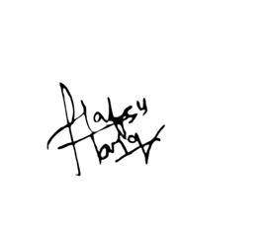
Sincerely,
HR Manager

