Vehicle Routing Problem: School Bus Routing Problem

We want to formulate and design an algorithm to solve a specific case of The Vehicle Routing Problem (VRP) which is The School Bus Routing Problem (SBRP). A VRP is a generalization of the Traveling Salesman Problem (TSP) but in a more complex way. The Vehicle Routing Problem (VRP) is everywhere, and solving it is critical in helping to facilitate the movement of goods and services from one place to another. Essentially, you have a fleet of vehicles and a collection of stops. You’re trying to figure out:

1. Which vehicle should I assign to each stop?
2. In what order should the vehicles visit those stops to minimize distance and travel time (while satisfying any other constraints you might have)

The School Bus Routing problem (SBRP) is concerned with transporting students from their homes (or a near station to their home) to their schools via transportation systems such as buses. The SBRP resembles the VRP; however, there are some specific characteristics of the problem and these are outlined below:

1. The total number of students each bus carries cannot exceed the capacity of the bus.
2. The bus should first pick up the students before visiting the schools.

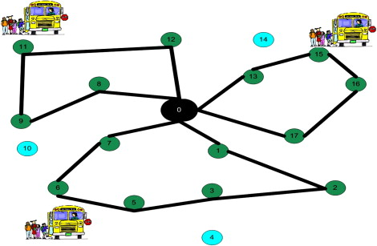

Figure : School Bus Routing Problem

Assumptions:

To simplify the problem, we will consider the following assumptions:

1. Students’ homes are gathered into clusters. To each cluster is associated a station i=1, …, 8 and students should be picked up from their respective stations.
2. We have 2 schools and students should arrive at their respective schools j = 1,2.
3. The number of vehicles is limited but sufficient. All the vehicles have the same capacity (homogenous fleet).
4. Consider only one time slot, only the forward path and only direct journeys (no connection).
5. At first, you can start by not considering capacity constraints then add it later.
6. Assume that necessarily all stations shall be served before any schools.
7. As a start, we won’t consider the depot.
8. The objective function should only consider one criterion (e.g., minimize the total distance, minimize the costs)

Data:

1. The number of employees going from each station i to school j.
2. The distance between each two sites (a site can be a station or a school).
3. The capacity of vehicles.
4. The cost of using each vehicle.

Assignement :

1. Give a simple mathematical formulation of the problem (variables, objective function, constraints). The final goal is to generate:
   1. The routes that each bus should follow.
   2. The groups of students affected to each bus.
2. Program the solution and try to find a solution.