Specific Aims
Precise temporal control of gene expression is required for neurons to establish and maintain their identity throughout post-mitotic maturation, operating at the level of both chromatin (histone modification) and DNA (cytosine methylation). Mutations affecting Polycomb Repressive Complex 1 (PRC1) and its deubiquitinase BAP1 cause syndromic neurodevelopmental disorders (NDDs) marked by developmental delay, seizures, and intellectual disability — phenotypes overlapping a broader family of chromatin-regulator disorders, including Kabuki and Coffin-Siris syndromes. How disruption of one histone-modifying enzyme produces such pervasive neurodevelopmental dysfunction, and whether its effects propagate to the DNA methylation machinery, is unknown.
Our lab discovered that histone H2A ubiquitination (H2AK119ub, hereafter H2Aub), deposited by PRC1, is dynamically redistributed away from silenced loci toward active enhancers and promoters during cerebellar neurodevelopment, overturning the textbook view that Polycomb complexes act only at repressed genes (Parmar et al., 2025). To determine how disease-causing loss of the deubiquitinase BAP1 perturbs this system, we generated two complementary conditional Bap1 mutant mouse models. In Bap1^{fl/fl},Math1-cre mice, which delete Bap1 in postmitotic cerebellar granule neurons, CUT&RUN and transcriptomic profiling revealed that euchromatin and heterochromatin come to resemble one another in mutant neurons: euchromatic genes gain H2Aub and PRC2-dependent H3K27me3, lose the activating mark H3K27ac, and become repressed, while heterochromatic loci show the reciprocal pattern and become overexpressed. These changes emerge only in adult neurons, implicating BAP1 in post-mitotic chromatin maturation rather than initial cell-fate specification. In a second model, Bap1^{fl/fl},Emx1-Cre mice, which delete Bap1 in forebrain excitatory neurons, mutants recapitulate the developmental delay, seizures, and behavioral abnormalities of BAP1-syndrome patients; this model serves as our platform for the phenotypic rescue experiments below.
Because H2Aub biochemically recruits the DNA methylation writer DNMT3A, we asked whether BAP1 loss also remodels the neuronal methylome, using the Math1-cre model to match our molecular datasets. Using the Biomodal evoC assay to simultaneously profile 5-methylcytosine (5mC) and 5-hydroxymethylcytosine (5hmC), we found that Bap1 mutant neurons show reciprocal methylation changes tracking the histone changes: euchromatic loci gain 5mC and lose 5hmC, while heterochromatic loci show the opposite pattern. MeCP2, the reader of methylated DNA, redistributes in parallel, particularly at synapse genes. Together, these findings support an explicit mechanistic model: aberrant H2Aub redistribution alters recruitment of DNMT3A, redirecting methylation — including non-CG methylation — to loci that gain H2Aub; this altered methylation landscape in turn redirects binding of MeCP2, which recruits the NCoR corepressor complex and its associated histone deacetylase to strip H3K27ac from these loci. This cascade (H2Aub → DNMT3A recruitment → DNA methylation → MeCP2 → NCoR/HDAC3 → H3K27ac loss) resolves a central conundrum in our data: how loss of a single histone ubiquitin mark produces such severe, widespread loss of a seemingly unrelated modification, H3K27ac, at euchromatic genes. Because BAP1 loss perturbs H2Aub bidirectionally, our system offers an unusually clean test of this cascade, pursued in the following aims.
Aim 1: Establish the sequence of H2Aub, DNMT3A recruitment, and DNA methylation changes after Bap1 loss, and determine their dependence on DNMT3A. In the Bap1^{fl/fl},Math1-cre cerebellar granule neuron model, we will map H2Aub (CUT&RUN), DNMT3A occupancy (ChIP-seq), and 5mC/5hmC (evoC) across a developmental time course (P7, P12, P21, adult) to directly test our proposed cascade: DNMT3A binding should track, and follow, the redistribution of H2Aub, and methylation changes should in turn follow DNMT3A occupancy. We will use Enzymatic Methyl-seq to capture non-CG methylation (mCH), a neuronally enriched, DNMT3A-dependent mark. In parallel, we will cross a conditional Dnmt3a knockout onto this Bap1 background to test whether DNMT3A is cell-autonomously required for methylation changes at sites of H2Aub redistribution.
Aim 2: Determine whether BAP1 catalytic-domain mutations remodel DNA methylation through H2Aub in human neurons. We are introducing two patient UCH-domain mutations into a doxycycline-inducible NGN2 human iPSC line to generate isogenic excitatory neurons. We will profile H2Aub, H3K27ac, and H3K27me3 alongside transcriptomics and methylation (evoC, Enzymatic Methyl-seq, MeCP2 CUT&RUN), extending differentiation to capture the slow accrual of non-CG methylation. Concordant histone and methylation changes will establish that BAP1 controls DNA methylation through H2Aub in a human, disease-relevant background, moving this mechanism from correlation to causation.
Aim 3: Determine whether restoring non-CG methylation rescues seizures caused by BAP1 loss. Because seizures — unlike the developmental delay and broader behavioral abnormalities also present in this model — were characterized specifically in the Bap1^{fl/fl},Emx1-Cre line, we will cross this model to global Dnmt3a heterozygous mice (Dnmt3a^{+/-}), which carry a partial (~50%) reduction in non-CG methylation, generating Bap1,Dnmt3a compound mutants. This epistasis design directly tests whether reduced non-CG methylation is sufficient to modify the neurological consequences of BAP1 loss. Because Dnmt3a^{+/-} mice have their own baseline behavioral deficits and growth delay — though notably not seizures — we will restrict phenotypic assessment of the compound mutant to seizure activity (video-EEG), which provides an unconfounded readout of the epistatic interaction between Bap1 and Dnmt3a. In parallel, we will assess neuronal morphology and electrophysiological maturation in the BAP1-mutant iPSC-neurons from Aim 2, testing whether reducing DNMT3A activity normalizes these phenotypes. Together, this aim tests whether non-CG methylation is a druggable node through which the neurological consequences of BAP1 loss — specifically seizures — could be reversed, rather than merely a downstream correlate.
RESEARCH STRATEGY
This proposal will establish a causal, mechanistic link between a chromatin-modifying enzyme and the DNA methylation machinery in neurons, with the goal of understanding how loss of Bap1 ultimately impacts H3K27ac through an H2Aub-DNMT3A-MeCP2-NCoR cascade. We will define the developmental window in which this cascade operates in neurons, and determine whether DNMT3A and/or HDAC3 are candidate therapeutic targets for BAP1-related NDD. Because PRC1-dependent H2Aub, PRC2-dependent H3K27me3, DNA methylation and H3K27ac are relevant to broader family of NDDs that result from perturbed chromatin regulation, our findings should generalize beyond BAP1.

A. SIGNIFICANCE
Epigenetic control of neurodevelopment and its disruption in disease. Building a functional nervous system requires that developing neurons execute precise, cell type- and stage-specific gene expression programs as they exit the cell cycle, differentiate and become functionally integrated into circuits as mature neurons. This process relies primarily upon cell intrinsic processes of epigenetic regulation. Principal among these are chemical modifications to DNA and histone proteins that establish the transcriptionally permissive euchromatin and repressive heterochromatin states at individual loci. The centrality of these processes for neurodevelopment is underscored by inherited NDDs: epigenetic regulators rank among the largest classes of genes implicated in inherited forms of NDD. Furthermore, syndromes like Kabuki (KMT2D), Coffin-Siris (SWI/SNF), Cornelia de Lange (NIPBL/cohesin), Rett (MECP2), and Tatton-Brown-Rahman (DNMT3A), share striking overlapping features, including intellectual disability, seizures and autism¹. This phenotypic convergence suggests that these disorders disrupt the shared underlying mechanism of perturbing neuronal gene regulation. Therefore, defining how the individual parts contribute to this shared logic, and how they interact with one another, informs our understanding of the entire disease class and the fundamental process of neuronal gene regulation.
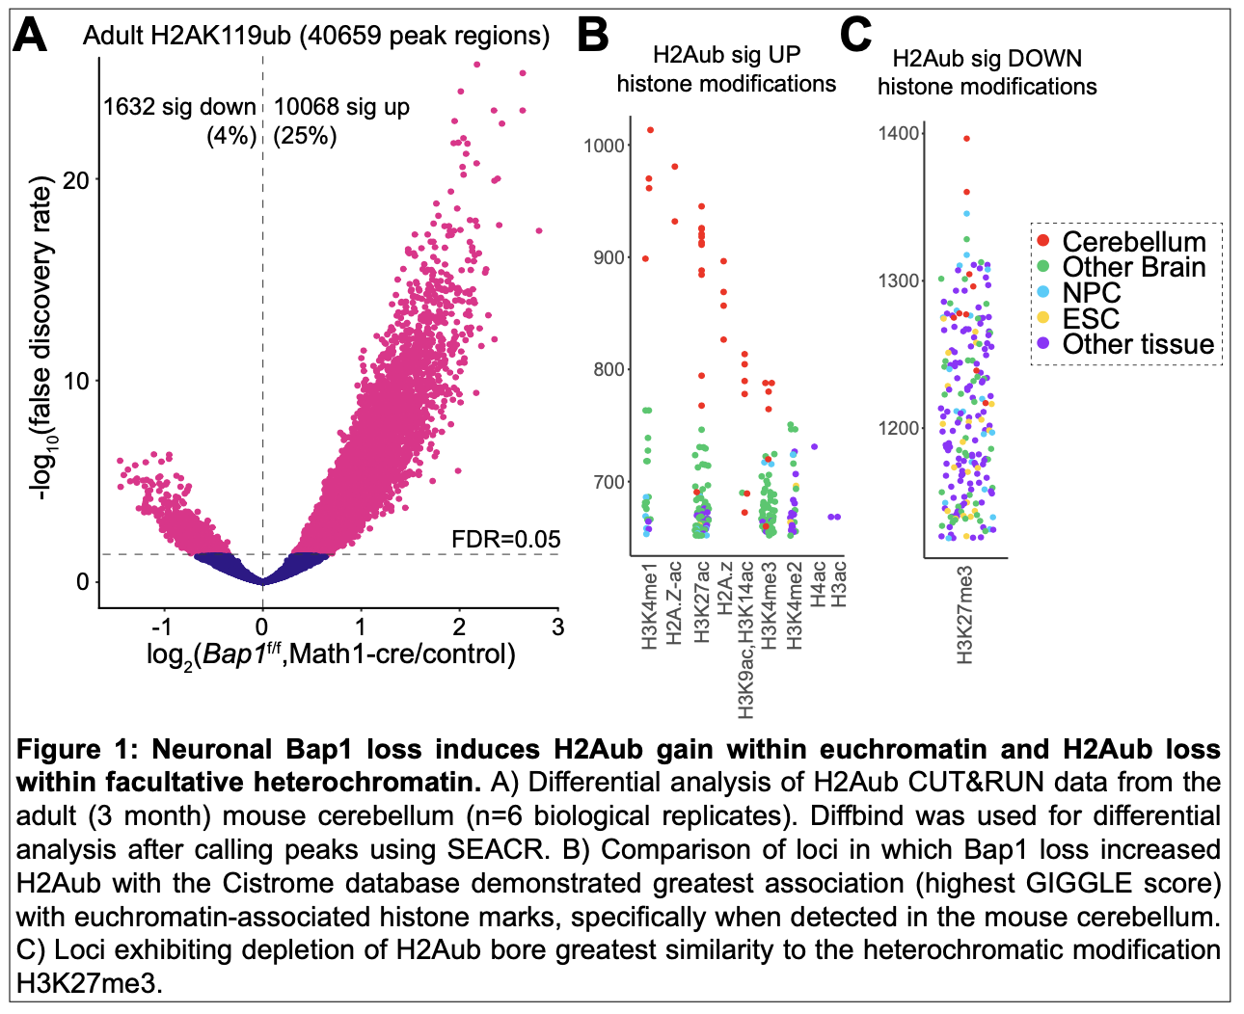
BAP1-mediated control of a multifaceted chromatin regulatory program in neurons. BAP1 is the catalytic subunit of the Polycomb Repressive Deubiquitinase (PR-DUB) complex. The principal function of BAP1’s enzymatic activity is removal of H2A ubiquitinated at lysine 119 (H2AK119ub1, hereafter H2Aub). H2Aub is initially deposited by the ubiquitin ligase subunits of Polycomb Repressive Complex 1 (PRC1) before BAP1 acts to constrain the abundance and distribution of H2Aub. As such, loss of BAP1 in embryonic stem cells (ESCs) causes H2Aub to spread more broadly². An essential PRC1 effector is Polycomb Repressive Complex 2 (PRC2), which deposits H3K27me3, the hallmark of gene repression in facultative heterochromatin. PRC1 and PRC2 engage in a mutual read-write relationship — PRC2 is recruited and activated by H2Aub, while PRC1 is recruited to H3K27me3-marked chromatin by Cbx7. In this way, dysregulation of either mark can reshape the genome-wide distribution of the other. However, our lab recently discovered that neuronal H2Aub often appears in the absence of H3K27me3, and in this context H2Aub is much more developmentally dynamic than where H2Aub and H3K27me3 are colocalized³. We also discovered that neuronal H2Aub appears within active enhancers and promoters (i.e. euchromatic loci), where it becomes enriched during neurodevelopment while simultaneously undergoing depletion from facultative heterochromatin³. We have now gone on to perturb H2Aub by creating the first brain-specific mouse mutants in Bap1, discovering that Bap1 loss perturbs a multitude of histone modifications beyond H2Aub within both heterochromatin and euchromatin. Furthermore, the consequences of Bap1 loss differ depending upon the chromatin context—euchromatin loses activating histone modifications while gaining repressive modifications, whereas heterochromatin loses repressive modifications and gains activating modifications, effectively homogenizing chromatin states. This leads inappropriate reducing expression of euchromatic genes while heterochromatic loci escape repression. As far as I am aware, this is one the few if not the only instance in which a single protein is required for the formation of both heterochromatin and euchromatin.
Our observations broaden the understanding of the role of Bap1 in the brain, and the regulation of euchromatin by ubiquitin (i.e. H2Aub), which in neurons may turn out to be as important as the role of H2Aub in gene silencing. Remarkably, in both forms of chromatin, the active mark H3K27ac moves in opposition to H2Aub (euchromatin loses the former and gains the latter, while heterochromatin gains the former and loses the latter). But the mechanistic intermediaries lying between BAP1’s direct target H2Aub and H3K27ac is a central gap this proposal is designed to close. If true, our hypothesis that this intermediary is DNA methylation (which our preliminary data show is markedly perturbed by BAP1 loss) would place Bap1 and its substrate H2Aub at the heart of a multifaceted gene regulatory program operating at multiple levels and required for the function of both euchromatin and heterochromatin.
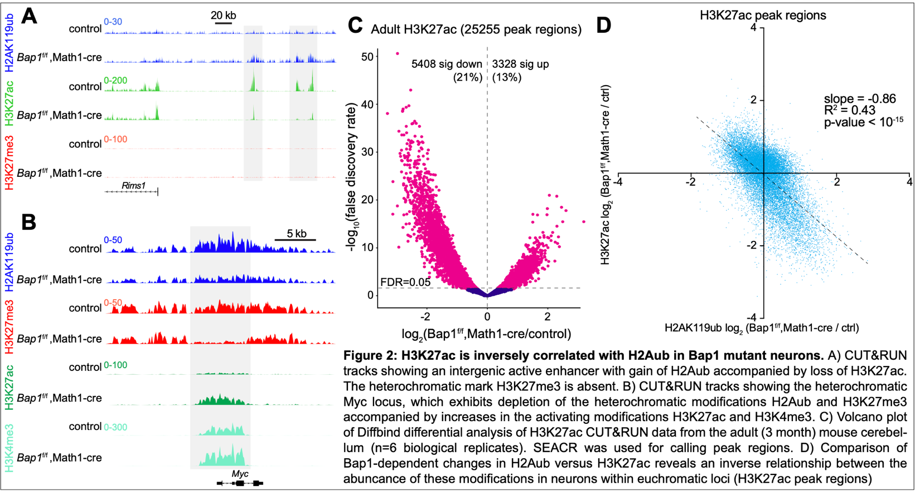
BAP1 as a neurodevelopmental disease gene. BAP1 has long been studied as a tumor suppressor gene: somatic loss of function mutations are associated with multiple malignancies, and germline loss-of-function variants cause the BAP1 tumor predisposition syndrome. However, is now established that a distinct set of germline BAP1 mutations underlie the neurodevelopmental disease Küry-Isidor syndrome, which includes intellectual disability and seizures⁴. In this proposal we will introduce patient mutations that congregate in the enzymatic UCH (ubiquitin-specific hydrolase) domain into human induced pluripotent stem cells (iPSCs) to develop the first human neuronal model of BAP1 mutation. This model will allow us to connect alterations in H2Aub to changes in DNA methylation and ultimately the neuronal transcriptome, which remain entirely undefined and central to the pathology of patients. These cellular models also allows us to ask a critical question in molecular biology, which relates to the structural versus strictly enzymatic roles of BAP1 in chromatin regulation. BAP1 interact with many different chromatin regulatory complexes, and it is unclear whether these the molecular phenotypes we observe result from loss of its enzymatic activity or from loss of its ability to interact with binding partners and potentially recruit them to chromatin. The mouse mutant deletes BAP1 entirely, prevent us from inferring which phenotypes result from loss of BAP1.
Our model’s broader significance. Our central hypothesis is BAP1 loss triggers a defined molecular cascade: redistribution of H2Aub into euchromatin and away from heterochromatin alters genomic recruitment of the de novo methyltransferase DNMT3A, which changes patterns of non-CG methylation; this in turn redirects binding of the methyl-CpG reader MeCP2, which recruits the NCoR corepressor complex and its associated histone deacetylase to remove H3K27ac. This would account for our observation that H3K27ac decreases in euchromatin and increases within heterochromatin. While there is strong preliminary evidence from several different labs for each step in this cascade, ours is the first proposal to tie them together into a single model in which H2Aub drives a multifaceted gene silencing program. In particular, the recruitment of DNMT3A by H2Aub has been defined biochemically but not functionally, as our proposal will. We will also test the prediction that H2Aub is the upstream regulator of non-CG methylation, the neuron-specific epigenetic modification that has garnered intense interest among molecular neuroscientists for its potential to tune neuronal gene expression. These experiments thus carry significance well beyond the BAP1 neurodevelopmental syndrome by placing it mechanistically alongside two of the best-studied neurodevelopmental disorders that act through the same terminal steps — Rett syndrome (MECP2) and Tatton-Brown-Rahman syndrome (DNMT3A), for which methylation-dependent, MeCP2-mediated repression is similarly central^{5,6}. Establishing this connection would be the first direct evidence that histone ubiquitination, DNA methylation, and 5-methylcytosine reading function as a single regulatory pathway in neurons, rather than three independently studied layers, reframing how a broader class of overlapping chromatin-based neurodevelopmental syndromes is understood. Because the terminal step of the proposed cascade — NCoR-associated HDAC activity — is already pharmacologically tractable, defining this pathway also opens a concrete, testable path toward pharmacologic intervention in BAP1 syndrome and in mechanistically related disorders, a possibility that has not previously existed for a Polycomb-pathway disease gene.

B. INNOVATION
DNA methylation as an instructed output of histone ubiquitination. H2Aub and DNA methylation have been conventionally studied separately. However, multiple recent studies have shown a biochemical interaction between DNMT3A and H2Aub^{7–9}. However, we have barely scratched the surface of understanding the functional consequences of this interaction, particularly in the brain.
The major form of DNA methylation in most cells is 5-methylcytosine (5mC). 5mC appears almost entirely at CG dinucleotides, being deposited by DNMT1 during S phase. However, after neurons exit the cell cycle, 5mC is deposited de novo by DNMT3A outside of the typical CG context, mainly at CA dinucleotides. CG is a palindrome, therefore methyl-CG is symmetric across both DNA strands. The fact that CA dinucleotides are non-palindromic adds another layer of regulation because 5mC occurs on the sense or anti-sense strand but not both. Because methyl-CA is abundant in neurons but rare in other cell types, its epigenetic functions have garnered significant attention since its discovery. The current model is that DNMT3A deposits non-CG methylation following recruitment by the histone modifications H3K36me2 and H3K36me3. This proposal advances a distinct model with strong support from preliminary data: that in postmitotic neurons, non-CG DNA methylation is directly regulation by H2Aub. This reframing yields a directional, falsifiable prediction pursued in Aim 1: DNMT3A occupancy and methylation change should require, and follow, H2Aub redistribution rather than arise independently of it — a hierarchy that has not been tested for BAP1 or any other Polycomb related protein.
A single mechanistic cascade unifying three neurodevelopmental disease genes. Küry-Isidor (BAP1), Tatton-Brown-Rahman (DNMT3A), and Rett (MECP2) syndromes are presently grouped only by their overlapping symptoms. One of this proposal's conceptual advances is to specify the molecular order of operations connecting them: H2Aub redistribution redirects DNMT3A, which redirects non-CG methylation, which redirects MeCP2, which recruits the NCoR/HDAC complex to erase H3K27ac. Framed this way, BAP1 is not merely phenotypically adjacent to Rett and Tatton-Brown-Rahman syndromes but mechanistically upstream of them, predicting for the first time a specific sequence linking histone ubiquitination to the reading of neuronal DNA methylation.
Resolving a chromatin paradox by inserting DNA methylation as the causal intermediate. A central puzzle in our preliminary data is that loss of a single deubiquitinase produces a disproportionate, genome-scale loss of H3K27ac, a euchromatic mark without any obvious relation to H2Aub. No existing model can explain account for the scale and locus-selectivity of the H3K27ac loss we observe. We resolve this paradox by inserting an intervening step: aberrant DNA methylation, not H2Aub or H3K27me3 directly, redirects MeCP2 and its associated HDAC activity to strip H3K27ac. This is a mechanistically distinct explanation from anything previously proposed for BAP1 or any other PRC1-pathway phenotype, and it is directly testable because each step of the cascade — H2Aub, DNMT3A, methylation, MeCP2, H3K27ac — can be independently measured.
Bidirectional H2Aub perturbation converts a correlative claim into an internally controlled test. Because BAP1 loss redistributes H2Aub in both directions at once — gained at euchromatin, lost at heterochromatin — our system predicts reciprocal changes in methylation at specific loci. This presents a unifying model in which BAP1 controls methylation state within both heterochromatin and euchromatin, a key aspect of these compartments’ identities.
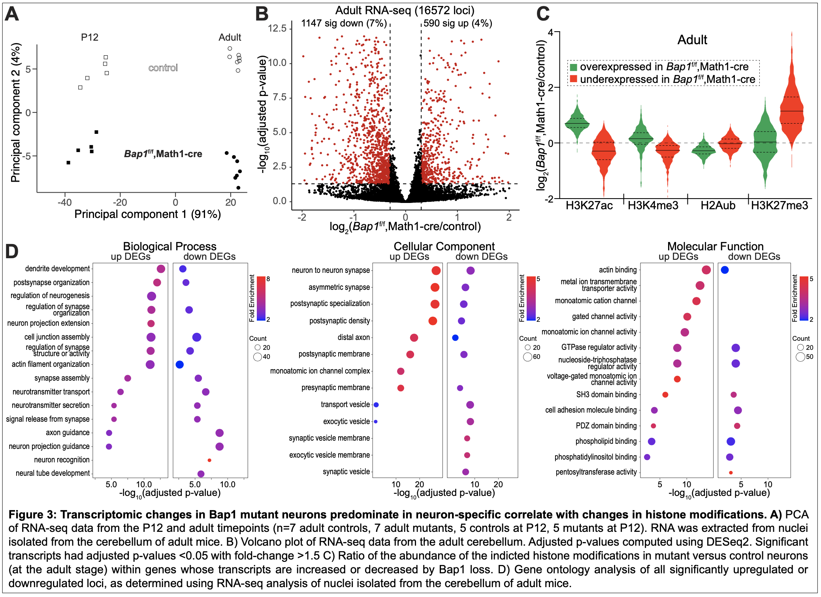
Testing whether one node of the cascade is sufficient to modify neurological phenotypes. Prior work on Polycomb-related disease genes has documented chromatin abnormalities without testing whether any single downstream change is sufficient to modify any specific phenotype. Aim 3's epistasis testing of the interaction between H2Aub and DNA methylation via Bap1/Dnmt3a double mutants titrates non-CG methylation on a Bap1-mutant background, isolating seizures as an unconfounded readout in vivo. This will determine not only whether methylation changes accompany BAP1 loss, but also whether they are causally required for one of its neurological consequences, and whether that consequence is reversible.
Base-resolution discrimination of 5-methylcytosine (5mC) from 5-hydroxymethylcytosine (5hmC), rather than their conflation into a single signal. Standard bisulfite sequencing and enzymatic methods such as EM-seq cannot distinguish 5-methylcytosine from 5-hydroxymethylcytosine, as both marks are protected from conversion and are read identically as unconverted cytosine. This is a critical limitation for our model, because 5hmC is not simply an inert intermediate but a dynamically regulated mark with its own distinct genomic distribution, being enriched at expressed gene bodies and active enhancers and particularly abundant in neurons. Use of Biomodal’s duet evoC assay, which resolves this ambiguity biochemically rather than computationally. This method accomplishes this feat by converting 5mC and 5hmC into distinct identifiable two-base sequencing code using a combination of TET2 oxidation, β-glucosyltransferase protection, and strand-specific enzymatic copying, rather than relying on a single base call per cytosine¹⁰. This remarkable advance has allowed us track 5mC and 5hmC as two independent readouts at single-base resolution from the same DNA molecule in a single closed experimental system, allowing us to confidently determine that BAP1 loss causes opposing effects on 5mC and 5hmC in both the context of euchromatin and heterochromatin.
Enzymatic, rather than bisulfite, detection of non-CG methylation for improved specificity and coverage. Profiling non-CG methylation is technically demanding because non-CG methylation is present at far lower baseline levels than traditional CG methylation, so inefficient cytosine conversion produces a disproportionately large number of false-positive calls. Traditional whole-genome bisulfite sequencing (WGBS) relies on harsh chemical treatment (high temperature, low pH) to deaminate unmethylated cytosines, which frequently under-converts and inflates apparent methylation, while degrading DNA, producing GC-biased, non-uniform genome coverage. We will instead use Enzymatic Methyl-seq (EM-seq), in which TET2/β-glucosyltransferase protection and APOBEC3A-mediated deamination replace bisulfite chemistry to achieve more complete and specific conversion of unmodified cytosine while preserving DNA integrity¹¹. In direct comparisons at matched sequencing depth, EM-seq detects substantially more unique methylated CGs than WGBS from the same low-input DNA (e.g., 54 million vs. 36 million CpGs at 1x coverage from only 10 ng of input), and remains effective from as little as 100 pg of DNA, a practical advantage given the limited neuronal populations obtained from cell-type-restricted Cre models and low-yield iPSC-neuron cultures used throughout this proposal.
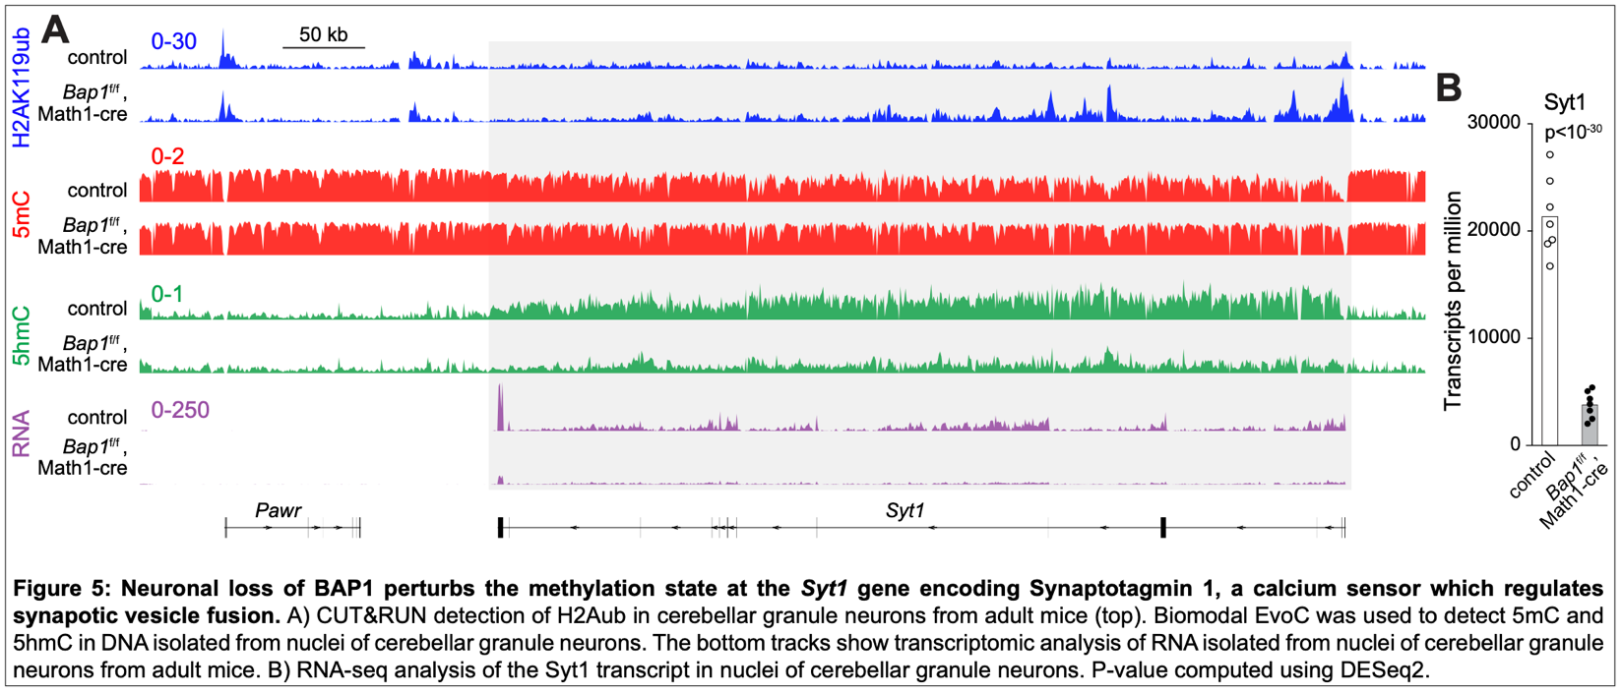
MeCP2 CUT&RUN to easily detect bulk levels of non-CG methylation. In mature neurons, non-CG methylation accumulates postnatally and becomes MeCP2’s dominant genomic binding substrate^{12,13}. We found that the new CUTANA meCUT&RUN from EpiCypher, in which a recombinant GST-tagged MeCP2 methyl-binding domain serves as the primary affinity reagent in a native CUT&RUN reaction, effectively reads out non-CG methylation.

C. APPROACH
C1. PRELIMINARY STUDIES
Experimental neurodevelopmental systems. We have employed two complementary conditional Bap1 mouse mutants tailored to the goals of determining the molecular functions of Bap1 and the behavioral consequences Bap1 loss. Bap1^{f/f},Math1-cre mice allow us to examine the consequences of Bap1 loss within a single, relatively homogeneous postmitotic neuronal population for the deep molecular time-course in Aim 1. In contrast, the Bap1^{f/f},Emx1-cre mice, with Bap1 loss in excitatory neurons of the forebrain, recapitulates patient-relevant seizure phenotype, making it an ideal system for evaluating the potential for functional rescuing by restoration of DNA methylation levels. Finally, the induced neurons in Aim 2 represent a non-animal model for evaluating the effects on patient-specific BAP1 mutation on DNA methylation.
BAP1 loss redistributes H2AK119ub away from facultative heterochromatin and into euchromatin. BAP1 is the catalytic subunit of the PR-DUB complex, which removes the H2AK119ub (H2Aub) histone modification deposited by the Polycomb Repressive Complex 1. To define BAP1’s role in postmitotic neurons, we deleted Bap1 in progenitors of cerebellar granule neurons of Bap1^{f/f},Math1-cre, before profiling H2Aub in the adult cerebellum using the high-resolution/low background next generation sequencing method CUT&RUN (Cleavage Under Targets and Release Using Nuclease). Rather than a uniform increase, as might be predicted from loss of a deubiquitinating enzyme, and as was observed in Bap1 mutant embryonic stem cells, we observed a striking redistribution: 10,068 H2Aub peak regions (25%) gained H2Aub while 1,632 (4%) exhibited H2Aub reduction (Fig. 1A). We compared dysregulated H2Aub regions with the Cistrome repository ^{14,15}, which compares user-defined regions of interest with thousands of chromatin mapping datasets to report the GIGGLE score (Genomics Search Engine for Large-Scale Integrated Genome), a statistical measure of similarity. These comparisons showed that regions where H2Aub was gained resembled euchromatic marks — H3K4me1, H2A.Z-ac, H3K27ac — with the strongest concordance in cerebellum-derived datasets, whereas depleted regions bore greatest similarity to H3K27me3 (Fig. 1B–C). BAP1 therefore does not simply oppose PRC1; it bidirectionally perturbs H2Aub to enforce the partitioning of H2Aub between active and Polycomb-repressed compartments.
Redistributed H2Aub antagonizes acetylation of active enhancers and promoters. CUT&RUN detection of H3K27ac in Bap1 deficient neurons demonstrated loci such as the intergenic enhancers upstream of the Rims1 gene in which increases in H2Aub occurred in concert with decreases in the euchromatin-associated modification H3K27ac. In contrast, loci like Myc exhibited a paradoxical reduction in H2Aub that was accompanied by reduction of the repressive heterochromatin-associated modification H3K27me3. Remarkably, this locus and other heterochromatic loci exhibited simultaneous increases in H3K27ac and active promoter-associated H3K4me3. Genome-wide differential analysis demonstrated that decreases in H3K27ac predominated (Fig. 2C), and the two marks change in opposite directions. These observations indicate a bidirectional interference with maintenance of chromatin state, while also revealing a surprising and previously unrecognized inverse relationship between H2Aub and H3K27ac in neuronal chromatin.
Chromatin dysregulation converges on the synapse-related transcriptome. RNA-seq analysis of nuclei isolated from the developing (age P12) and adult cerebellum and the transcriptome of Adult mutant cerebellum shows 1,147 downregulated and 590 upregulated transcripts (Fig. 3B), with mark changes tracking expression direction — most notably H3K27me3 accumulation at underexpressed genes (Fig. 3C). GO enrichment is dominated by synapse assembly, postsynaptic density, neurotransmitter secretion, and ion channel activity (Fig. 3D), implicating synaptic function as the principal downstream target.
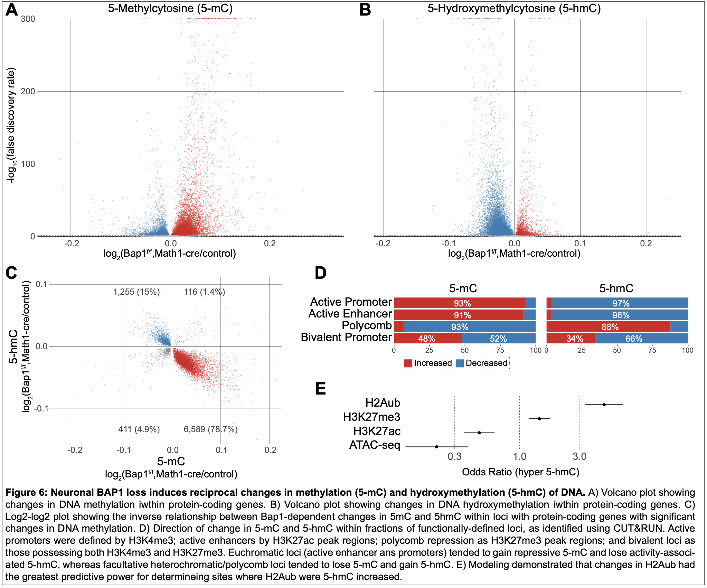
These data establish BAP1 as a required maintainer of neuronal chromatin architecture and motivate the proposed Aims.

C2. EXPERIMENTAL DESIGN AND RESEARCH METHODS
Rigor and Reproducibility. The genome-wide experiments proposed here are, by design, simple two-condition comparisons that are well suited to rigorous execution in mice. In every mouse experiment, mutants are compared to Cre-negative or, given the recessive nature of Bap1 loss, flox-negative littermate controls generated from the same crosses and housed together, so that genotype is the only systematic variable. Both sexes are included at each developmental timepoint, with sex incorporated as a covariate in all differential models and tested explicitly for genotype-by-sex interaction. Sample sizes follow our completed preliminary studies, in which n=6 biological replicates per genotype yielded well-powered CUT&RUN differential analyses and n=7 sufficed for RNA-seq. We will maintain n≥6 per genotype per timepoint for CUT&RUN and RNA-seq, and n=4 per genotype per timepoint for methylation profiling (evoC and EM-seq).
Analyses use established, publicly available pipelines already validated in our hands — SEACR for peak calling, DiffBind for differential binding, DESeq2 for transcript abundance, the modality XPLR binomial logistic regression for CG differential methylation, and the edgeR quasi-likelihood F-test for non-CG differential methylation — with statistical thresholds (FDR<0.05) and spike-in normalization (per-sample lambda phage conversion rate as a model covariate for EM-seq) specified in advance. evoC reads will be processed through the Biomodal DUET v1.5.0 pipeline (Fullgrabe et al. 2023). EM-seq reads will be aligned with bwa-meth and methylation called with MethylDackel using the NEB EM-seq Nextflow pipeline (Vaisvila et al. 2021). All antibodies and CUT&RUN affinity reagents are validated for CUT&RUN and show obvious gebotype difference, which are highly unlikely for non-secific reagents. All sequencing data will be deposited in GEO with processing code released publicly.
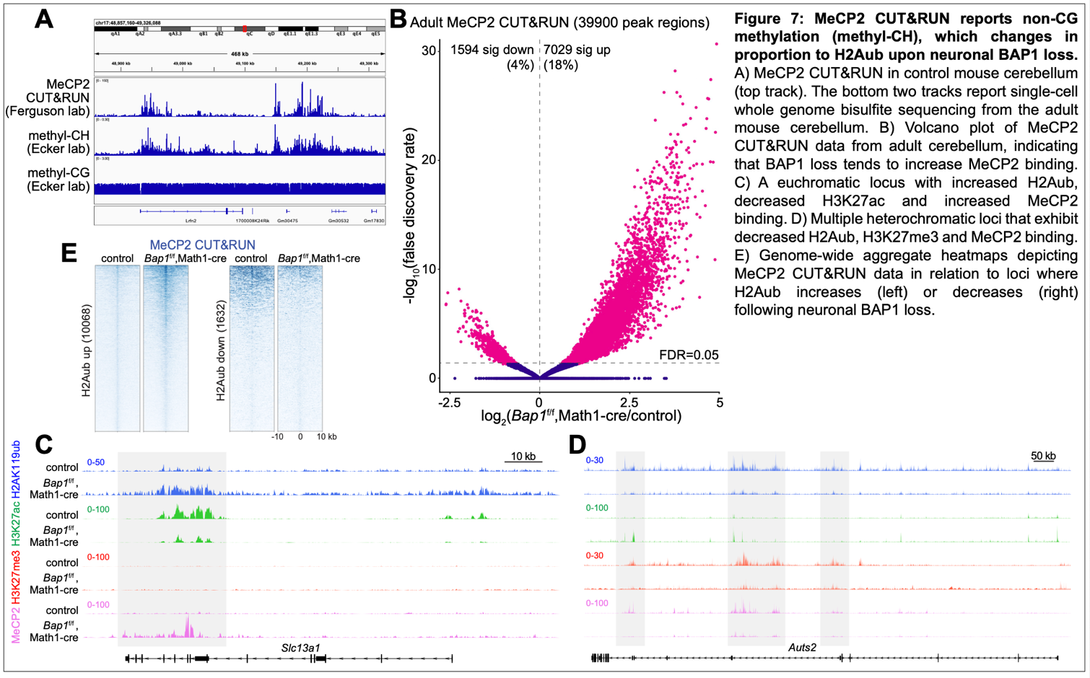
The human iPSC experiments require additional safeguards because CRISPR editing can introduce off-target mutations that segregate with a single clone rather than with the intended genotype. We will therefore analyze three independently derived clones for each patient BAP1 mutation and three independently edited isogenic wild-type clones that have passed through the identical editing and single-cell cloning process. Clone is treated as the unit of biological replication, and only phenotypes reproduced across all three independent clones per genotype will be interpreted as mutation-dependent. Predicted off-target sites will be sequenced in each clone, and karyotype and pluripotency markers confirmed before differentiation.
C3. SPECIFIC AIMS
Aim 1: Establish the sequence of H2Aub, DNMT3A recruitment, and DNA methylation changes after Bap1 loss, and determine their dependence on DNMT3A.
Aim 1 rationale. Our preliminary data establish that Bap1 loss redistributes H2Aub away from heterochromatin toward euchromatin in postmitotic granule neurons, and that H2Aub biochemically recruits DNMT3A. If DNA methylation is genuinely an instructed output of H2Aub redistribution, as proposed in our model (Innovation, Section B), then DNMT3A occupancy and methylation change should be temporally and spatially downstream of H2Aub redistribution rather than arising in parallel with, or independently of, it. This aim tests that directional prediction directly, using the Bap1^{fl/fl},Math1-cre model because it isolates a single, relatively homogeneous postmitotic neuronal population, allowing us to match epigenomic and transcriptomic datasets to a defined molecular time course without the confound of mixed cell types. Establishing both the sequence and the genetic requirement for DNMT3A here is the foundation for Aims 2 and 3: Aim 2 asks whether the same hierarchy holds in human neurons carrying disease-causing BAP1 mutations, and Aim 3 asks whether the methylation step identified here is functionally required for a defined neurological phenotype.
Aim 1 preliminary data.
BAP1 loss alters the DNA methylation landscape at synaptic genes. Because H2Aub redistribution alone did not fully explain the transcriptional phenotype, we asked whether BAP1 loss also perturbs DNA modification. At Syt1, which encodes the presynaptic Ca²⁺ sensor synaptotagmin-1, Bap1^f/f,Math1-cre granule neurons accumulate H2Aub across the gene body, lose gene-body 5hmC, and show near-complete transcriptional collapse (~21,000 to ~3,500 TPM, p < 10⁻³⁰; Fig. 5A–B). This positions Syt1 — a gene central to synaptic vesicle fusion — as a candidate mediator of the synaptic and excitability phenotypes described above.
5mC and 5hmC change reciprocally and in a chromatin-state–specific manner. Using biomodal EvoC to resolve 5mC and 5hmC in granule neuron nuclei, we found that BAP1 loss predominantly increases 5mC (Fig. 6A) and decreases 5hmC (Fig. 6B) within protein-coding loci. These changes are strongly anticorrelated: 78.7% of significantly altered genes gain 5mC while losing 5hmC, and 15% show the converse (Fig. 6C). Stratifying by chromatin state revealed that the direction of change is dictated by the underlying compartment. Active promoters (H3K4me3) and enhancers (H3K27ac) gain 5mC (93% and 91%) and lose 5hmC (97% and 96%), whereas Polycomb-repressed loci (H3K27me3) show the opposite pattern (93% lose 5mC, 88% gain 5hmC); bivalent promoters are split (Fig. 6D). Logistic modeling across candidate predictors identified change in H2Aub as the strongest determinant of 5hmC gain (OR > 3), outperforming H3K27me3, while H3K27ac and chromatin accessibility were negatively associated (Fig. 6E). Thus, BAP1-dependent H2Aub redistribution predicts where the DNA methylome is remodeled.
MeCP2 binding tracks non-CG methylation and follows H2Aub. MeCP2 CUT&RUN signal in control cerebellum closely mirrors methyl-CH, not methyl-CG, when compared to published single-cell WGBS (Fig. 7A), establishing MeCP2 CUT&RUN as a readout of neuronal mCH. In mutants, MeCP2 binding is markedly increased (7,029 peaks up, 18%; 1,594 down, 4%; Fig. 7B). At euchromatic loci such as Slc13a1, H2Aub gain and H3K27ac loss are accompanied by increased MeCP2 (Fig. 7C); at heterochromatic regions of Auts2, H2Aub, H3K27me3, and MeCP2 fall together (Fig. 7D). Genome-wide aggregate analysis confirms that MeCP2 rises across the 10,068 H2Aub-gained regions and falls across the 1,632 H2Aub-lost regions (Fig. 7E).
Technical feasibility. We have validated EM-seq in adult cerebellum against both published snmC-seq and our own WGBS, demonstrating faithful recovery of the mCH landscape (Fig. 8) and establishing the base-resolution platform proposed in Aim 1.
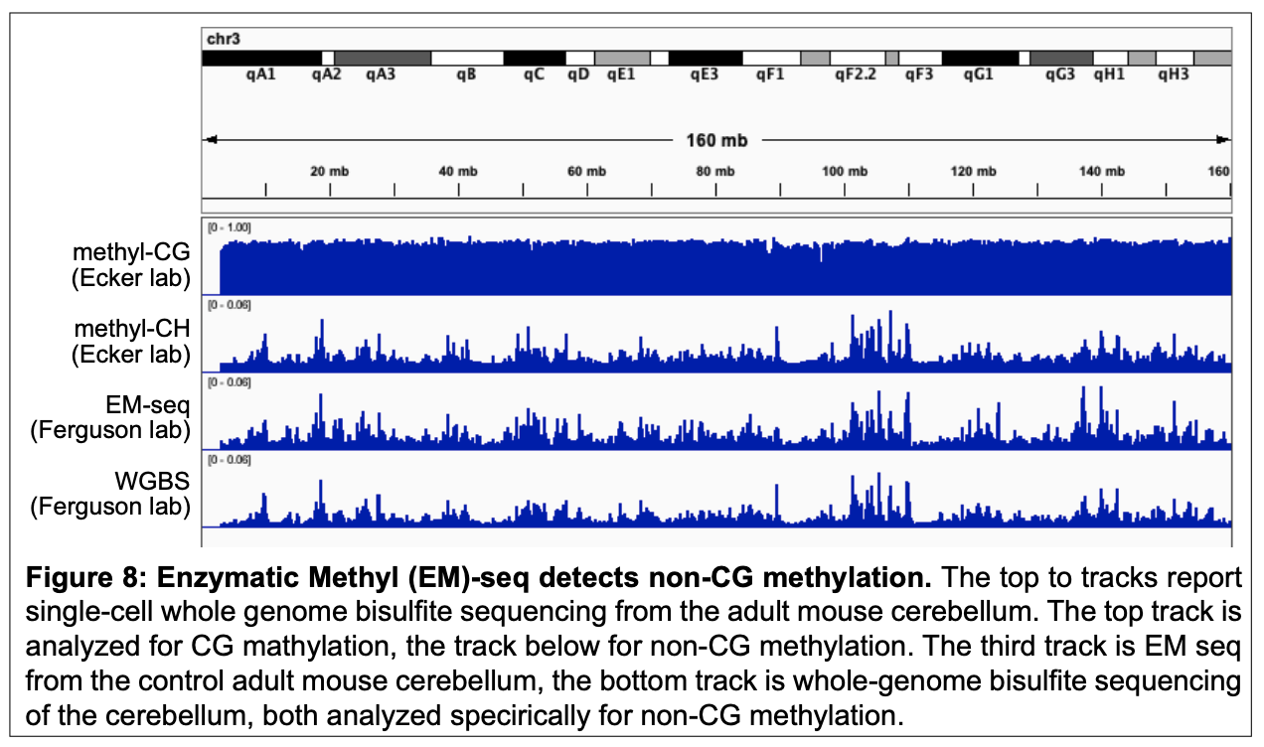
Aim 1.1: Define the developmental sequence of H2Aub redistribution, DNMT3A occupancy, and 5mC/5hmC change. We will profile H2Aub (CUT&RUN), DNMT3A (ChIP-seq), and 5mC/5hmC (Biomodal evoC) in Bap1fl/fl,Math1-cre and littermate control cerebella at P7, P12, P21, and adult (P60), spanning the window in which granule neurons complete postmitotic maturation. At each timepoint, we will test for differential methylation using the modality XPLR analysis pipeline, which fits a binomial logistic regression per region and tests the genotype coefficient by Wald test, with sex as a covariate. The model tests 5mC and 5hmC independently across six GENCODE vM25 annotation classes (gene bodies, promoters, CpG islands, CpG shores, CpG shelves, and TSS regions), with significance defined by Benjamini-Hochberg FDR at q < 0.05. We will classify genes significant in both 5mC and 5hmC by the direction of change in each context: we predict that loci that gain H2Aub will show coordinated 5mC increase and 5hmC decrease — the signature of impaired TET-mediated demethylation — while loci that lose H2Aub will show the reciprocal pattern. To ask whether DNMT3A occupancy and methylation change follow H2Aub redistribution rather than co-occur with or precede it, we will run the differential analyses at each timepoint independently and record the earliest timepoint at which each mark (H2Aub, DNMT3A, 5mC/5hmC) first reaches significance at each gene. We will test by permutation whether the predicted ordering — H2Aub before DNMT3A, DNMT3A before methylation change — occurs more frequently than expected by chance.
Aim 1.2: Profile non-CG methylation (mCH) across the same time course. Profile non-CG methylation (mCH) across the same time course. Because mCH is a neuronally enriched, DNMT3A-dependent mark rarely profiled at this resolution in a disease model, we will apply Enzymatic Methyl-seq to the same P7–adult time course to determine whether mCH accrual is redirected toward loci that gain H2Aub and DNMT3A occupancy, and lost at loci that lose them, in parallel with the CG methylation changes captured by evoC. We will quantify mCH at the gene-body level by aggregating all CH (CHH and CHG) sites within each GENCODE vM25 protein-coding gene body per sample. We will test differential gene-body mCH using the edgeR quasi-likelihood F-test (Benjamini-Hochberg FDR q < 0.05), with genotype and sex as biological covariates and log(total_coverage) as a per-gene offset. We will incorporate the per-sample conversion rate at lambda phage CH sites as a technical covariate to adjust for between-sample differences in enzymatic conversion efficiency.
Aim 1.3: Test the cell-autonomous requirement for DNMT3A. We will cross a conditional Dnmt3a allele onto the Bap1^{fl/fl},Math1-cre background to generate Bap1;Dnmt3a double conditional mutants and ask whether Dnmt3a loss blocks the methylation changes that follow H2Aub redistribution at the sites mapped in Aim 1.1–1.2. Because our model predicts that methylation is itself instructive for the downstream loss of H3K27ac (Significance, Innovation), we will also profile H3K27ac and MeCP2 occupancy in this double mutant to test whether removing DNMT3A blunts the disproportionate H3K27ac loss observed with Bap1 loss alone, directly linking the upstream chromatin lesion to its downstream transcriptional consequence.
Aim 1 expected outcomes, caveats & pitfalls, and additional experiments. We expect H2Aub redistribution to precede changes in DNMT3A occupancy, which in turn precede changes in 5mC, 5hmC, and mCH, consistent with an instructed rather than an independently regulated methylome, and we expect Dnmt3a loss to blunt both the methylation changes and the associated H3K27ac loss at H2Aub-redistributed loci. A caveat is that temporal precedence alone is correlative; the Dnmt3a conditional cross provides the genetic, causal test and is therefore central to this aim. A related caveat is functional redundancy with DNMT3B, which is expressed at low levels in neurons; if Dnmt3a loss only partially blocks methylation change, we will assess Dnmt3b expression and occupancy by CUT&RUN and, if warranted, generate Dnmt3a;Dnmt3b double conditional mutants. If DNMT3A occupancy or methylation change fails to follow H2Aub redistribution in the predicted order, this would argue against a strict instructive hierarchy and instead support a model of parallel, co-regulated chromatin and DNA methylation change — a distinction our densely sampled time course is well powered to make, and one that would itself refine the model tested in Aims 2 and 3.

Aim 2: Determine whether BAP1 catalytic-domain mutations remodel DNA methylation through H2Aub in human neurons.
Aim 2 rationale. Aim 1 establishes the H2Aub-DNMT3A-methylation hierarchy using a mouse Bap1 null allele. Patients, however, carry heterozygous missense mutations in the BAP1 UCH catalytic domain, not complete loss of function, and neurodevelopmental disease mechanism is best tested in a human, isogenic background that removes confounds of genetic variation between patients and controls. This aim tests whether the mechanism defined in Aim 1 generalizes to disease-relevant human mutations, converting a mouse loss-of-function mechanism into direct evidence relevant to BAP1/Küry-Isidor syndrome and moving the model from correlation to causation in a human cellular system.
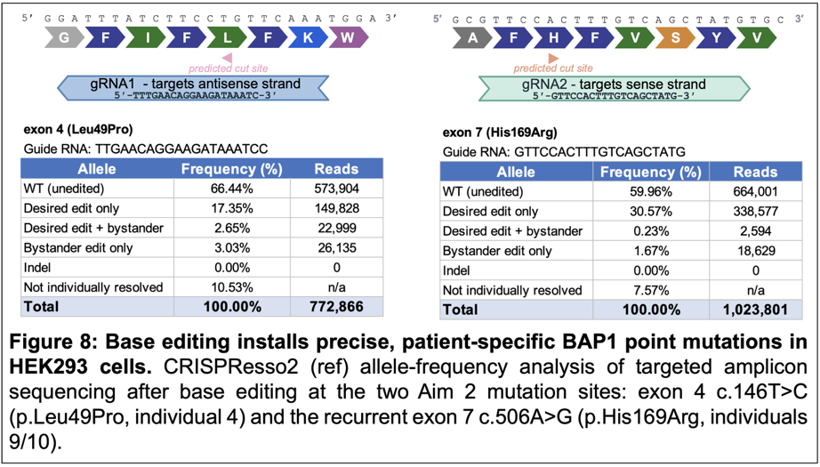
Aim 2 preliminary data. We have successfully installed patient-specific BAP1 mutations in HEK293T cells using base editing. We have introduced two mutations selected for this aim: exon 4 c.146T>C (p.Leu49Pro), carried by individual 4, and the recurrent mutation in exon 7 c.506A>G (p.His169Arg) carried by individuals 9 and 10 in the published cohort⁴. Individual 4 has a comparatively mild presentation, while individual 9 is more severely affected, with severe intellectual disability, very short stature and congenital malformations. His169 sits in the UCH catalytic pocket alongside Cys91¹⁶, and the His169Arg mutation abolished H2AK119ub deubiquitination in a heterologous rescue assay⁴. Amplicon sequencing of edited HEK293 cells shows efficient, precise editing at both sites — 17.4% for Leu49Pro and 30.6% His169Arg of reads carry only the intended substitution, with minimal bystander editing and no indels (Figure 8). We are now introducing both mutations by the same approach into ES cells for the isogenic NGN2 line in Aim 2.1.
Aim 2.1: Generate isogenic, patient-mutation NGN2 iPSC-neuron lines. We are introducing two recurrent patient UCH-domain missense mutations, individually, into a doxycycline-inducible NGN2 human iPSC line by CRISPR knock-in, generating isogenic mutant and wild-type control lines that differ only at the BAP1 locus. We will confirm catalytic loss of function by measuring bulk H2Aub levels by western blot and by CUT&RUN prior to downstream profiling.
Aim 2.2: Profile chromatin and transcriptional consequences across neuronal differentiation. We will differentiate isogenic lines into excitatory neurons and profile H2Aub, H3K27ac, and H3K27me3 by CUT&RUN alongside RNA-seq at serial time points across differentiation, testing whether patient mutations reproduce the euchromatin/heterochromatin blurring — H2Aub and H3K27me3 gain with H3K27ac loss at euchromatic genes, and the reciprocal pattern at heterochromatic loci — that we observe in Bap1^{fl/fl},Math1-cre mice.
Aim 2.3: Profile DNA methylation and MeCP2 redistribution. We will apply evoC, Enzymatic Methyl-seq, and MeCP2 CUT&RUN to the same differentiation time course, extending culture duration as needed to capture the slow accrual of non-CG methylation during neuronal maturation. Concordant, direction-matched changes in methylation and MeCP2 occupancy at loci that gain or lose H2Aub will establish that BAP1 controls the neuronal methylome through H2Aub in a human, disease-relevant genetic background.
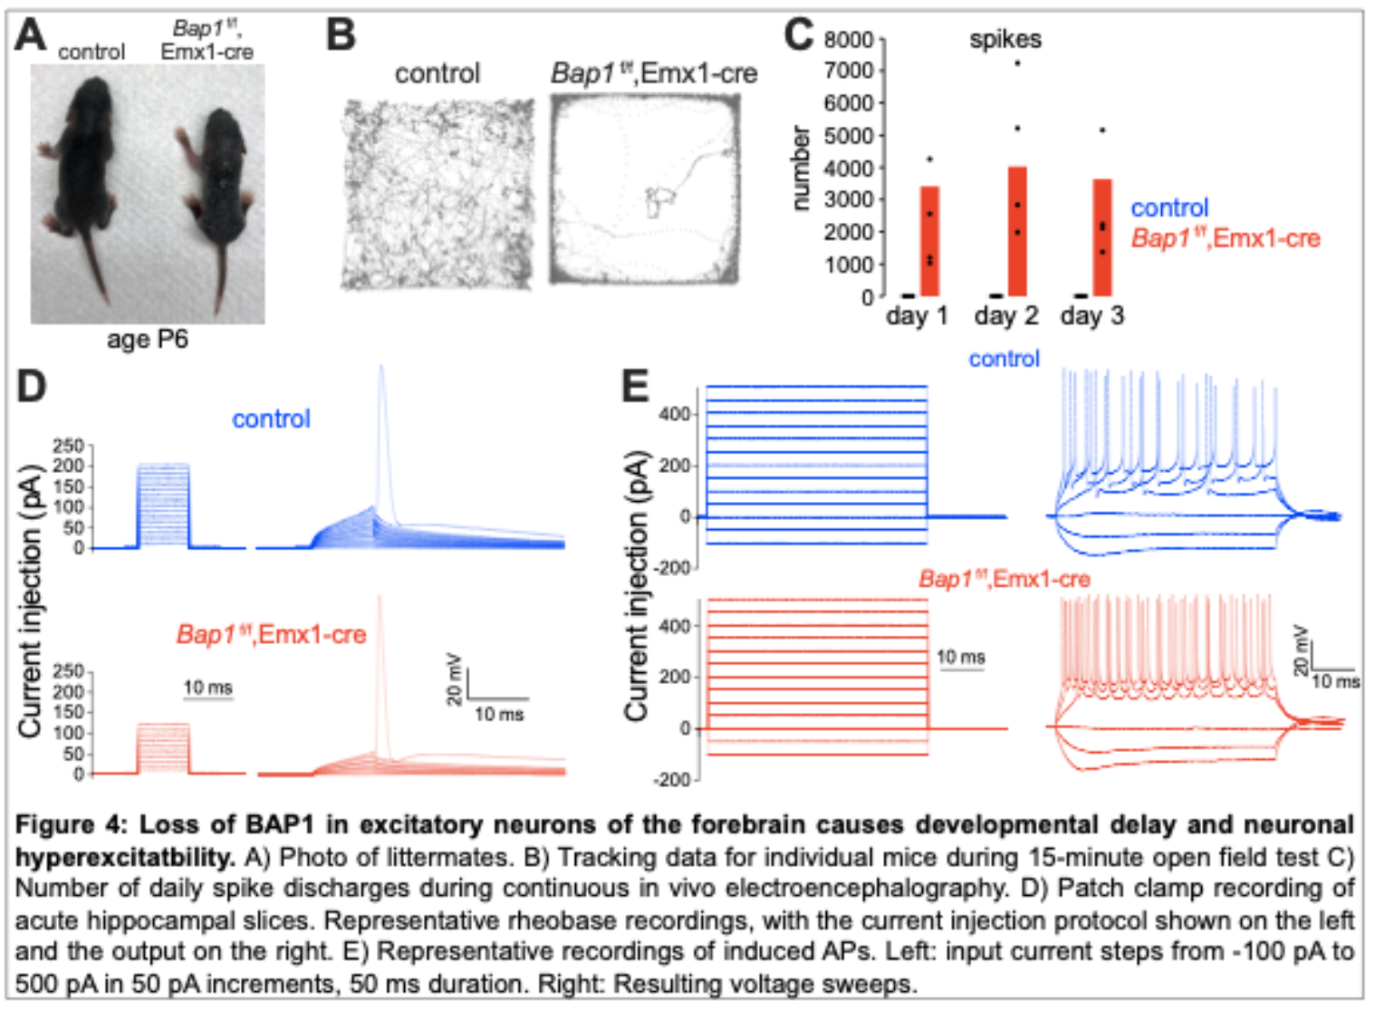
Aim 2 expected outcomes, caveats & pitfalls, and additional experiments. We expect patient UCH-domain mutations to reproduce the mouse cascade — H2Aub redistribution, reciprocal methylation change, MeCP2 redistribution, and H3K27ac loss — in human neurons, with the two mutations producing concordant changes that may differ in magnitude, consistent with an allelic series. A significant caveat of iPSC-neuron models is differentiation heterogeneity and relative immaturity compared to neurons in vivo; we address this with a synchronized, inducible NGN2 system, independent isogenic clones per genotype, and extended culture duration, since mCH accrual requires weeks to months of maturation in vitro as in vivo. If human neurons fail to show the mouse-concordant cascade despite adequate maturation, this would indicate a species-specific difference in DNMT3A regulation or in the H2Aub-DNMT3A biochemical interaction — a possibility our time-resolved design can distinguish from an immaturity artifact, and one that would itself be an important finding about the limits of cross-species conservation of this pathway.
Aim 3: Ascertain whether restoring non-CG methylation toward normal levels rescues seizures caused by BAP1 loss.
Aim 3 rationale. Aims 1 and 2 establish that BAP1 loss redirects non-CG methylation as a consequence of H2Aub redistribution, in mouse and human neurons respectively, but neither establishes that this methylation change is functionally required for any neurological phenotype rather than an accompanying correlate. This aim performs an in vivo epistasis test: partially reducing non-CG methylation on a Bap1-mutant background isolates whether this specific molecular change is causally sufficient to modify a defined, patient-relevant phenotype. We focus on seizures because, unlike the developmental delay and broader behavioral abnormalities also present in Bap1^{fl/fl},Emx1-cre mice, seizures were specifically characterized in this line and can be measured by video-EEG as an objective, unconfounded readout that is not complicated by the baseline behavioral deficits of Dnmt3a^{+/-} mice.
Aim 3 preliminary data. We found that deleting Bap1 in forebrain excitatory neurons (Emx1-cre) produces developmental delay by P6 (Fig. 4A), reduced open-field exploration (Fig. 4B), and thousands of daily epileptiform discharges on continuous EEG (Fig. 4C). Hippocampal patch clamp confirms a cell-autonomous substrate: reduced rheobase and increased evoked firing (Fig. 4D–E).
Aim 3.1: Generate and validate Bap1,Dnmt3a compound mutants. We will cross Bap1^{fl/fl},Emx1-cre mice to global Dnmt3a heterozygous null mice (Dnmt3a^{+/-}) to generate Bap1^{fl/fl},Emx1-cre;Dnmt3a^{+/-} compound mutants alongside Bap1^{fl/fl},Emx1-cre;Dnmt3a^{+/-}, and wild-type littermate controls. We will confirm the expected ~50% reduction in non-CG methylation in forebrain excitatory neurons by Enzymatic Methyl-seq before proceeding to phenotypic assessment.
Aim 3.2: Determine whether reduced non-CG methylation modifies seizure activity. We will perform continuous video-EEG monitoring across all four genotypes to quantify seizure frequency, duration, and severity, testing whether Dnmt3a heterozygosity modifies the seizure phenotype of Bap1^{fl/fl},Emx1-cre mice. Because Dnmt3a^{+/-} mice have baseline behavioral and growth deficits of their own but do not have seizures, we restrict formal phenotypic comparison across genotypes to seizure activity, which provides a readout specific to the epistatic interaction between Bap1 and Dnmt3a rather than to the general health of Dnmt3a^{+/-} animals.
Aim 3.3: Test cell-autonomous rescue in patient iPSC-neurons. In parallel, we will assess neuronal morphology (dendritic arborization and spine density) and electrophysiological maturation (intrinsic excitability, synaptic properties) in the Bap1-mutant iPSC-neurons generated in Aim 2, comparing untreated mutant neurons to mutant neurons in which DNMT3A activity is reduced pharmacologically or by heterozygous DNMT3A knockdown. This provides a complementary, cell-autonomous test of whether reducing DNMT3A activity normalizes cellular phenotypes associated with BAP1 loss, independent of the systemic and circuit-level factors present in vivo.
Aim 3: expected outcomes, caveats & pitfalls, and additional experiments. If reduced non-CG methylation rescues or attenuates seizure activity in Bap1^{fl/fl},Emx1-cre;Dnmt3a^{+/-} compound mutants, and correspondingly normalizes morphological and electrophysiological phenotypes in patient iPSC-neurons, this would establish non-CG methylation as a causally required, druggable node in BAP1-related neurodevelopmental disease and identify DNMT3A, or its downstream effectors, as a candidate therapeutic target. A key caveat is that a partial (~50%) reduction in DNMT3A dosage may be insufficient to produce a detectable rescue even if the underlying mechanism is correct; if so, we will pursue a postnatally restricted, more complete reduction of DNMT3A activity (e.g., an inducible DNMT3A conditional allele) to avoid the developmental confounds of constitutive, complete DNMT3A loss. A second caveat is that epistatic interactions are not always linear; we will therefore treat methylation level and seizure severity as quantitative, correlated variables across the compound mutant cohort rather than relying solely on a categorical comparison between genotypes. Finally, because iPSC-neuron electrophysiology cannot fully recapitulate in vivo seizure circuitry, we treat the cellular rescue experiments in Aim 3.3 as complementary evidence supporting, rather than substituting for, the in vivo epistasis result in Aim 3.2.

