

**Islamic University of Technology**

**Project Report**

**Course Name:** Microcontroller-Based System Design Lab

**Course Code:** EEE 4706

**Project Topic:** Bluetooth interfacing with Microcontroller

**Group No:** 03

**Group Members:**

Wasik Billah Ibn Rashid (190021335)

Sumaiya Tasnim Prapti (190021325)

A.S.M. Sarwar Jahan Shad (190021337)

Tasmiah Rahman (190021313)

Ziyaulhaq Haruna (190021345)

# Objective

This project aims to develop a Bluetooth interface with an 8051 microcontroller assembly language. This project incorporates an interface connecting the Microcontroller and Bluetooth. All additional functionalities are programmed in assembly language, and the chosen hardware for implementation is the 8051 microcontrollers.

The Bluetooth modules allow for wireless data transmission and reception between two devices. Communication through smartphones to other devices is commonly used in home automation and new technologies. It is primarily applicable for controlling other devices.

The Bluetooth connection between the Microcontroller and Bluetooth module gives the power to control something remotely. Also, it helps to send data from one device to another device.

# Required Components

|  |  |
| --- | --- |
| Components | Cost (Tk) |
| Microcontroller Development Board | 7000 |
| Jumper wires |
| DC Motor |
| Relay |
| Buzzer |
| Bluetooth Module HC-05 | 450 |
| Total | 7450 |

Circuit Diagram

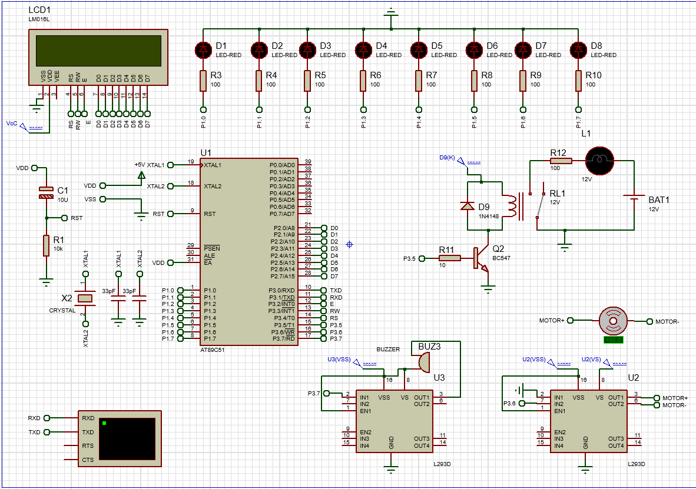

# Mandatory Features

1. Control all 8 LEDs via Bluetooth and send out Morse code from Bluetooth device using any one of the LEDs. Display the coded message on the LCD.

2. Use two relays to connect and control two lights using Bluetooth.

3. Send an encrypted message from a Bluetooth device and display the decrypted message on the LCD.

# Additional features

1. Display Morse code on the LCD when alphabets are sent from a smartphone.

2. Turn on the Buzzer accordingly when Morse code is sent from the smartphone to the Microcontroller.

3. Jump to the next line automatically when the 1st line of LCD is filled up.

4. Two-way communication: Retrieve data from Bluetooth and display it on the connected mobile phone. Additionally, we can transmit data from the phone to the Microcontroller and display it on the LCD monitor.

5. Motor control via Bluetooth: A motor can be controlled through a Bluetooth device. Using this Motor, we can move any other device.

6. Control the Buzzer: Wirelessly control the Buzzer.

# Working Principle

For Bluetooth interfacing, a virtual terminal was used in Proteus. At first, we initialized the serial port communication. Here, Timer mode-2 was taken to use 8-bit auto-reload. Then, the TH1 register was given a 0FDH value for 9600 baud rates as the crystal frequency is 11.0592MHz. The SBUF register is used with the Bluetooth HC05 module to facilitate serial communication. The data from the Bluetooth goes into 8051 through the RX line. In the Microcontroller, the data was kept in the SBUF register. Then, the flag register TI is raised, and the data is moved from SBUF to A register. That is how the input was taken from the HC-05 Bluetooth module. After displaying the input in the LCD, the TI flag register was cleared, and the next input could be taken from the HC-05 module. In the hardware, we used the code and burned it into the Microcontroller. We sent our data from a smart smartphone through the HC-05 Bluetooth module. The RX and TX pins of HC-05 were connected with the Microcontroller's TX and RX pins, respectively. Microcontroller for transmission and receiving. The following symbols have to be sent from the smartphone to perform the mentioned tasks:

Turn On LEDS: 1 to 8

Turn Off LEDS: ! to *

Turn On Relay: 9

Turn Off Relay: (

Turn On Motor: +

Turn Off Motor: =

Turn on the Buzzer: "

Turn off Buzzer: :

Show MORSE Code: A to Z

Go back to taking new input: ,

Start encryption: <; A will be shown as B, B as C, and Z as A.

Stop encryption : >

Start Morse decrypt:?

Print Morse decrypt letter : )

Stop Morse decrypt: /

The given flowchart shows the workflow of this project.

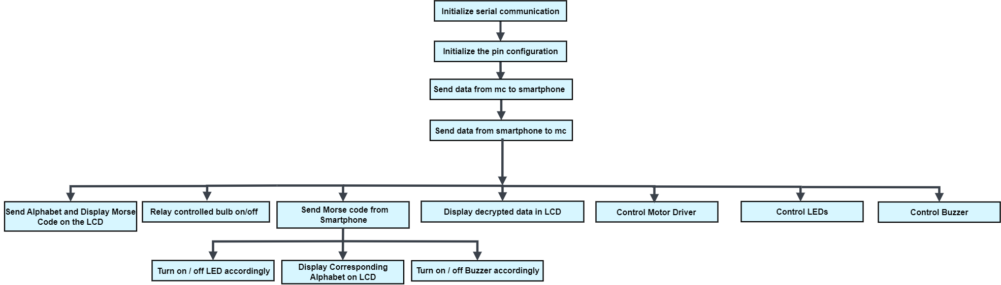

# Code

ORG 00H

; INITIALIZE SERIAL COMMUNICATION

MOV TMOD,#20H ;Timer 1, mode 2 ; 0010 0000 ; 8 bit auto reload

MOV TH1,#0FDH ;9600 baud rate

MOV SCON,#50H; 8 bit data,1 stop bit, 1 start bit, REN enabled ; 0101 0000

CLR T1 ; Clear Timer 1 register

SETB TR1 ;start timer 1

;PIN CONFIGURATION

LED_1 BIT P1.0 ; the buffer port is port 1.

LED_2 BIT P1.1

LED_3 BIT P1.2

LED_4 BIT P1.3

LED_5 BIT P1.4

LED_6 BIT P1.5

LED_7 BIT P1.6

LED_8 BIT P1.7

LED_RELAY BIT P3.5

MOTOR BIT P3.6

BUZZER BIT P3.7

CLR LED_1

CLR LED_2

CLR LED_3

CLR LED_4

CLR LED_5

CLR LED_6

CLR LED_7

CLR LED_8

SETB LED_RELAY

CLR MOTOR

RS EQU P3.4

RW EQU P3.3

ENBL EQU P3.2

;SEND DATA FROM MICROCONTROLLER TO SMARTPHONE

MOV DPTR, #MYDATA

GO:

CLR A

MOVC A,@A+DPTR

JZ LCD ; LCD Subroutine

ACALL SEND

SJMP GO

SEND:

MOV SBUF, A

INC DPTR

HERE: JNB TI, HERE ;wait for the last bit to transfer

CLR TI ;clear TI for the next INPUT

RET

;MAKING THE LCD READY FOR DISPLAYING DATA FROM SMARTPHONE

; LCD Sub routine

LCD:

MOV SP,#70H ; 112D of ROM

MOV PSW,#00H

MOV A,#38H ;LCD 2 lines,5 by 7 matrix

LCALL COMMAND ;call command subroutine

LCALL DELAY ;give LCD some time

MOV A,#0EH ;display on, cursor on

LCALL COMMAND

LCALL DELAY

WELCOME:

MOV 32H, #16

LCALL CLEAR_LCD

MOV A,#06H ;shift cursor right

LCALL COMMAND

LCALL DELAY

MOV A,#80H ;force cursor to begin at 1st line

LCALL COMMAND

LCALL DELAY

;DISPLAY WELCOME MESSAGE

LCALL DELAY

; Display the MYDATA string

MOV DPTR, #MYDATA ; Load the address of the string

LOOP_1 : CLR A

MOVC A,@A+DPTR

JZ FINISH

LCALL DISPLAY

LCALL DELAY

INC DPTR

LJMP LOOP_1

FINISH:

LJMP SMARTPHONE

MSG_A: DB ".-",0

MSG_B: DB "-...",0

MSg_C: DB "-.-.",0

MSG_D: DB "-..", 0

MSG_E: DB ".", 0

MSG_F: DB "..-.", 0

MSG_G: DB "--.", 0

MSG_H: DB "....", 0

MSG_I: DB "..", 0

MSG_J: DB ".---", 0

MSG_K: DB "-.-", 0

MSG_L: DB ".-..", 0

MSG_M: DB "--", 0

MSG_N: DB "-.", 0

MSG_O: DB "---", 0

MSG_P: DB ".--.", 0

MSG_Q: DB "--.-", 0

MSG_R: DB ".-.", 0

MSG_S: DB "...", 0

MSG_T: DB "-", 0

MSG_U: DB "..-", 0

MSG_V: DB "...-", 0

MSG_W: DB ".--", 0

MSG_X: DB "-..-", 0

MSG_Y: DB "-.--", 0

MSG_Z: DB "--..", 0

MYDATA: DB "Group 03, Bluetooth Interfacing",0 ; this data is shown from virtual terminal

;COMMAND FROM THE SMARTPHONE

SMARTPHONE:

MOV A, "H"

LCALL TRANS

TRANS:

MOV SBUF, A

MOV 32H, #16

LCALL CLEAR_LCD

INPUT_NEW:

LCALL GENERAL_INPUT

MOV A, SBUF ;save incoming byte in A

CJNE A,#'1', LED_1_OFF

SETB LED_1;turn on the LED

LJMP INPUT_NEW ;print the INPUT_NEW_NEWacter pressed

LED_1_OFF:

MOV A,SBUF

CJNE A,#'2', LED_2_OFF

SETB LED_2 ;turn ofF the LED

LJMP INPUT_NEW

LED_2_OFF:

MOV A,SBUF

CJNE A,#'3', LED_3_OFF

SETB LED_3

LJMP INPUT_NEW

LED_3_OFF :

MOV A,SBUF

CJNE A,#'4', LED_4_OFF

SETB LED_4

LJMP INPUT_NEW

LED_4_OFF:

MOV A,SBUF

CJNE A,#'5',LED_5_OFF

SETB LED_5

LJMP INPUT_NEW

LED_5_OFF:

MOV A,SBUF

CJNE A,#'6',LED_6_OFF

SETB LED_6

LJMP INPUT_NEW

LED_6_OFF:

MOV A,SBUF

CJNE A,#'7',LED_7_OFF

SETB LED_7

LJMP INPUT_NEW

LED_7_OFF:

MOV A,SBUF

CJNE A,#'8',LED_8_OFF

SETB LED_8

LJMP INPUT_NEW

LED_8_OFF:

MOV A,SBUF

CJNE A,#'!',TURN_ON_RELAY

CLR LED_1

LJMP INPUT_NEW

TURN_ON_RELAY:

MOV A,SBUF

CJNE A,#'9',TURN_OFF_RELAY

CLR LED_RELAY

LJMP INPUT_NEW

TURN_OFF_RELAY:

MOV A,SBUF

CJNE A,#'(', NOT_TURN_OFF_RELAY

SETB LED_RELAY

LJMP INPUT_NEW

NOT_TURN_OFF_RELAY: ; TURN ON MOTOR

MOV A,SBUF

CJNE A,#'+', NOT_TURN_ON_MOTOR

SETB MOTOR

LJMP INPUT_NEW

NOT_TURN_ON_MOTOR: ; TURN OFF MOTOR

MOV A,SBUF

CJNE A,#'=', NOT_TURN_OFF_MOTOR

CLR MOTOR

LJMP INPUT_NEW

NOT_TURN_OFF_MOTOR:

MOV A,SBUF

CJNE A, #'"' , NOT_TURN_ON_BUZZER

CLR BUZZER

LJMP INPUT_NEW

NOT_TURN_ON_BUZZER:

MOV A, SBUF

CJNE A, #':' , NOT_TURN_OFF_BUZZER

SETB BUZZER

LJMP INPUT_NEW

NOT_TURN_OFF_BUZZER:

LED_1_ON:

MOV A, SBUF

CJNE A,#'@',LED_2_ON

CLR LED_2

LJMP INPUT_NEW

LED_2_ON:

MOV A, SBUF

CJNE A,#'#',LED_3_ON

CLR LED_3

LJMP INPUT_NEW

LED_3_ON:

MOV A, SBUF

CJNE A,#'$',LED_4_ON

CLR LED_4

LJMP INPUT_NEW

LED_4_ON:

MOV A, SBUF

CJNE A,#'%',LED_5_ON

CLR LED_5

LJMP INPUT_NEW

LED_5_ON:

MOV A, SBUF

CJNE A,#'^',LED_6_ON

CLR LED_6

LJMP INPUT_NEW

LED_6_ON:

MOV A, SBUF

CJNE A,#'&',LED_7_ON

CLR LED_7

LJMP INPUT_NEW

LED_7_ON:

MOV A, SBUF

CJNE A,#'*',CHECK_A

CLR LED_8

LJMP INPUT_NEW

CHECK_A:

MOV A, SBUF

CJNE A,#'A' , NOT_A ; Jump if not equal to "A"

MOV DPTR, #MSG_A

LJMP DISPLAY_MORSE ; Display Morse code for "A"

NOT_A:

MOV A, SBUF

CJNE A, #'B', NOT_B

MOV DPTR, #MSG_B

LJMP DISPLAY_MORSE

NOT_B:

MOV A, SBUF

CJNE A, #'C', NOT_C

MOV DPTR, #MSG_C

LJMP DISPLAY_MORSE

NOT_C:

MOV A, SBUF

CJNE A, #'D', NOT_D

MOV DPTR, #MSG_D

LJMP DISPLAY_MORSE

NOT_D:

MOV A, SBUF

CJNE A, #'E', NOT_E

MOV DPTR, #MSG_E

LJMP DISPLAY_MORSE

NOT_E:

MOV A, SBUF

CJNE A, #'F', NOT_F

MOV DPTR, #MSG_F

LJMP DISPLAY_MORSE

NOT_F:

MOV A, SBUF

CJNE A, #'G', NOT_G

MOV DPTR, #MSG_G

LJMP DISPLAY_MORSE

NOT_G:

MOV A, SBUF

CJNE A, #'H', NOT_H

MOV DPTR, #MSG_H

LJMP DISPLAY_MORSE

NOT_H:

MOV A, SBUF

CJNE A, #'I', NOT_I

MOV DPTR, #MSG_I

LJMP DISPLAY_MORSE

NOT_I:

MOV A, SBUF

CJNE A, #'J', NOT_J

MOV DPTR, #MSG_J

LJMP DISPLAY_MORSE

NOT_J:

MOV A, SBUF

CJNE A, #'K', NOT_K

MOV DPTR, #MSG_K

LJMP DISPLAY_MORSE

NOT_K:

MOV A, SBUF

CJNE A, #'L', NOT_L

MOV DPTR, #MSG_L

LJMP DISPLAY_MORSE

NOT_L:

MOV A, SBUF

CJNE A, #'M', NOT_M

MOV DPTR, #MSG_M

LJMP DISPLAY_MORSE

NOT_M:

MOV A, SBUF

CJNE A, #'N', NOT_N

MOV DPTR, #MSG_N

LJMP DISPLAY_MORSE

NOT_N:

MOV A, SBUF

CJNE A, #'O', NOT_O

MOV DPTR, #MSG_O

LJMP DISPLAY_MORSE

NOT_O:

MOV A, SBUF

CJNE A, #'P', NOT_P

MOV DPTR, #MSG_P

LJMP DISPLAY_MORSE

NOT_P:

MOV A, SBUF

CJNE A, #'Q', NOT_Q

MOV DPTR, #MSG_Q

LJMP DISPLAY_MORSE

NOT_Q:

MOV A, SBUF

CJNE A, #'R', NOT_R

MOV DPTR, #MSG_R

LJMP DISPLAY_MORSE

NOT_R:

MOV A, SBUF

CJNE A, #'S', NOT_S

MOV DPTR, #MSG_S

LJMP DISPLAY_MORSE

NOT_S:

MOV A, SBUF

CJNE A, #'T', NOT_T

MOV DPTR, #MSG_T

LJMP DISPLAY_MORSE

NOT_T:

MOV A, SBUF

CJNE A, #'U', NOT_U

MOV DPTR, #MSG_U

LJMP DISPLAY_MORSE

NOT_U:

MOV A, SBUF

CJNE A, #'V', NOT_V

MOV DPTR, #MSG_V

LJMP DISPLAY_MORSE

NOT_V:

MOV A, SBUF

CJNE A, #'W', NOT_W

MOV DPTR, #MSG_W

LJMP DISPLAY_MORSE

NOT_W:

MOV A, SBUF

CJNE A, #'X', NOT_X

MOV DPTR, #MSG_X

LJMP DISPLAY_MORSE

NOT_X:

MOV A, SBUF

CJNE A, #'Y', NOT_Y

MOV DPTR, #MSG_Y

LJMP DISPLAY_MORSE

NOT_Y:

MOV A, SBUF

CJNE A, #'Z', NOT_Z

MOV DPTR, #MSG_Z

LJMP DISPLAY_MORSE

DISPLAY_MORSE:

LOOP_MORSE: CLR A

MOVC A,@A+DPTR

JNZ NOT_ZERO_MORSE

ZERO_MORSE : LJMP INPUT_NEW

NOT_ZERO_MORSE:

LCALL DISPLAY

LCALL DELAY

INC DPTR

LJMP LOOP_MORSE

NOT_Z:

MOV A, SBUF

CJNE A, #'<', NOT_ENCRYPTION

LJMP ENCRYPTION

NOT_ENCRYPTION:

MOV A, SBUF

CJNE A, #'?', NOT_MORSE_DECRYPT

LJMP MORSE_DECRYPT

NOT_MORSE_DECRYPT:

MOV A, SBUF

CJNE A, #',' , NOT_NEW_INPUT

LJMP SMARTPHONE

NOT_NEW_INPUT:

LJMP SMARTPHONE

ENCRYPTION:

MOV 32H, #16

LCALL CLEAR_LCD

ENCRYPTION_INPUT:

LCALL GENERAL_INPUT

MOV A, SBUF

CJNE A, #'Z', NOT_Z_ENCRYPTION

MOV A, #'A' ; EQUAL TO Z

LCALL DISPLAY

LCALL DELAY

LJMP ENCRYPTION_INPUT

NOT_Z_ENCRYPTION:

MOV A, SBUF

CJNE A, #'>', CONTINUE_ENCRYPTION

LJMP WELCOME ; STOP ENCRYPTION AND GO BACK TO MAIN INPUT SUBROUTINE

CONTINUE_ENCRYPTION:

ADD A, #1

LCALL DISPLAY

LCALL DELAY

LJMP ENCRYPTION_INPUT

MORSE_DECRYPT:

MOV 32H, #16

;SETB LED_1

LCALL CLEAR_LCD

INPUT_NEW_MORSE:

MOV R0 , #0

MOV R2 , #0

MOV R6 , #0

MOV R7 , #0

MOV R5 , #1 ;COUNTER

MORSE_DECRYPT_INPUT:

LCALL GENERAL_INPUT

MOV A, SBUF

CJNE A, #'/', NOT_STOP_MORSE_DECRYPT

LJMP WELCOME

NOT_STOP_MORSE_DECRYPT:

MOV A, SBUF

CJNE A, #')' , CONTINUE_MORSE_DECRYPT

LJMP DISPLAY_MORSE_DECRYPT

CONTINUE_MORSE_DECRYPT:

MOV A, SBUF

CJNE R5 , #1 , NOT_1 ; if R5=1, store the input in R0

SJMP COUNTER_1

NOT_1:

CJNE R5 , #2 , NOT_2 ; if R5=2, store the input in R6

SJMP COUNTER_2

NOT_2:

CJNE R5 , #3 , NOT_3

SJMP COUNTER_3

NOT_3:

CJNE R5 , #4 , NOT_4

SJMP COUNTER_4

NOT_4:

LJMP WELCOME

COUNTER_1:

MOV R0 , A

INC R5

LJMP MORSE_DECRYPT_INPUT

COUNTER_2:

MOV R6 , A

INC R5

LJMP MORSE_DECRYPT_INPUT

COUNTER_3:

MOV R2, A

INC R5

LJMP MORSE_DECRYPT_INPUT

COUNTER_4:

MOV R7 , A

LJMP MORSE_DECRYPT_INPUT

DISPLAY_MORSE_DECRYPT:

;CHECK FOR A

CJNE R0, #'.' , NOT_MORSE_DECRYPT_A

CJNE R6, #'-' , NOT_MORSE_DECRYPT_A

CJNE R2, #0 , NOT_MORSE_DECRYPT_A

CJNE R7, #0 , NOT_MORSE_DECRYPT_A

LJMP MORSE_DECRYPT_A

;CHECK FOR B

NOT_MORSE_DECRYPT_A:

CJNE R0, #'-' , NOT_MORSE_DECRYPT_B

CJNE R6, #'.' , NOT_MORSE_DECRYPT_B

CJNE R2, #'.' , NOT_MORSE_DECRYPT_B

CJNE R7, #'.' , NOT_MORSE_DECRYPT_B

LJMP MORSE_DECRYPT_B

; CHECK FOR C

NOT_MORSE_DECRYPT_B:

CJNE R0, #'-' , NOT_MORSE_DECRYPT_C

CJNE R6, #'.' , NOT_MORSE_DECRYPT_C

CJNE R2, #'-' , NOT_MORSE_DECRYPT_C

CJNE R7, #'.' , NOT_MORSE_DECRYPT_C

LJMP MORSE_DECRYPT_C

; CHECK FOR D

NOT_MORSE_DECRYPT_C:

CJNE R0, #'-' , NOT_MORSE_DECRYPT_D

CJNE R6, #'.' , NOT_MORSE_DECRYPT_D

CJNE R2, #'.' , NOT_MORSE_DECRYPT_D

CJNE R7, #0 , NOT_MORSE_DECRYPT_D

LJMP MORSE_DECRYPT_D

; CHECK FOR E

NOT_MORSE_DECRYPT_D:

CJNE R0, #'.' , NOT_MORSE_DECRYPT_E

CJNE R6, #0 , NOT_MORSE_DECRYPT_E

CJNE R2, #0 , NOT_MORSE_DECRYPT_E

CJNE R7, #0 , NOT_MORSE_DECRYPT_E

LJMP MORSE_DECRYPT_E

; CHECK FOR F

NOT_MORSE_DECRYPT_E:

CJNE R0, #'.' , NOT_MORSE_DECRYPT_F

CJNE R6, #'.' , NOT_MORSE_DECRYPT_F

CJNE R2, #'-' , NOT_MORSE_DECRYPT_F

CJNE R7, #'.' , NOT_MORSE_DECRYPT_F

LJMP MORSE_DECRYPT_F

; CHECK FOR G

NOT_MORSE_DECRYPT_F:

CJNE R0, #'-' , NOT_MORSE_DECRYPT_G

CJNE R6, #'-' , NOT_MORSE_DECRYPT_G

CJNE R2, #'.' , NOT_MORSE_DECRYPT_G

CJNE R7, #0 , NOT_MORSE_DECRYPT_G

LJMP MORSE_DECRYPT_G

; CHECK FOR H

NOT_MORSE_DECRYPT_G:

CJNE R0, #'.' , NOT_MORSE_DECRYPT_H

CJNE R6, #'.' , NOT_MORSE_DECRYPT_H

CJNE R2, #'.' , NOT_MORSE_DECRYPT_H

CJNE R7, #'.' , NOT_MORSE_DECRYPT_H

LJMP MORSE_DECRYPT_H

; CHECK FOR I

NOT_MORSE_DECRYPT_H:

CJNE R0, #'.' , NOT_MORSE_DECRYPT_I

CJNE R6, #'.' , NOT_MORSE_DECRYPT_I

CJNE R2, #0 , NOT_MORSE_DECRYPT_I

CJNE R7, #0 , NOT_MORSE_DECRYPT_I

LJMP MORSE_DECRYPT_I

; CHECK FOR J

NOT_MORSE_DECRYPT_I:

CJNE R0, #'.' , NOT_MORSE_DECRYPT_J

CJNE R6, #'-' , NOT_MORSE_DECRYPT_J

CJNE R2, #'-' , NOT_MORSE_DECRYPT_J

CJNE R7, #'-' , NOT_MORSE_DECRYPT_J

LJMP MORSE_DECRYPT_J

; CHECK FOR K

NOT_MORSE_DECRYPT_J:

CJNE R0, #'-' , NOT_MORSE_DECRYPT_K

CJNE R6, #'.' , NOT_MORSE_DECRYPT_K

CJNE R2, #'-' , NOT_MORSE_DECRYPT_K

CJNE R7, #0 , NOT_MORSE_DECRYPT_K

LJMP MORSE_DECRYPT_K

; CHECK FOR L

NOT_MORSE_DECRYPT_K:

CJNE R0, #'.' , NOT_MORSE_DECRYPT_L

CJNE R6, #'-' , NOT_MORSE_DECRYPT_L

CJNE R2, #'.' , NOT_MORSE_DECRYPT_L

CJNE R7, #'.' , NOT_MORSE_DECRYPT_L

LJMP MORSE_DECRYPT_L

; CHECK FOR M

NOT_MORSE_DECRYPT_L:

CJNE R0, #'-' , NOT_MORSE_DECRYPT_M

CJNE R6, #'-' , NOT_MORSE_DECRYPT_M

CJNE R2, #0 , NOT_MORSE_DECRYPT_M

CJNE R7, #0 , NOT_MORSE_DECRYPT_M

LJMP MORSE_DECRYPT_M

; CHECK FOR N

NOT_MORSE_DECRYPT_M:

CJNE R0, #'-' , NOT_MORSE_DECRYPT_N

CJNE R6, #'.' , NOT_MORSE_DECRYPT_N

CJNE R2, #0 , NOT_MORSE_DECRYPT_N

CJNE R7, #0 , NOT_MORSE_DECRYPT_N

LJMP MORSE_DECRYPT_N

; CHECK FOR O

NOT_MORSE_DECRYPT_N:

CJNE R0, #'-' , NOT_MORSE_DECRYPT_O

CJNE R6, #'-' , NOT_MORSE_DECRYPT_O

CJNE R2, #'-' , NOT_MORSE_DECRYPT_O

CJNE R7, #0 , NOT_MORSE_DECRYPT_O

LJMP MORSE_DECRYPT_O

; CHECK FOR P

NOT_MORSE_DECRYPT_O:

CJNE R0, #'.' , NOT_MORSE_DECRYPT_P

CJNE R6, #'-' , NOT_MORSE_DECRYPT_P

CJNE R2, #'-' , NOT_MORSE_DECRYPT_P

CJNE R7, #'.' , NOT_MORSE_DECRYPT_P

LJMP MORSE_DECRYPT_P

; CHECK FOR Q

NOT_MORSE_DECRYPT_P:

CJNE R0, #'-' , NOT_MORSE_DECRYPT_Q

CJNE R6, #'-' , NOT_MORSE_DECRYPT_Q

CJNE R2, #'.' , NOT_MORSE_DECRYPT_Q

CJNE R7, #'-' , NOT_MORSE_DECRYPT_Q

LJMP MORSE_DECRYPT_Q

; CHECK FOR R

NOT_MORSE_DECRYPT_Q:

CJNE R0, #'.' , NOT_MORSE_DECRYPT_R

CJNE R6, #'-' , NOT_MORSE_DECRYPT_R

CJNE R2, #'.' , NOT_MORSE_DECRYPT_R

CJNE R7, #0 , NOT_MORSE_DECRYPT_R

LJMP MORSE_DECRYPT_R

; CHECK FOR S

NOT_MORSE_DECRYPT_R:

CJNE R0, #'.' , NOT_MORSE_DECRYPT_S

CJNE R6, #'.' , NOT_MORSE_DECRYPT_S

CJNE R2, #'.' , NOT_MORSE_DECRYPT_S

CJNE R7, #0 , NOT_MORSE_DECRYPT_S

LJMP MORSE_DECRYPT_S

; CHECK FOR T

NOT_MORSE_DECRYPT_S:

CJNE R0, #'-' , NOT_MORSE_DECRYPT_T

CJNE R6, #0 , NOT_MORSE_DECRYPT_T

CJNE R2, #0 , NOT_MORSE_DECRYPT_T

CJNE R7, #0 , NOT_MORSE_DECRYPT_T

LJMP MORSE_DECRYPT_T

; CHECK FOR U

NOT_MORSE_DECRYPT_T:

CJNE R0, #'.' , NOT_MORSE_DECRYPT_U

CJNE R6, #'.' , NOT_MORSE_DECRYPT_U

CJNE R2, #'-' , NOT_MORSE_DECRYPT_U

CJNE R7, #0 , NOT_MORSE_DECRYPT_U

LJMP MORSE_DECRYPT_U

; CHECK FOR V

NOT_MORSE_DECRYPT_U:

CJNE R0, #'.' , NOT_MORSE_DECRYPT_V

CJNE R6, #'.' , NOT_MORSE_DECRYPT_V

CJNE R2, #'.' , NOT_MORSE_DECRYPT_V

CJNE R7, #'-' , NOT_MORSE_DECRYPT_V

LJMP MORSE_DECRYPT_V

; CHECK FOR W

NOT_MORSE_DECRYPT_V:

CJNE R0, #'.' , NOT_MORSE_DECRYPT_W

CJNE R6, #'-' , NOT_MORSE_DECRYPT_W

CJNE R2, #'-' , NOT_MORSE_DECRYPT_W

CJNE R7, #0 , NOT_MORSE_DECRYPT_W

LJMP MORSE_DECRYPT_W

; CHECK FOR X

NOT_MORSE_DECRYPT_W:

CJNE R0, #'-' , NOT_MORSE_DECRYPT_X

CJNE R6, #'.' , NOT_MORSE_DECRYPT_X

CJNE R2, #'.' , NOT_MORSE_DECRYPT_X

CJNE R7, #'-' , NOT_MORSE_DECRYPT_X

LJMP MORSE_DECRYPT_X

; CHECK FOR Y

NOT_MORSE_DECRYPT_X:

CJNE R0, #'-' , NOT_MORSE_DECRYPT_Y

CJNE R6, #'.' , NOT_MORSE_DECRYPT_Y

CJNE R2, #'-' , NOT_MORSE_DECRYPT_Y

CJNE R7, #'-' , NOT_MORSE_DECRYPT_Y

LJMP MORSE_DECRYPT_Y

; CHECK FOR Z

NOT_MORSE_DECRYPT_Y:

CJNE R0, #'-' , NOT_MORSE_DECRYPT_Z

CJNE R6, #'-' , NOT_MORSE_DECRYPT_Z

CJNE R2, #'.' , NOT_MORSE_DECRYPT_Z

CJNE R7, #'.' , NOT_MORSE_DECRYPT_Z

LJMP MORSE_DECRYPT_Z

NOT_MORSE_DECRYPT_Z:

LJMP INPUT_NEW_MORSE

MORSE_DECRYPT_A:

MOV A, #'A'

LJMP MORSE_LED

MORSE_DECRYPT_B:

MOV A, #'B'

LJMP MORSE_LED

MORSE_DECRYPT_C:

MOV A, #'C'

LJMP MORSE_LED

MORSE_DECRYPT_D:

MOV A, #'D'

LJMP MORSE_LED

MORSE_DECRYPT_E:

MOV A, #'E'

LJMP MORSE_LED

MORSE_DECRYPT_F:

MOV A, #'F'

LJMP MORSE_LED

MORSE_DECRYPT_G:

MOV A, #'G'

LJMP MORSE_LED

MORSE_DECRYPT_H:

MOV A, #'H'

LJMP MORSE_LED

MORSE_DECRYPT_I:

MOV A, #'I'

LJMP MORSE_LED

MORSE_DECRYPT_J:

MOV A, #'J'

LJMP MORSE_LED

MORSE_DECRYPT_K:

MOV A, #'K'

LJMP MORSE_LED

MORSE_DECRYPT_L:

MOV A, #'L'

LJMP MORSE_LED

MORSE_DECRYPT_M:

MOV A, #'M'

LJMP MORSE_LED

MORSE_DECRYPT_N:

MOV A, #'N'

LJMP MORSE_LED

MORSE_DECRYPT_O:

MOV A, #'O'

LJMP MORSE_LED

MORSE_DECRYPT_P:

MOV A, #'P'

LJMP MORSE_LED

MORSE_DECRYPT_Q:

MOV A, #'Q'

LJMP MORSE_LED

MORSE_DECRYPT_R:

MOV A, #'R'

LJMP MORSE_LED

MORSE_DECRYPT_S:

MOV A, #'S'

LJMP MORSE_LED

MORSE_DECRYPT_T:

MOV A, #'T'

LJMP MORSE_LED

MORSE_DECRYPT_U:

MOV A, #'U'

LJMP MORSE_LED

MORSE_DECRYPT_V:

MOV A, #'V'

LJMP MORSE_LED

MORSE_DECRYPT_W:

MOV A, #'W'

LJMP MORSE_LED

MORSE_DECRYPT_X:

MOV A, #'X'

LJMP MORSE_LED

MORSE_DECRYPT_Y:

MOV A, #'Y'

LJMP MORSE_LED

MORSE_DECRYPT_Z:

MOV A, #'Z'

LJMP MORSE_LED

MORSE_LED:

LCALL DISPLAY

LCALL DELAY

CHECK_R0:

CJNE R0, #'-' , R0_NOT_DASH

LJMP R0_DASH

R0_NOT_DASH:

CJNE R0, #'.' , R0_NOT_DOT

LJMP R0_DOT

R0_NOT_DOT:

CJNE R0, #'0' , R0_NOT_ZERO

LJMP R0_ZERO

R0_NOT_ZERO:

LJMP INPUT_NEW_MORSE

R0_DASH:

LCALL DASH

LJMP CHECK_R6

R0_DOT:

LCALL DOT

LJMP CHECK_R6

R0_ZERO:

LJMP INPUT_NEW_MORSE

CHECK_R6:

CJNE R6, #'-' , R6_NOT_DASH

LJMP R6_DASH

R6_NOT_DASH:

CJNE R6, #'.' , R6_NOT_DOT

LJMP R6_DOT

R6_NOT_DOT:

CJNE R6, #'0' , R6_NOT_ZERO

LJMP R6_ZERO

R6_NOT_ZERO:

LJMP INPUT_NEW_MORSE

R6_DASH:

LCALL DASH

LJMP CHECK_R2

R6_DOT:

LCALL DOT

LJMP CHECK_R2

R6_ZERO:

LJMP INPUT_NEW_MORSE

CHECK_R2:

CJNE R2, #'-' , R2_NOT_DASH

LJMP R2_DASH

R2_NOT_DASH:

CJNE R2, #'.' , R2_NOT_DOT

LJMP R2_DOT

R2_NOT_DOT:

CJNE R2, #'0' , R2_NOT_ZERO

LJMP R2_ZERO

R2_NOT_ZERO:

LJMP INPUT_NEW_MORSE

R2_DASH:

LCALL DASH

LJMP CHECK_R7

R2_DOT:

LCALL DOT

LJMP CHECK_R7

R2_ZERO:

LJMP INPUT_NEW_MORSE

CHECK_R7:

CJNE R7, #'-' , R7_NOT_DASH

LJMP R7_DASH

R7_NOT_DASH:

CJNE R7, #'.' , R7_NOT_DOT

LJMP R7_DOT

R7_NOT_DOT:

CJNE R7, #'0' , R7_NOT_ZERO

LJMP R7_ZERO

R7_NOT_ZERO:

LJMP INPUT_NEW_MORSE

R7_DASH:

LCALL DASH

LJMP INPUT_NEW_MORSE

R7_DOT:

LCALL DOT

LJMP INPUT_NEW_MORSE

R7_ZERO:

LJMP INPUT_NEW_MORSE

CLEAR_LCD:

LCALL DELAY

MOV A,#01H ;clear lcd

LCALL COMMAND

LCALL DELAY

RET

GENERAL_INPUT:

ACALL DELAY

CLR A

CLR RI ;get ready to receive data

WAIT_INPUT: JNB RI, WAIT_INPUT ;wait for the INPUT_NEW to come in

RET

COMMAND:

LCALL READY

MOV P2,A

CLR RS ;control reg is selected, send command to LCD controller

CLR RW ;write to LCD

SETB ENBL

LCALL DELAY

CLR ENBL ;H to L pulse

RET

DISPLAY:

LCALL READY

MOV P2,A

SETB RS ;data register is selected, RS=1 send data to LCD

CLR RW ;write to LCD

SETB ENBL

LCALL DELAY

CLR ENBL ;H to L pulse

DJNZ 32H, SAME_LINE

LJMP NEW_LINE

NEW_LINE:

LCALL DELAY

MOV A,#0C0H ;2ND LINE

LCALL COMMAND

LCALL DELAY

SAME_LINE:

RET

;COMMAND and DISPLAY subroutine is same except the RS pin

READY:

SETB P2.7

CLR RS ;control reg is selected, send command to LCD controller

SETB RW ;reading from LCD

WAIT:

CLR ENBL ; disables communication with the LCD temporarily

ACALL DELAY ;L to H pulse

SETB ENBL

JB P2.7,WAIT ;checks the busy flag

RET

DASH:

SETB LED_1

CLR BUZZER

LCALL DELAY

LCALL DELAY

LCALL DELAY

LCALL DELAY

LCALL DELAY

LCALL DELAY

CLR LED_1

SETB BUZZER

LCALL DELAY

RET

DOT:

SETB LED_1

CLR BUZZER

LCALL DELAY

LCALL DELAY

CLR LED_1

SETB BUZZER

LCALL DELAY

RET

DELAY:

MOV R1,#1

AGAIN_3:

MOV R3,#220

AGAIN_2:

MOV R4,#220 ; delay

AGAIN:

DJNZ R4, AGAIN

DJNZ R3, AGAIN_2

DJNZ R1, AGAIN_3

RET

EXIT_2: SJMP EXIT_2

END

# Hardware Implementation

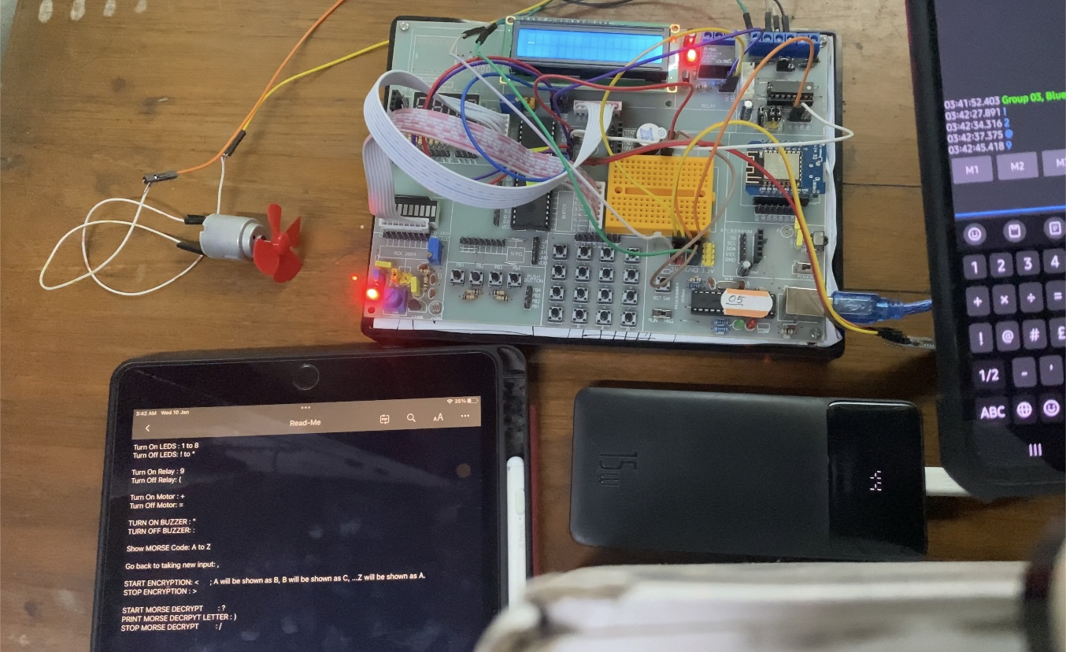

# Video Demonstration

<https://iutdhaka-my.sharepoint.com/:f:/g/personal/wasikbillah_iut-dhaka_edu/Ek9FEO7103tKtd-ibCEePaMBv0jdrJ3xidin6IIt1EDzHQ?e=Yetp1E>

N.B. Please copy and paste the link in any browser, preferably in a desktop browser.

# Problems Faced

1. The HC05 module in Proteus software was not working as expected. So, a virtual terminal was used.
2. Debugging required LEDs to be turned on and off at potential places of the code. This required many trial and error consuming a lot of time.

# Conclusion

The objective of the project on Bluetooth interfacing has been implemented here. With three mandatory features, six other new features were also included. In completing this project, the knowledge of Bluetooth communication using a serial port of interfacing Bluetooth module was gained and learned. The project is done in both hardware and software. Proteus 8.16 Professional was used to build the circuit for the software part. Hardware was implemented using a Microcontroller, LCD monitor, HC-05 Bluetooth module, Relay, Motor, and Buzzer.