Clinic Management System – Scope & First Impression Strategy

# 1. Client Overview

Our client is a former Ministry of Defense official. With extensive experience in structured and secure environments, he brings a clear vision of discipline, accountability, and high standards. The clinic network under his leadership is expanding across the city with multiple branches in the pipeline, although our current focus is on building the system for a single branch. The client is also investing in a local server infrastructure, which indicates a strong preference for data ownership, security, and long-term scalability.  
  
While not tech-savvy in the modern sense, the client is detail-oriented, strategic, and expects a system that is intuitive, secure, and impressively polished.

# 2. System Scope (MVP – Single Branch Focus)

The system scope is carefully tailored to meet the immediate needs of one clinic branch while laying the groundwork for multi-branch expansion.

* • Patient Management – registration, medical and visit history, search and filtering.
* • Appointments – doctor scheduling, appointment tracking, calendar interface.
* • Invoices & Billing – automatic invoice generation, export, print, and payment tracking.
* • HR Management – employee registry, roles, leave, and payroll basics.
* • Finance Module – income/expense tracking, petty cash, and revenue analytics.
* • CT Scan, Lab & Imaging Modules – record uploads, department-specific access, and reporting.
* • Inventory & Logistics – department-level inventory, low stock alerts, and audits.
* • Department Interfaces – role-based UIs: Doctor, Lab, Pharmacy, Finance, HR, CT Scan, Ultrasound.
* • Audit Logging – logs of changes and user activity for transparency and compliance.
* • Server-Aware Architecture – offline-first with optional syncing, backup strategy prepared.

# 3. First Impression Strategy

Key visual and functional elements that will immediately convey quality and professionalism include:

* • Modern login screen with clinic logo, branch name, and secure look.
* • Light and dark theme toggle for user preference.
* • Snackbar notifications instead of intrusive popups.
* • Loading spinners and splash screen to prevent UI freezing.
* • Professional-looking invoice printouts with branding and barcode.
* • Role-specific dashboards with KPIs (e.g., daily income, number of patients).
* • Auto-saving in long forms (e.g., patient records, lab tests).
* • Audit trail logs visible to administrators.
* • Clear color-coded buttons and consistent UX patterns.

# 4. Future-Ready Expansion

While Phase 1 targets a single branch, the system will be developed with scalability in mind:

* • Multi-branch capability with branchID fields in core tables.
* • Central server integration for aggregating reports.
* • Cloud or LAN sync options for remote and local use.
* • Telehealth integrations (optional).
* • Performance tracking and analytics dashboards.
* • Internal messaging system for staff collaboration.

# 5. Final Note

The client values structure, accountability, and simplicity. This system will not only meet their operational needs but also reflect a standard worthy of their background. By carefully balancing usability, performance, and scalability, we aim to deliver a system that exceeds expectations from the first click.

# 6. Resources

<https://www.jotform.com/form-templates/category/human-resources>

<https://help.sap.com/docs/itcm/end-user-information/dashboard>

# 6. System Mockups & Diagrams

## 6.1 Desktop App Dashboard Mockups

These wireframes represent planned layouts for key user dashboards. The design prioritizes clarity, responsiveness, and fast access to core actions.

Doctor Dashboard:



Finance Dashboard:



## 6.2 Database Structure (Core Tables)

Below is a simplified version of the database schema for Phase 1. All tables are branch-aware and designed for normalization and scalability.

|  |  |  |  |
| --- | --- | --- | --- |
| Table Name | Key Fields | Relations | Notes |
| Patients | PatientID, Name, DOB, Gender | Appointments, Invoices, History | Stores core patient data |
| Appointments | AppointmentID, PatientID, DoctorID, Date, Status | Patients, Departments | Links patients with doctors and services |
| Invoices | InvoiceID, AppointmentID, Total, Status | Appointments, Payments | Billing information tied to appointments |
| Departments | DepartmentID, Name, BranchID | Staff, Services | Defines organizational structure |
| Staff | StaffID, Name, Role, DepartmentID | Appointments, Payroll | Employee data and access level |
| Inventory | ItemID, Name, Stock, DepartmentID | Departments | Tracks usage per department |
| Payments | PaymentID, InvoiceID, Amount, Date | Invoices | Transaction history |

## 6.3 ER Diagram

The following diagram represents the Entity-Relationship design of the system, outlining table connections and primary flows.

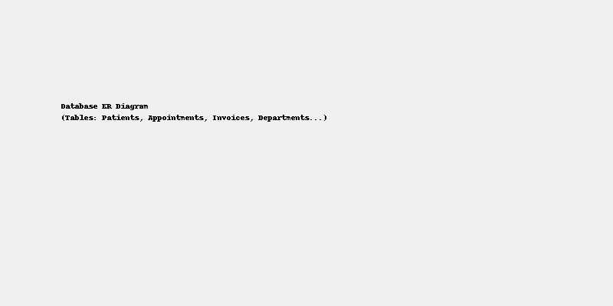

## 6.4 Operational Workflow Diagram

This workflow shows the path of patient interaction across departments and how different modules interconnect.



# 7. Full Database Schema (Tables & Relationships)

|  |  |  |  |
| --- | --- | --- | --- |
| Table Name | Fields | Relations | Notes |
| Branches | BranchID (PK), Name, Location, Phone | Linked to Departments, Staff, Appointments, Patients | Allows multi-branch scaling in future |
| Departments | DepartmentID (PK), Name, BranchID (FK) | Linked to Staff, Inventory, Appointments | Examples: HR, Finance, Lab, CT Scan |
| Staff | StaffID (PK), Name, Role, DepartmentID (FK), BranchID (FK), Phone, Email | Linked to Appointments, Payroll | Includes doctors, lab techs, HR, finance staff |
| Patients | PatientID (PK), FullName, Gender, DOB, Contact, Address, CreatedAt | Linked to Appointments, MedicalHistory, Invoices | Stores patient master data |
| Appointments | AppointmentID (PK), PatientID (FK), DoctorID (FK), DepartmentID (FK), Date, Time, Status, Notes | Linked to Invoices, Lab Tests, Prescriptions | Central table linking services and billing |
| MedicalHistory | HistoryID (PK), PatientID (FK), Summary, Diagnosis, CreatedAt | Linked to Patients | Patient visit history and diagnoses |
| Invoices | InvoiceID (PK), AppointmentID (FK), TotalAmount, Status, CreatedAt | Linked to Payments, Appointments | Tracks billing per service rendered |
| Payments | PaymentID (PK), InvoiceID (FK), AmountPaid, Method, PaidAt | Linked to Invoices | Transaction records for accounting |
| Inventory | ItemID (PK), Name, Quantity, DepartmentID (FK), Threshold | Linked to Departments | Tracks stock levels and alerts |
| LabTests | TestID (PK), AppointmentID (FK), TestType, Result, PerformedBy, Date | Linked to Appointments, Staff | Handles lab module data |
| Prescriptions | PrescriptionID (PK), AppointmentID (FK), Medicine, Dosage, Frequency, Notes | Linked to Appointments, Pharmacy | Medication data post-appointment |
| Expenses | ExpenseID (PK), DepartmentID (FK), Description, Amount, Date | Linked to Departments | Tracks all operational spending |
| Revenues | RevenueID (PK), Source, Amount, Date, BranchID (FK) | Branch-level income tracking | Used for financial reports |