Research Workspace
Designing and Securing a Multi-Tier Application Across Component Boundaries
Software Security — Assignment I
MSc in Cybersecurity, Aarhus University
October 2026
Author: Zaki Nahimi
Repository: research-workspace (git history included in submission)
AI usage declared in docs/AI_USE_DECLARATION.md

1. System Choice and Component Boundaries
I built Research Workspace, a system in which researchers upload private datasets and request exports of them. I chose this domain directly from the assignment brief's own worked example (the “Research workspace / Private datasets and results / Export library” row, and the Figure 1 export workflow), because it gives a natural, non-contrived reason for three components with genuinely different responsibilities and permissions, rather than three components built only to satisfy a “three components” requirement.
The three boundaries follow the brief's own architecture table. The Application API is the only component that ever sees a password; it is the natural place to put identity establishment and request routing, and nothing else. The Resource Service is the only component that opens the dataset database; making it the sole owner of that data, reachable only over its own HTTP API, means every other component's “permission” to touch a dataset is really just a token the Resource Service chooses whether to honour — ownership and enforcement live in the same place. The Processing Service is pulled out separately specifically because it needs a capability the other two don't: running a third-party dependency (exportkit) against data it was handed. Separating it means a compromise of that dependency is contained to one process with one, specific, narrow job, rather than running inside the component that also holds the database or issues credentials.
This also means the component boundaries are not arbitrary — each one corresponds to a different trust decision (who are you / do you own this / what is this external code allowed to touch), and that mapping is what makes the authorization design in Section 2 possible.
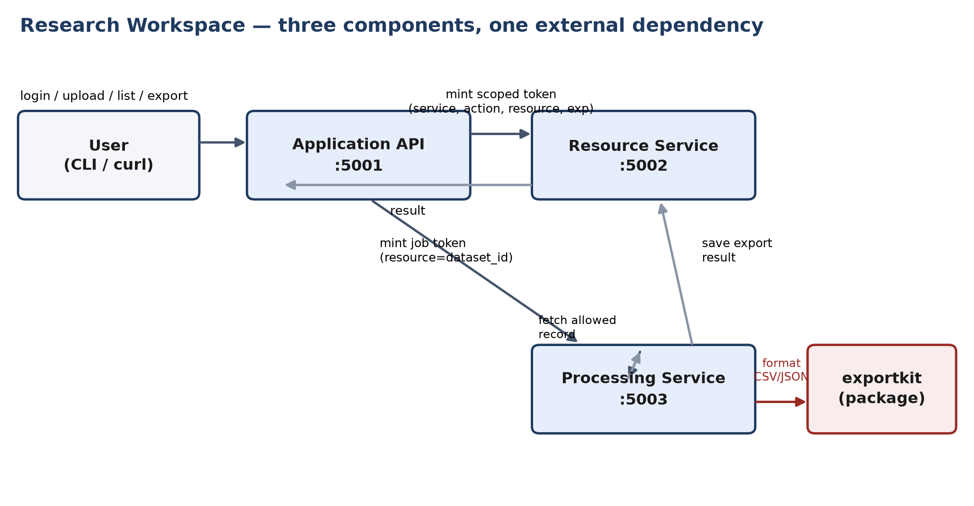
Figure 1. The three components, their ports, and where the external dependency sits.

2. Identity, Authority, Ownership and Dependency Trust
Identity is established exactly once: at POST /auth/login on the Application API, which checks a password hash against a seeded account and returns a signed session JWT (sub, role, 30-minute validity). From there, authority is never reused directly — every downstream call gets its own, freshly minted, narrowly scoped token (security.py::mint_service_token), binding exactly four things: which service may accept it (aud), which action it permits (scope, e.g. dataset:read), which resource, if any, it is restricted to (resource, a dataset id), and how long it is valid (exp, 60 seconds for service tokens).
Ownership is established in exactly one place: the Resource Service's SQLite datasets table has an owner column set once, at creation, forced from the verified token's sub — never from a client-supplied field. Every later read, export, or delete re-derives “is this allowed” from record.owner == token.sub (or token.role == admin), not from any cached decision made earlier in the request chain.
Dependency trust is handled differently again, because exportkit is not a request we control the shape of — it's code we run. The Processing Service treats it as supplied, not owned: installed from a separately built wheel, checked against a consumer-held digest manifest before installation (Experiment A, Section 5), and not trusted at runtime either — its output is re-validated against the one record it was authorized to touch before that output is saved or returned.

How the three selected design principles appear
Principle | Design decision | Implementation & test evidence
Least privilege | Tokens are scoped to one action and (where applicable) one resource, with a 60-second lifetime, instead of one broad session credential reused everywhere. | mint_service_token() mints per-call; dataset creation forces owner = token.sub server-side. Evidence: test_create_dataset_owner_is_forced_from_token_not_body.
Complete mediation | Every service — not only the Application API — independently re-verifies signature, audience, scope and ownership on every call, including calls from another trusted service. | Each service has its own security.py verifying signature/aud/scope; Resource Service re-checks ownership in save_export() even though the Processing Service already decided. Evidence: V1–V4 regression suites, all services' 401/403 tests.
Fail-safe defaults | Every authorization decision defaults to deny; a token missing an expected claim (e.g. no resource claim) authorizes nothing, not everything. | verify_password() returns None on any failure; V4's fix rejects a missing resource claim. Evidence: test_login_wrong_password / test_login_unknown_user (identical 401), test_V4_token_without_a_resource_claim_is_rejected.
Table 1. The three required secure design principles: decision, implementation, and test evidence.

3. How Authority Is Carried Through the Workflow
Figure 2 shows F3 (export), the functionality the brief requires to involve all three components. The key property it illustrates is that authority is re-derived and re-checked at every hop, not passed through as an unexamined bearer credential.
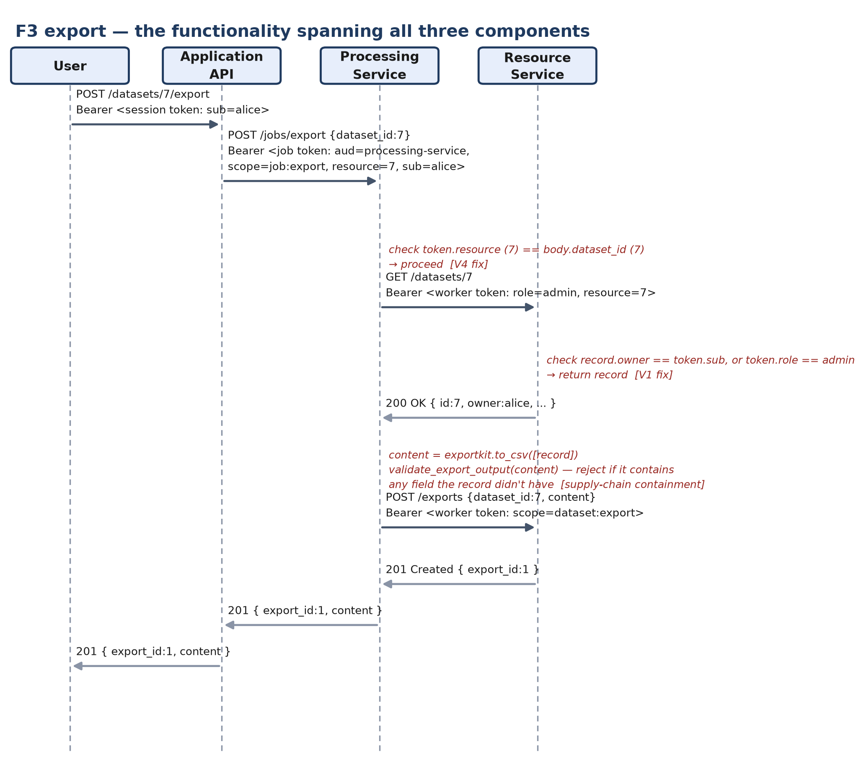
Figure 2. The export workflow (F3), with the V1 and V4 checks and the supply-chain output-validation check marked.
Five things happen in sequence. First, the user's session token (identity only) reaches the Application API. Second, the Application API mints a new token for the Processing Service, binding the specific dataset id into its resource claim — this is the one moment the Application API's own authorization decision (“alice may export dataset 7”) is made explicit and signed. Third, the Processing Service's own check — the fix for V4 — is that it must compare this resource claim against the job parameters in the request body before doing anything; this is the check that prevents a permitted service (the Processing Service, which legitimately can read many users' data to do its job) from performing an unauthorized action. Fourth, the Processing Service's own call to the Resource Service uses a third, separately minted token, and the Resource Service's own check (the fix for V1) independently re-verifies ownership again, regardless of what the Processing Service already decided. Fifth, before the result is saved or returned, validate_export_output checks what exportkit actually produced against what it was allowed to produce.
Five independent checks, by three different pieces of code, each of which could in principle be bypassed by a bug in just one of the others — this redundancy is what “complete mediation” and “defense in depth” mean concretely in this system, rather than as abstract principles.

4. Planted Vulnerabilities
Four vulnerabilities were planted as real, exploitable code, each proven exploitable by an automated test that passed against the exact commit that introduced it, then fixed with the same test file rewritten to assert the secure behaviour. Table 2 summarizes; full before/after code, exact commit hashes, and the specific test for each are in docs/THREAT_MODEL.md.
# | Vulnerability (CWE) — component | Nature of the fix
V1 | IDOR (CWE-639) — Resource Service: GET /datasets/<id> checked scope but never ownership. | Added record.owner == token.sub (or role == admin) check before returning the record.
V2 | Broken signature verification (CWE-347) — Application API: session tokens decoded with verify_signature=False. | Signature, algorithm, audience and required claims are now all verified before any claim is trusted.
V3 | SQL injection (CWE-89) — Resource Service: search query concatenated into SQL, defeating the owner filter. | Both the owner filter and the search pattern are now bound as query parameters.
V4 | Confused deputy (CWE-441) — Processing Service × Resource Service (composition): job used body.dataset_id, not the token's authorized resource. | Job now requires token.resource to be present and equal to body.dataset_id, rejecting otherwise.
Table 2. The four planted-then-fixed vulnerabilities (3 from the course catalog, 1 from composing the components).
V1 and V3 both live in the Resource Service and were both examples of a scope check being mistaken for a resource check, or a parameterized half of a query being undermined by an unparameterized other half — the kind of narrow, specific mistake a single missing line produces, not a structural flaw. V2 was structurally more serious: because every downstream authority in the system is derived from the Application API's session-token verification, a bug in that one verification step propagated as genuine, correctly-signed elevated authority into services that verified signatures perfectly correctly themselves — exactly what complete mediation is meant to prevent at the layer where it's actually violated.
V4 is the vulnerability required to stem from composing the three components, and it genuinely could not exist in a single-process version of this application: the Processing Service needs broader read access than any single end user has, in order to do its job across many users' datasets, and the only thing standing between that legitimate power and a confused-deputy exploit is a check that the specific job being run matches what was specifically authorized for it. Planted, the check was simply missing — the job trusted a client-suppliable parameter instead of its own signed credential's claim. The fix does not reduce the Processing Service's power, which is architecturally necessary; it closes the gap between what this component can do and what this specific request was authorized to do.

5. Controlled Supply Chain Attack (Optional, Attempted)
exportkit, the required external dependency, formats dataset records into CSV/JSON for the Processing Service. I built a malicious fixture (packages/exportkit-malicious) declaring the identical package name and version as the real one, preserving its normal output, but additionally attempting to read RESEARCH_WORKSPACE_JWT_SECRET — the shared inter-service signing secret — from the process environment and smuggle it into the exported content as an extra field. I chose this target because it is the highest-impact thing reachable from inside the Processing Service's own process: the secret would let an attacker forge tokens for every service. What the compromised package can reach is set by the Processing Service's own credentials and deployment, which Experiment B measured with a probe inside the container: its process environment (including that secret), the Resource Service's HTTP API (401 without a token) and outbound internet access — but no database file and no volumes, because the Resource Service's SQLite file lives in a separate container.
The malicious code enters entirely through the package installation path and the package's own functions — nothing in services/processing-service/app.py was edited to accommodate it. Experiment B (scripts/experiment_b.py) models a compromised supplier release that the consumer accepts: in an isolated docker-compose project, a separate manifest approves the malicious wheel's name, version and digest, the Dockerfile installs it, and the normal workflow (login, upload, export through the Application API) is run.
Two independent mitigations were implemented and tested, matching the brief's instruction that checking only a package's filename or version is not a sufficient runtime defence:
- Experiment A (install-time): manifest/approved_packages.json, controlled by the consumer rather than the supplier, pins the benign wheel's exact SHA-256 digest. scripts/verify_manifest.py rejects the malicious wheel even though its declared name and version are byte-for-byte identical to the approved one — identity alone was never the gate. The check sits in the installation path itself: the Processing Service Dockerfile and the Jenkins build stage verify the wheel before pip install, and a Docker build with the malicious wheel in place fails (artifacts/docker-build-malicious-wheel-rejected.txt).
- Experiment B (approved compromised update, three phases, evidence in artifacts/experiment-b/). Before the boundary, using the Processing Service as it was in commit 0fca8b3 (no output validation), alice's ordinary export returned HTTP 201 with the JWT secret in an extra column, and the same secret was stored in the Resource Service: the unauthorized access succeeded, and that output is preserved. After the boundary, validate_export_output re-parses whatever exportkit actually produced and rejects the export (HTTP 422, nothing stored) if it contains any field beyond the authorized record's own keys. With the benign wheel the legitimate job still completes (HTTP 201, no extra field). The probe also showed the container ran as root, so a non-root user was added. This contains only the in-band channel: code already running inside the Processing Service could still use the shared secret directly (for example to forge an admin token) or send it out over the open network, which is why per-service asymmetric keys and egress filtering are the first production changes listed in Section 6.

6. SSDLC, Where Protections Came From, and Production Readiness
docs/SSDLC_PLAN.md was committed before any service code, mapping each phase (requirements → implementation/build → testing → release) to a required deliverable and a gate. In practice this meant the architecture, trust boundaries, and the four vulnerability classes to plant were decided before implementation started, which is why V1–V4 map cleanly onto specific, pre-identified places in the design (a resource-owning endpoint, the one identity-verification function, a database query, a cross-service trust boundary) rather than being bugs found by chance afterward. The testing gate in that plan — “investigation and fixes,” with test evidence — is the reason every vulnerability in this project exists in git history as a real planting commit that includes a passing exploit test, followed by a fix commit that rewrites that test to assert the secure behaviour — not just a described risk. (The initial plan had described a separate failing exploit-test commit; this deviation is recorded in section 9 of docs/SSDLC_PLAN.md.)
The Jenkinsfile defines which findings block a release: any failing unit or end-to-end functional/authorization test, any ruff finding, any pip-audit finding (pip-audit has no severity threshold, so every finding blocks), a broken dependency set (pip check), and any wheel whose name, version and SHA-256 do not match the approval manifest, which is checked before the wheel is installed; the malicious wheel is the control case and must be rejected. The pipeline itself has not been run to completion on a Jenkins server. The same commands were run by hand and their results are saved in artifacts/ (all unit and end-to-end tests passing, ruff clean, pip-audit clean for all three services, the end-to-end suite run against the docker-compose stack). Evidence by commit: V1 and V3 planted in 1dfd1d8 and fixed in cde57d6; V2 in 1ccefc1, fixed in 5cdc098; V4 in d0303b2, fixed in 0fca8b3; the supply-chain experiment in 47a5eb1 and Experiment B in aa04424; the docker-compose environment and end-to-end tests in c10d1f0.
Protection in this system comes from several different layers, deliberately not just one:
- Language/runtime: Python's sqlite3 parameter binding is what actually closes V3 once used correctly — the fix is using the mechanism the runtime already provides, not “more validation.”
- Libraries: PyJWT with algorithms= and audience= pinned explicitly (never left to default or caller-chosen) is what closes V2; werkzeug.security password hashing keeps credentials out of the threat model entirely.
- Application logic: ownership checks, scope checks, and the V4 resource-claim check are all bespoke logic no library provides — this is where most of this project's actual design work sits.
- Deployment configuration: the shared JWT secret is read from an environment variable with a clearly-labelled dev-only fallback, and each service runs as its own container/process with its own SQLite file, so a compromise of one component's filesystem does not automatically expose another's data. This follows from the compose configuration; it does not limit what a compromised component can do with the shared secret and its network access (Section 5).
For an actual production release, the most important changes would be: real secrets management instead of an environment variable; per-service asymmetric signing keys instead of one shared HMAC secret, so a compromised service cannot mint tokens for the others it trusts; TLS between services; a token revocation/replay story beyond short TTLs; structured audit logging of every authorization decision, not just the requested_by field currently on export results; rate limiting on /auth/login; a real package registry and signing instead of a local manifest file; and narrowing the Processing Service's admin-equivalent worker credential to a purpose-built scope restricted to exactly the resource on its current job, enforced by the Resource Service itself, rather than relying entirely on the Processing Service's own V4 check.

7. Conclusion
This project's main lesson was that composing independently-reasonable components across a network boundary creates authorization questions that don't exist in any one component alone — V4 was real, exploitable, and invisible from inside either the Processing Service's or the Resource Service's code reviewed separately. Complete mediation (checking authority again at every hop, even when the caller is “one of ours”) and treating an external dependency as supplied rather than owned (checking both its identity before installation and its behaviour at runtime) were the two principles that did the most work here, and both are things a single-process application would never have needed to think about.

References
Aarhus University. Software Security course vulnerability catalog (Brightspace, module 219647/2943887).
Aarhus University. Software Security Assignment I brief (Assignemnt1/Software_Security_Assignment_I.pdf, this repository).
MITRE. CWE-639: Authorization Bypass Through User-Controlled Key. cwe.mitre.org/data/definitions/639.html
MITRE. CWE-347: Improper Verification of Cryptographic Signature. cwe.mitre.org/data/definitions/347.html
MITRE. CWE-89: SQL Injection. cwe.mitre.org/data/definitions/89.html
MITRE. CWE-441: Unintended Proxy or Intermediary (‘Confused Deputy’). cwe.mitre.org/data/definitions/441.html
PyJWT documentation — algorithm and audience verification. pyjwt.readthedocs.io

Appendix A: Repository Map
Full detail is in the repository itself (README.md gives exact build/seed/run/test commands); this is a pointer, not a duplicate.
- services/application-api, services/resource-service, services/processing-service — the three components, each with its own security.py, app.py, requirements.txt, Dockerfile, and tests/.
- packages/exportkit, packages/exportkit-malicious — the external dependency's benign and malicious builds, plus their built wheels under dist/.
- manifest/approved_packages.json, scripts/verify_manifest.py — Experiment A's integrity gate; manifest/experiment_b/ and scripts/experiment_b.py — Experiment B.
- tests/ — cross-service integration and V1–V4 authorization regression tests against the real, running system.
- docs/SSDLC_PLAN.md, docs/ARCHITECTURE.md, docs/THREAT_MODEL.md, docs/ACCESS_CONTROL_MATRIX.md, docs/AI_USE_DECLARATION.md — the supporting documentation this report summarizes.
- Jenkinsfile, docker-compose.yml — the CI/CD pipeline and the fresh test environment it drives.

Appendix B: Test Suite Summary
40 per-service unit/security tests (16 resource-service, 11 application-api, 13 processing-service) plus 8 cross-service integration/authorization tests in tests/, all passing; the 8 end-to-end tests were also run against the full docker-compose stack, and Experiment B was run end to end (see README.md §4–6). Saved results are in artifacts/.

