

**GURU SHREE SHANTHIVIJAI JAIN COLLEGE FOR WOMEN**

|  |  |  |
| --- | --- | --- |
| **Team Leader** | **Zakiya Tabbassum A** | **Azeezis@gmail.com** |
| **Team Member 1** | **Akshaya S** | **achu58497@gmail.com** |
| **Team Member 2** | **Asma Parveen A** | **aasmaparveen2005@gmail.com** |
| **Team Member 3** | **Lokeshwari A M** | **Lokeshwari154@gmail.com** |
| **Team Member 4** | **Sharini Abarna R** | **abarnaram2403@gmail.com** |

(Affiliated to university of madras & re-accredited by NAAC 96,vepery high road,Chennai-07)

**Frontend Development with React.js**

**INTRODUCTION:**

PROJECT TITLE: FITFLEX

FitFlex is a revolutionary fitness app designed to transform your workout experience. It offers an intuitive interface, dynamic search, and a vast library of exercises for all fitness levels. Join FitFlex to embark on a personalized fitness journey and achieve your wellness goals.

**TEAM MEMBERS:**

1) AKSHAYA S

2) ASMA PARVEEN A

3) LOKESHWARI A M

4) SHARINI ABARNA R

5) ZAKIYA TABBASSUM A

**Project Overview:**

**PURPOSE:**

1. **Promote Physical Fitness & Well-being**: The core purpose of a project under FitFlex would be to promote healthier lifestyles by improving users' physical fitness, mental well-being, and overall health through various personalized fitness programs, workout plans, or wellness services.
2. **Provide Flexibility**: As the name suggests, FitFlex could be focused on providing flexible fitness solutions tailored to different fitness levels, personal goals, and schedules.
3. **Encourage Consistency**: By offering flexibility in how and when people work out or track their fitness journey, the project might aim to foster long-term commitment to fitness and healthy habits.
4. **Community Building**: It could serve to build a supportive community of fitness enthusiasts who share progress, challenges, and motivation.

**GOALS:**

1. **Personalized Fitness Plans**: Offer tailored fitness plans based on individual goals (weight loss, muscle gain, overall health) and available resources (equipment, time commitment, etc.).
2. **Increased Accessibility**: Ensure that people of all fitness levels and backgrounds can access the platform, promoting inclusivity in fitness.
3. **Track Progress**: Provide tools to track progress and results, such as fitness trackers, goals, or feedback mechanisms.
4. **Offer Guidance and Education**: Include educational content on nutrition, fitness techniques, mental health, injury prevention, etc., to help users lead healthier lives.
5. **Create a Motivating Environment**: Leverage features like challenges, social sharing, or achievements to keep users motivated and connected to their goals.
6. **Integrate Technology**: Utilize apps, wearable devices, or virtual trainers to enhance the fitness experience, offering real-time feedback and monitoring.

**FEATURES:**

**1.User Interface (UI) Design**

* **Responsive Design**: Ensures the platform works smoothly on both mobile devices and desktops.
* **Clean & Intuitive Layout**: Easy navigation with a user-friendly interface to enhance the user experience.

**2. User Authentication**

* **Sign-up/Login**: User registration, login, and secure authentication via email, social media, or third-party integrations.
* **Profile Management**: Users can update their personal information, fitness goals, and preferences.

**3. Personalized Dashboards**

* **Fitness Goals & Progress**: Displays custom fitness plans, progress tracking (e.g., weight loss, strength improvements), and achievements.
* **Activity Feed**: Visualizes daily activities, workouts, calories burned, etc.

**4. Workout Plans & Programs**

* **Customized Plans**: Personalized workout programs based on user goals (e.g., weight loss, muscle gain).
* **Video Tutorials**: Step-by-step guides or video demonstrations for exercises.

**5. Progress Tracking**

* **Real-Time Tracking**: Users can track their daily workouts, meals, calories, and fitness metrics (e.g., steps, distance).
* **Charts & Reports**: Visual representations (graphs, stats) to show progress over time.
* **Challenges**: Fitness challenges that users can join to stay motivated and compete with others.

**6. Integration with Wearable Devices**

* **Sync with Fitness Trackers**: Sync data from wearables like Fitbit, Apple Watch, or other fitness devices for real-time tracking.

**ARCHITECTURE:**

**COMPONENT STRUCTURE**:

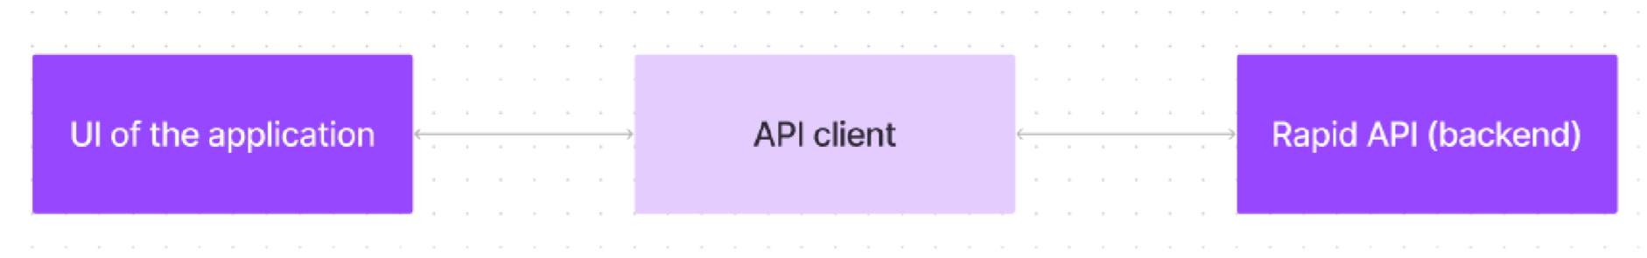

FitFlex prioritizes a user-centric approach from the ground up. The engaging user interface (UI), likely built with a framework like React Native, keeps interaction smooth and intuitive.

An API client specifically designed for FitFlex communicates with the backend, but with a twist: it leverages Rapid API. This platform grants access to various external APIs, allowing FitFlex to potentially integrate features like fitness trackers, nutrition data, or workout tracking functionalities without building everything from scratch. This approach ensures a feature-rich experience while focusing development efforts on the core FitFlex functionalities.

**App Component (Root)**

* **Purpose**: The root component that contains the overall structure of the app and handles routing.
* **Responsibilities**:
  + Wrapping the main UI components and routing logic.
  + Passing necessary data (via props) to child components.

**Authentication Components**

* **Components**: Login, Signup, ForgotPassword
* **Purpose**: Handles user authentication processes (signing in, signing up, resetting passwords).
* **Responsibilities**:
  + Collecting user credentials (username, email, password).
  + Validating the user input and interacting with an API to authenticate or register the user.
  + Redirecting to the Dashboard or Home page on successful login.

**Dashboard Component**

* **Purpose**: Displays the user's personalized fitness dashboard with progress, goals, and activity.
* **Responsibilities**:
  + Fetches user-specific data (e.g., workout history, goals).
  + Renders charts, progress bars, and stats.
  + Offers navigation to different sections (workouts, progress tracking, community)

**Workout Components**

* **Components**: WorkoutList, WorkoutDetail, WorkoutCard
* **Purpose**: Handles the display of workout plans, details, and individual exercises.
* **Responsibilities**:
  + Displaying a list of available workouts.
  + Showing detailed workout instructions (e.g., exercise description, sets, reps).
  + Allowing users to filter workouts based on difficulty, category, or goal.

**Progress Tracker Component**

* **Purpose**: Tracks and displays the user's fitness progress, such as weight, body measurements, or other fitness stats.
* **Responsibilities**:
  + Display progress over time with graphs or charts.
  + Allow the user to add or update their progress (e.g., weight changes, reps, or endurance).

**STATE MANAGEMENT:**

### ****React Context API**** (for Global State)

The **React Context API** is a simple and efficient way to manage global state without the complexity of Redux. It is particularly useful for managing relatively small amounts of state or for sharing state between deeply nested components.

* **User Authentication**: The Context API can manage user authentication state (whether a user is logged in or not) and store user details like name, email, and fitness preferences. This makes it accessible to any component that needs to know the current user's status or profile data.

### ****React Context API**** (for Global State)

The **React Context API** is a simple and efficient way to manage global state without the complexity of Redux. It is particularly useful for managing relatively small amounts of state or for sharing state between deeply nested components.

* **User Authentication**: The Context API can manage user authentication state (whether a user is logged in or not) and store user details like name, email, and fitness preferences. This makes it accessible to any component that needs to know the current user's status or profile data.

**ROUTING STRUCTURE:**

In a typical **FitFlex** app, the routing system would manage the navigation between different views based on user actions or authentication state. For example:

* **Home** (Landing page for login/signup)
* **Dashboard** (User's personalized fitness data, workouts, and progress)
* **Workouts** (Browse and select workout plans)
* **Profile** (Manage personal details, goals, and settings)
* **Community** (View posts, interact with other users)
* **Not Found** (Fallback route for invalid URLs)

### ****Dynamic Routes****

For dynamic content, such as workout details or progress tracking, React Router allows you to create routes that accept parameters (e.g., :id). This can be used for specific workout plans or user progress.

### ****Navigation Between Pages****

In **FitFlex**, users can navigate between different routes using Link or NavLink components from React Router.

**Setup Instructions**

**Setting Up React Router in FitFlex**

First, we need to install React Router:

“npm install react-router-dom”

* **Node.js and npm**:

Node.js is a powerful JavaScript runtime environment that allows you to run JavaScript code on the local environment. It provides a scalable and efficient platform for building network applications.

Install Node.js and npm on your development machine, as they are required to run JavaScript on the server-side.

* + Download: <https://nodejs.org/en/download/>
  + Installation instructions: <https://nodejs.org/en/download/package-manager/>
* **React.js**:

React.js is a popular JavaScript library for building user interfaces. It enables developers to create interactive and reusable UI components, making it easier to build dynamic and responsive web applications.

Install React.js, a JavaScript library for building user interfaces.

* + Create a new React app:

npx create-react-app my-react-app

* + Navigate to the project directory:

cd my-react-app

* + Running the React App:

With the React app created, you can now start the development server and see your React application in action.

* + Start the development server:

npm start

This command launches the development server, and you can access your React app at http://localhost:3000 in your web browser.

* **HTML, CSS, and JavaScript**: Basic knowledge of HTML for creating the structure of your app, CSS for styling, and JavaScript for client-side interactivity is essential.

* **Version Control**: Use Git for version control, enabling collaboration and tracking changes throughout the development process. Platforms like GitHub or Bitbucket can host your repository.

• Git: Download and installation instructions can be found at:

<https://git-scm.com/downloads>

* **Development Environment**: Choose a code editor or Integrated Development Environment (IDE) that suits your preferences, such as Visual Studio Code, Sublime Text, or WebStorm.

* + - Visual Studio Code: Download from <https://code.visualstudio.com/download>
    - Sublime Text: Download from <https://www.sublimetext.com/download>
    - WebStorm: Download from [https://www.jetbrains.com/webstorm/download](https://www.jetbrains.com/webstorm/download%20)

**INSTALLATION:**

**Milestone 1: Project setup and configuration.**

* **Installation of required tools**:
  + To build the FitFlex app, we'll need a developer's toolkit. We'll leverage React.js for the interactive interface, React Router Dom for seamless navigation, and Axios to fetch fitness data. To style the app, we'll choose either Bootstrap or Tailwind CSS for pre-built components and a sleek look.
  + Open the project folder to install necessary tools. In this project, we use: o React Js o React Router Dom o React Icons o Bootstrap/tailwind css Axios
* For further reference, use the following resources o <https://react.dev/learn/installation> o <https://react-bootstrap-v4.netlify.app/getting-started/introduction/> o <https://axios-http.com/docs/intro> o <https://reactrouter.com/en/main/start/tutorial>

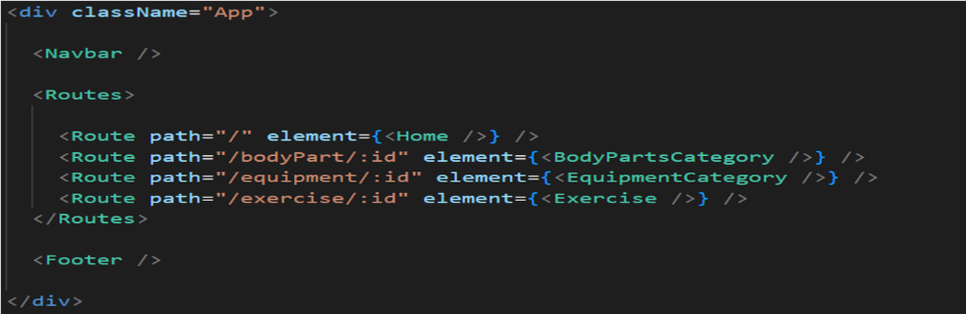**Milestone 2: Project Development**

* Setup the Routing paths Setup the clear routing paths to access various files in the application.
* Develop the Navbar and Hero components
* Code the popular search/categories components and fetch the categories from ***rapid Api***.
* Additionally, we can add the component to subscribe for the newsletter and the footer.
* Now, develop the category page to display various exercises under the category.
* Finally, code the exercise page, where the instructions, other details along with related videos from the YouTube will be displayed.

**Important Code snips:**

**Fetching available Equipment list & Body parts list**

From the Rapid API hub, we fetch available equipment and list of body parts with an API request.

**BASIC STEPS FOR INSTALLATION:**

### **Step 1: Clone the Repository**

1. Open your terminal.
2. Navigate to the directory where you want to store the project.
3. Clone the **FitFlex** repository from GitHub.

### ****Step 2: Install Dependencies****

1. Ensure **Node.js** is installed on your computer.
2. Install the project dependencies using npm or Yarn (depending on your preference).

### ****Step 3: Configure Environment Variables****

1. Create a .env file in the project root.
2. Set the necessary environment variables (like API URLs, authentication keys, etc.) in the .env file.

### ****Step 4: Start the Development Server****

1. Run the development server using npm or Yarn.
2. Open your browser and navigate to http://localhost:3000 to view the app.

### ****Step 5: Verify Everything Works****

1. Make sure the app is running correctly.
2. Test by interacting with the application.

**FOLDER STRUCTURE:**

• **Reusable Components**: Any component you use frequently (like buttons, inputs, or cards) will live in the **/components** folder. This helps in maintaining a DRY (Don't Repeat Yourself) codebase.

* **Page Components**: Larger components that represent a specific view or page (such as Dashboard, Profile, or Home) are stored in **/pages**.
* **Global State**: The **/context** folder holds all shared state management logic (like user authentication or workout data) so you can easily access these states throughout your app.
* **API Calls**: The **/services** folder contains code for handling all external data fetching, like sending requests to your backend API for workouts or user info.

│

├── /public # Public files accessible by the browser (static files)

│ ├── index.html # Main HTML file, the entry point for the React app

│ ├── favicon.ico # Favicon for the app

│ └── /assets # Static assets (images, fonts, etc.)

│ ├── logo.png

│ └── hero-image.jpg

│

├── /src # Source code for the React app

│ ├── /assets # Images, videos, and other static assets used by the app

│ │ ├── logo.png

│ │ ├── background.jpg

│ │ └── icons/ # Additional icons (e.g., social media icons)

│ │

│ ├── /components # Reusable UI components (buttons, inputs, modals, etc.)

│ │ ├── Navbar.js # Navigation bar component

│ │ ├── WorkoutCard.js # Display individual workout plans

│ │ └── Button.js # Reusable button component

│ │

│ ├── /pages # Main page components representing views (e.g., Home, Dashboard)

│ │ ├── Home.js # Landing page (login/signup)

│ │ ├── Dashboard.js # User's dashboard page

│ │ ├── Profile.js # User profile settings page

│ │ └── Workouts.js # Workouts listing page

│ │

│ ├── /context # React Context API for state management (if used)

│ │ ├── AuthContext.js # Handles user authentication context

│ │ └── WorkoutContext.js # Handles workout data context

│ │

│ ├── /hooks # Custom hooks for reusability (e.g., form handling)

│ │ ├── useAuth.js # Custom hook for managing user authentication state

│ │ └── useWorkout.js # Custom hook for handling workout data

│ │

│ ├── /services # API calls and service-related files

│ │ ├── api.js # File for API requests

│ │ └── authService.js # Authentication-related services (login, signup)

│ │

│ ├── /styles # Global styles or specific component styles

│ │ ├── App.css # Global styles for the entire app

│ │ └── button.css # Specific styles for buttons

│ │

│ ├── App.js # Main component that initializes routes and global setup

│ ├── index.js # Main entry point, renders the app to the DOM

│ └── reportWebVitals.js # For web performance monitoring

│

├── /node_modules # Node.js packages (auto-generated by npm or yarn)

├── .env # Environment variables (API keys, etc.)

├── package.json # Project configuration and dependencies

└── README.md # Project documentation

**UTILITIES:**

### ****1. Helper Functions****

* **Purpose**: These are simple, reusable functions for common tasks.

**Examples**:

* + - Format dates.
    - Validate email addresses.
    - Calculate BMI.
    - Convert workout duration into readable formats.

### ****2. Utility Classes****

* **Purpose**: Contain methods for performing tasks that are not tied to a specific component but need to be accessed globally.

**Examples**:

* + - **ApiService**: Manages API calls (fetching, creating, or deleting workout data).
    - **AuthUtils**: Handles authentication tasks like logging in, logging out, and managing tokens

### ****3. Custom Hook****

* **Purpose**: Encapsulate reusable logic related to state or side effects in React components.

**Examples**:

* + - **useAuth()**: Manages user authentication (login, logout, checking user status).
    - **useWorkout()**: Manages workout data (fetching, adding, and updating workouts).
    - **useForm()**: Handles form state, validation, and submission for user input forms.

**RUNNING THE APPLICATION**

* **Provide commands to start the frontend server locally.**

1.**Goto the project directory**:  
 Open your terminal or command prompt and navigate to the folder where the FitFlex frontend code is located.

2.**Install Dependencies**:  
 If this is your first time running the project, you need to install all necessary dependencies.You can do this by running the installation command.

3.**Start the Development Server**:  
 To start the frontend server, run the command that launches the development server.

4.**Open in Browser**:  
 Once the server is running, open your web browser and go to the local server URL (usually http://localhost:3000) to view the app running on your machine.

* **Frontend: npm start in the client directory.**

**1.navigate to the client directory:**

Go to the client directory where the frontend code is located in the FitFlex project.

**2.Install dependecies** (if not already done):  
 If you haven't installed the necessary packages yet, make sure to do so by installing dependencies. This step ensures all the required libraries are in place.

**3.Run the application**  
 Once you're in the client directory and the dependencies are installed, you can run the command to start the frontend server.

**4.Access the application**After running the command to start the server, open your web browser and go to the local address, typically **http://localhost:3000**, to view the FitFlex frontend in action.

**COMPONENT DOCUMENTATION:**

**Key Components: Document major components, their purpose, and any props they receive**

**1. Header Component**

* **Purpose:**  
  The Header component is responsible for rendering the top navigation bar of the application. It typically includes the logo, navigation links, and possibly a user authentication button (sign up/login/logout).
* **Props:**
  + user: (Object) Contains user information if the user is logged in. Example: { name: 'John Doe', avatar: 'path/to/avatar.png' }
  + onLogout: (Function) A function to handle user logout action.

**2. Footer Component**

* **Purpose:**  
  The Footer component renders the footer section of the webpage. It may include copyright information, social media links, and other utility links.
* **Props:**
  + year: (String or Number) The current year to display in the footer, usually for the copyright notice.
  + links: (Array) A list of objects containing link text and URLs for footer navigation.

**3. WorkoutCard Componen**

* **Purpose:**  
  The WorkoutCard component displays a single workout plan or session. It may show details like the workout name, duration, type, and a brief description.
* **Props:**
  + title: (String) The title of the workout (e.g., "Morning Yoga").
  + duration: (String) Duration of the workout (e.g., "30 minutes").
  + description: (String) A brief description of the workout.
  + image: (String) URL to an image representing the workout (e.g., a picture of a yoga pose).
  + onClick: (Function) A callback function to handle the user clicking on the workout card (e.g., for navigation or opening more details).

**4. ProgressTracker Component**

* **Purpose:**  
  The ProgressTracker component displays the user's progress toward their fitness goals, such as weight loss, strength training, or running distance.
* **Props:**
  + goalType: (String) The type of goal (e.g., "Weight Loss", "Running Distance").
  + currentProgress: (Number) The user's current progress toward the goal (e.g., "5kg lost" or "10 miles run").
  + goalTarget: (Number) The target goal (e.g., "10kg" or "20 miles").
  + onProgressUpdate: (Function) A function that triggers when the progress needs to be updated (e.g., after a user logs a new workout).

**5. LoginForm Component**

* **Purpose:**  
  The LoginForm component is used for user authentication, allowing users to enter their username and password to log in to the application.
* **Props**:
  + onSubmit: (Function) A function to handle the form submission, usually for validating and logging in the user.
  + isLoading: (Boolean) Indicates whether the login request is currently being processed, to show a loading spinner.
  + error: (String) A string that displays an error message if the login fails (e.g., "Incorrect username or password").

**6. WorkoutList Component**

* **Purpose**:  
  The WorkoutList component renders a list of available workout plans, usually as individual WorkoutCard components.
* Props:
  + workouts: (Array) An array of workout objects that contain the data for each workout plan.
  + onWorkoutSelect: (Function) A callback function that is triggered when the user selects a workout from the list.

**7. UserProfile Component**

* **Purpose:**  
  The UserProfile component displays the user's profile details, such as their name, avatar, and recent activity.
* **Props**:
  + userInfo: (Object) Contains the user's profile information (e.g., { name: 'John', age: 25, avatar: 'path/to/avatar.png' }).
  + activityLogs: (Array) A list of recent activities or workouts completed by the user.

**8. Notification Component**

* **Purpose:**The Notification component is responsible for displaying messages or alerts to the user, such as workout reminders or success/failure messages.
* **Props:**
  + message: (String) The message to display in the notification.
  + type: (String) The type of notification (e.g., "success", "error", "info").
  + onClose: (Function) A function to close or dismiss the notification.

**9. MealPlanCard Component**

* **Purpose:**  
  The MealPlanCard component displays details about a specific meal plan, including the meals for the day, calorie count, and nutritional information.
* **Props:**
  + mealPlanName: (String) The name of the meal plan (e.g., "Keto Diet").
  + meals: (Array) A list of meals in the plan with details like name, calories, and description.
  + onMealClick: (Function) A function that triggers when the user clicks on a specific meal for more details.
* **Purpose:**  
  The Modal component renders a pop-up window for additional content, such as a login form, workout details, or confirmation dialogs.
* **Props:**
  + isOpen: (Boolean) Whether the modal is visible or not.
  + content: (ReactNode) The content that should be displayed inside the modal (can be text, forms, images, etc.).
  + onClose: (Function) A function to close the modal.

**Reusable Components**: Detail any reusable components and their configurations

**1. Button Component**

* **Purpose**:  
  The Button component is used throughout the application for actions like submitting forms, starting a workout, or logging in.
* **Configurations**:
  + **Props**:
    - label: (String) The text displayed on the button (e.g., "Submit", "Start Workout").
    - onClick: (Function) The function that gets executed when the button is clicked.
    - type: (String) Specifies the type of button ("primary", "secondary", "danger", etc.).
    - disabled: (Boolean) Disables the button if set to true.
    - isLoading: (Boolean) If true, displays a loading spinner on the button.
  + **Example Usage**: jsx

<Button label="Start Workout" onClick={startWorkout} type="primary" />

**2. InputField Component**

* **Purpose**:  
  The InputField component is used for creating input fields in forms, such as for entering the user's name, email, or password.
* **Configurations**:
  + **Props**:
    - label: (String) The label text displayed above the input field (e.g., "Email", "Password").
    - value: (String) The current value of the input field.
    - onChange: (Function) A callback function to handle changes to the input value.
    - type: (String) The type of input (e.g., "text", "password", "email").
    - placeholder: (String) A placeholder text displayed in the input field.
    - error: (String) Error message displayed below the input field if there's a validation error.
  + **Example Usage**: jsx

<InputField label="Email" type="email" value={email} onChange={handleEmailChange} error={emailError} />

**3. Card Component**

* **Purpose**:  
  The Card component is used to display content inside a visually distinct container, such as workout details, meal plans, or user profiles.
* **Configurations**:
  + **Props**:
    - title: (String) The title of the card (e.g., "Morning Yoga").
    - content: (ReactNode) The main content inside the card (could be text, images, etc.).
    - footer: (ReactNode) Optional footer content (e.g., "Learn More" button).
    - image: (String) URL of an image to display at the top of the card.
  + **Example Usage**: jsx

<Card title="Morning Yoga" content={<p>Yoga for beginners</p>} image="path/to/image.jpg" />

**4. Modal Component**

* **Purpose**:  
  The Modal component is used for rendering pop-up dialogs to display additional information or prompt user actions (e.g., confirming an action, displaying workout details).
* **Configurations**:
  + **Props**:
    - isOpen: (Boolean) Whether the modal is visible or not.
    - content: (ReactNode) The content that should be displayed inside the modal.
    - onClose: (Function) A function to close the modal.
    - title: (String) The title displayed at the top of the modal.
  + **Example Usage**: jsx

<Modal isOpen={isModalOpen} onClose={closeModal} title="Workout Details" content={<p>Details about the workout</p>} />

**5. ProgressBar Component**

* **Purpose**:  
  The ProgressBar component displays the user's progress toward a goal, such as workout completion or weight loss.
* **Configurations**:
  + **Props**:
    - current: (Number) The current progress value (e.g., 50% completed).
    - goal: (Number) The total goal value (e.g., 100%).
    - color: (String) The color of the progress bar (e.g., "green", "blue").
  + **Example Usage**: js

<ProgressBar current={50} goal={100} color="green" />

**6. Avatar Component**

* **Purpose**:  
  The Avatar component is used to display user profile pictures or other images in a circular format.
* **Configurations**:
  + **Props**:
    - src: (String) The URL of the image to display (e.g., user's avatar).
    - alt: (String) Alternative text for the image (e.g., "User Profile Picture").
    - size: (String) Size of the avatar ("small", "medium", "large").
  + **Example Usage**: js

<Avatar src="path/to/avatar.jpg" alt="John Doe" size="medium" />

**7. Alert Component**

* **Purpose**:  
  The Alert component is used to display notifications, such as success, error, or info messages.
* **Configurations**:
  + **Props**:
    - message: (String) The message text to display in the alert.
    - type: (String) The type of alert (e.g., "success", "error", "info").
    - onClose: (Function) A function to dismiss or close the alert.
  + **Example Usage**: js

<Alert message="Workout completed successfully!" type="success" onClose={closeAlert} />

**8. Dropdown Component**

* **Purpose**:  
  The Dropdown component is used for displaying a list of options that the user can choose from (e.g., workout types, meal plans).
* **Configurations**:
  + **Props**:
    - options: (Array) A list of options to display in the dropdown.
    - selectedOption: (String) The currently selected option.
    - onSelect: (Function) A function to handle selection changes.
  + **Example Usage**: jsx

<Dropdown options={['Yoga', 'Cardio', 'Strength']} selectedOption="Yoga" onSelect={handleSelection} />

**9. Checkbox Component**

* **Purpose**:  
  The Checkbox component is used for creating checkboxes in forms (e.g., agreeing to terms or selecting workout preferences).
* **Configurations**:
  + **Props**:
    - label: (String) The text next to the checkbox (e.g., "I agree to the terms").
    - checked: (Boolean) Whether the checkbox is checked or not.
    - onChange: (Function) A callback function to handle the checkbox state change.
  + **Example Usage**:jsx

<Checkbox label="I agree to the terms" checked={isChecked} onChange={handleCheckboxChange} />

**10. Spinner Component**

* **Purpose**:  
  The Spinner component is used to display a loading animation when content is being fetched or processed.
* **Configurations**:
  + **Props**:
    - size: (String) The size of the spinner (e.g., "small", "medium", "large").
    - color: (String) The color of the spinner (e.g., "blue", "green").

**STATE MANAGEMENT:**

**Global State**: Describe global state management and how state flows across the application

1. **User Authentication State**:
   * **Purpose**: To store the logged-in user's information (e.g., username, profile picture).
   * **Why it’s global**: User authentication is needed across many parts of the app, like the header, profile page, or workout tracker.
   * **Flow**: Once the user logs in or out, their state is updated and can be accessed by other components (like the header or profile section).
2. **Workout Data**:
   * **Purpose**: Tracks the user's ongoing or completed workouts.
   * **Why it’s global**: The workout data, such as current exercises, progress, or workout history, needs to be available in different sections of the app, such as workout tracking or progress pages.
   * **Flow**: As the user interacts with different workouts, the workout data can be updated and accessed by various components throughout the app, like progress trackers or workout cards.
3. **Meal Plan Data**:
   * **Purpose**: To manage meal plans, calories consumed, and nutritional information.
   * **Why it’s global**: Meal plan data needs to be available throughout the app, especially in the dashboard and user profile, for easy tracking and updating.
   * **Flow**: As users log their meals or make changes to their diet, the meal plan state can be accessed and updated across different pages of the app.
4. **Notifications**:
   * **Purpose**: Displaying messages to the user, such as workout reminders, errors, or success messages.
   * **Why it’s global**: Notifications need to be available across different sections of the app, no matter where the user is navigating.
   * **Flow**: When an event happens (e.g., completing a workout or logging a meal), the notification system can trigger alerts that show up anywhere in the app.

**State Flow Across the Application:**

1. **Centralized State**:  
   All the global state (e.g., user info, workout data, meal plans) is stored centrally, making it accessible to any part of the app that needs it. For example, once a user logs in, their information is updated in the global state and can be accessed by the header or profile components.
2. **Components Access Global State**:  
   Various components (such as the header, workout tracker, and meal plan) can access the global state to render dynamic content. For instance, the workout tracker may show the user’s current workout progress, which is updated in real-time.
3. **State Changes Trigger Re-render**:  
   When the global state changes (e.g., a new workout is logged, or a user logs out), the components that depend on that state are automatically updated. This ensures that the app reflects the most recent data.

**Benefits of Global State Management in FitFlex:**

1. **Consistency**:  
   Since the data is centrally managed, the app provides a consistent experience across different pages. Whether the user is on the home page, tracking a workout, or viewing their profile, the app will reflect the same data in all places.
2. **Simplified Data Flow**:  
   Global state management removes the need for prop drilling (passing props through many levels of components), simplifying how data is passed around in the app. Instead, components can directly access the global state.
3. **Scalability**:  
   As the app grows, adding new features or components becomes easier because you don’t need to pass data through multiple layers of components. You can simply connect the components to the global state.
4. **Easier Debugging**:  
   When data is centralized, tracking issues or debugging becomes more straightforward since you can easily identify the source of data flow problems.

**Local State:**

**Explain the handling of local states within components**

In addition to global state management, **local state** refers to data that is confined to a specific component. It's typically used for handling transient data that doesn't need to be shared across multiple components or pages. Local state is managed within individual components and is often used to track user interactions, form input values, and UI-related behaviors.

Here’s how local state works in **FitFlex** and how it’s handled within components:

**What is Local State?**

Local state is used to store data that only affects the specific component it's defined in. For instance, a form input value, the visibility of a modal, or a loading spinner are all examples of things that can be managed using local state.

In React (and by extension, FitFlex), local state is managed using the useState hook (for functional components) or this.state in class components. Local state is transient, meaning that when the component is unmounted or re-rendered, the local state is reset unless it's saved somewhere else (e.g., to global state or a database).

**Common Use Cases for Local State in FitFlex**

1. **Handling Form Inputs**:
   * **Example**: A user entering their name, email, or workout preferences in a form.
   * **Why it’s local**: Each form input's value is specific to that particular form and doesn’t need to be shared with other components.
2. **UI Interactions**:
   * **Example**: Toggling the visibility of a modal or dropdown menu.
   * **Why it’s local**: The state here only affects the visibility of the modal within the current component.
3. **Loading States**:
   * **Example**: Managing a loading spinner or progress bar when fetching data.
   * **Why it’s local**: The loading state is temporary and only relevant during the data fetching process.
4. **Component-Specific Flags**:
   * **Example**: Managing the open/closed state of a specific menu or the active state of a button.
   * **Why it’s local**: These flags only control the behavior of a specific component.

**How Local State is Managed in FitFlex**

1. **Using useState for Local State**: In **FitFlex**, local state is typically managed in functional components using the useState hook. The useState hook lets you declare a piece of state inside a component and provides a way to update that state.

For example, let’s say we have a form in FitFlex where the user inputs their email address:

* + **State**: The email input value.
  + **Initial Value**: An empty string or the current email if editing a profile.

Example flow:

* + The user types in the email input field.
  + The useState hook tracks the value of that input.
  + When the user submits the form, the value is passed to a handler function that processes it (e.g., sending it to an API or updating the global state).

1. **Managing Local State in FitFlex Components**:
   * **Example 1: Handling Form Input** If you have a form where the user enters their name or email, you can use local state to store the input values temporarily.
     + **State**: Input value (e.g., email, name).
     + **Flow**: As the user types in the input field, the state updates. When the form is submitted, the values can be sent to a backend or stored in global state.

**Why local state**: This state only concerns the form component and doesn’t need to be shared or saved elsewhere.

* + **Example 2: Toggling a Modal** If you have a modal component in FitFlex, the visibility of that modal is usually controlled with local state.
    - **State**: A boolean value (isModalOpen).
    - **Flow**: When a button is clicked to open the modal, setIsModalOpen(true) is triggered to show the modal. When the modal is closed, setIsModalOpen(false) hides it.

**Why local state**: This state only affects the modal’s visibility, and it doesn't need to be shared with other components.

* + **Example 3: Managing Loading State** If you are fetching data for a workout or meal plan, you might show a loading spinner while the data is being retrieved.
    - **State**: Loading state (e.g., isLoading).
    - **Flow**: Before the data is fetched, the state is set to true to show the spinner. Once the data is loaded, isLoading is set to false to hide the spinner.

**Why local state**: This is a temporary state that’s only relevant to the component handling the fetch operation and doesn't need to persist beyond the lifecycle of the fetch request.

**Advantages of Local State in FitFlex**

1. **Simplicity**: Local state is easy to implement and doesn’t require the overhead of global state management tools. For simple, isolated state changes (e.g., a button toggle, form input, or loading spinner), local state is the most appropriate and straightforward choice.
2. **Encapsulation**: By using local state, you ensure that each component is self-contained. A component managing its own state doesn't need to worry about how other parts of the app are affected, which makes it easier to maintain.
3. **Performance**: Local state is updated locally, which means that only the component using that state will re-render when it changes. This can improve performance compared to more expensive global state updates, especially in large applications.
4. **Less Complex**: For features that don’t require sharing data across multiple components, using local state helps keep the application simple and avoids the complexity of global state management.

**Local State Flow in FitFlex Example:**

**Login Form Component**: A login form that captures the user’s email and password. Local state handles each input field’s value until the user submits the form.

* + **State Example**: email, password.
  + **Flow**: The component reads and updates these values based on user input and sends them to the global state or a backend when the form is submitted.
* **Workout Tracker Component**: A component that allows users to track their workout progress (e.g., sets, reps, or calories burned). The state here might include user inputs or selections that are temporary.
  + **State Example**: sets, reps, isTracking.
  + **Flow**: These values are updated as the user interacts with the app but are only relevant within the workout session.

**USER INTERFACE:**

• Provide screenshots or GIFs showcasing different UI features, such as pages, forms, or interactions.

**1. Home Page:** Displays a sleek, interactive dashboard with personalized fitness stats and easy navigation to workout programs.

**2. Workout Forms:** Users can easily input their workout progress with clean, intuitive forms that track reps, sets, and time.

**3. Progress Tracking:** Graphical charts and stats to show users’ fitness journey over time with visually appealing progress indicators.

**4. Settings and Preferences:** Simple toggle switches and sliders allow users to customize their fitness goals, notifications, and app preferences.

If you'd like, I can also help generate a concept image or GIF for these descriptions **using**DALL·E!

**STYLING:**

• CSS Frameworks/Libraries: Describe any CSS frameworks, libraries, or preprocessors (e.g., Sass, Styled-Components) used.

• Theming: Explain if theming or custom design systems are implemented.

**CSS Frameworks/Libraries**:

**1. CSS Frameworks:** If a CSS framework like Bootstrap or Tailwind CSS is used, it would provide pre-built components and utility classes to speed up development and ensure consistency across the application.

Tailwind CSS is a common choice for utility-first styling, where developers can apply utility classes directly to HTML elements. This makes the design flexible and responsive without writing much custom CSS.

**2. Preprocessors**: Sass (Syntactically Awesome Stylesheets) might be used for more advanced features like variables, nesting, and mixins, allowing for more maintainable and scalable CSS code.

**3. Styled-Components**: If React is used, Styled-Components would be an excellent option for scoped, reusable components that can be styled using JavaScript. It also supports dynamic styling based on props, making it highly flexible and reusable in the context of the FitFlex app.

**Theming and Custom Design Systems:**

**1. Theming:** FitFlex could implement a light and dark mode theme, possibly using CSS custom properties (variables) or styled-components' theme provider to toggle between them based on user preferences. If the project has a branding theme, colors, fonts, and spacing values can be abstracted into a central theme configuration. This would ensure consistency across all UI elements.

**2. Design System:** FitFlex might follow a custom design system that defines reusable design patterns, such as buttons, forms, modals, and typography styles. A well-organized design system ensures that the UI components are consistent, easy to update, and adaptable across different pages and features of the app.

This design system could be based on Atomic Design Principles, ensuring that components are broken down into simple, reusable parts (atoms, molecules, organisms, and templates).

In conclusion, a combination of a utility-first CSS framework (like Tailwind CSS), a preprocessor (like Sass), and a design system would likely be used in FitFlex, ensuring both flexibility and maintainability while maintaining a consistent, branded user interface.

**TESTING:**

• **Testing Strategy**: Describe the testing approach for components, including unit, integration, and end-to-end testing (e.g., using Jest, React Testing Library).

• **Code Coverage**: Explain any tools or techniques used for ensuring adequate test coverage.

**1. Testing Strategy:**

**Unit Testing:**

**Description:** Unit tests verify the functionality of individual components or functions. This ensures that each unit works in isolation as expected.

**Tools Used:**

**Test:** For running the unit tests and assertions. It is easy to configure and provides a great set of built-in utilities for mocking and testing functions.React Testing Library: For testing React components in isolation and ensuring the user interface behaves correctly by interacting with components as a user would.

Example: Testing individual functions like form validation logic or button click handlers within React components.

**Integration Testing**

**Description:** Integration tests ensure that multiple components or systems work together correctly. This is particularly important for testing the interaction between the backend and frontend, or between React components that depend on each other.

**Tools Used:**

Jest for testing.React Testing Library for testing how different React components interact when rendered together.Mock Service Worker (MSW) can be used for mocking API calls in integration tests to simulate backend interactions.

Example: Testing the interaction between the user authentication component and API for login or registration.

**End-to-End Testing:**

**Description:** End-to-end tests simulate real user scenarios, verifying the entire application’s functionality from start to finish.

**Tools Used:**

**Cypress:** For automating browser interactions and running end-to-end tests. Cypress allows testing real user behavior such as navigating the app, filling out forms, and submitting data.

**Playwright:** An alternative to Cypress, it can also be used for E2E tests across different browsers.

**Example:** Testing the full user journey, like a user signing up, creating a workout plan, and updating their profile information.

**2. Code Coverage:**

**Tools Used:**

**Jest:** Jest has built-in support for generating code coverage reports. This helps to visualize how much of the code is being covered by the tests.

**Istanbul (via Jest):** This is the code coverage tool used internally by Jest. It generates coverage reports showing which lines of code are executed by tests and which are not.

**Coverage Thresholds:** Jest allows us to set minimum thresholds for coverage (e.g., 80% coverage) so that tests fail if coverage falls below a specified limit.

**Technique:**

Measure test coverage for each component and function to ensure that critical code paths are adequately tested.

Set coverage thresholds for unit, integration, and end-to-end tests to maintain a high level of test coverage, ensuring the reliability and stability of the application.

**Example:** Ensuring that business logic functions like calculating a workout's calories burned are fully tested through unit tests, and then verifying integration with other components like the user's progress tracking.

By combining these approaches, FitFlex ensures that the application is robust, maintainable, and functional.

**Project Execution:**

After completing the code, run the react application by using the command “npm start” or “npm run dev” if you are using vite.js

Here are some of the screenshots of the application.

**Hero component**

This section would showcase trending workouts or fitness challenges to grab users' attention.

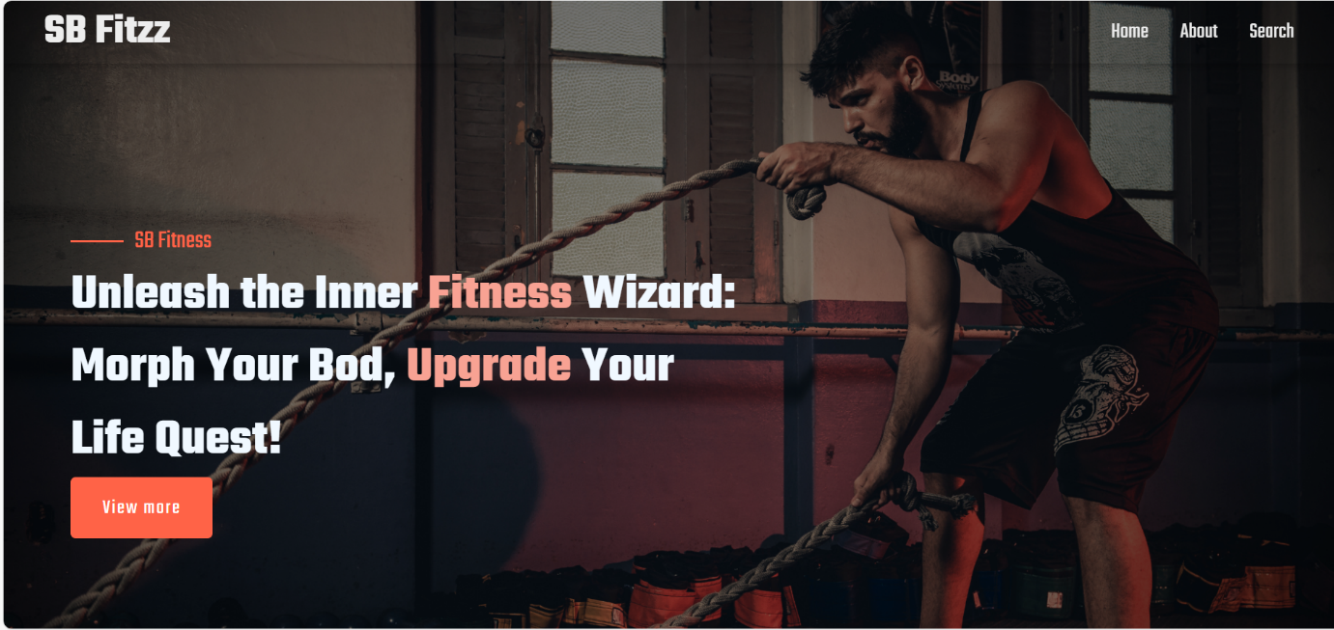

**About**

FitFlex isn't just another fitness app. We're meticulously designed to transform your workout experience, no matter your fitness background or goals.

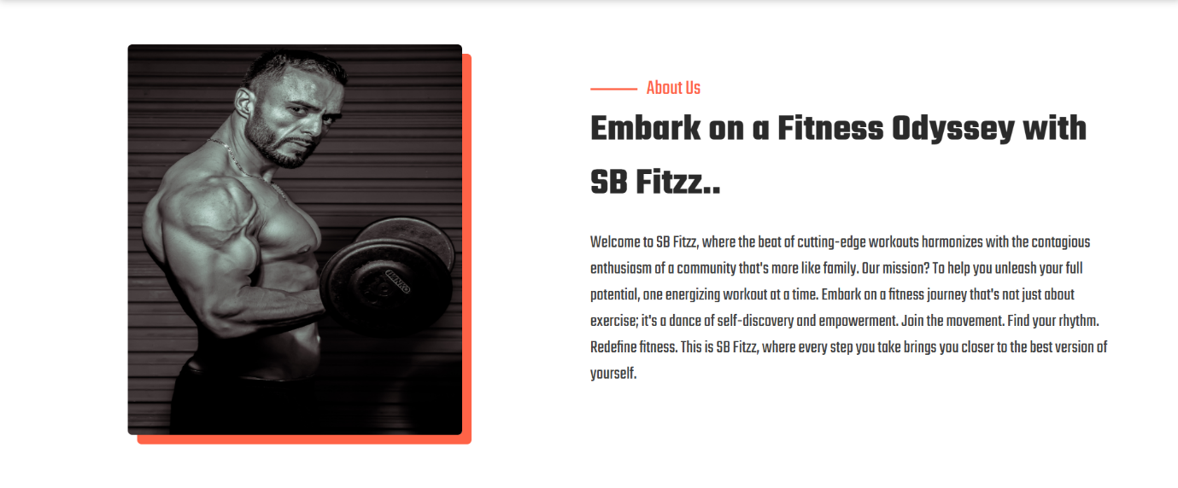

**Search**

FitFelx makes finding your perfect workout effortless. Our prominent search bar empowers you to explore exercises by keyword, targeted muscle group, fitness level, equipment needs, or any other relevant criteria you have in mind. Simply type in your search term and let FitFlex guide you to the ideal workout for your goals.

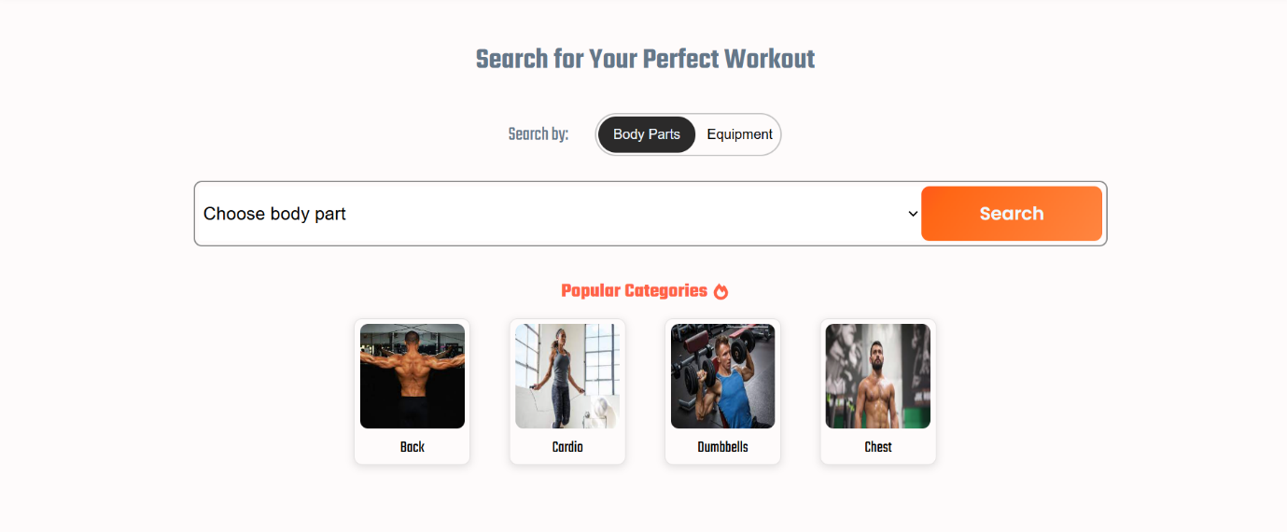

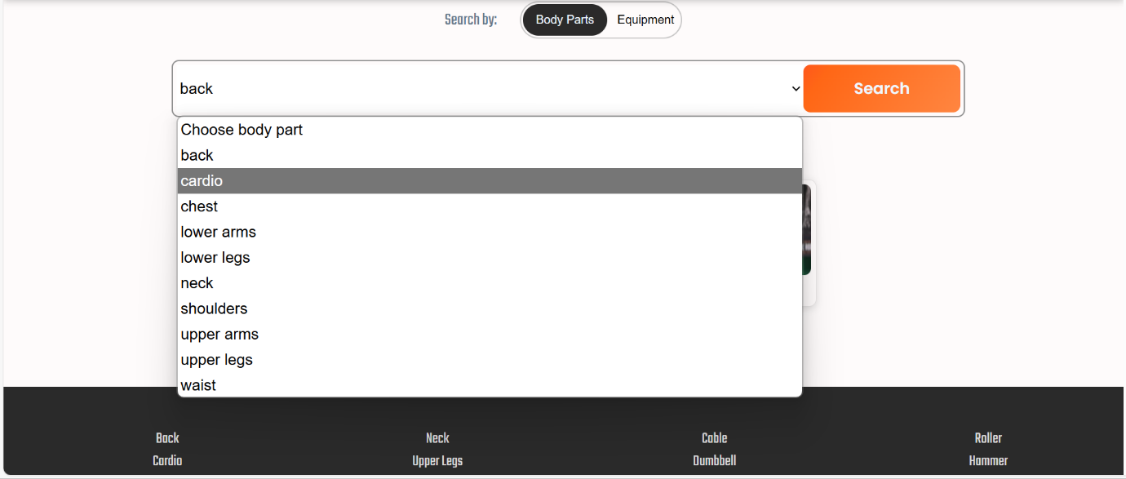

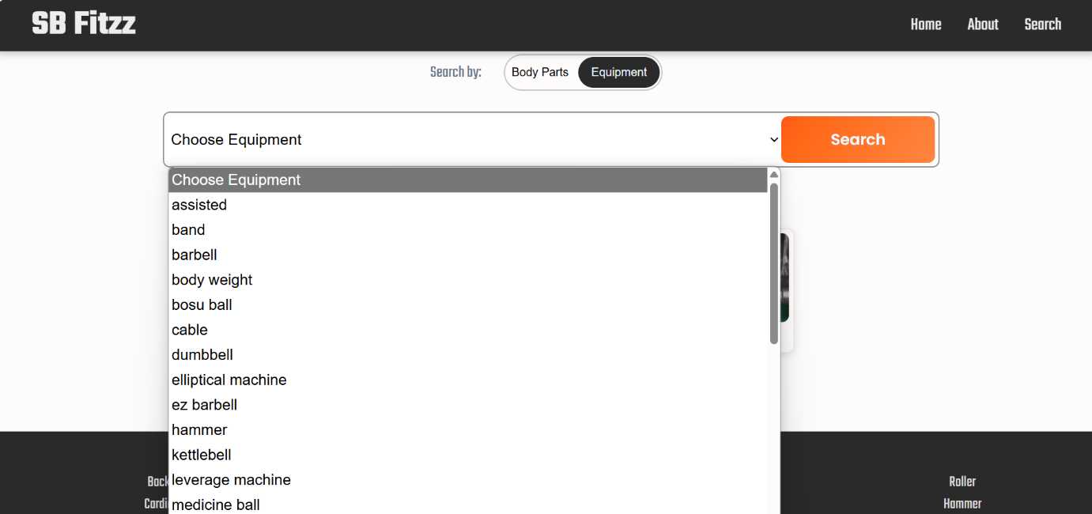

**Category page**

FitFlex would offer a dedicated section for browsing various workout categories. This could be a grid layout with tiles showcasing different exercise types (e.g., cardio, strength training, yoga) with icons or short descriptions for easy identification.

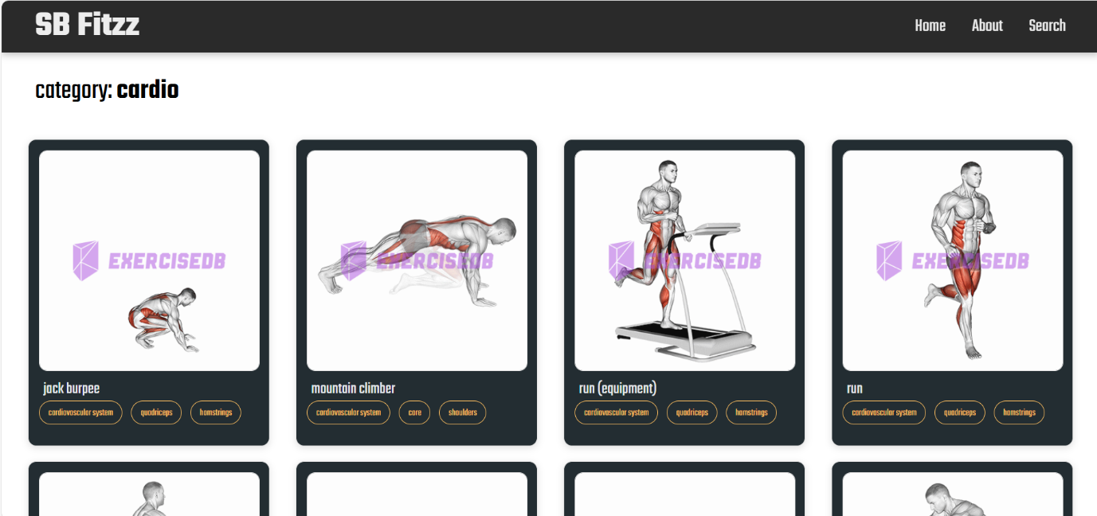

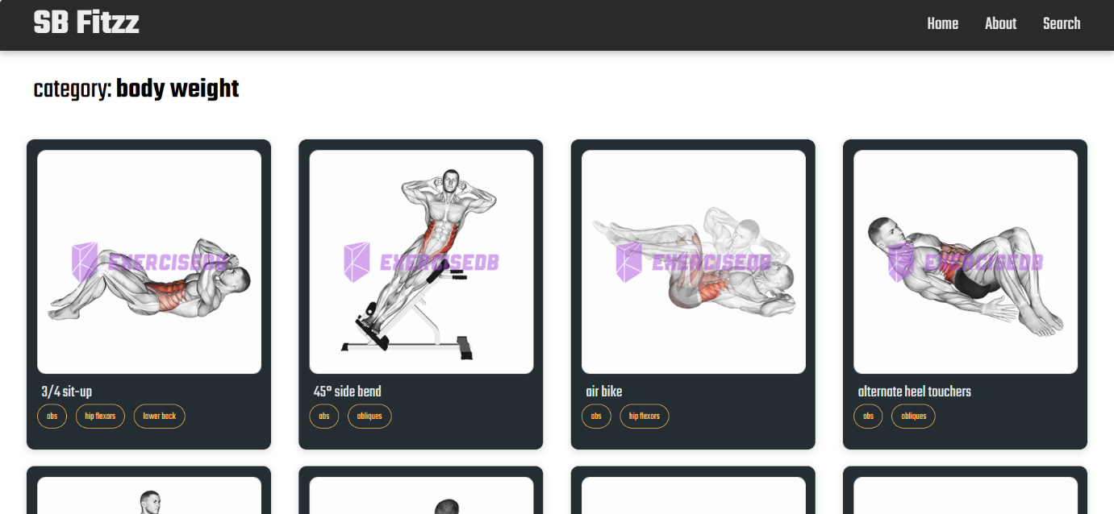

**Demolink:**  https://drive.google.com/drive/folders/1nqWaEWjRDd0ftiMcxE0UGWdM0UEZf6c6

**Known Issues**

Known Bugs/Issues in FitFlex (Hypothetical Example):

**1. Data Syncing Issues**

* **Problem:** Some users report that their workout data does not sync properly between devices (e.g., mobile app and web platform).
* **Solution:**
  + Ensure the app uses proper API calls with correct user authentication tokens to sync data.
  + Periodically check sync logs to ensure seamless data transfer.
  + Use background tasks to retry syncing in case of network interruptions.

**2. Incorrect Progress Tracking**

* **Problem:** Users' progress on fitness goals or workout history does not update correctly after completing exercises or challenges.
* **Solution:**
  + Implement real-time event listeners to immediately update progress after a workout.
  + Ensure data flow from backend to frontend is consistent by reviewing API endpoints.

**3. App Crashes on Start (iOS/Android)**

* **Problem:** Some devices experience crashes when launching the app, especially on older versions of iOS or Android.
* **Solution:**
  + Review memory allocation and startup code.
  + Ensure backward compatibility with older devices by testing on a range of devices.
  + Use crash analytics tools (e.g., Firebase Crashlytics) to identify specific causes.

**4. Workout Plan Bug**

* **Problem:** Custom workout plans may show missing exercises or revert to default ones after saving.
* **Solution:**
  + Ensure all custom workout plan data is correctly saved in the database.
  + Use data validation on the frontend to avoid conflicts when saving user-made plans.
  + Test edge cases when users create and save new workout plans.

**5. User Profile Issue**

* **Problem:** Users report that their profile information (e.g., weight, height, fitness level) is not saved or displayed correctly.
* **Solution:**
  + Verify that profile data is stored properly in the database and troubleshoot form submission or validation errors.
  + Implement real-time feedback for users when profile data changes, ensuring it saves properly.
  + Review network calls that update profile data for potential issues.

**6. Push Notification Problems**

* **Problem:** Push notifications (for reminders or updates) may not be delivered or show incorrect content.
* **Solution:**
  + Ensure integration with push notification services (Firebase, OneSignal) is configured properly.
  + Test push notification delivery for various user scenarios (new vs. returning users, different OS versions).
  + Implement fallback strategies for cases where notifications fail.

**7. Slow Load Times**

* **Problem:** The app takes longer than expected to load workout plans or progress, especially on devices with lower RAM.
* **Solution:**
  + Optimize API calls by reducing the amount of data returned per request.
  + Use lazy loading to load elements (images, data) only when needed.
  + Compress images and reduce size to improve performance on low-resource devices.

**8. Subscription Payment Issues**

* **Problem:** Users report problems with subscription payments (missed payments, incorrect charges).
* **Solution:**
  + Verify payment gateway integration (Stripe, PayPal) is functioning correctly.
  + Implement automatic subscription renewal checks and retry failed payments.
  + Provide users with clear error messages when payments fail, and ensure support for manual fixes.

**9. Graph/Stats Display Glitch**

* **Problem:** Graphs or charts that track performance sometimes show inaccurate or empty data points.
* **Solution:**
  + Investigate data parsing or processing issues before sending data to the graph component.
  + Implement error handling for missing or corrupted data.
  + Implement tests to ensure the graph displays accurate, real-time information.

**10. Exercise Video Playback Issues**

* **Problem:** Exercise demonstration videos may not play correctly (e.g., buffering or no audio).
* **Solution:**
  + Ensure videos are encoded in formats compatible with various devices.
  + Use adaptive bitrate streaming to optimize playback for different network speeds.
  + Implement error handling for network interruptions and provide users with a way to retry loading the video.

**Additional Developer Recommendations**

* **Testing on Multiple Devices:**
  + Test thoroughly on a wide range of devices and OS versions. Ensure that the app works across different screen sizes, network conditions, and hardware specifications.
* **Error Logging:**
  + Implement detailed error logging on both the client and server sides. Track any failures in API calls, UI rendering issues, and network errors to provide developers with real-time diagnostics.
* **User Feedback:**
  + Continuously collect user feedback through in-app surveys, reviews, and support tickets. Actively respond to common issues and identify patterns that require urgent attention.
* **Frequent Updates:**
  + Release updates regularly to address known bugs and improve performance. Prioritize fixing critical bugs in hotfixes and aim to address minor improvements in scheduled updates.
* **Optimize for Low-End Devices:**
  + In addition to focusing on high-performance devices, ensure that the app is optimized for lower-end devices to enhance accessibility for a wider user base.

**Future Enhancements for FitFlex**

**1. Personalized AI Trainer**

* **Description:** An AI-powered virtual trainer that adapts to user performance and offers real-time feedback.
* **Key Features:**
  + **Adaptive workout plans:** AI adjusts based on user performance (e.g., increasing intensity or changing exercises).
  + **Voice-guided instructions:** Personalized vocal feedback during workouts.
  + **Posture correction via camera integration (mobile):** Utilize the device's camera to analyze the user’s form and offer feedback.
  + **Integration with wearables:** Sync with devices like smartwatches or heart rate monitors for more accurate tracking.
* **Considerations:**
  + **AI model training:** Ensure the AI can learn from a broad range of exercise styles and user feedback.
  + **Privacy concerns:** Ensure proper handling of user data, especially when using the camera for form correction.

**2. Advanced Progress Visualization**

* **Description:** More interactive and detailed charts/graphs for tracking user progress.
* **Key Features:**
  + **3D body change charts:** Display muscle gain, fat loss, and other changes in 3D charts.
  + **Interactive progress maps:** Users can scroll through visual timelines of their journey.
  + **Gamification elements:** Badges, achievements, and streaks to motivate continued progress.
* **Considerations:**
  + **Customization options:** Allow users to adjust what metrics they want to track most prominently.
  + **Data storage:** Ensure efficient data storage for large amounts of progress data without impacting app performance.

**3. In-App Challenges and Social Features**

* **Description:** Enable community-driven features for competition and collaboration.
* **Key Features:**
  + **Fitness challenges:** Users can participate in global or friend-based challenges like step counts or calories burned.
  + **Social feeds:** Allow users to share workouts, milestones, and progress photos.
  + **Leaderboards:** Display rankings to encourage healthy competition.
* **Considerations:**
  + **Privacy settings:** Allow users to control who can see their progress and social interactions.
  + **Moderation:** Implement tools to ensure a positive, motivational community environment.

**4. Augmented Reality (AR) Workouts**

* **Description:** Use AR to enhance the workout experience, making it more immersive and interactive.
* **Key Features:**
  + **Form guidance:** AR can show the correct form for exercises in the user’s environment.
  + **Virtual fitness environment:** Users can experience immersive, gamified workouts.
  + **Real-time progress tracking with AR:** Track reps, distance, or other metrics in an AR environment.
* **Considerations:**
  + **Hardware requirements:** AR features may require more powerful devices or sensors.
  + **User experience:** Ensure that the AR experience is smooth and not distracting during workouts.

**5. Enhanced Animation and UI Transitions**

* **Description:** Improve the app’s visual appeal and user interface by adding smooth animations and modern design elements.
* **Key Features:**
  + **Engaging transitions:** Create dynamic animations for screen transitions (e.g., between exercise selection, workout tracking).
  + **Micro-interactions:** Animated progress bars, buttons that respond to user actions.
  + **Customizable themes:** Allow users to switch between light, dark, and other aesthetic modes.
* **Considerations:**
  + **Performance optimization:** Ensure that animations do not hinder the app’s speed or responsiveness.

**6. Integrated Nutritional Guidance**

* **Description:** Provide personalized nutritional advice to complement workout routines.
* **Key Features:**
  + **Meal tracking:** Suggest high-protein or other meals based on workout plans.
  + **Integration with nutrition databases:** Sync with apps like MyFitnessPal for easier meal logging.
  + **Automated grocery lists:** Generate shopping lists based on weekly meal plans.
* **Considerations:**
  + **Dietary preferences:** Allow for customization based on dietary restrictions (e.g., vegan, keto).
  + **Local integrations:** Consider local food databases and regional preferences for more accurate meal suggestions.

**7. Voice Interaction**

* **Description:** Implement voice control and feedback for hands-free operation.
* **Key Features:**
  + **Voice commands:** Start, stop, or adjust workouts using voice commands.
  + **Real-time voice feedback:** Give feedback like "Great job!" or "Increase intensity" during exercises.
  + **Virtual assistant integration:** Sync with Google Assistant, Siri, or Alexa.
* **Considerations:**
  + **Accuracy of voice recognition:** Ensure the app accurately understands voice commands in noisy environments.

**8. Customizable Workout Plans with Drag-and-Drop Interface**

* **Description:** Let users build custom workout plans using an intuitive drag-and-drop interface.
* **Key Features:**
  + **Pre-built exercise libraries:** Easy-to-drag exercises to create custom routines.
  + **Customization for intensity and rest periods:** Tailor workouts according to personal goals.
  + **Sharing options:** Allow users to share their custom plans with the community.
* **Considerations:**
  + **User-friendliness:** Ensure that the drag-and-drop feature is simple and intuitive, especially for beginners.

**9. Gamification & Rewards System**

* **Description:** Introduce deeper gamification to enhance user engagement.
* **Key Features:**
  + **Unlockable achievements and titles:** Achievements like “Ironman” or “Early Bird” based on workout completion.
  + **Rewards store:** Users can redeem points for virtual goods (skins, challenges).
  + **Daily/weekly/monthly rewards:** Maintain motivation with consistent rewards for engagement.
* **Considerations:**
  + **Balance between rewards and effort:** Ensure that rewards feel earned and not arbitrary.

**10. Integration with Smart Home Devices**

* **Description:** Create a more connected fitness experience by integrating with smart home devices.
* **Key Features:**
  + **Sync with smart scales and trackers:** Track weight, muscle mass, heart rate, etc.
  + **Voice assistant integration:** Start workouts or get stats through devices like Alexa or Google Assistant.
* **Considerations:**
  + **Cross-platform support:** Ensure compatibility with multiple smart home ecosystems (e.g., Alexa, Google Home, Apple HomeKit).

**11. Multi-User Support**

* **Description:** Support multiple profiles within the app, ideal for families or couples.
* **Key Features:**
  + **Individual progress tracking:** Separate profiles for each user with personalized workouts and goals.
  + **Family/group challenges:** Engage in group-based fitness activities.
  + **Admin controls:** Manage and monitor multiple profiles.
* **Considerations:**
  + **Profile switching:** Ensure smooth switching between profiles for family members without data mixing.

**12. Offline Mode**

* **Description:** Ensure that users can still access workout plans and track progress without an internet connection.
* **Key Features:**
  + **Offline workout saving:** Download and save workouts for offline access.
  + **Automatic data sync when online:** Sync data once an internet connection is re-established.
  + **Offline instructional videos:** Provide access to workout demos even without a network connection.
* **Considerations:**
  + **Data storage limitations:** Consider the impact on device storage, especially for videos and large workout data.

**13. Real-Time Workout Feedback Using Camera/AI**

* **Description:** Use AI and camera-based motion tracking for real-time form correction.
* **Key Features:**
  + **Form detection and corrections:** Automatically detect bad form and give suggestions for improvement.
  + **Comparison with demo videos:** Use camera analysis to compare the user’s form with trainer models.
* **Considerations:**
  + **User privacy:** Ensure that video capture and analysis are processed securely on the device.

**14. Fitness Tracker Integration**

* **Description:** Enable deeper integration with fitness trackers for more accurate data collection.
* **Key Features:**
  + **Real-time health data sync:** Track heart rate, calories burned, steps, etc., in real-time.
  + **Automatic workout updates:** Sync data from fitness trackers automatically to update workouts and health stats.
* **Considerations:**
  + **Wide compatibility:** Support integration with a variety of fitness trackers (e.g., Fitbit, Apple Watch, Garmin).

**15. Sleep and Recovery Tracking**

* **Description:** Add features for tracking sleep and recovery, aiding in overall fitness.
* **Key Features:**
  + **Sleep tracking:** Monitor sleep patterns and suggest recovery days based on sleep quality.
  + **Sync with wearables:** Integrate with wearables to track recovery metrics.
  + **Stretching routines:** Offer recovery stretches or relaxation techniques to improve sleep and recovery.
* **Considerations:**
  + **Personalization:** Ensure suggestions are tailored to each user’s fitness and sleep habits.