[TheStreet](https://www.thestreet.com/)

**Nvidia CEO's bombshell raises the bar for the stock**

Silin Chen

Sat, October 5, 2024 at 2:03 PM GMT+1 3 min read

35

**In This Article:**

[StockStory Top Pick](https://stockstory.org/high-quality/top-6-to-buy-this-week?partner=yahoo&utm_source=yahoo&utm_medium=content_ticker&utm_campaign=contenthighqualitystock" \t "_blank)

[NVDA](https://finance.yahoo.com/quote/NVDA/" \o "NVDA)

[+1.68%](https://finance.yahoo.com/quote/NVDA/" \o "NVDA)

Think of how Nvidia’s GeForce 8800 chip, launched in 2006, changed the gaming landscape. Now, almost two decades later, Nvidia is still making that progression, with its Blackwell designed to change the world of artificial intelligence.

Demand is "insane," Nvidia’s chief executive Jensen Huang recently said. Major cloud providers like AWS, Azure, and Google Cloud are integrating Blackwell into their infrastructure to support high-performance AI workloads.

[**Related: Nvidia CEO Jensen Huang just told investors what’s next for the AI chipmaker**](https://www.thestreet.com/technology/nvidias-jensen-huang-addressed-three-big-questions-about-ai-future)

Oracle [announced](https://www.oracle.com/news/announcement/oracle-to-invest-in-ai-and-cloud-computing-in-malaysia-2024-10-02/) on October 2 that it would need 131,072 Nvidia Blackwell GPUs as part of a $6.5 billion investment to establish a new public cloud region in Malaysia, another proof of a strong need for advanced AI processing capabilities.

Blackwell is a platform Nvidia launched in March that allows organizations to run real-time generative AI on models with trillions of parameters. These large language models are trained on extensive datasets to understand and generate responses in human language.

“Blackwell is in full production,” Huang said in an interview with CNBC. “The demand for Blackwell is insane. Everybody wants to have the most, and everybody wants to be first.”

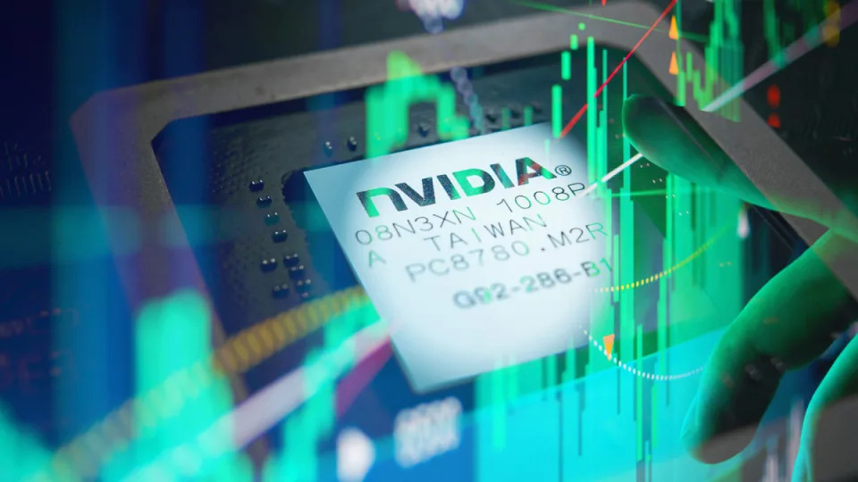

Nvidia's stock has surged by over 150% this year, following an impressive 240% gain in 2023.

Hyperscaler buyers like Amazon  ([**AMZN**](https://finance.yahoo.com/quote/AMZN)) , Microsoft  ([**MSFT**](https://finance.yahoo.com/quote/MSFT)) , and Alphabet  ([**GOOGL**](https://finance.yahoo.com/quote/GOOGL))  are expected to spend around $160 billion in 2024 on AI infrastructure, according to Bernstein analysts. The cost of Blackwell is expected to range between $30,000 and $40,000 per unit.

Huang emphasized the importance of continuous updates to Nvidia’s AI infrastructure, with the company releasing new platforms annually. “If we can increase the performance, like we've done for Hopper and Blackwell ... we're effectively increasing the revenue or throughput for our customers on these infrastructures by a couple to three times each year," Huang added.

**Nvidia's financial performance exceeds expectations**

Nvidia’s latest earnings report further solidifies its strong position in the AI market.

On August 28, the company posted earnings per share of 68 cents, beating Wall Street expectations of 64 cents. Revenue hit $30.04 billion, up 122%, surpassing the anticipated $28.7 billion.

Nvidia forecasts $32.5 billion in revenue for the current quarter, an 80% increase from last year.

[**Related: Veteran trader targets Nvidia as shares slide**](https://www.thestreet.com/investing/stocks/veteran-trader-targets-nvidia-as-shares-slide)

Nvidia plans to ship Blackwell GPUs to clients in Q4 of this year, with a consumer release expected in 2025. “In the fourth quarter, we expect to ship several billion dollars in Blackwell revenue,” Nvidia Chief Financial Officer Colette Kress said during the August earnings call.

Story Continues

View Comments (35)

[Terms](https://guce.yahoo.com/terms?locale=en-US)

 and

[Privacy Policy](https://guce.yahoo.com/privacy-policy?locale=en-US)

[Privacy & Cookie Settings](https://guce.yahoo.com/privacy-settings?locale=en-US)

* [Motley Fool](http://www.fool.com/)

**Palantir Stock vs. Nvidia Stock: Wall Street Says Sell One and Buy the Other**

Trevor Jennewine, The Motley Fool

Sun, October 6, 2024 at 8:55 AM GMT+1 5 min read

18

**In This Article:**

[NVDA](https://finance.yahoo.com/quote/NVDA/" \o "NVDA)

[+1.68%](https://finance.yahoo.com/quote/NVDA/" \o "NVDA)

[PLTR](https://finance.yahoo.com/quote/PLTR/" \o "PLTR)

[^GSPC](https://finance.yahoo.com/quote/%5EGSPC/" \o "^GSPC)

**Palantir** **Technologies** (NYSE: PLTR) and **Nvidia** (NASDAQ: NVDA) are two of the hottest [artificial intelligence (AI) stocks](https://www.fool.com/investing/stock-market/market-sectors/information-technology/ai-stocks/?utm_source=yahoo-host-full&utm_medium=feed&utm_campaign=article&referring_guid=af12089f-4285-476b-b17c-6ce924f7b71a) on Wall Street. In fact, with year-to-date returns of 132% and 150%, respectively, they rank among the five best-performing components of the **S&P 500**.

However, Wall Street expects the stocks to move in opposite directions over the next year.

* + Among the 23 analysts who follow Palantir, the median price target is $27 per share, which implies 32% downside from its current share price of $40.
  + Among the 65 analysts following Nvidia, the median price target is $150 per share, which implies 20% upside from the current share price of $125.

Furthermore, Palantir is the most overvalued stock in the S&P 500 based on the difference between its current price and median price target. Meanwhile, according to **FactSet Research**, Nvidia ranks among the most highly recommended stocks in the S&P 500 in terms of its percentage of buy ratings.

Suffice it to say Wall Street is overwhelmingly bearish on Palantir but very bullish on Nvidia. Here are the most important details for investors.

**Palantir Technologies: 32% downside implied by the median price target**

Palantir has deep roots in counterterrorism and clandestine military operations. The company spent its earliest days building analytics software for federal agencies in the U.S. intelligence community. But it has since expanded its customer base to include international governments and commercial organizations.

Palantir's data operations platforms, Foundry and Gotham, let customers incorporate data and machine learning models into analytical applications that improve decision-making. And its AI platform, AIP, allows commercial and government clients to use [large language models](https://www.fool.com/terms/l/large-language-models/?utm_source=yahoo-host-full&utm_medium=feed&utm_campaign=article&referring_guid=af12089f-4285-476b-b17c-6ce924f7b71a) and generative AI within Foundry and Gotham.

Some analysts have lauded Palantir for its sophisticated technology. For instance, it was a top-ranked vendor in Dresner Advisory Services' 2024 market study on artificial intelligence, data science, and machine learning platforms. **Forrester Research** recently recognized its leadership in AI and machine learning platforms.

Other analysts are less impressed. **Gartner** scored Palantir below a dozen other vendors in data integration capabilities, citing overreliance on consulting services. That means some clients find Palantir's software so complex that they struggle to use it independently. Gartner also omitted Palantir in its latest report on data science and machine learning platforms.