Containarizing simple flask application

step1:

optimize the code

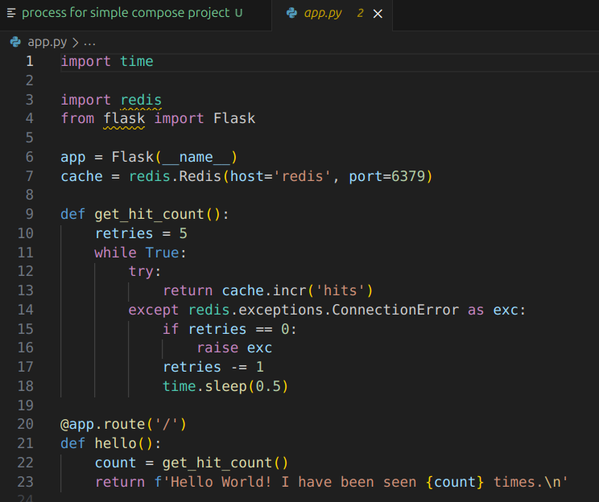
write the requirement file for your application

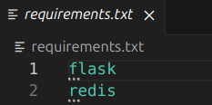

write the dockerfile for your application

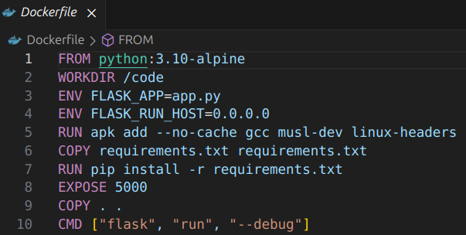
step2:

build the image using the dockerfile

#docker build -t zakkariyab/simpleflask:v2 .

Step3:

push the image to the dockerhub

#docker push zakkariyab/simpleflask:v2 .

Step4:

create the 2 repository for your app and infra
(infra repo will have the compose file for your app)

services:
web:
image : zakkariyab/simpleflask:v2
ports:
- "8000:5000"
redis:
image: "redis:alpine"

step5:

*create the EC2 instance and clone the infra repo to the instance
*up the container using the compose file

