2D RACING GAME
GUI-Based Implementation (C++ / SFML)

INSTRUCTOR …..
Course Mr. Sajid ALI
Lab Mr. Zaheer Ahmed
Group Members

Reg No: 2025924 | Muhammad Zakria
Reg No: 2025222 | Fatima Abbasi
Reg No: 2025325 | Izza Rana

1. Introduction
This project is a GUI-based 2D racing game developed in C++ using the SFML (Simple and Fast Multimedia Library) framework, building upon an initial console-based prototype. The game simulates a race between a player-controlled car and an AI-controlled car within a visually rendered bounded track.
The system demonstrates core programming concepts such as class design, inheritance, polymorphism, and real-time interaction — now enhanced with a graphical window, colored car sprites, traffic cone obstacles, and a checkered finish line.
The player controls their car using keyboard inputs, while the AI car moves automatically. The game includes boundary checking, obstacle handling, collision detection, and winner declaration.

2. Motivation
The motivation behind this project was to understand how real-world systems like games can be modeled using object-oriented programming — and then extended to include graphical rendering with SFML. Racing games provide an interactive way to implement logic such as movement, collision detection, and AI decision-making.
Additionally, the project offered hands-on experience in structuring programs using multiple classes, managing interactions between different components, and integrating a multimedia library to produce a visually engaging product rather than a console-only output.

3. Purpose / Objectives
- To develop a fully functional 2D racing game with a graphical user interface using C++ and SFML
- To implement object-oriented programming concepts in a practical, real-world scenario
- To simulate real-time player interaction and AI behavior within a rendered game window
- To implement collision detection, boundary constraints, and obstacle avoidance logic
- To demonstrate file handling for persisting game initialization data and results
- To visually represent the track with walls, traffic cone obstacles, and a finish line

4. Problem Statement
Traditional text-based simulations lack the user engagement and realism needed to demonstrate game mechanics effectively. Console output is limited in depicting spatial movement, obstacle placement, and real-time car races in an intuitive way.
The challenge was to design a system that:
- Accurately represents 2D spatial movement and collision scenarios
- Supports real-time player input alongside autonomous AI car behavior
- Provides a visually clear track environment with obstacles and boundaries
- Persists game data and winner information beyond program execution

5. Proposed Solution
The solution is a C++ and SFML-based 2D racing game with the following key components:
- SFML Window Rendering: A 2D window displays the track, cars (colored rectangles with wheels), traffic cones (orange triangles), red boundary walls, and a checkered finish line.
- Player Car: Controlled via keyboard (arrow keys or WASD), rendered as a blue rectangle at the top of the track.
- AI Car: Rendered as a green rectangle, automatically moves upward and avoids obstacles randomly.
- Obstacle System: Three traffic cones placed at fixed positions on the track; collisions cancel the move.
- Boundary Detection: Red walls on both sides prevent cars from leaving the track.
- Checkered Finish Line: A visual finish line at the bottom signals the race end condition.
- File Handling: Game initialization data and winner information are saved to gamedata.txt.

6. OOP Concepts Used
The following table summarizes all OOP concepts applied in this project:

OOP Concept | Application in Project
Classes & Objects | Car, PlayerCar, AICar, Track, Game classes with their respective objects
Encapsulation | Private/protected data members with getters/setters (getRow, getCol, setRow, setCol)
Inheritance | PlayerCar and AICar inherit from Car base class
Polymorphism | Virtual move() function behaves differently for PlayerCar vs AICar
Abstraction | Player uses simple w/a/s/d commands; internal logic is hidden
Composition | Game class contains and manages Track and Car objects
File Handling | Game data and winner info saved to gamedata.txt
Vectors | Dynamic vector<Car*> stores and manages all car objects
CLI (Command Line Interface) | CLI is used in this project to allow user interaction through simple keyboard commands instead of a graphical interface.

6.1 Classes and Objects
Classes serve as blueprints for the game entities. Key classes include Car (base), PlayerCar, AICar, Track, and Game. Each class encapsulates its own state and behavior.

6.2 Encapsulation
Data members such as row, col, speed, and symbol are declared as protected or private. Access is controlled via getter methods (getRow(), getCol(), getSymbol()) and setter methods (setRow(), setCol()).

6.3 Inheritance
PlayerCar and AICar both inherit from the abstract base class Car. They reuse common attributes (speed, row, col, symbol) and override the pure virtual move() function with their own specific logic.

6.4 Polymorphism
The move() function is declared as a pure virtual function in Car, making it an abstract class. At runtime, calling move() on a Car pointer invokes the correct overridden version — player input logic for PlayerCar, or automatic forward movement for AICar.

6.5 Abstraction
The player interacts only through simple keyboard commands. All internal logic — collision checks, obstacle detection, boundary enforcement, AI pathfinding — is abstracted away within the respective classes.

6.6 Association / Composition
The Game class is the central controller. It owns (composes) a Track object and a vector<Car*> of car objects. This composition models the real-world relationship where a race game contains a track and racers.

6.7 File Handling
An ofstream writes game initialization details (track dimensions, car starting positions) and the winner's symbol to gamedata.txt using append mode after the race ends.

6.8 Vectors (Dynamic Data Structures)
A std::vector<Car*> stores polymorphic Car pointers, allowing flexible management of the PlayerCar and AICar objects at runtime without fixed-size array limitations.

6.9 CLI (Command Line Interface)
CLI is used in this project for user interaction through the console.
The player controls the car using simple keyboard commands like w, a, s, and d.
This approach keeps the system lightweight and focuses on implementing core game logic and OOP concepts.

7. Flow Diagram / Architecture
The flowchart below illustrates the complete execution flow of the 2D Racing Game — from program start through the game loop to winner declaration.

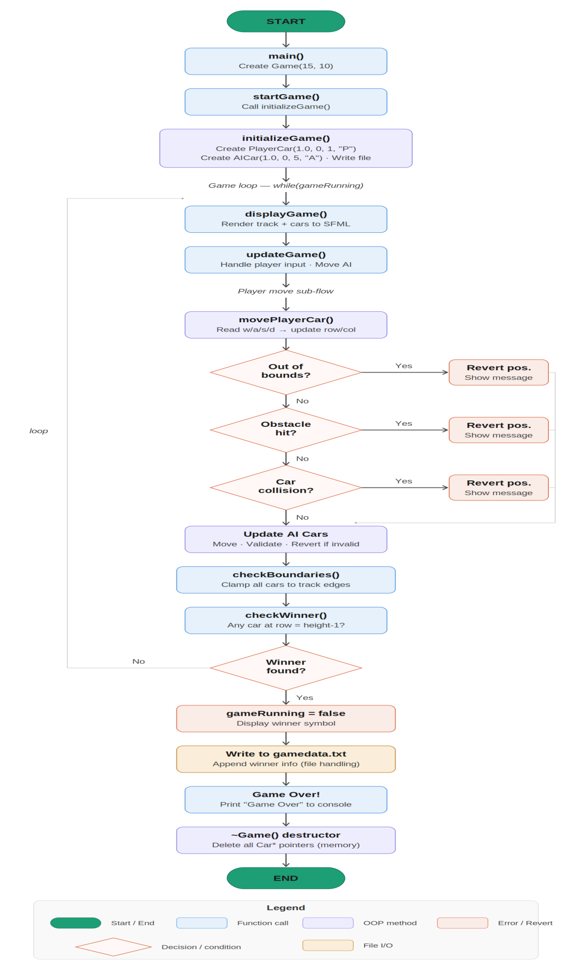

8. Screenshots
The following screenshots show the working GUI-based game in action.

8.1 Game Window – In Progress
The screenshot below shows the SFML game window with the player car (blue, top-left), AI car (green, near finish line), three traffic cone obstacles, red boundary walls, and the checkered finish line.

Game start
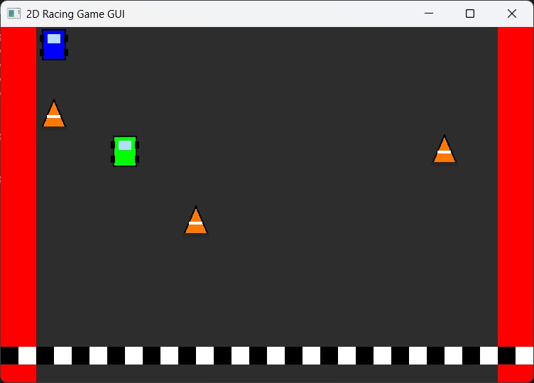

Game in progress
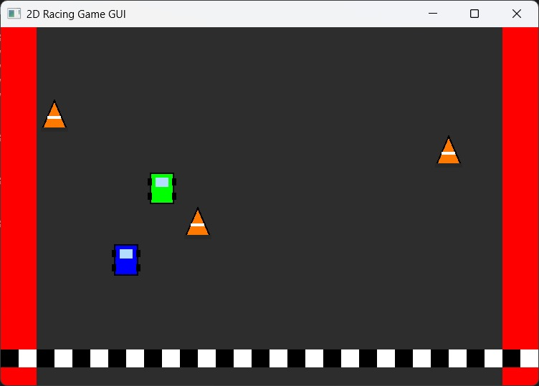
Player wins
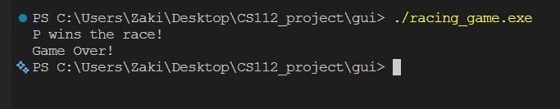
File handling
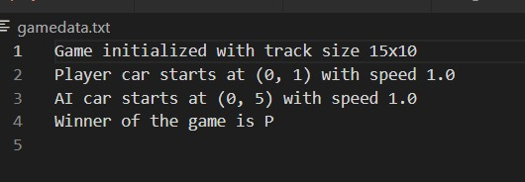

8.2 Key Visual Features
Feature | Visual Representation
Player Car | Blue filled rectangle with wheel details (top-left)
AI Car | Green filled rectangle with wheel details (near finish line)
Obstacles | Three orange triangle traffic cones at fixed positions
Track Walls | Red vertical panels on left and right sides
Finish Line | Black and white checkered strip at the bottom
Track Surface | Dark gray background simulating asphalt

9. Conclusion
This project successfully demonstrates the implementation of a 2D racing game using C++ with SFML for graphical rendering, built upon solid object-oriented programming principles. The evolution from a console-based prototype to a GUI application showcases how OOP design decisions scale well when adding new layers of complexity.

