**DEPARTMENT OF COMPUTER & SOFTWARE ENGINEERING**

**COLLEGE OF E&ME, NUST, RAWALPINDI**



**Digital Image Processing**

**Semester Project**

**SUBMITTED TO:**

**Dr. Usman Akram**

**L.E Sundas Ashraf**

**SUBMITTED BY:**

**Muhammad Zakria Mehmood 391449**

**Syed Muhammad Aoun Abbas 368223**

**FAIZAN EJAZ 384102**

**DE: C&SE**

**Submission Date: 20/6/24**

# Flowchart:

CLASSIFICATION

SEGMENTATION

# CLASSIFICATION

For classifying between the three classes (safe, gun, knives) I’ve used a CNN model Resnet18 which contains 18 conv layers with 11M trainable parameters suitable for this job. Here is the complete of the model on dummy input (3,256,256). Dataset loading is done on batch size 4 after which this is the images and mask in one batch:

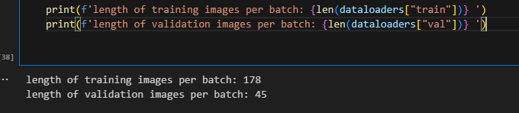

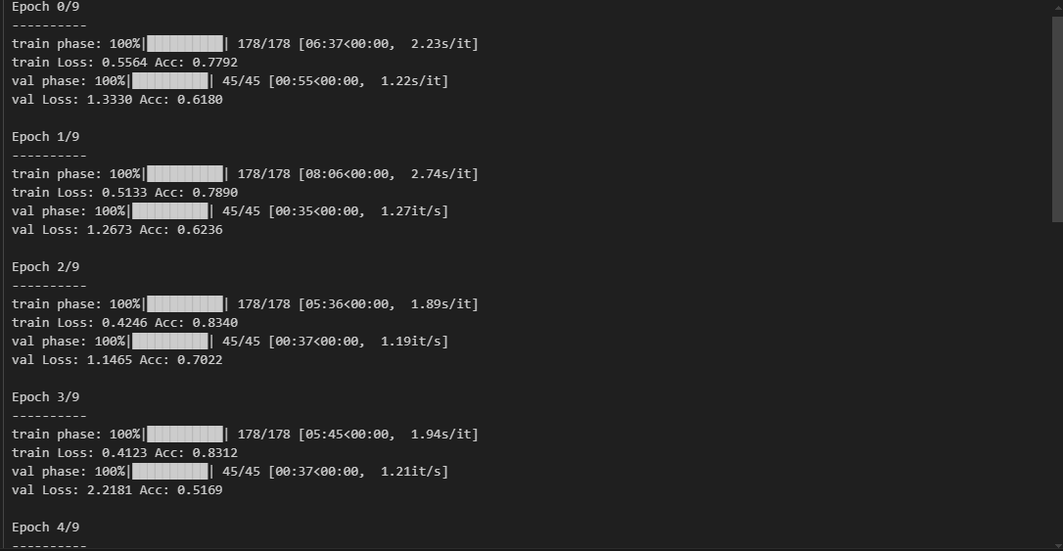

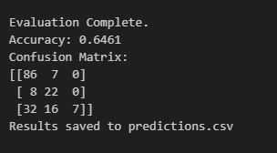

I’ve made a predictions csv file for predictions data and true labels side by side:



# SEGMENTATION

root_dataset_folder/

│

├── train/

│ ├── images/

│ │ ├── img1.jpg

│ │ └── ...

│ ├── gt/

│ │ ├── mask1.png

│ │ └── ...

├── test/

│ ├── images/

│ │ ├── img1.jpg

│ │ └── ...

│ ├── gt/

│ │ ├── mask1.png

│ │ └── ...

For segmentation I’ve used the lab provided WNET model architecture code and organized the dataset in this format for semantic segmentation.

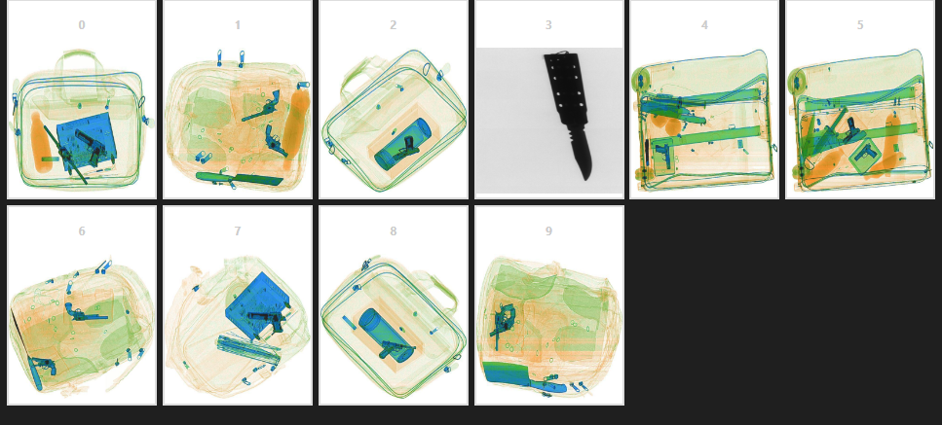



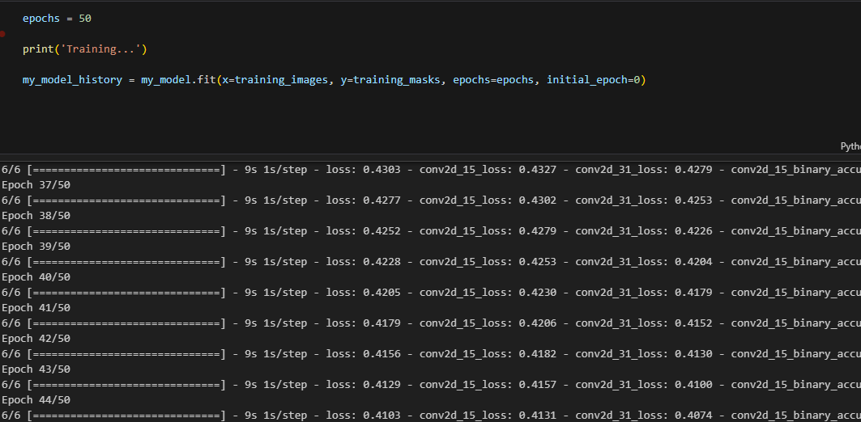

F1 SCORE

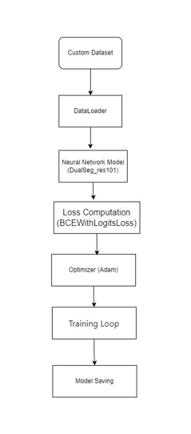UNET (COMPARISON):

My previous work on this same dataset I used unet to implement semantic segmentaion. UNET provided accuracy/F1 61%. Both models seems to work fine in isolated object’s Xrays but complete baggage Xrays seems to become a problem for these kind of small models.

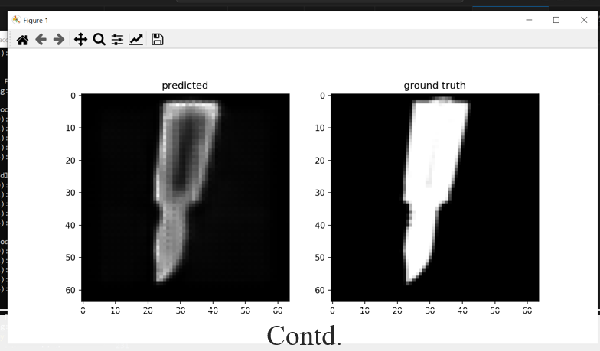WNET UNET TRUE