**DEPARTMENT OF COMPUTER & SOFTWARE ENGINEERING**

**COLLEGE OF E&ME, NUST, RAWALPINDI**

**Microprocessor and Microcontroller Based Design**

**Project Report**

**SUBMITTED TO:**

**Instructor Taimoor Zahid**

**SUBMITTED BY:**

**CE 43 A**

|  |  |
| --- | --- |
| Muhammad Zakria Mehmood |  |
| Faizan Ejaz |  |
| Syed Muhammad Irtaza Hyder |  |

**Submission Date: 05-01-24**

**Project: Autonomous Robotic Car with Live Video Streaming**

**Introduction:**

* **Overview:**

The aim of the project was to develop a road-based navigation robot, which broadcasts its own location to the user and travels to the nearby road-accessible location specified by the user. Alongside this, the robot also incorporates live video streaming using cloud.

* **Hardware:**

1. Raspberry Pi 3
2. GPS Module NEO6M V2 Ublox
3. 4x L298N Motor Drivers
4. 4x 3-6V TT Gear Motors
5. MPU 6050
6. IR Sensor
7. USB Web Camera

* **Misc:**

1. 5V Power Bank
2. 4x 3.7V Lithium Cells
3. 2x Battery Holder
4. 4x Rubber Wheels
5. 1x Chassis

* **Software:**

1. Arduino IDE
2. VSCode

**Pictures:**

**Car:**

[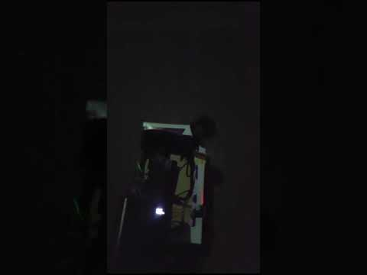](https://www.youtube.com/embed/8ybqrKF6dUw?feature=oembed)

**Configuration:**

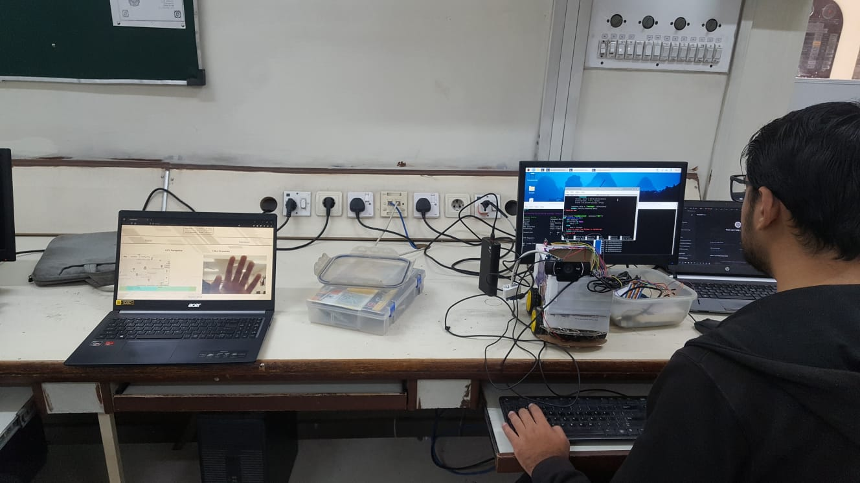

* 1. *Video Streaming on NGROK*

**Live Streaming via USB webcam**:

[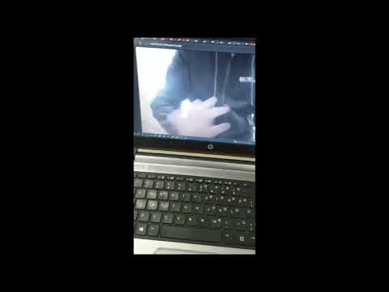](https://www.youtube.com/embed/OpzDrNYBJgI?feature=oembed)

* 1. *Video Streaming on NGROK*

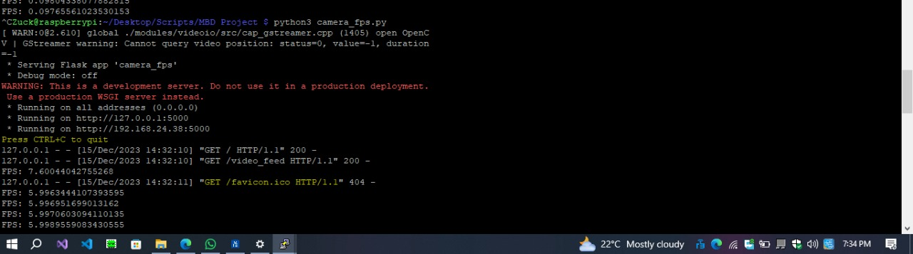

*1.3. Camera server online on Raspberry Pi*

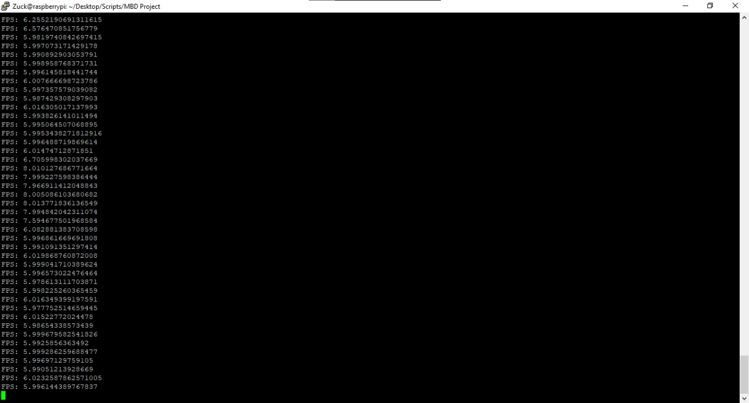

*1.4. FPS from slower camera*

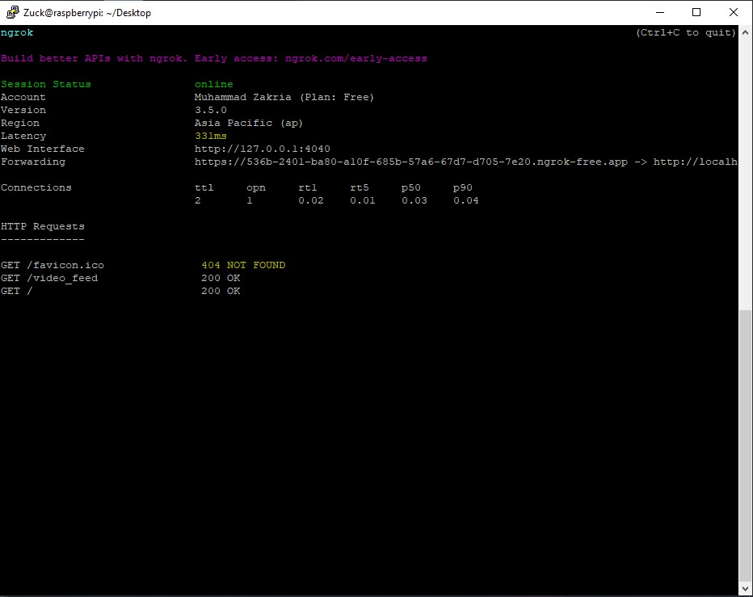

*1.5. NGROK server online*

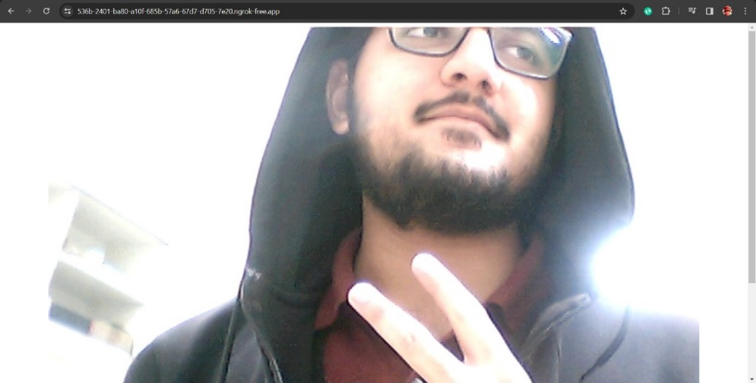

*1.6. Live stream on NGROK Cloud provided URL*

**Real-time location of car via GPS:**

*1.7. Sensor Reading sent from PI ttyAMA0*

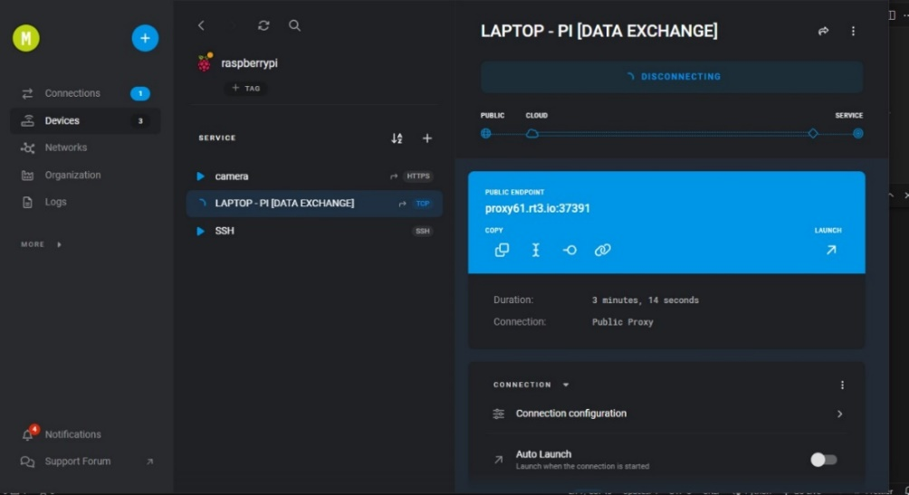

*1.8. Device registered on RemoteIT*

*1.8. Communication between JavaScript and Flask Server for exchange of GPS data and Route*

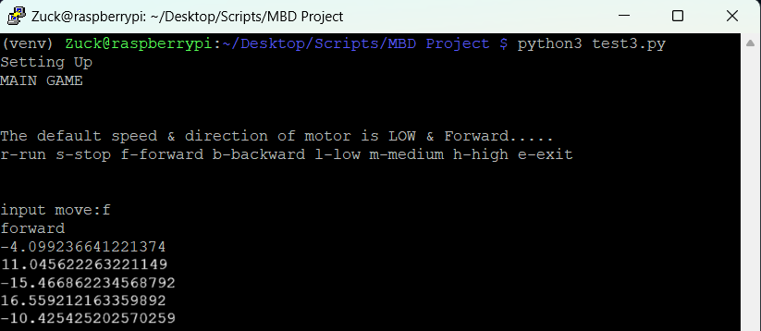

*1.9. MPU 6050 returning Gyro readings whenever Gyro readings have difference of > 10 degrees*

**Website:**

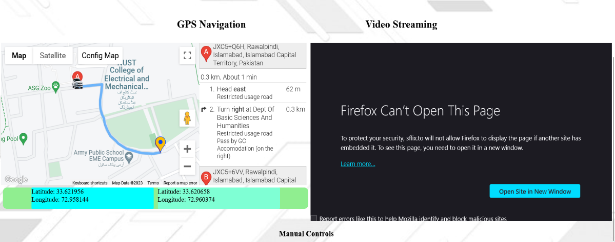

*1.12. Webpage*

**Car Moving Based on MPU and Direction sent from Website:**

**[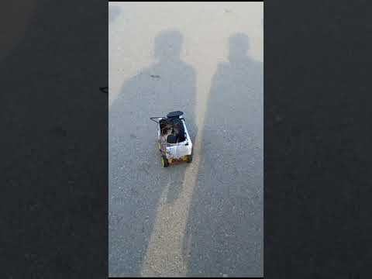](https://www.youtube.com/embed/8OIE8YjhjAg?feature=oembed)**