**University of Engineering and Technology, Taxila**

**Faculty of Telecommunication and Information Technology**

**Software Engineering Department**

**Visual Language**

**Submitted By:  
Zakria Rehman**

**18-SE-30**

**Dated: Oct,6 2021**

**Code:**

"""

Created on Wed Oct 6 19:15:51 2021

@author: zakria

"""

#student details

student={

'name':'Zakria Rehman',

'session': 2018,

'semester': 7,

'reg_Number':"18-SE-30",

}

#subject details

subjects=(

'SPM','ST', 'ML', 'VL', 'HRM'

)

#departments of UET Taxila

departments= {'Software', 'Computer', 'Mechanical', 'Civil', 'Electrical', 'Industrial'}

#declaring a grade calculator

#as definition is not equired,but definition is as follows

def compute_grade(weightage):

grade= None

if (weightage >= 80):

grade="A"

elif (weightage >= 70):

grade= "B"

elif (weightage >= 60):

grade= "C"

elif (weightage>=50):

grade= "D"

else:

grade= "F"

return grade

marks= int(input("Enter Your Marks: "))

grade= compute_grade(marks)

print("Your Calculated Grade is: ", grade)

#

#loop for displaying subjects

print("Student Details:\n")

for subject in subjects:

print(subject)

print("Departments of UET Taxila:\n")

for department in departments:

print(department)

#loop for displaying students

#displaying keys

print(student.keys())

#displaying values

print(student.values())

print()

**Output:**Here’s output of function: This function calculates student’s grade on the basis of their entered marks.

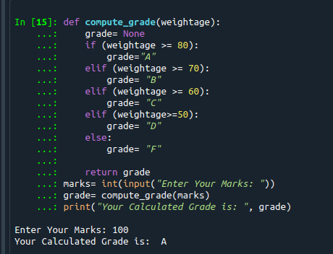

Here are studen details entered in tuple.

