PYTHON CALCULATOR CODE:

Input and output for calculator:

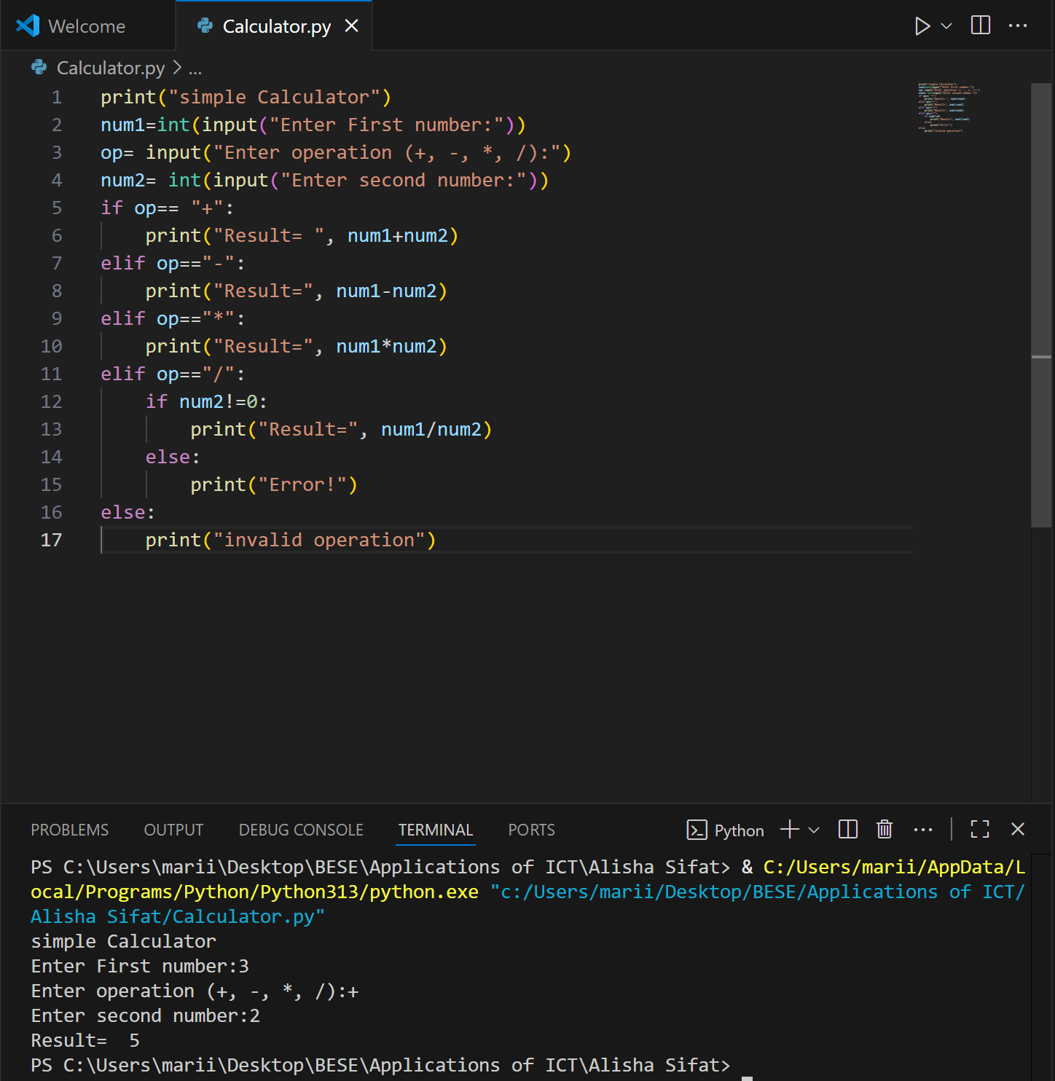

ASSEMBLY CALCULATOR

