1. Create Table Mahasiswa  
   Graphical user interface, text, application

   Description automatically generated  
   Table

   Description automatically generated
2. Masukkan 15 data  
   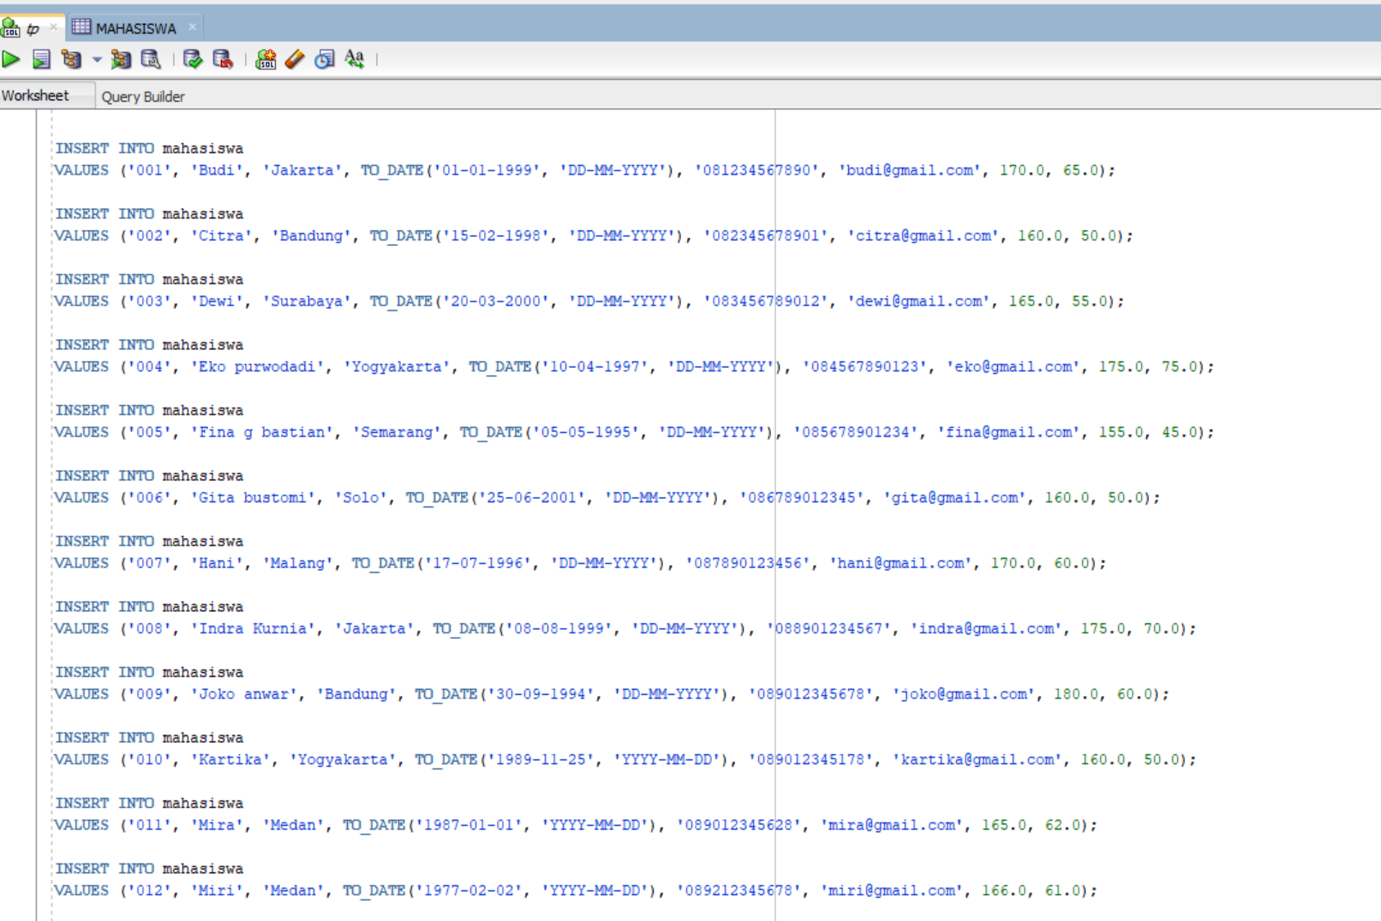Graphical user interface

   Description automatically generated with low confidence  
     
   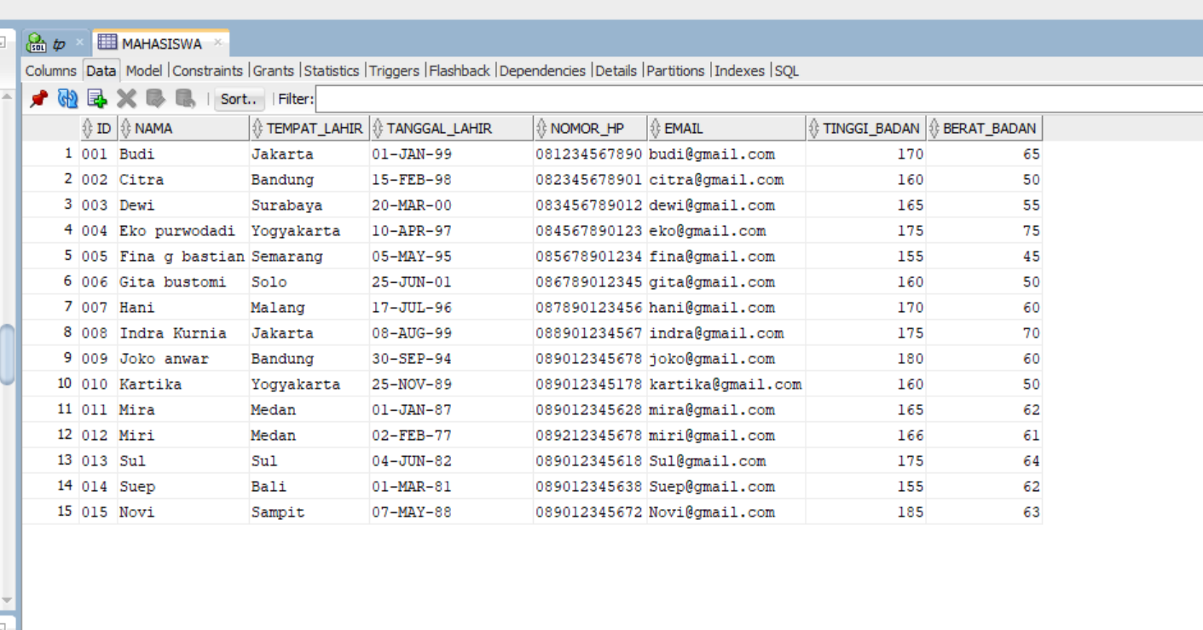  
   3.   
   a. Fungsi Karakter dan String (LOWER/UPPER, INITCAP, CONCAT, LENGTH, SUBSTR, LPAD/RPAD, LTRIM, RTRIM, INSTR, REPLACE)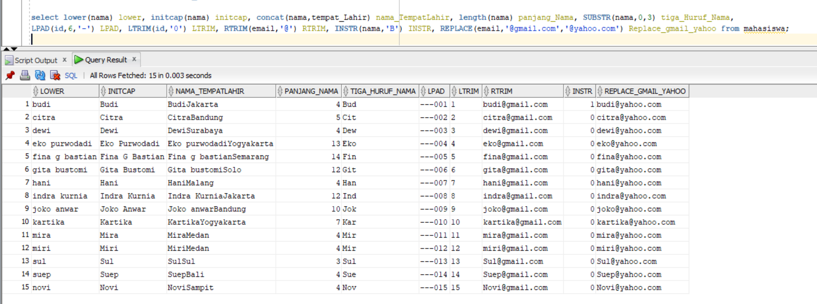  
     
   b. fungsi time dan date  
   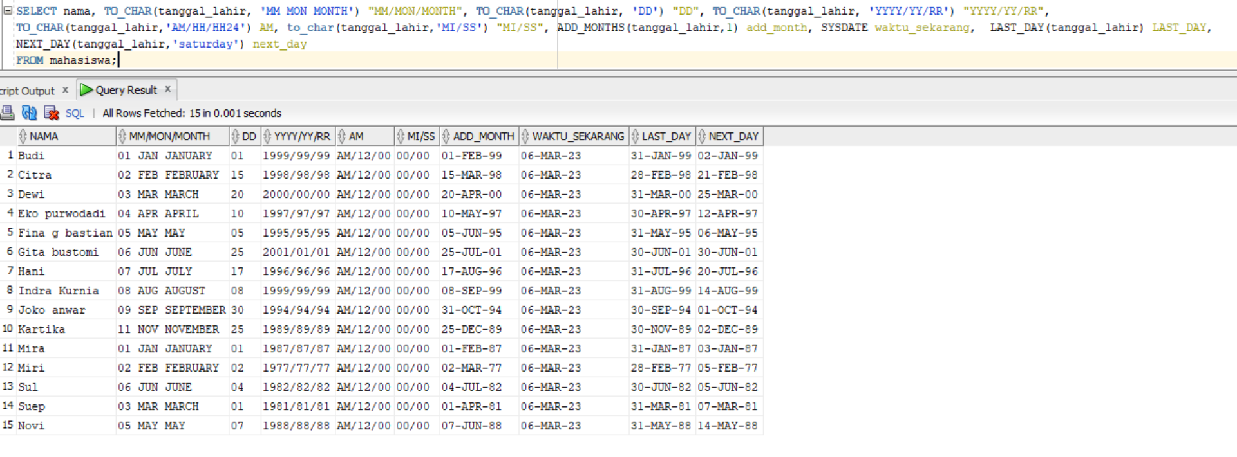  
     
   c. Fungsi convert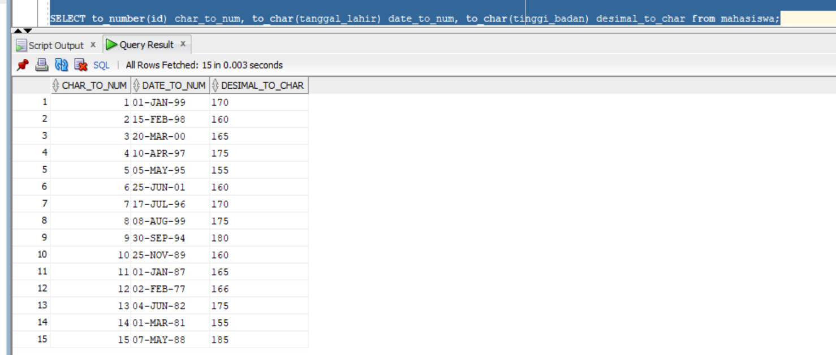  
     
   d. fungsi numerik   
   Graphical user interface, application, Word

   Description automatically generated