Writing Reports with R Markdown

Beth VanDusen

2022-10-21

This report was prepared for the UN. It analyzes the relationship between a country’s GDP, life expectancy, and CO2 emissions. Our goal was to determine to what degree the country’s economic strength or weakness may be related to its public health status and impact on climate pollution. We hypothesize that both life expectancy and CO2 emissions will increase with a country’s GDP.

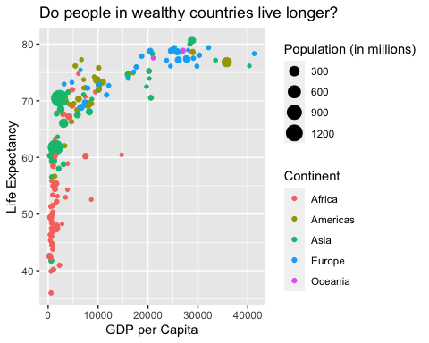

The above plot shows the relationship between GDP per capita and life expectancy for a total of 142 countries. For this set of countries, economic wealth ranged from a minimum of $312 to a maximum of $41283 per capita.

| Summary of Data |  |
| --- | --- |
| Number of countries | 142 |
| Minimum GDP per cap | 312 |
| Maximum GDP per cap | 41283 |

| country | pop | continent | lifeExp | gdpPercap |
| --- | --- | --- | --- | --- |
| Australia | 18565243 | Oceania | 78.83 | 26997.94 |
| New Zealand | 3676187 | Oceania | 77.55 | 21050.41 |

## lists

### unordered lists

* **R**
* *mutate*
* ***retention is the struggle!***

### ordered lists

1. **R**
2. *mutate*
3. ***retention is the struggle!***
4. [Basic Markdown Syntax](https://www.rstudio.com/wp-content/uploads/2015/03/rmarkdown-reference.pdf)