
UNITEDWORLD SCHOOL OF COMPUTATIONAL INTELLIGENCE (USCI)

Summative Assessment (SA)

Submitted BY
Name | Enrollment No
Patel Dhyana Jigar | 20220701016
Patel Zalak Bipinkumar | 20220701020

B.Sc. (Hons.) Computer Science / Data Science / AIML
III Semester – July – Nov 2023

SUBJECT: DATABASE MANAGEMENT SYSTEM



Nov/Dec 2023

GitHub Project Link:
https://github.com/ZalakBPatel/DBMS-Project
https://github.com/DHYANAJPATEL/DBMS-PROJECT

INDEX

Sr. No. | Title | Page No.
1 | Introduction  (Story / Game scenario / Simple explanation about the database) | 3
2 | Database Design ER Diagram | 4
3 | Table Schema (Includes Table name and column names) | 5
4 | Tables with dummy data (Also share in EXCEL file separately) | 6,7
5 | SQL Commands  (for building and populating the database - share in a Text file separately) | 8
 | - Create Table commands | to
 | - Insert commands | 20
6 | Sample queries for practicing and learning SQL  (Questions and Answers) | 21 to 28

STEP:1

GAME SCENARIO
SQL Hospital Game
Our game is about a boy named Raghav, who with his mother has just moved to the town. Raghav’s mother is not well from a few days she is experiencing chest pain and shortness of breath.
Our story revolves around the procedure that will take place in the hospital when Raghav takes his mother there. In this game, we have a database which consist of different tables which will help the player in making decisions to help Raghav’s mother get the treatment.
Our database consists of tables like :-
Ø Doctors
Ø Medicines
Ø Patients
Ø Reports
Ø Packages
Ø Illness
In this game the player will have to make various decisions, for eg: what type of package to choose, on what day to book an appointment etc. TAB
The player will have to use different type of operators to reach the end of the game.
This is a fun game which will help the players to enhance their knowledge in SQL.

STEP:2
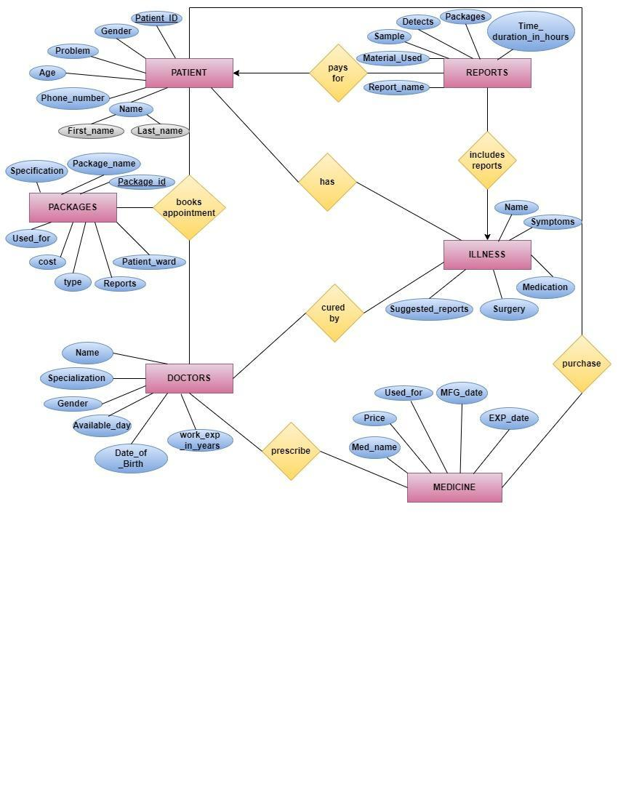

STEP:3
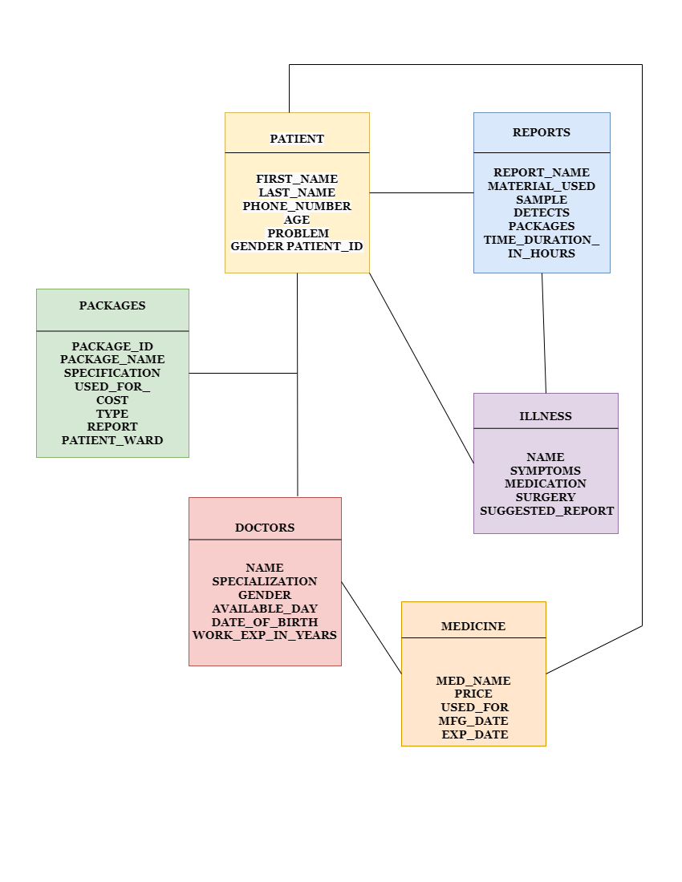

STEP: 4 TABLES WITH DUMMY DATA
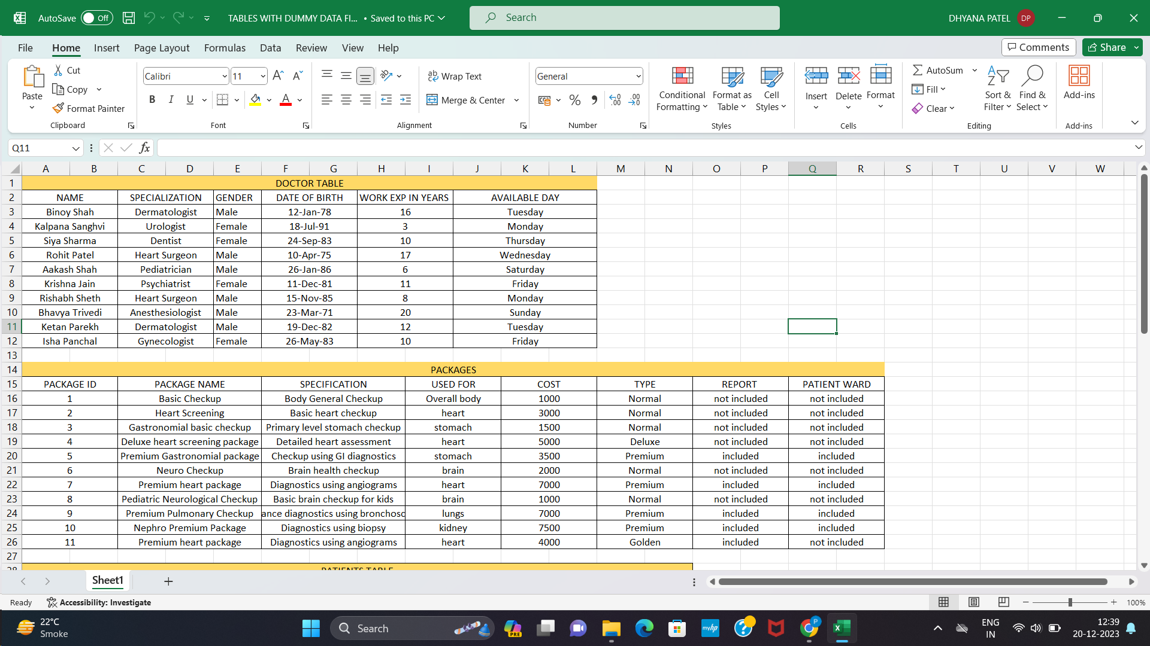
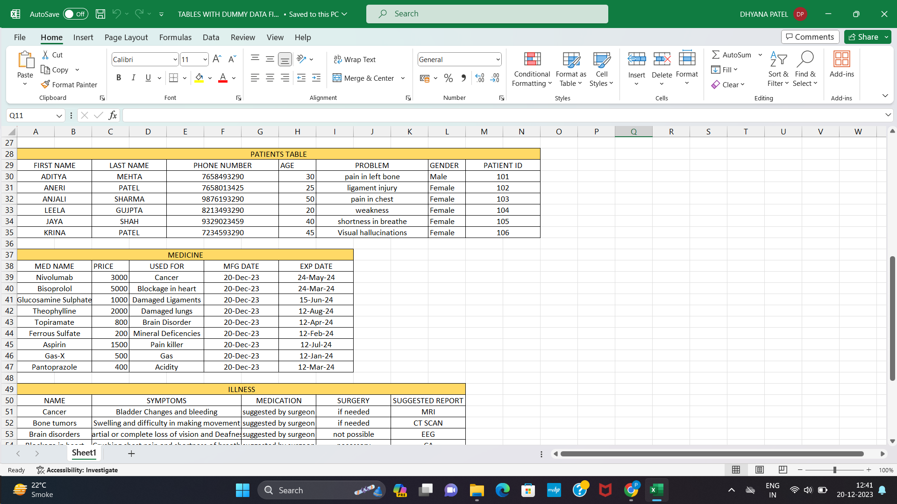

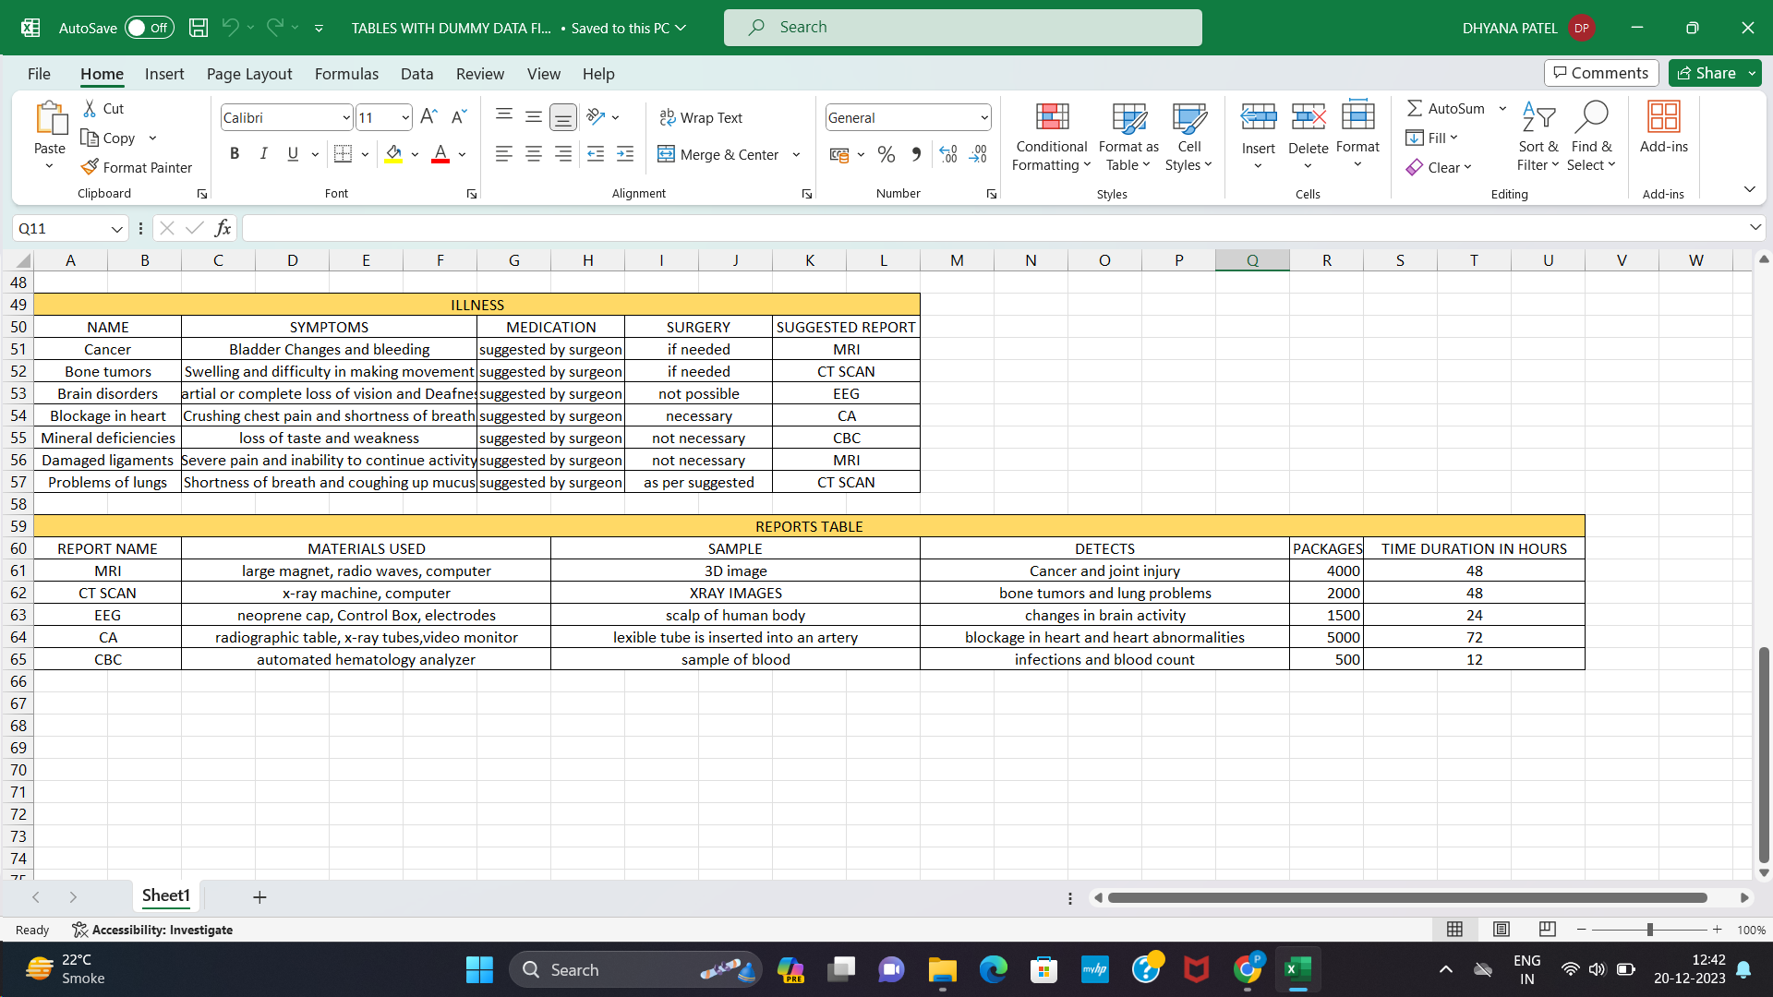

STEP 5: CREATE AND INSERT TABLE COMMANDS:

CREATION OF DOCTORS TABLE
create table doctors
(
name varchar(20),
specialization varchar(30),
gender varchar(10),
Available_Day varchar(10),
date_of_birth date,
work_exp_in_years int not null
);
INSERT INTO doctors(name,specialization,gender,Available_Day,date_of_birth,work_exp_in_years)
VALUES('Binoy Shah','Dermatologist','Male','Tuesday','12 January 1978','16');
INSERT INTO doctors(name,specialization,gender,Available_Day,date_of_birth,work_exp_in_years)
VALUES('Kalpana Sanghvi','Urologist','Female','Monday','18 July 1991','3');
INSERT INTO doctors(name,specialization,gender,Available_Day,date_of_birth,work_exp_in_years)
VALUES('Siya Sharma','Dentist','Female','Thursday','24 September 1983','10');
INSERT INTO doctors(name,specialization,gender,Available_Day,date_of_birth,work_exp_in_years)
VALUES('Rohit Patel','Heart Surgeon','Male','Wednesday','10 April 1975','17');
INSERT INTO doctors(name,specialization,gender,Available_Day,date_of_birth,work_exp_in_years)
VALUES('Aakash Shah','Pediatrician','Male','Saturday','26 January 1986','6');
INSERT INTO doctors(name,specialization,gender,Available_Day,date_of_birth,work_exp_in_years)
VALUES('Krisha Jain','Psychiatrist','Female','Friday','11 December 1981','11');
INSERT INTO doctors(name,specialization,gender,Available_Day,date_of_birth,work_exp_in_years)
VALUES('Rishabh Sheth','Heart Surgeon','Male','Monday',' 15 November 1985','8');
INSERT INTO doctors(name,specialization,gender,Available_Day,date_of_birth,work_exp_in_years)
VALUES('Bhavya Trivedi','Anesthesiologist','Male','Sunday','23 March 1971','20');
INSERT INTO doctors(name,specialization,gender,Available_Day,date_of_birth,work_exp_in_years)
VALUES('Ketan Parekh','Dermatologist','Male','Tuesday','19 December 1982','12');

INSERT INTO doctors(name,specialization,gender,Available_Day,date_of_birth,work_exp_in_years)
VALUES('Isha Panchal','Gynecologist','Female','Friday','26 May 1983','10');

Select * from DOCTORS;
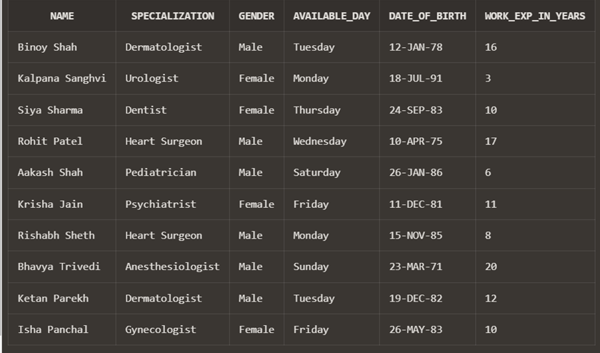

CREATION OF MEDICINE TABLE
CREATE TABLE MEDICINE
(
MED_NAME VARCHAR2(20),
PRICE integer not null,
USED_FOR varchar(70),
MFG_DATE DATE,
EXP_DATE DATE
);
INSERT INTO MEDICINE (MED_NAME, PRICE, USED_FOR, MFG_DATE , EXP_DATE)
VALUES('Nivolumab','3000','Cancer','20-December-2023','24-May-2024');
INSERT INTO MEDICINE (MED_NAME, PRICE, USED_FOR, MFG_DATE , EXP_DATE)
VALUES('Bisoprolol','5000','blockage in heart','20-December-2023','24-March-2024');
INSERT INTO MEDICINE (MED_NAME, PRICE, USED_FOR, MFG_DATE , EXP_DATE)
VALUES('Glucosamine Sulphate','1000','Damaged Ligaments','20-December-2023','15-June-24');
INSERT INTO MEDICINE (MED_NAME, PRICE, USED_FOR, MFG_DATE , EXP_DATE)
VALUES('Theophylline','2000','Damages lungs','20-December-2023','12-August-24');
INSERT INTO MEDICINE (MED_NAME, PRICE, USED_FOR, MFG_DATE , EXP_DATE)
VALUES('topiramate','800','Brain Disorder','20-December-2023','12-April-24');
INSERT INTO MEDICINE (MED_NAME, PRICE, USED_FOR, MFG_DATE , EXP_DATE)
VALUES('Ferrous sulfate','200','Mineral Deficencies','20-December-2023','12-February-24');
INSERT INTO MEDICINE (MED_NAME, PRICE, USED_FOR, MFG_DATE , EXP_DATE)
VALUES('Aspirin','1500','pain killer','20-December-2023','12-July-24');
INSERT INTO MEDICINE (MED_NAME, PRICE, USED_FOR, MFG_DATE , EXP_DATE)
VALUES('Gas-X,','500','Gas','20-December-2023','12-January-24');
INSERT INTO MEDICINE (MED_NAME, PRICE, USED_FOR, MFG_DATE , EXP_DATE)
VALUES('pantoprazole,','400','Acidity','20-December-2023','12-March-24');
Select * from MEDICINE;
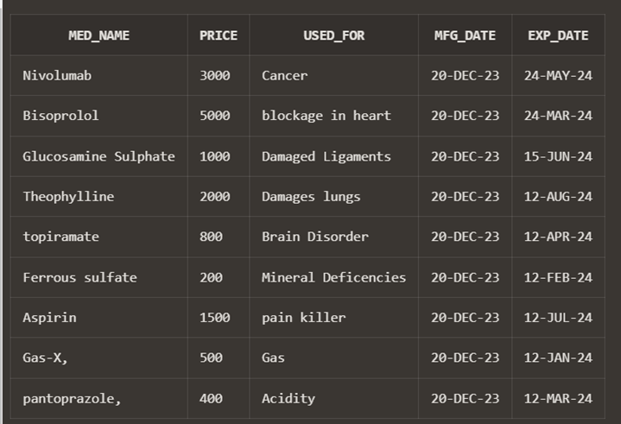

CREATION OF PACKAGES TABLE
create table PACKAGES (
Package_ID number,
Package_Name varchar(30),
Specification varchar(40),
Used_for varchar(30),
Cost int not null,
Report varchar2(20),
Patient_ward varchar2(20),
Type varchar(20)
);
INSERT INTO PACKAGES(Package_ID,Package_Name,Specification,Used_for,Cost,Type,Report,Patient_ward)
VALUES('4','Deluxe Heart Screening Package','Detailed heart assessment','heart','5000','Deluxe','not included','included');
INSERT INTO PACKAGES(Package_ID,Package_Name,Specification,Used_for,Cost,Type,Report,Patient_ward)
VALUES('1',' Basic Checkup','Body General Checkup','Overall body','1000','Normal','not included','not included');
INSERT INTO PACKAGES(Package_ID,Package_Name,Specification,Used_for,Cost,Type,Report,Patient_ward)
VALUES('11','Premium Heart Package','Diagnostics using angiograms','heart','4000','Golden','included','not included');

INSERT INTO PACKAGES(Package_ID,Package_Name,Specification,Used_for,Cost,Type,Report,Patient_ward)
VALUES('3','Gastronomial basic checkup','Primary level stomach checkup','stomach','1500','Normal','not included','not included');
INSERT INTO PACKAGES(Package_ID,Package_Name,Specification,Used_for,Cost,Type,Report,Patient_ward)
VALUES('7','Premium Heart Package','Diagnostics using angiograms','heart','7000','Premium','included','included')
INSERT INTO PACKAGES(Package_ID,Package_Name,Specification,Used_for,Cost,Type,Report,Patient_ward)
VALUES('5','Premium Gastronomial Package','Checkup using GI diagnostics','stomach','3500','Premium','included','included');
INSERT INTO PACKAGES(Package_ID,Package_Name,Specification,Used_for,Cost,Type,Report,Patient_ward)
VALUES('6','Neuro Checkup',' Brain health checkup','brain','2000','Normal','not included','not included');
INSERT INTO PACKAGES(Package_ID,Package_Name,Specification,Used_for,Cost,Type,Report,Patient_ward)
VALUES('8','Pediatric Neurological Checkup','Basic brain checkup for kids','brain','1000','Normal','not included','not included');
INSERT INTO PACKAGES(Package_ID,Package_Name,Specification,Used_for,Cost,Type,Report,Patient_ward)
VALUES('9','Premium Pulmonary Checkup','Advance diagnostics using bronchoscopy','lungs','7000','Premium','included','included');
INSERT INTO PACKAGES(Package_ID,Package_Name,Specification,Used_for,Cost,Type,Report,Patient_ward)
VALUES('10','Nephro Premium Package','Diagnostics using biopsy','kidney','7500','Premium','included','included');
INSERT INTO PACKAGES(Package_ID,Package_Name,Specification,Used_for,Cost,Type,Report,Patient_ward)
VALUES('2',' Heart Screening','Basic heart checkup','heart','3000','Normal','not included','not included');
Select * from PACKAGES;
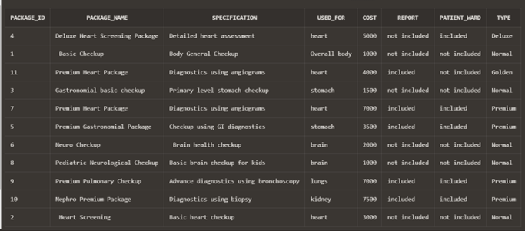

CREATION OF REPORTS TABLE
create table REPORTS
(
Report_Name varchar(70),
material_used varchar(70),
sample varchar(70),
detects varchar(70),
packages numeric,
time_duration_in_hours int not null
);
INSERT INTO REPORTS (Report_Name, material_used, sample, detects, packages,time_duration_in_hours)
VALUES('MRI','large magnet, radio waves, computer',' 3D image','Cancer and joint injury.','4000','48');
INSERT INTO REPORTS (Report_Name, material_used, sample, detects, packages,time_duration_in_hours)
VALUES('CT SCAN','x-ray machine, computer','XRAY IMAGES','bone tumors and lung problems.','2000','48');
INSERT INTO REPORTS(Report_Name, material_used, sample, detects, packages,time_duration_in_hours)
VALUES('EEG','neoprene cap, Control Box, electrodes','scalp of human body','changes in brain activity','1500','24');
INSERT INTO REPORTS(Report_Name, material_used, sample, detects, packages,time_duration_in_hours)
VALUES('CA','radiographic table, x-ray tubes, video monitor','lexible tube is inserted into an artery','blockage in heart and heart abnormalities','5000','72');
INSERT INTO REPORTS(Report_Name, material_used, sample, detects, packages,time_duration_in_hours)
VALUES('CBC','automated hematology analyzer','sample of blood ','infections and blood count','500','12');
Select * from REPORTS;
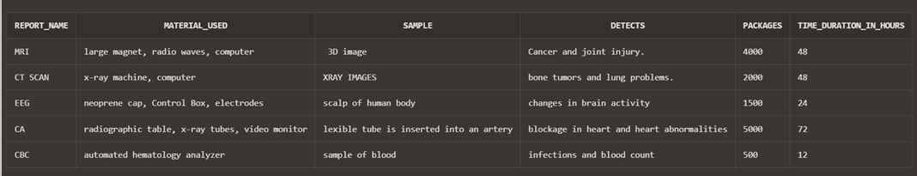

CREATION OF ILLNESS TABLE
create table illness
(
name varchar(70),
symptoms varchar(200),
medication varchar(70),
surgery varchar(70),
suggested_report varchar(70)
);
INSERT INTO illness(name, symptoms, medication, surgery, suggested_report)
VALUES('Cancer','Bladder Changes and bleeding','suggested by surgeon','if needed','MRI');
INSERT INTO illness(name, symptoms, medication, surgery, suggested_report)
VALUES('Bone tumors','swelling and difficulty in making movement','suggested by surgeon','if needed','CT SCAN');
INSERT INTO illness(name, symptoms, medication, surgery, suggested_report)
VALUES('brain disorders','Partial or complete loss of vision and Deafness','suggested by surgeon','not possible','EEG');
INSERT INTO illness(name, symptoms, medication, surgery, suggested_report)
VALUES('blockage in heart','crushing chest pain and shortness of breath','suggested by surgeon','necessary','CA');
INSERT INTO illness(name, symptoms, medication, surgery, suggested_report)
VALUES('mineral deficiencies','loss of taste and weakness ','suggested by surgeon','not necessary','CBC');
INSERT INTO illness(name, symptoms, medication, surgery, suggested_report)
VALUES('damaged ligaments','Severe pain and inability to continue activity','suggested by surgeon','not necessary','MRI');
INSERT INTO illness(name, symptoms, medication, surgery, suggested_report)
VALUES('problems of lungs','shortness of breath and coughing up mucus','suggested by surgeon','as per suggested','CT SCAN');

Select * from ILLNESS;
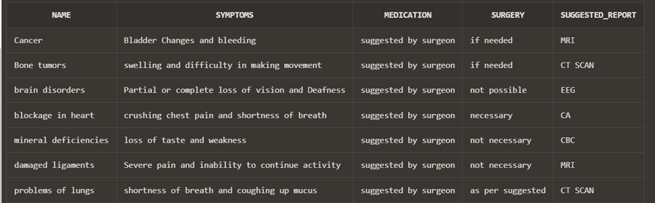

CREATION OF PATIENT TABLE
CREATE TABLE PATIENT
(
First_NAME VARCHAR2(70),
Last_NAME VARCHAR2(70),
phone_number varchar(70),
AGE INTEGER,
problem varchar(70),
GENDER CHAR(6),
Patient_ID NUMBER(30)
);
INSERT INTO PATIENT(First_NAME,Last_NAME,phone_number, AGE, problem,GENDER, Patient_ID)
VALUES('Aditya','Mehta','7658493290','30','pain in left leg bone','Male','101');

INSERT INTO PATIENT(First_NAME,Last_NAME,phone_number, AGE, problem,GENDER, Patient_ID)
VALUES('Aneri','Patel','7658013425','25','ligament injury','Female','102');
INSERT INTO PATIENT(First_NAME,Last_NAME,phone_number, AGE, problem,GENDER, Patient_ID)
VALUES('Anjali','Sharma','9876193290','50','pain in chest','Female','103');
INSERT INTO PATIENT(First_NAME,Last_NAME,phone_number, AGE, problem,GENDER, Patient_ID)
VALUES('Leela','Gujpta','8213493290','20','weakness','Female','104');
INSERT INTO PATIENT(First_NAME,Last_NAME,phone_number, AGE, problem,GENDER, Patient_ID)
VALUES('Jaya','Shah','9329023459','40','shortness in breathe','Female','105');
INSERT INTO PATIENT(First_NAME,Last_NAME,phone_number, AGE, problem,GENDER, Patient_ID)
VALUES('Krina','Patel','7234593290','45','Visual hallucinations','Female','106');
Select * from PATIENT;
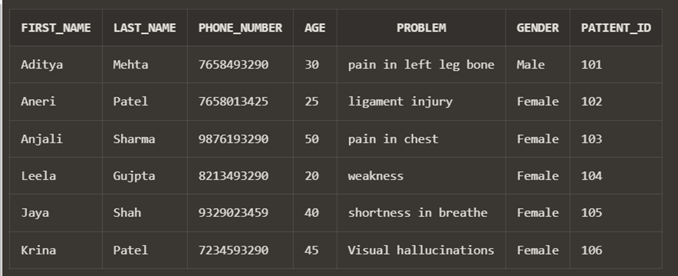

DATABASE MANAGEMENT PROJECT
HOSPITAL STORY

Raghav took his mom to the hospital on Monday because she was experiencing chest pains and shortness of breath.
1)Raghav asked for different packages at the reception desk.
SELECT * FROM PACKAGES;
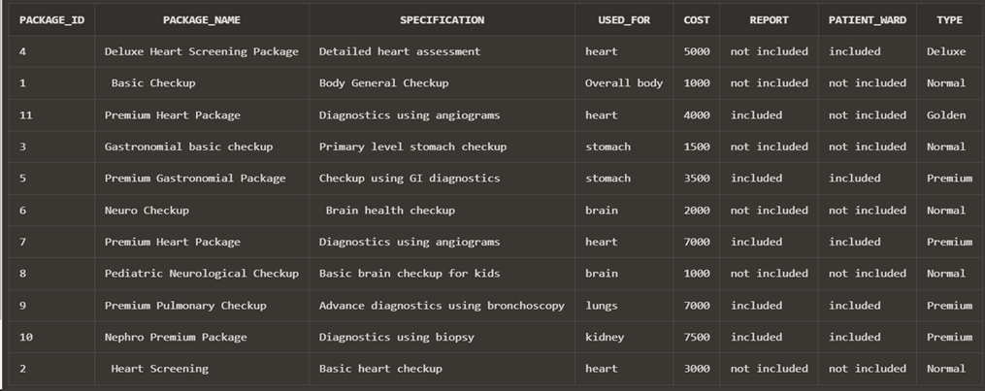

Out of these packages Raghav only wanted packages which were related to heart problems.
2) Help him short list the packages related to heart problems.
select * from PACKAGES
where USED_FOR='heart';
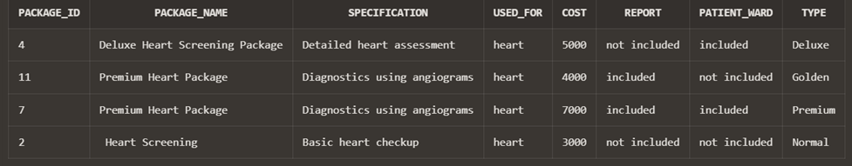

3) After getting the list of packages related to heart, make it easy for Raghav to compare the cost of packages.
SELECT * FROM PACKAGES
where USED_FOR='heart'
ORDER BY cost;
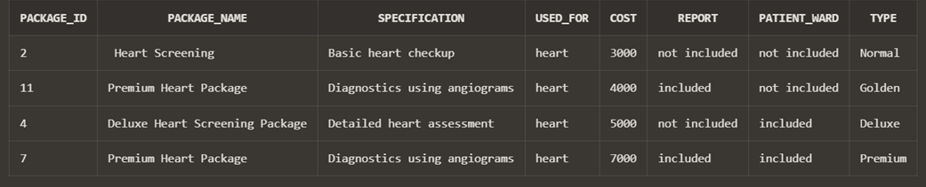

4) After comparing the cost of all packages help Raghav choose the best package. (WHICH INCLUDES REPORT AND PATIENT WARD).
SELECT * FROM PACKAGES
WHERE USED_FOR='heart' AND REPORT='included' AND PATIENT_WARD='included';
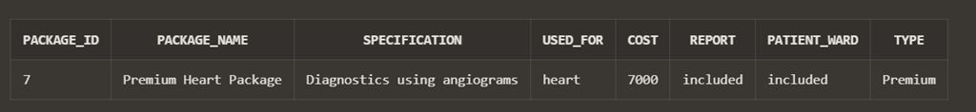

5) After selecting the package Raghav is given a list of doctors.
select * from DOCTORS;
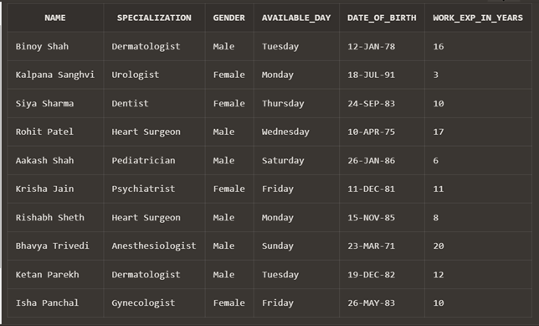
6) Shortlist the doctors specialized in heart surgery.
select * from DOCTORS
where SPECIALIZATION='Heart Surgeon';
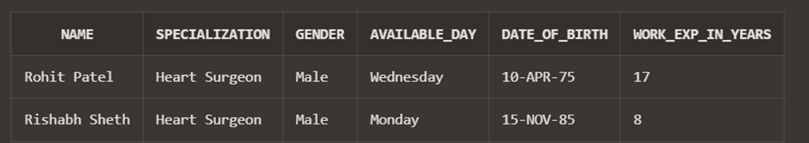

Two specialist are available, one is on Monday and second is on Wednesday.

7) Raghav wants the checkup to be performed as early as possible. Help him book on earliest day possible.(Wednesday).
select * from DOCTORS
where SPECIALIZATION='Heart Surgeon' AND AVAILABLE_DAY='Wednesday';
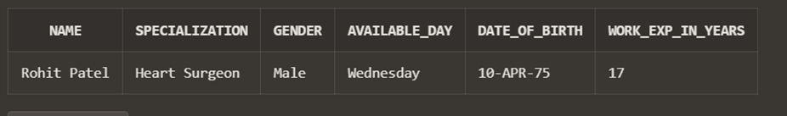

Raghav goes to meet the doctor on Wednesday.
Raghav’s mother has symptoms of crushing chest pain and shortness of breath.
8) Help doctor find what illness can it be (were symptoms are crushing chest pain and shortness of breath).
select * from ILLNESS
where SYMPTOMS='crushing chest pain and shortness of breath';
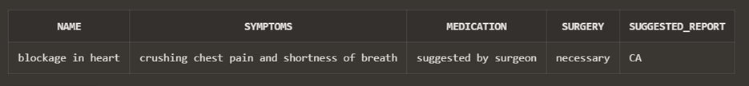

As per the symptoms doctor thinks its blockage of heart but to be sure he has suggested reports.
But before reports, Raghav’s mothers name has to be inserted into the patients table.
9) Raghav’s mother name is Mita Shah, her age is 65 years, her phone number is 9080706050, she is facing problem of shortness of breath,she is given patient no 107.
INSERT INTO PATIENT(FIRST_NAME,LAST_NAME,PHONE_NUMBER,AGE,PROBLEM,GENDER,PATIENT_ID)
VALUES('Mita','Shah','9080706050','56','shortness of breath','Female','107');
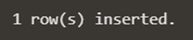
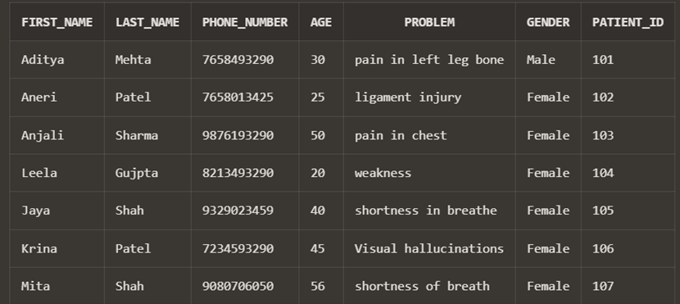

After inserting her name in patients table, Raghav takes her mom for the reports.
Raghav’s mother had symptoms of crushing chest pain and shortness of breath.
10) Help him find the suggested report from the symptoms.
select SUGGESTED_REPORT from ILLNESS
WHERE SYMPTOMS LIKE 'c%';
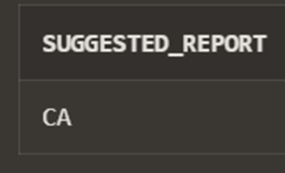

After finding the suggested report based on the symptoms
11) Help Raghav to find how much time will be needed for the report.
select TIME_DURATION_IN_HOURS from REPORTS
where REPORT_NAME='CA';
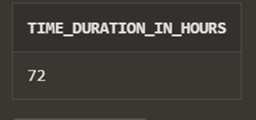
After knowing the time, Raghav wants to know what type of samples are taken.
12) Help Raghav to know the type of sample and material used for taking the sample.
SELECT REPORT_NAME,MATERIAL_USED,SAMPLE FROM REPORTS
WHERE TIME_DURATION_IN_HOURS BETWEEN 70 AND 80;
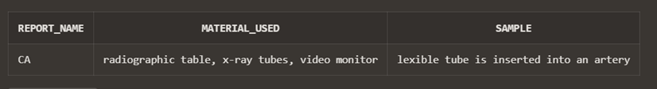

After the reports were performed, while checking the reports it was found that Raghav’s mother’s age was inserted wrong in the patients information.
13) Update Raghav’s mother’s age in the patient table.
UPDATE PATIENT
SET AGE = 65
where PATIENT_ID='107';
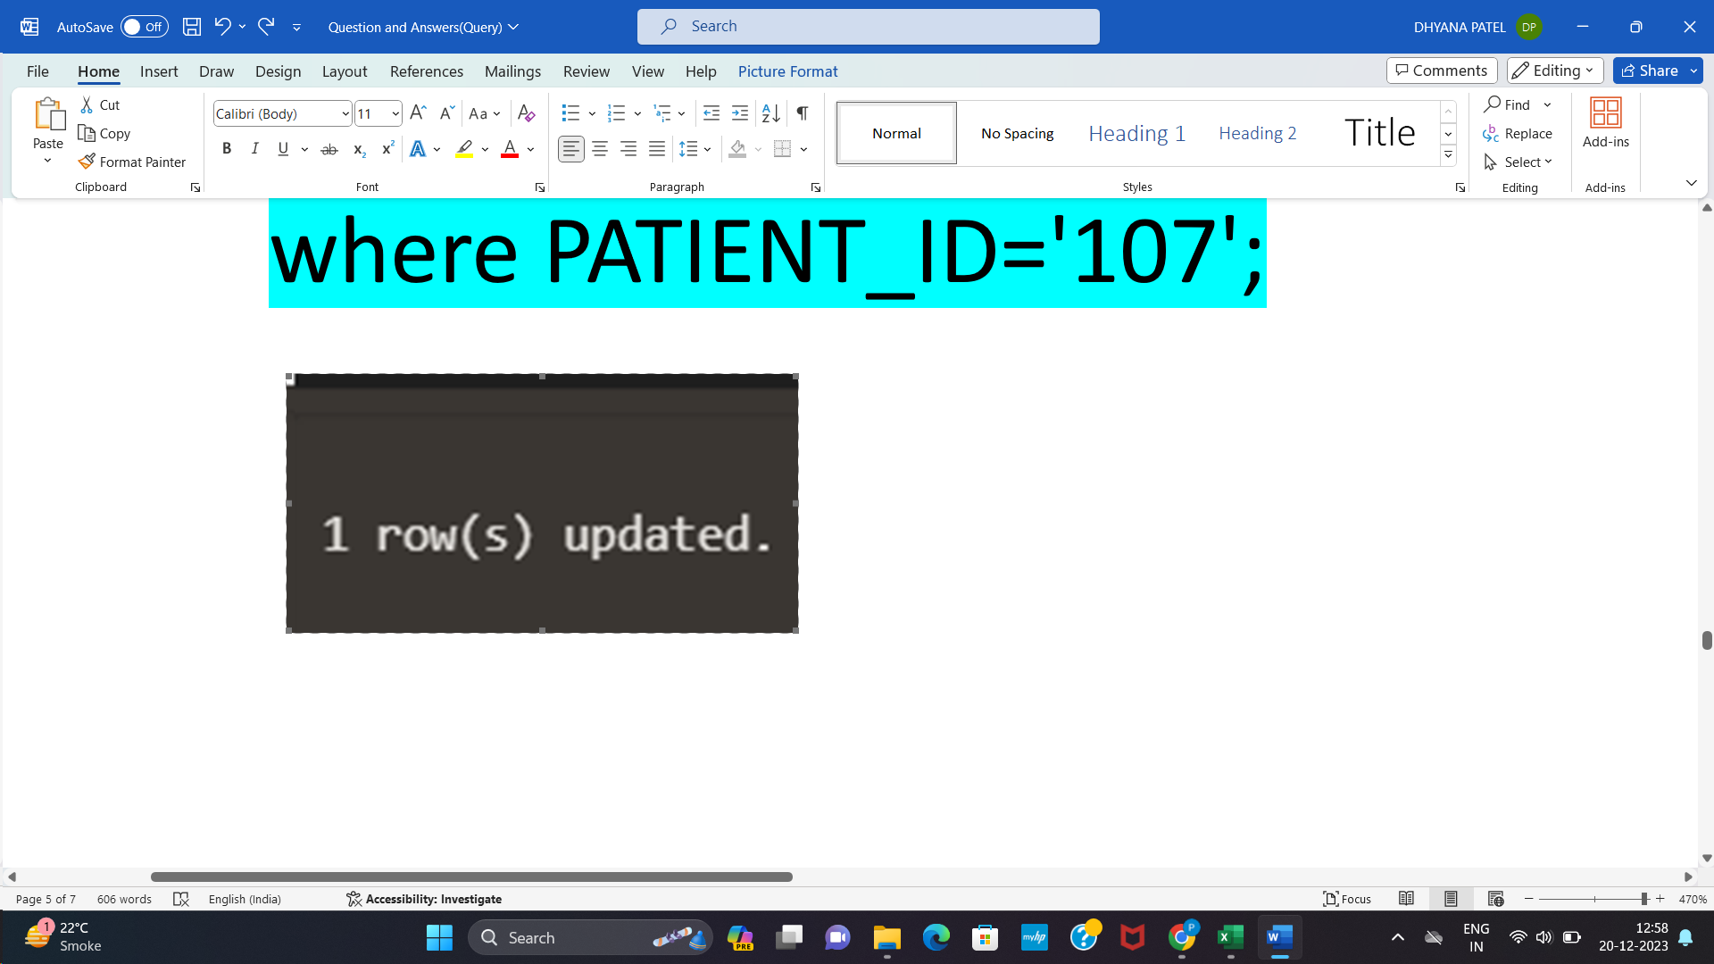

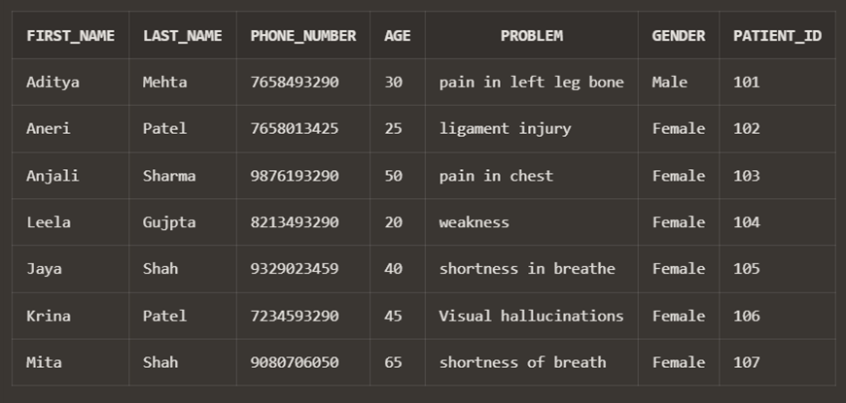

After looking at the reports, surgery was performed and was successful. Doctor prescribed a medicine for blockage in heart to decrease pain.

14) Help Raghav to know the name,manufacturing date and expiry date of the medicine (medicine used for blockage in heart) .
select MED_NAME,MFG_DATE,EXP_DATE from MEDICINE
where USED_FOR='blockage in heart';
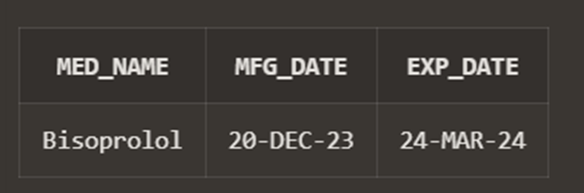

15) As the dosage of medicine is very high, he recommended to take some medicines for acidity,gas.
select * from MEDICINE
where USED_FOR='Gas' or USED_FOR='Acidity';
