Kevin Szmyd
Artificial Intelligence

Code Design
This was my first ever project in go, hadn't touched the language prior, and it served as a
fantastic learning experience. Files were split into three sections, commands, search
algorithms, and puzzle object definitions. The command program is responsible for passing f unctions from the puzzle objects to the algorithms. The functions pointed at the puzzle object, so while the algorithms are able to modify values within these puzzle objects, there is a layer of
abstraction separating the two. This is an example of a function type declaration and
initialization of a search algorithm

type fn func([]int, []int)

aiInst.SolvePuzzle(focusObject.GetState(), h1, focusObject.SetState, focusObject.GetStates)

calling

func (x *Astar) SolvePuzzle(inState []int, hMod fn, setState ssn, stateOptions gsn)

The alternative to this is to pass puzzle objects directly to the algorithms, however with the type
system in go this would have limited the ability of the algorithms to process puzzle objects
that were not coded directly into the algorithm. This way, we maintain the ability to use these
searches on other like objects through passing in relevant functions rather than objects.

The usage of deep copying along with getter/setter methods was to prevent accidental
modification of underlying slices (a concept in go akin to mutable arrays) which would have
led to undesired results. This issue was discovered after switching from arrays of fixed length
to slices in order to accommodate puzzles of varying state size. Append is the troublemaker
as it may modify a slice directly, or copy a slice then modify depending on the given length
of the slice which is hidden by default.

func copySlice(s []string) []string {
t := make([]string, len(s))
copy(t, s)
return t
}

Code Correctness
These are the commands for each algorithms' random run:
go run project1.go h1test
go run project1.go h2test
go run project1.go beamtest

These test sets are given a maxNode value of 4096, and expected values out of 20 trial runs
can be found in the column second from right in the graph below (Experiments 1). Beam
here is set to 8.

As the code runs, the last node considered is displayed next to the total cost (for beam, h2,
for a*, h + dist) as well as a list of moves to achieve that current state. If the solution is found
the system prints the move list, followed by the amount of nodes, followed by a printout of
the last state searched before the solution was found. If no solution is found, it prints out
the last state searched before the algorithm gave up.

Experiments
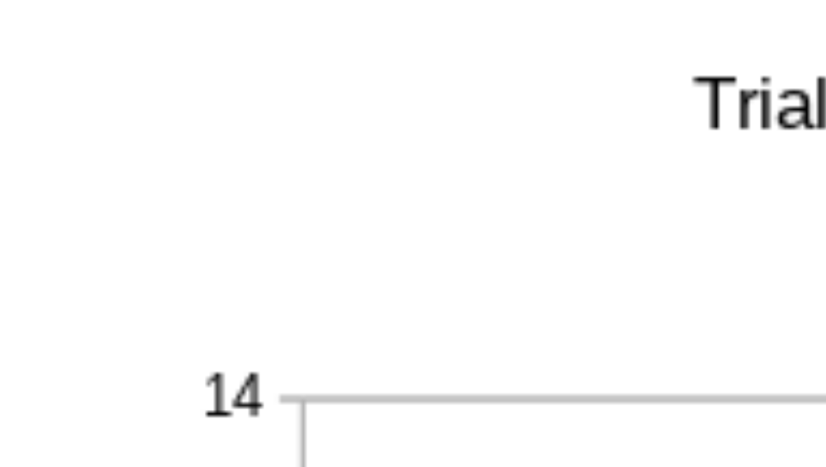
Beam outperformed A* by a significant amount, with little difference in result given a beam
of size 8 and 16. A slight penalty was observed for the beam size of 4, however this could be
due to natural variation. A* lagged, and my conjecture is that the amount of potential
nodes to be evaluated prevented a path in any specific direction from taking root without
more nodes. The h1 algorithm was the most reliable overall. but also showed
improvement given a larger amount of nodes. The greater amount of nodes, the more likely
the algorithms to find a solution. Simply, they are allowed to look at more states, so the amount
of correct states found increases,

H2 is the more powerful of the two heuristics. While h1 only accounts for misplaced tiles, h2
accounts for both this as well as the distance from tile origin to destination. In this way, it is
more robust and can better show distance from start state to goal state.

H1 has the shortest paths because it searches states that are potentially out of the way
while the h2 heuristic prioritizes constant motion towards the goal state regardless of cost.
As far as h2 versions, a* does take path size into account and will have a lower path size
than beam, which does not consider path size when moving.

Beam: Average 52% [93/180]
A* [h1]: Average 3% [2/60]
A* [h2]: Average 22% [13/60]

Discussion
Beam seems to be the algorithm best suited to this problem. While A* does minimize path
length, I found that the amount of nodes required for A* to catch up to the success rate of
beam is larger than my computer could compute in a reasonable amount of time. The amount
of nodes that have to be evaluated grows too quickly, as it is not limited like in beam. Beam
has superior space management limiting the amount of states that can be evaluated, it also
has a leg up in speed through rushing a depth first solution rather than the breath based A*
implementation. So with the advantage in this situation being speed of evaluation, beam
is best suited to the task.

I observed that there was a limit to the maximum amount of nodes to be evaluated as a function
of how long it took my computer to sort through the evaluation list. This affected both
algorithms as they both look to see if the state is unique, but because A* also sorts the entirety
of unevaluated nodes at the end of every move set, A*'s running time expands quickest.
As discussed earlier, issues coding stemmed from a learning experience revolving around
how go handles slices and arrays, as well as pointer errors to be expected when coding
in a new language. I expected A* to perform better, and would expect that if I was using
a more powerful machine, that it would function as the more optimal algorithm, as it would
be less affected by this time complexity expansion.

Extra Credit
For the extra credit, I created a new puzzle object like the 8 puzzle, but instead of being
3x3, it is 3x4, three wide four across. It reuses the search algorithms with no changes to the
code, and can be ran with the commands:
go run extraCredit.go h1test
go run extraCredit.go h2test
go run extraCredut.go beamtest

NOTE
export $GOPATH to project folder with export GOPATH=/path/to/project1
no executables included with this assignment
please build all programs with go build [program].go
programs include:
projectOne.go
extraCredit.go

