Linux sysctl Network Hardening Lab Report

Objective
The purpose of this lab was to explore how Linux kernel parameters can affect network behavior and improve security. Using the sysctl utility, ICMP settings were modified to observe how Linux responds to ping requests before and after hardening.
The lab also involved capturing and analyzing network packets using tshark and Wireshark.

Lab Environment
The lab environment was created using Oracle VirtualBox with two Ubuntu virtual machines that were already available from previous assignments.

Virtual Machines Used
VM Name | Purpose
Ubuntu-client | Traffic generator and packet capture
Ubuntu-server | Target system for sysctl hardening
Both systems were connected using the same NAT Network in VirtualBox.

Step 1 — Installing tshark
The tshark packet analysis tool was installed on the client VM to capture network traffic.

Command Used
sudo apt update
sudo apt install tshark -y
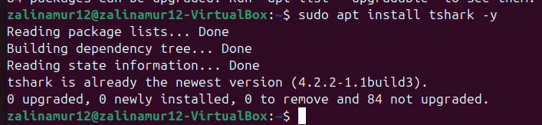

Step 2 — Capturing Baseline Traffic Before Hardening
Before making any security changes, ICMP traffic was captured to observe the normal network behavior between the client and server systems.

Starting Packet Capture
sudo tshark -i enp0s3 -w /tmp/before_sysctl.pcap

Normal Ping Test
ping -c 20 10.0.2.15

Broadcast Ping Test
sudo ping -b -c 20 10.0.2.255
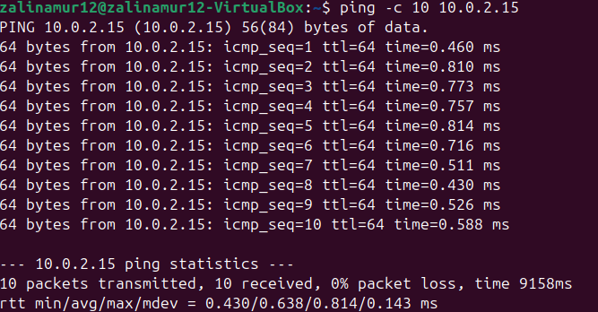
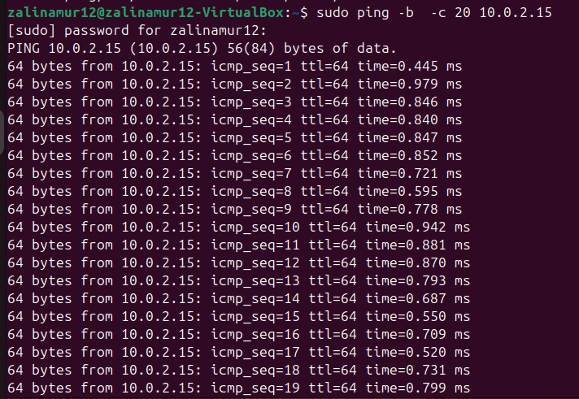

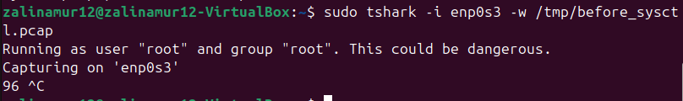

Step 3 — Applying sysctl Hardening
The server system was hardened by modifying Linux kernel networking parameters inside /etc/sysctl.conf.

File Edited
sudo nano /etc/sysctl.conf

Parameters Added
net.ipv4.icmp_echo_ignore_broadcasts = 1
net.ipv4.icmp_echo_ignore_all = 1
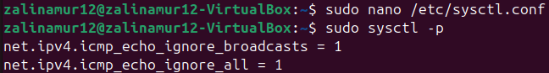

Applying the Changes
sudo sysctl -p
These settings configured the Linux kernel to ignore ICMP echo requests, including broadcast requests.

Step 4 — Capturing Traffic After Hardening
After applying the sysctl hardening settings, traffic was captured again to compare behavior before and after security changes.

Starting Packet Capture
sudo tshark -i enp0s3 -w /tmp/after_sysctl.pcap

Repeating Ping Test
ping -c 20 10.0.2.15

Repeating Broadcast Ping Test
sudo ping -b -c 20 10.0.2.255
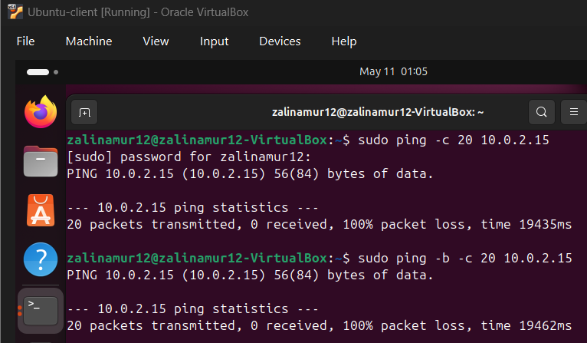
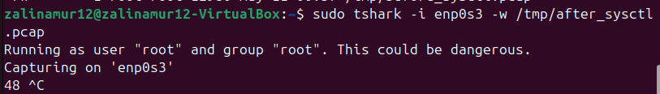

Step 5 — Wireshark Analysis
The .pcap files were opened using Wireshark for packet analysis.

Wireshark Filter Used
icmp

Before Hardening Analysis
Before hardening, ICMP Echo Requests and Echo Replies were visible between the client and server systems.
This demonstrated that the Ubuntu server responded normally to ICMP traffic.
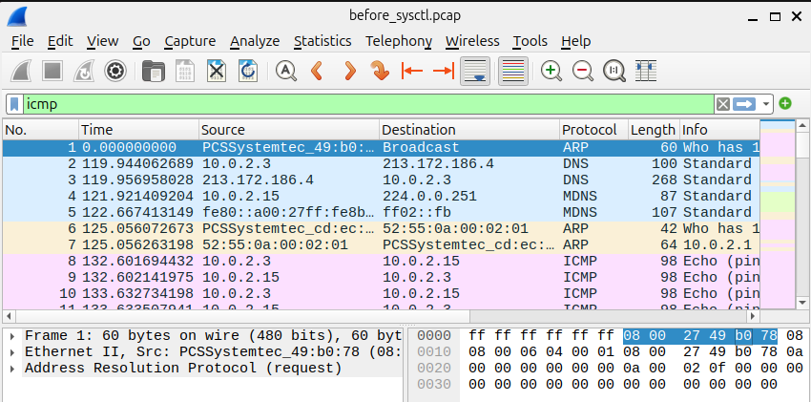

After Hardening Analysis
After hardening, ICMP Echo Requests could still be seen in Wireshark, but the Echo Replies were no longer present.
This confirmed that the sysctl settings successfully prevented the server from responding to ICMP requests.
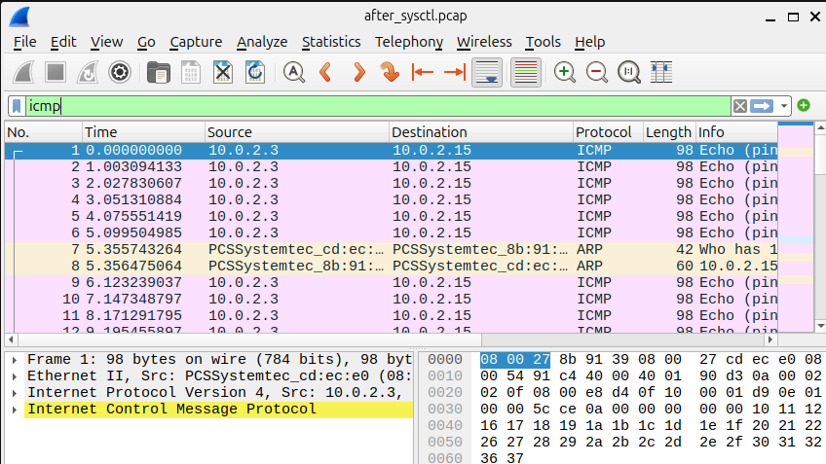

Questions:

1. What is sysctl?
sysctl is a Linux utility used to view and modify kernel parameters at runtime. It allows to tune networking, memory management, and security settings without rebooting the system.
The /etc/sysctl.conf file stores persistent kernel parameters that are automatically applied during system startup.

2. What is a Smurf Attack?
A Smurf attack is a Distributed Denial-of-Service (DDoS) attack that abuses ICMP broadcast traffic.
In a Smurf attack, an attacker sends ICMP Echo Requests to a broadcast address while spoofing the victim's IP address. All systems on the network reply to the victim simultaneously, overwhelming the victim system with traffic.

3. Why Were ICMP Replies Missing After Hardening?
The ICMP replies disappeared because the Linux kernel was configured to ignore ICMP Echo Requests using the following parameters:
net.ipv4.icmp_echo_ignore_broadcasts = 1
net.ipv4.icmp_echo_ignore_all = 1
These settings prevented the Ubuntu server from replying to ICMP requests, reducing vulnerability to ICMP amplification and Smurf attacks.

Challenges Encountered
During the lab, a few technical issues were encountered while working with tshark and VirtualBox.
Permission errors occurred when saving .pcap files, which was solved by saving the captures in the /tmp directory and changing file permissions afterward.

Conclusion
This lab successfully demonstrated how Linux sysctl settings can change network behavior and improve system security.
After modifying the ICMP-related kernel parameters, the Ubuntu server stopped responding to ping requests. The difference between the system behavior before and after hardening was clearly visible through packet captures and Wireshark analysis.
The lab provided practical experience with:
- Linux system hardening
- sysctl kernel tuning
- ICMP traffic analysis
- tshark packet capturing
- Wireshark network analysis
- VirtualBox networking
The assignment showed how Linux security hardening can reduce exposure to ICMP-based attacks such as Smurf attacks.

