IPSec VPN Lab
Gateway-to-Gateway Tunnel with IKEv2 and Certificate-Based Authentication
VirtualBox · Ubuntu 24.04.4 LTS · strongSwan · OpenSSL PKI · tshark

Phase 1 — VirtualBox VM & Network Setup
Two virtual machines were created in Oracle VirtualBox to simulate a gateway-to-gateway VPN scenario. Both VMs were initially configured with a NAT adapter to allow internet access during the installation phase.

Step 1.1 — Creating VM A (GatewayA)
A new VM was created in VirtualBox with the Ubuntu 24.04.4 Server ISO attached.
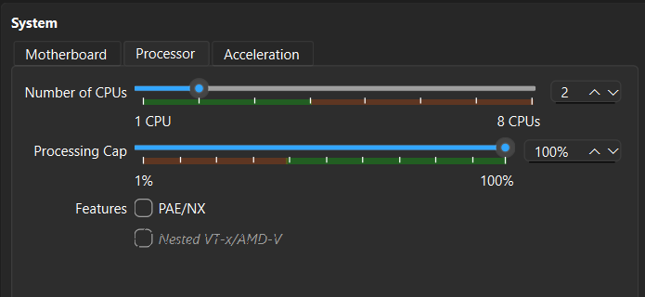
Hardware settings used:
- RAM: 2048 MB
- CPUs: 2
- Disk: 25 GB (VDI, dynamically allocated)
- Network Adapter 1: NAT (temporary, for package installation)
Step 1.2 — Creating VM B (GatewayB)
VM B was created as a full clone of VM A after completing the installation and package setup on VM A. New MAC addresses were generated during the clone to avoid network conflicts.
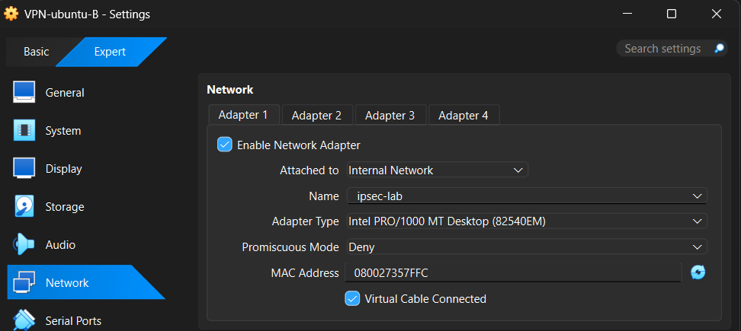

Phase 2 — Package Installation
All required packages were installed while the VM was still on NAT (internet access). This step had to be done before switching to Internal Network, as there would be no internet route afterwards.

The following command was used to install everything in one go:
sudo apt update && sudo apt upgrade -y
sudo apt install -y openssh-server strongswan strongswan-pki libcharon-extra-plugins
sudo apt install -y libstrongswan-extra-plugins strongswan-swanctl charon-systemd openssl tshark

During the tshark install, the prompt 'Should non-superusers be able to capture packets?' was answered Yes.

Installation was verified with:
swanctl --version
openssl version
tshark --version

Phase 3 — Static IP Configuration
After cloning VM B and powering both VMs off, the network adapter on each was switched from NAT to VirtualBox Internal Network, using the same network name on both so they could communicate.

- Attached to: Internal Network
- Network name: ipsec-lab (identical on both VMs)

Step 3.1 — Netplan Configuration — VM A
The existing Netplan file was edited to assign a static IP to VM A:
sudo nano /etc/netplan/50-cloud-init.yaml

Contents set to:
network:
version: 2
ethernets:
enp0s3:
dhcp4: no
addresses:
- 192.168.100.1/24
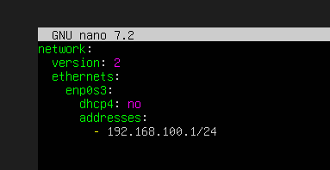
Cloud-init was disabled from overwriting the config on reboot:
sudo bash -c 'echo "network: {config: disabled}" > /etc/cloud/cloud.cfg.d/99-disable-network-config.cfg'
sudo netplan apply
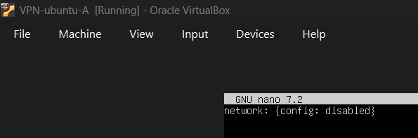
Step 3.2 — Netplan Configuration — VM B
The same process was repeated on VM B, using IP address 192.168.100.2/24.
Step 3.3 — Connectivity Test
Ping was used to confirm both VMs could reach each other before proceeding with the IPSec configuration.
ping -c 4 192.168.100.2
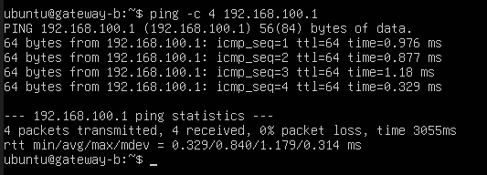

Phase 4 — PKI with OpenSSL
A simple PKI was built on VM A using OpenSSL with Ed25519 keys. This included a root CA, and individual certificates for each gateway. All certificate work was done on VM A, then the relevant files were copied to VM B.

Step 4.1 — Directory Structure
mkdir -p ~/pki/{ca,certs,private}
chmod 700 ~/pki/private

Step 4.2 — Root CA Key and Certificate
openssl genpkey -algorithm ED25519 -out ~/pki/private/ca.key
openssl req -x509 -new -nodes -key ~/pki/private/ca.key -sha256 -days 3650 -out ~/pki/ca/ca.crt -subj "/CN=IPSec-Lab-CA/O=Lab/C=PL"

Step 4.3 — Gateway A Certificate
A private key, CSR, and signed certificate were created for VM A. The Subject Alternative Name (SAN) was set to the VM's IP address, which is required by strongSwan for identity matching.
openssl genpkey -algorithm ED25519 -out ~/pki/private/gw-a.key
openssl req -new -key ~/pki/private/gw-a.key -out ~/pki/certs/gw-a.csr -subj "/CN=192.168.100.1/O=Lab/C=PL"
openssl x509 -req -in ~/pki/certs/gw-a.csr -CA ~/pki/ca/ca.crt -CAkey ~/pki/private/ca.key -CAcreateserial -out ~/pki/certs/gw-a.crt -days 365 -extfile /tmp/gw-a-ext.cnf -extensions v3_req
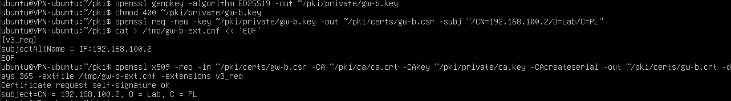
Step 4.4 — Gateway B Certificate
The same process was repeated for VM B (192.168.100.2).
Step 4.5 — Copying Files to VM B
The CA certificate, VM B's certificate, and VM B's private key were sent to VM B over SCP:
scp ~/pki/ca/ca.crt ubuntu@192.168.100.2:/tmp/ca.crt
scp ~/pki/certs/gw-b.crt ubuntu@192.168.100.2:/tmp/gw-b.crt
scp ~/pki/private/gw-b.key ubuntu@192.168.100.2:/tmp/gw-b.key
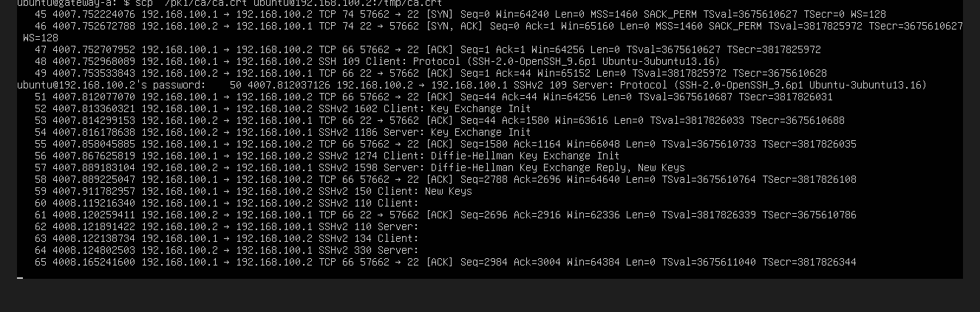

Phase 5 — strongSwan Configuration
Certificates were placed into the correct strongSwan directories on both VMs, and the swanctl.conf connection profiles were created.

Step 5.1 — Installing Certificates — VM A
sudo cp ~/pki/ca/ca.crt /etc/swanctl/x509ca/ca.crt
sudo cp ~/pki/certs/gw-a.crt /etc/swanctl/x509/gw-a.crt
sudo cp ~/pki/private/gw-a.key /etc/swanctl/private/gw-a.key
sudo chmod 600 /etc/swanctl/private/gw-a.key

Step 5.2 — Installing Certificates — VM B
sudo cp /tmp/ca.crt /etc/swanctl/x509ca/ca.crt
sudo cp /tmp/gw-b.crt /etc/swanctl/x509/gw-b.crt
sudo cp /tmp/gw-b.key /etc/swanctl/private/gw-b.key
sudo chmod 600 /etc/swanctl/private/gw-b.key

Step 5.3 — swanctl.conf — VM A
The connection profile for VM A defines the IKEv2 parameters, certificate identity, traffic selectors, and tunnel mode:
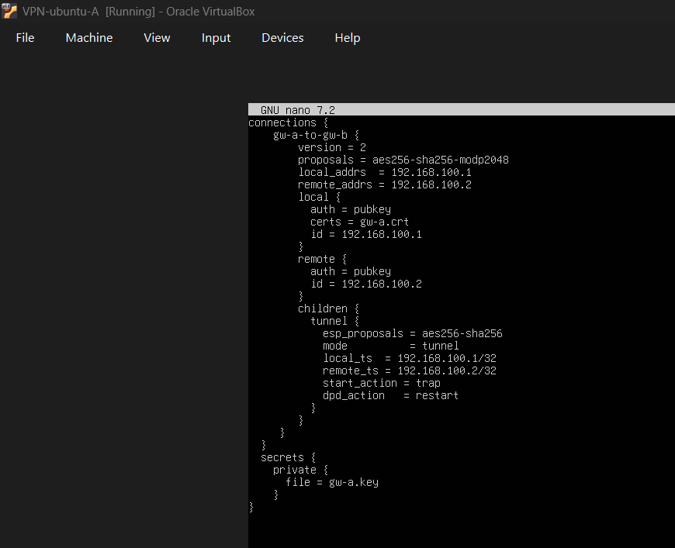
Step 5.4 — swanctl.conf — VM B
VM B's config mirrors VM A's but with local and remote addresses and traffic selectors swapped:

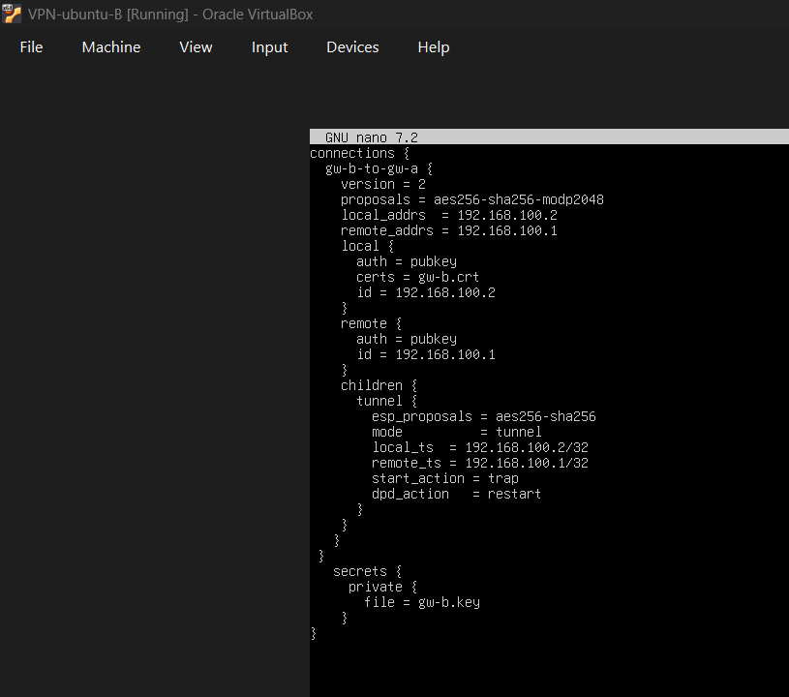

Phase 6 — Establishing the IPSec Tunnel

Step 6.1 — Starting strongSwan
The strongSwan services were enabled and started on both VMs:
sudo systemctl enable --now strongswan-starter
sudo systemctl enable --now strongswan
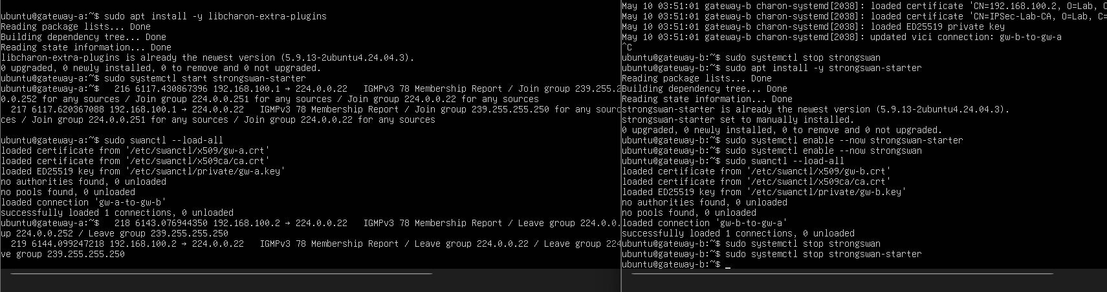
Step 6.2 — Loading Configuration
The swanctl configuration was loaded on both VMs. The output confirmed certificates and keys were read correctly:
sudo swanctl --load-all

Step 6.3 — Initiating the Tunnel
The tunnel was initiated from VM A. The output showed the full IKEv2 handshake completing successfully — IKE_SA_INIT and IKE_AUTH exchanges both succeeded, and the Child SA was installed:
sudo swanctl --initiate --child tunnel
] 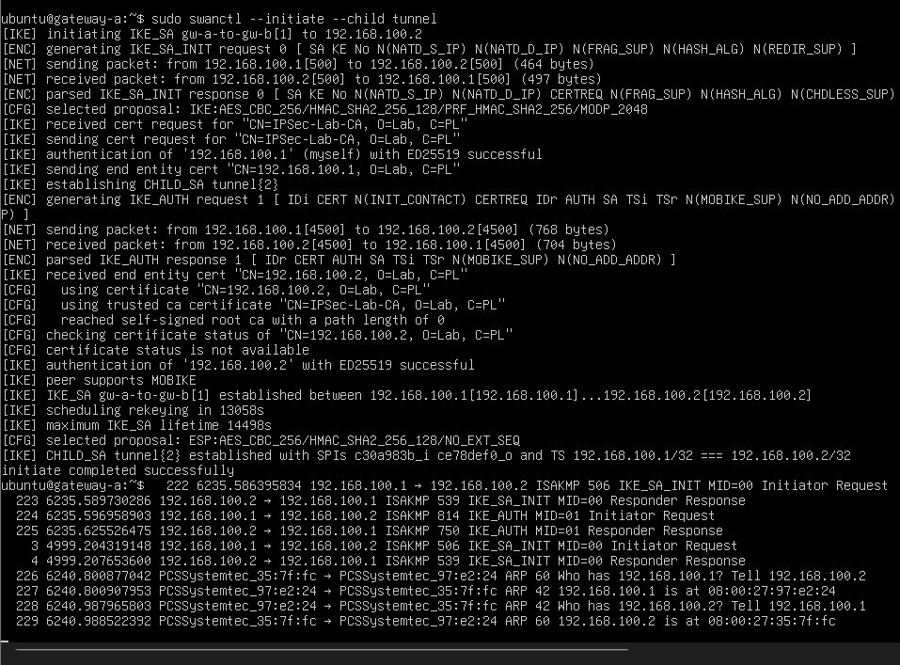

Step 6.4 — Verifying Tunnel Status
The tunnel status was confirmed using swanctl and the XFRM state database:
sudo swanctl --list-sas
sudo ip xfrm state
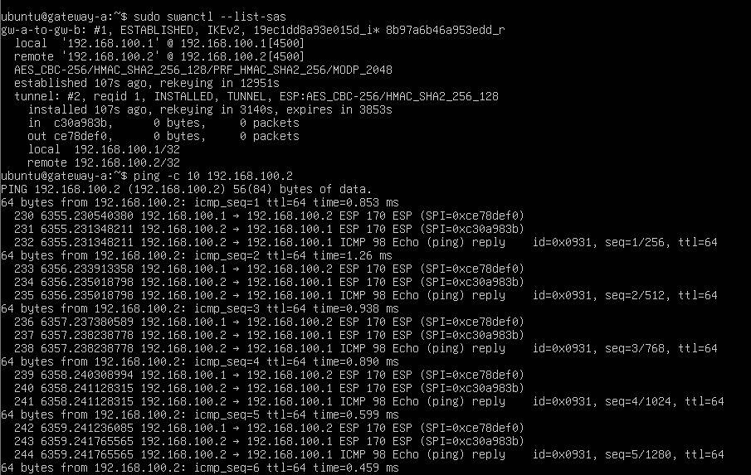
Step 6.5 — Sending Traffic Through the Tunnel
A ping was sent from VM A to VM B. The traffic was encrypted by ESP — visible in the tshark output as ESP packets rather than plaintext ICMP:
ping -c 10 192.168.100.2
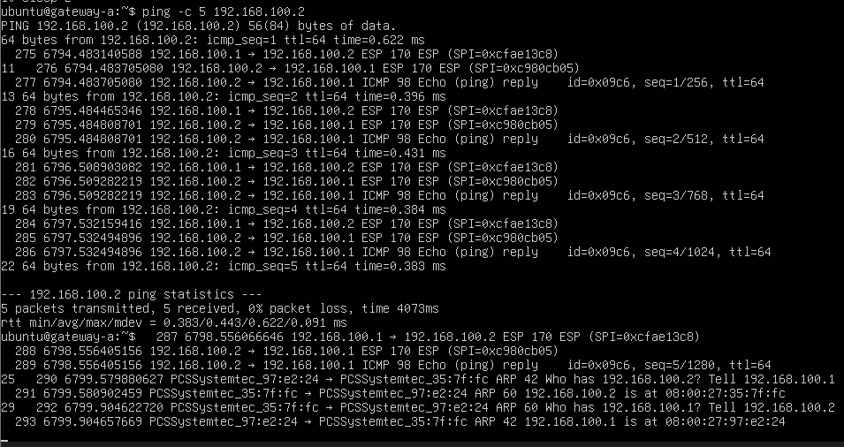

Phase 7 — Traffic Capture & Analysis

Step 7.1 — Capturing the Full IKE Handshake
The tunnel was torn down and a tshark capture was started before re-initiating, so the full IKE_SA_INIT and IKE_AUTH exchange could be captured from scratch:
sudo tshark -i enp0s3 -w /tmp/ipsec_full.pcap &
sudo swanctl --terminate --ike gw-a-to-gw-b
sudo swanctl --initiate --child tunnel
ping -c 5 192.168.100.2

Step 7.2 — IKE Traffic Analysis
IKE packets on UDP port 500 were filtered from the capture. Exchange type 34 = IKE_SA_INIT, exchange type 35 = IKE_AUTH:
sudo tshark -r /tmp/ipsec_full.pcap -Y 'udp.port == 500' -T fields -e frame.number -e ip.src -e ip.dst -e isakmp.exchangetype
Step 7.3 — ESP Traffic Analysis
ESP packets were filtered to show the encrypted data flow. The SPI values match those in the XFRM state table:
sudo tshark -r /tmp/ipsec_full.pcap -Y 'esp' -T fields -e frame.number -e ip.src -e ip.dst -e esp.spi -e esp.sequence
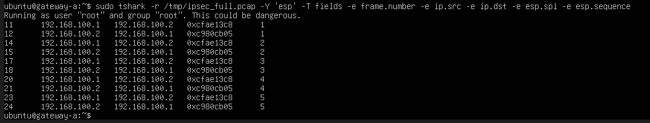
Step 7.4 — Protocol Hierarchy
The protocol hierarchy confirmed the presence of both ISAKMP (IKE) and ESP in the capture:
sudo tshark -r /tmp/ipsec_full.pcap -q -z io,phs
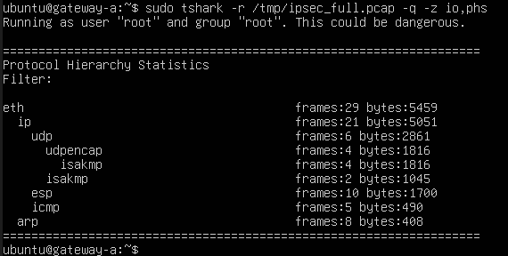

Phase 8 — PAD / SAD / SPD Correlation
The three IPSec databases were inspected and cross-referenced with the configuration and the packet capture.

PAD — Peer Authorization Database
The PAD is defined in swanctl.conf. The local and remote blocks specify who is trusted and how authentication is done:
cat /etc/swanctl/swanctl.conf
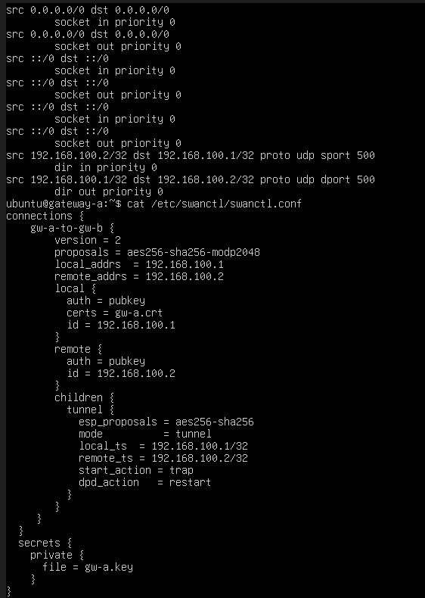
SAD — Security Association Database
The SAD holds the live cryptographic state negotiated by IKE — SPIs, algorithms, keys, and sequence numbers. Two entries exist: one per direction:
sudo ip xfrm state list
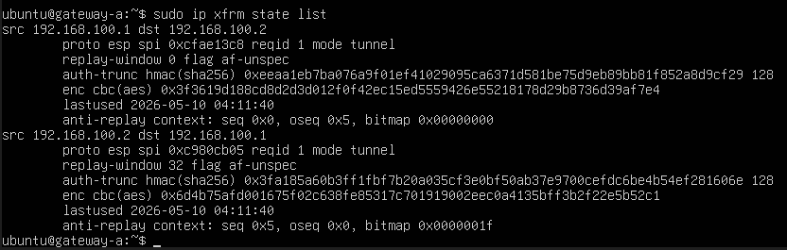
SPD — Security Policy Database
The SPD defines which traffic must be encrypted and how. The selectors here match the local_ts and remote_ts values from swanctl.conf:
sudo ip xfrm policy list
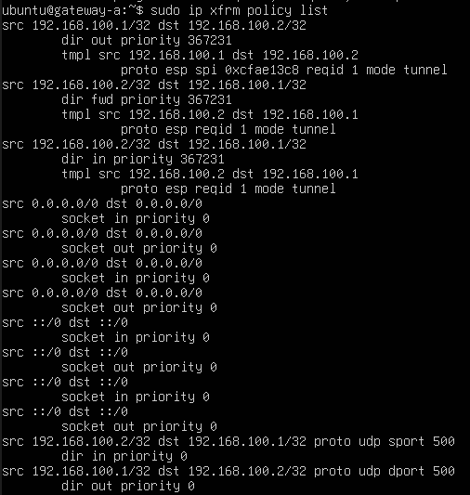

Summary

What is IPSec?
IPSec (Internet Protocol Security) is a suite of protocols used to secure IP communications by authenticating and encrypting each packet in a session. It operates at the network layer, which means it can protect any traffic regardless of the application above it. In this lab, IKEv2 (Internet Key Exchange version 2) was used for negotiating the security parameters, and ESP (Encapsulating Security Payload) was used for encrypting the actual data traffic.
The tunnel mode used here means that the entire original IP packet is encapsulated and encrypted inside a new packet — this is the classic gateway-to-gateway VPN setup, where two networks are connected securely over an untrusted link.

What Was Done
Two Ubuntu 24.04 virtual machines were configured as IPSec gateways using strongSwan. A PKI was built from scratch using OpenSSL with Ed25519 keys — a root CA was created, and individual certificates were issued for each gateway. The certificates were used for mutual authentication between the two gateways during the IKEv2 handshake. Once the tunnel was established, traffic between the two VMs was encrypted using AES-256 in CBC mode with SHA-256 for integrity.
The entire exchange was captured with tshark and analyzed — the IKE_SA_INIT messages were visible in plaintext (exchange type 34), while the IKE_AUTH exchange was encrypted (exchange type 35). All data traffic appeared only as ESP packets with no indication of the inner protocol.

Challenges
The most significant challenge in this lab was getting the IKE packets to actually leave VM A's network interface. Despite strongSwan reporting that packets were being sent, tshark on VM B showed nothing arriving on UDP port 500. After extensive troubleshooting, the issue turned out to be that charon-systemd was running without a socket implementation registered — meaning it was generating IKE packets internally but they were not being passed to the kernel's network stack.
The fix was enabling the strongswan-starter service alongside the main strongswan service, which correctly initialised the socket layer and allowed the IKE packets to reach the wire. Once that was resolved, the tunnel came up on the first attempt.
Other smaller challenges included a typo in VM B's swanctl.conf (remote_addrs written as 102.168.100.1 instead of 192.168.100.1), and ensuring cloud-init did not overwrite the static IP configuration on reboot.

Conclusion
The lab successfully demonstrated a fully functional gateway-to-gateway IPSec VPN using IKEv2 with certificate-based authentication. The setup covered the full lifecycle — PKI creation, certificate distribution, strongSwan configuration, tunnel establishment, traffic capture, and database inspection.
The key takeaway is how the three IPSec databases work together: the PAD (swanctl.conf) defines who is trusted, the SAD (ip xfrm state) holds the live cryptographic session, and the SPD (ip xfrm policy) enforces which traffic gets encrypted. Seeing this chain reflected in both the configuration files and the live kernel state — and then confirmed in the packet capture — makes the whole IPSec architecture much more understandable.

