At the end of April, for my dissertation I wanted to make a Minecraft/Vintage Story type of game but with dodecahedrons instead of cubes (since they are the next platonic solid shape in terms of complexity after the cube, ignoring the octahedrons because I think they look bad). During summer I started working on this idea and managed to make a function that would draw correctly spaced dodecahedrons in 32x32x32 chunks in Godot. (I wanted to learn a new game engine while doing my dissertation as well) After doing that, which took me about 1 month of intermittent work between vacations, I realized that this project would be too hard and complex to finish during a year filled with other assignments as well. Not to mention unrewarding since at the end of the day I’d have to design a fun game around my generated dodecahedron map which would’ve been a challenge in itself and the project would’ve probably end up incomplete which is not what a dissertation project should be like.
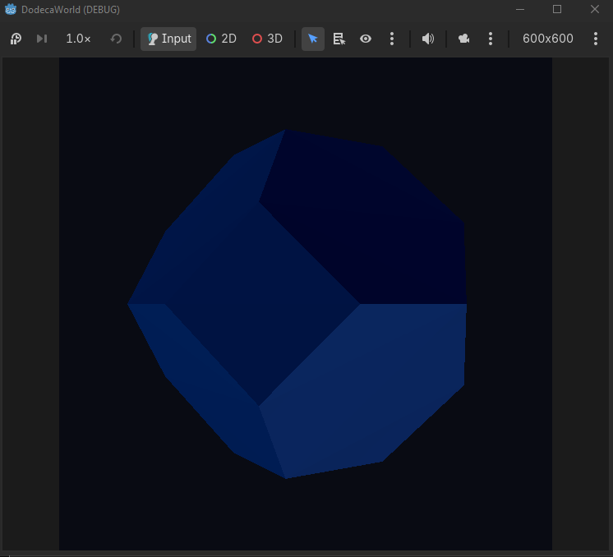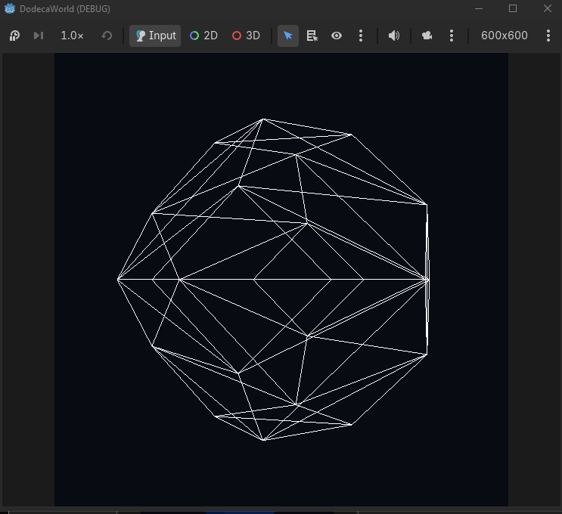
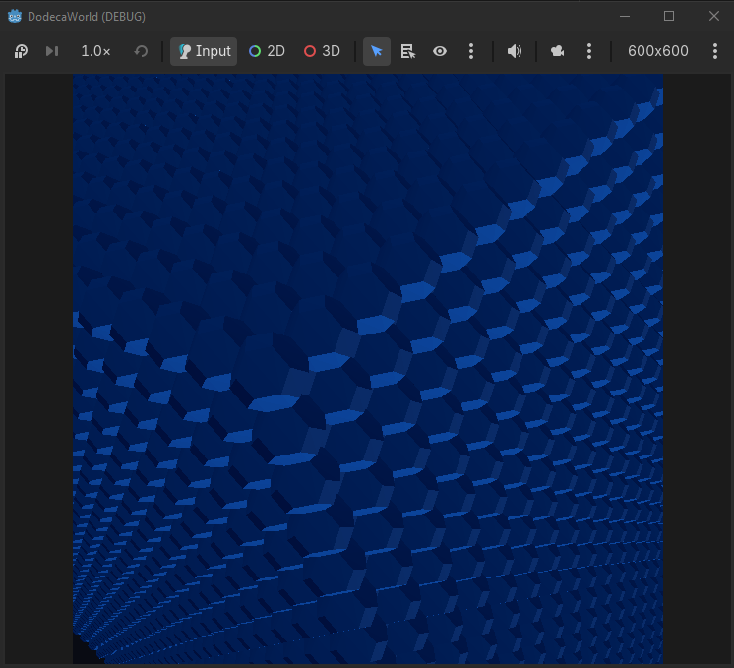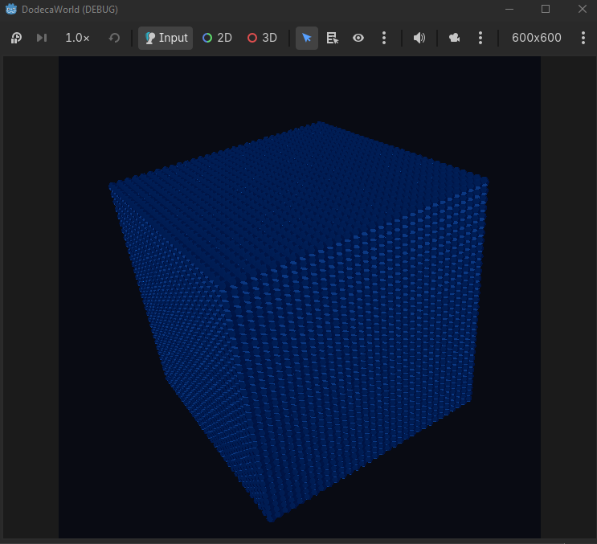
Therefore, I thought that the best idea would be to make an easy to complete game, that I could finish until the end of the year and spend the next one just playtesting and perfecting. An easy to complete game would have to be a game that I’d enjoy making, with low complexity and easy to jump into working on it without requiring a big context to add/change something. So, I came up with the idea of making an idle game, build up a storyline around it, and then turn it into a 2D/3D game by just linking its already existing functions and classes to other inputs and/or outputs. (while still having the base idle game as a backup in case I don’t manage to finish this transition)
Since I haven’t played many idle games before so I didn’t know what works and what doesn’t, and I was also quite unsure what I wanted my game to be exactly, I decided to play a few games in the genre to form a conclusion. I started with A Dark Room, then went on to Universal Paperclips, Kittens Game, Cookie Clicker, and Learn to Fly 3. During this time I realized I prefer the survival aspect and sense of progression of these games a lot more than just mindless “number go up over time”. And I also really liked the combat system in A Dark Room. So based on those observations, I concluded that the best course of action would be to make a role-playing survival, maybe survival-horror, idle game.
With these types of games I believe it would be best if I were to write down the entities I want my game to have in an Excell spreadsheet first, come up with a story line, perhaps add/change items based on the story requirements, then code the classes and functions for those entities. This way I think I could better visualise the bigger picture and plan ahead instead of starting to code and just add items, entities and mechanics as I go.
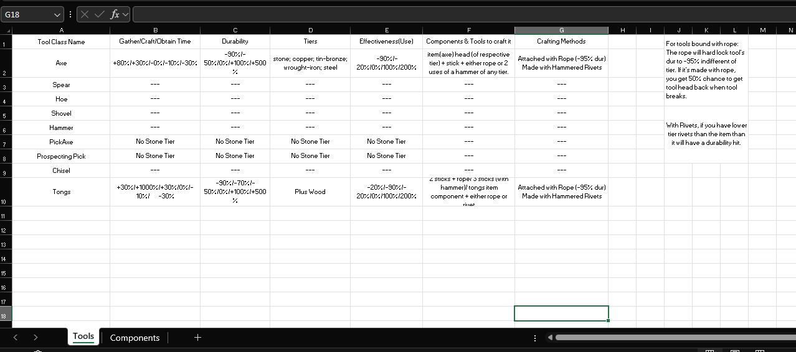
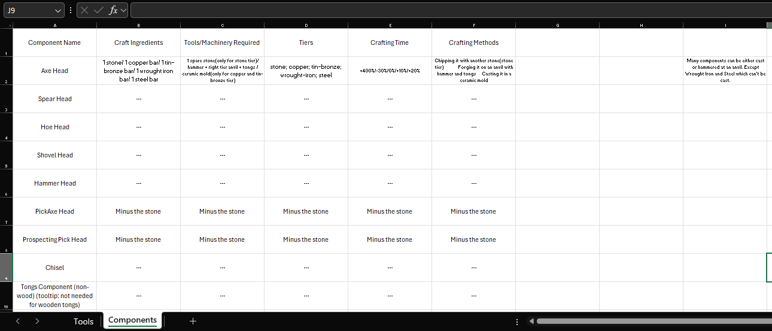

So far during this update I’ve made 2 Excell spreadsheets detailing a few tools and components my game will have, inspired mainly from Vintage Story, and I also made a very basic blog website with just a link to this update page, but the update page wasn’t started yet. Progress as of 04/October. Next up I plan(ned) to finish my first update page (11/Oct), add either a page or 2 to my Excell file or 20 or so entries with items, and play some story-driven survival games to get inspired for the story of this game.

