

Travel Mobile

|  |  |  |
| --- | --- | --- |
| **Supervisor:** | LÊ MỘNG THÚY | |
| **Semester:** | 2 | |
| **Batch No:** | T1.2008.A0 | |
| **Group No:** | 3 | |
| **Order:** | **Full name** | **Roll No.** |
| 1. | Nguyễn Ngọc Thiện | Student1275248 |
| 2. | Lê Nguyễn Thành Nhân | Student1277226 |
| 3. | Lê Hữu Tâm | Student1270662 |
| 4 | Phạm Quốc Toàn | Student1275028 |
| 5 | Phạm Viết Vương | Student1073134 |

**Month**: 07 **Year**: 2021



This is to certify that

|  |  |
| --- | --- |
| **Mr.** | **Nguyễn Ngọc Thiện** |
| **Mr.** | **Lê Nguyễn Thành Nhân** |
| **Mr.** | **Lê Hữu Tâm** |
| **Mr.** | **Phạm Quốc Toàn** |
| **Mr.** | **Phạm Viết Vương** |

Have successfully Designed & Developed

|  |  |  |
| --- | --- | --- |
|  |  |  |
| **Travel Mobile** | | |

Submitted by:

|  |
| --- |
| **Mr. LE MONG THUY** |

Date of Issue:

|  |  |
| --- | --- |
|  |  |

Authorized Signature:

|  |  |
| --- | --- |
|  |  |

Contents

Acknowledge 4

Introduction 4

Project Objectives 5

Problem Definition 5

Data Processing 6

From user 6

Input 6

Output 6

From Admin 6

Input 6

Output 6

Customer Requirement Specification 7

Hardware/ Software Requirements 9

Hardware 9

Software 9

Site Map 10

Task Sheet review 1 11

Entity Relation Diagram 12

Data Flow Diagram 13

Wireframe 14

15

16

# Acknowledge

We would like to express our special thanks of gratitude to our teacher Le Mong Thuy as well as Aptech who gave us the opportunity to do this wonderful project. We are thankful for the opportunity to increase our knowledge and fortified our skills on the subject of website development. We acknowledge this project was designed to advance our future prospect.

# Introduction

Human transportation has always been an essential part of society. The emergence needs for hired self-driving car has been increasingly common with multiple outstanding benefits.

Developing countries such as Vietnam still facing huge cost of car ownership for the majority of population. Car rentals save us from the worries of maintenance fee and depreciation loss. If a person doesn’t need a car every day and they use one on special occasions only, then, it is best for them to just rent one so they will be saved from the burden of insurance fee and servicing. The comfort and freedom of traveling using rental car are benefits which can’t be found by using taxis or bus service.

Travel mobile makes it easier for user to find a car to rent. The web application is also a convenient system for car owner to list their vehicle for hired. Finally, backend interface for admin to control the data.

# Project Objectives

The objective of this program is a functional web application which meet the requirement of a simple to use, ease of access for a user to find available vehicle for rent, registering vehicle and the capability for business to administer the system.

# Problem Definition

The www.travelmobile.com website is built for two main groups: the visitor & the administrator. Features for each group are listed as the following:

From the view point of visitors:

* Home page must be including a search box to ‘find a car’ along with starting date and ending date
* A menu that will include all the functions implemented in the website
* User can rent vehicle, view past rental after login their account
* Car owner can register vehicle, manage vehicle availability schedule and its status.

From the view point of administrator:

* A login page will grant access to dashboard & control panel
* Admin can view, add, update and delete rental vehicles
* Admin can view, add, update, delete, block & unblock user accounts
* Admin can manage blog articles

The web application is to be developed for the Windows Platform using Laravel. The app should work well in other operating system and all leading browsers including Chrome, IE, Firefox etc.

# Data Processing

## From user

### Input

* Register account on Travel Mobile, login to be able to book vehicle
* Register vehicle to display them on the webpage

### Output

Receive notification of:

* Successful logging in or successful register new account.
* Invalid register input (validator)
* Email notification of booking & booking request

## From Admin

### Input

* Able to view. add, edit, delete vehicle, user account, news blog

### Output

* Receive feedback (via mail)

# Customer Requirement Specification

The Web application is to be created for car rental service business based on the following requirements.

1. Home page must be designed by including a search box to ‘find a car’ along with starting date and ending date. Displaying a small list of most popular rental vehicle
2. A page displaying list of cars when user click the button find a car from homepage. The list car is displaying in a grid including images, brand, model, rental price, trips count, transmission, fuel type.

Filtering system to narrow choices down to user preference such as brand, type of vehicle, rental price sorting, transmission.

1. A car profile page for every single vehicle listed for hired on this website.

* Multiple images showing what the car looks like.
* Details of vehicle (transmission, fuel type, GPS, camera).
* Details of rental cost and any other fees calculation.
* Details of requirement to pick up the vehicle from owner.
* Confirmation page should user decide to book the car.

1. Login & registering account system.

* User should be able to view their profile, changing and update their credentials (password, driver license, contact details).

1. Registering vehicle

* Car owner have the option to register their vehicle with the website
* Car owner should be able to see their vehicles status and the calendar management system.

1. Backend system for administration

* Database
* Management system of registered vehicles
* Management system of registered user account
* Revenue record from rental contracts
* Website traffic count
* Management system of blog articles

1. Notification system

* Renter & car owner receive email notification relevant to booking status.

1. General policy pages provide details on how the system work.

* Responsibility of renter and car owner, responsibility of travel mobile in case of stolen vehicle, inappropriate or illegal use of vehicle or in the case of accident.
* Cancel booking policy, pricing policy, payment policy, car deliver policy

Questions & answer pages with content submit by user are saved and capable to search by query.

1. Look and feel must be made user friendly.
2. Uniformity and Navigation must be made smooth throughout the website.
3. The “Contact Us” page should have the Address of the Company and the mail address which when clicked will invoke the local mail client from where they can send an email. Address of the Company should be displayed using Geolocation API (e.g. Google Maps.)

# Hardware/ Software Requirements

## Hardware

Web Server

Processor Intel Core I5 or higher.

Memory 4 GB RAM or greater.

Modem/ADSL Internet access is required.

Client

Processor Intel Core I3 or higher.

Memory 2 GB RAM or greater.

Monitor Super VGA (1024x768) or higher resolution.

Modem/ADSL Internet access is required.

## Software

Web Server

Operation System Window 7 or later.

Browser Google Chrome

Database MySQL.

Software PHP - Laravel framework

Client

Operation System Window 7 or later.

Browser Google Chrome

# Site Map

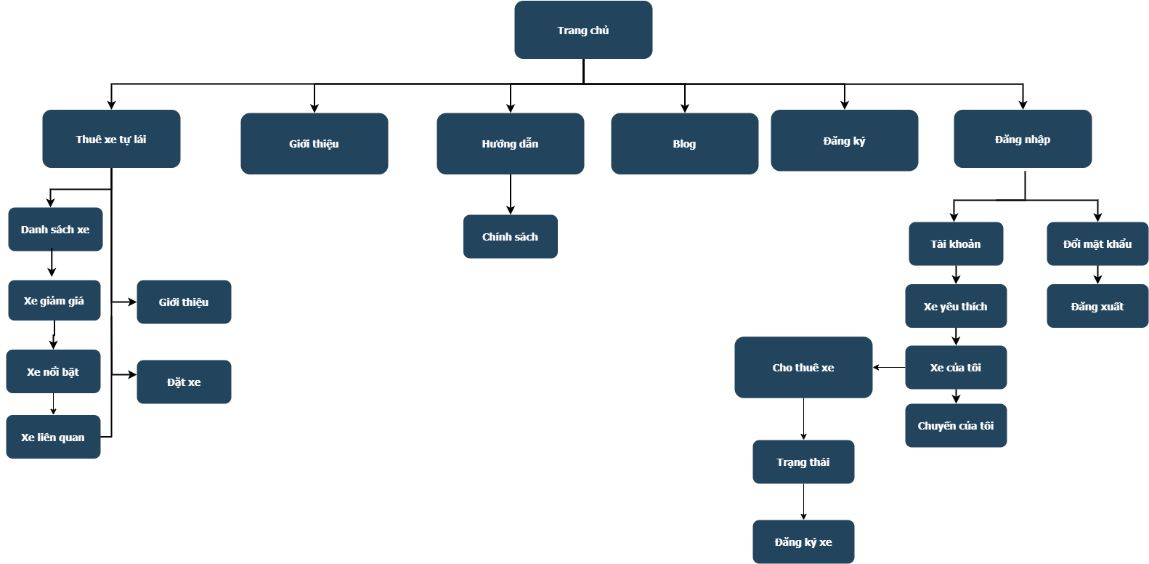

# Task Sheet review 1



# Entity Relation Diagram

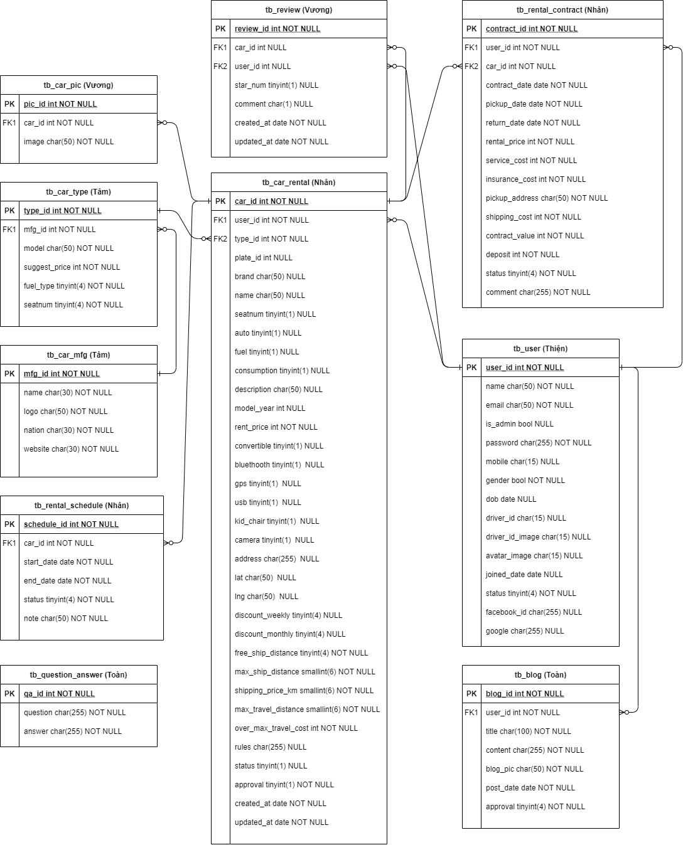

# Data Flow Diagram

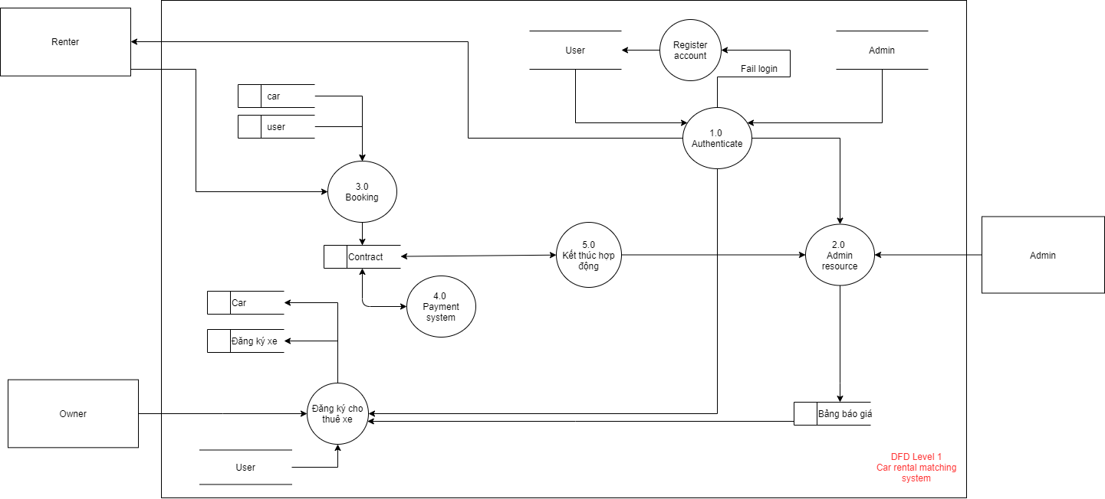

# Wireframe

# 

# 

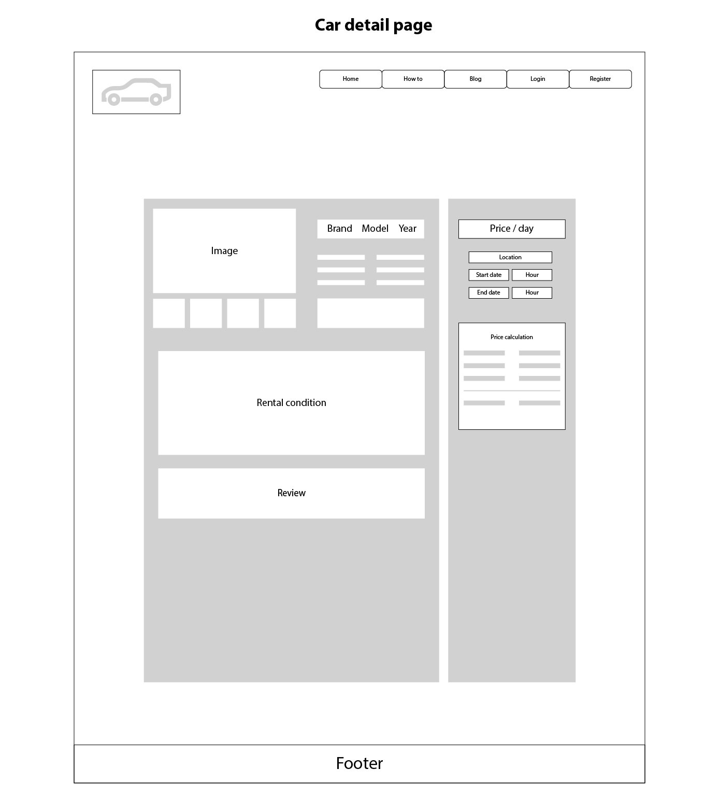

# Screenshot

Homepage

# 

Search for car page

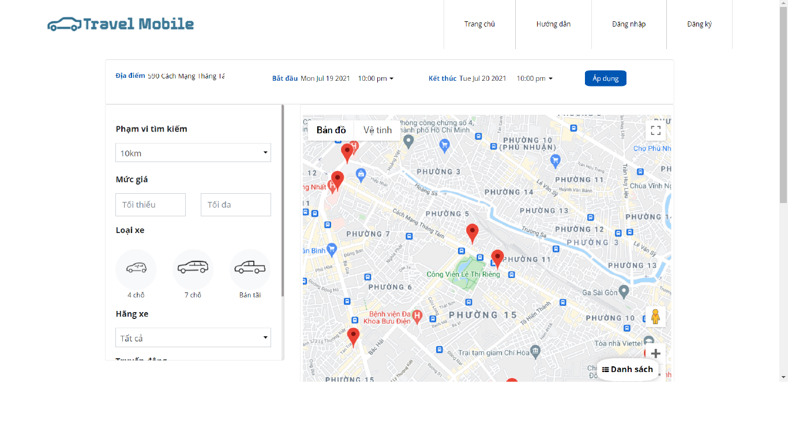Description: Open by pressing ‘search car’ from homepage

Search for car page (map version)

Description: turn on map view by pressing ‘map’ button from the page directly above

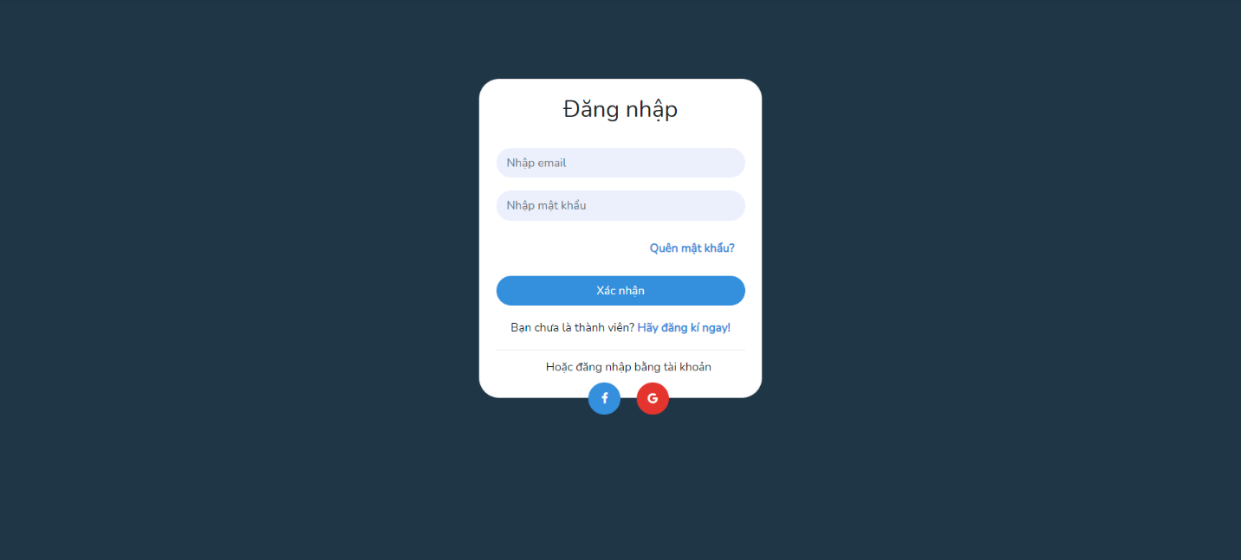

Login page

Description: open by pressing login from homepage top nav bar

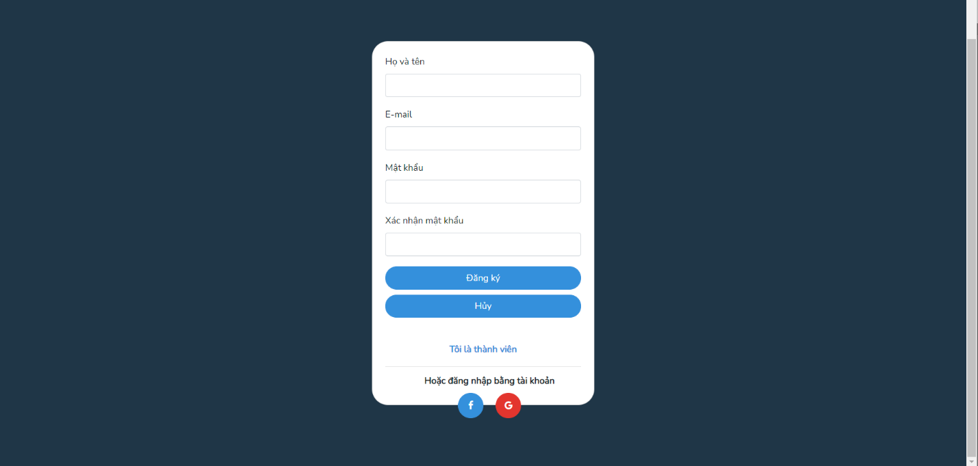

Register account page

Description: open by pressing ‘register’ from homepage top nav bar

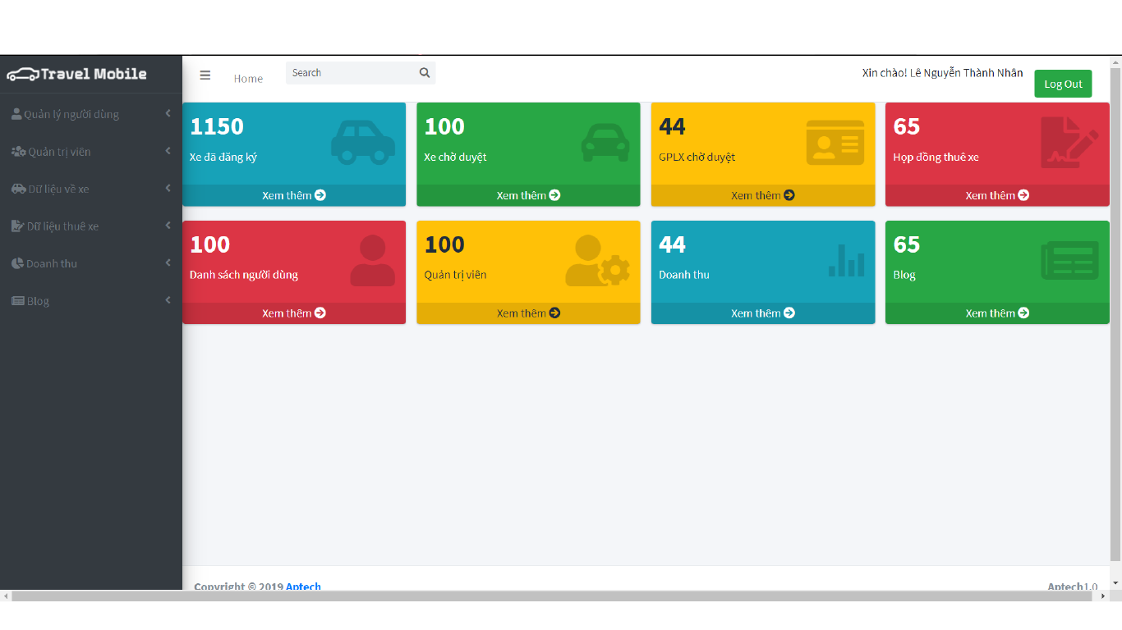

Admin index page

Description: open by login using user account with admin role

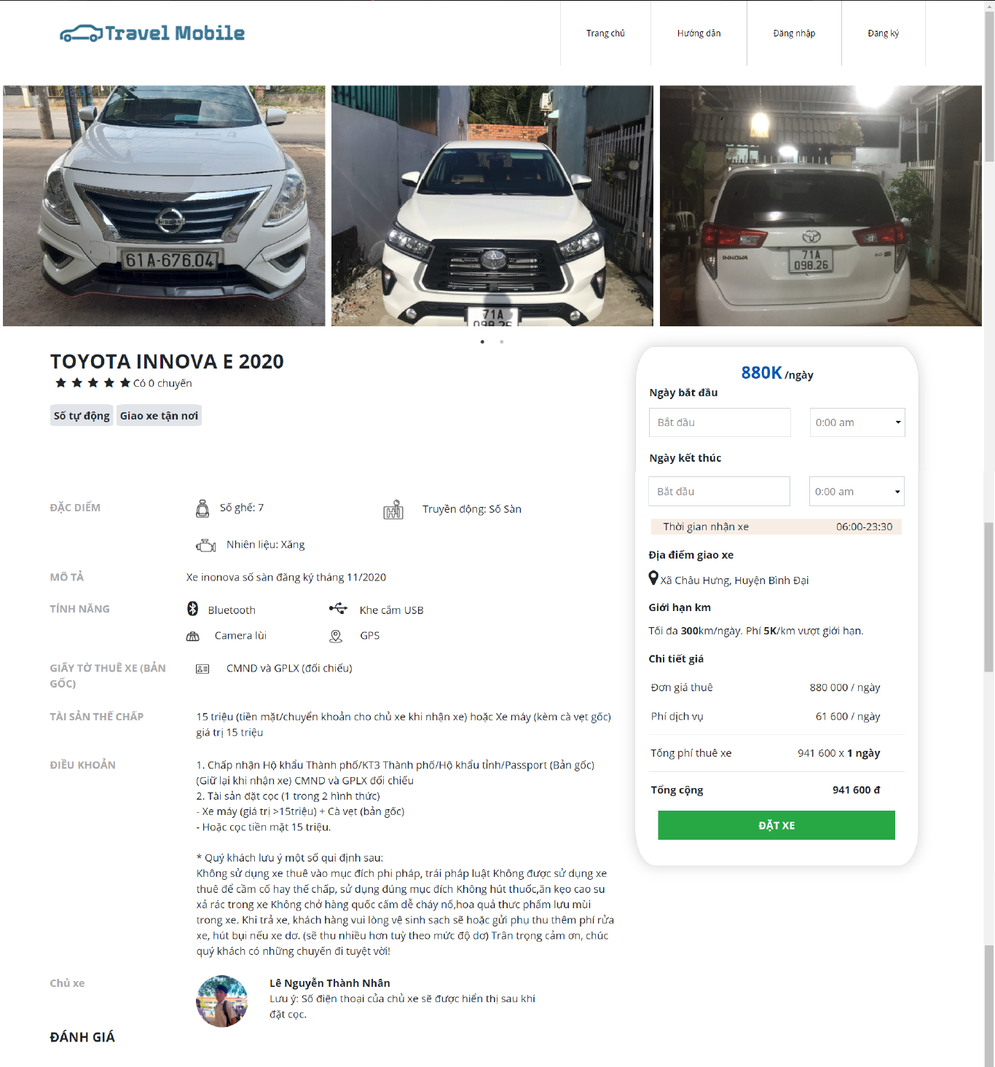

Car profile page

Description: open by choosing car from ‘search for car’ page

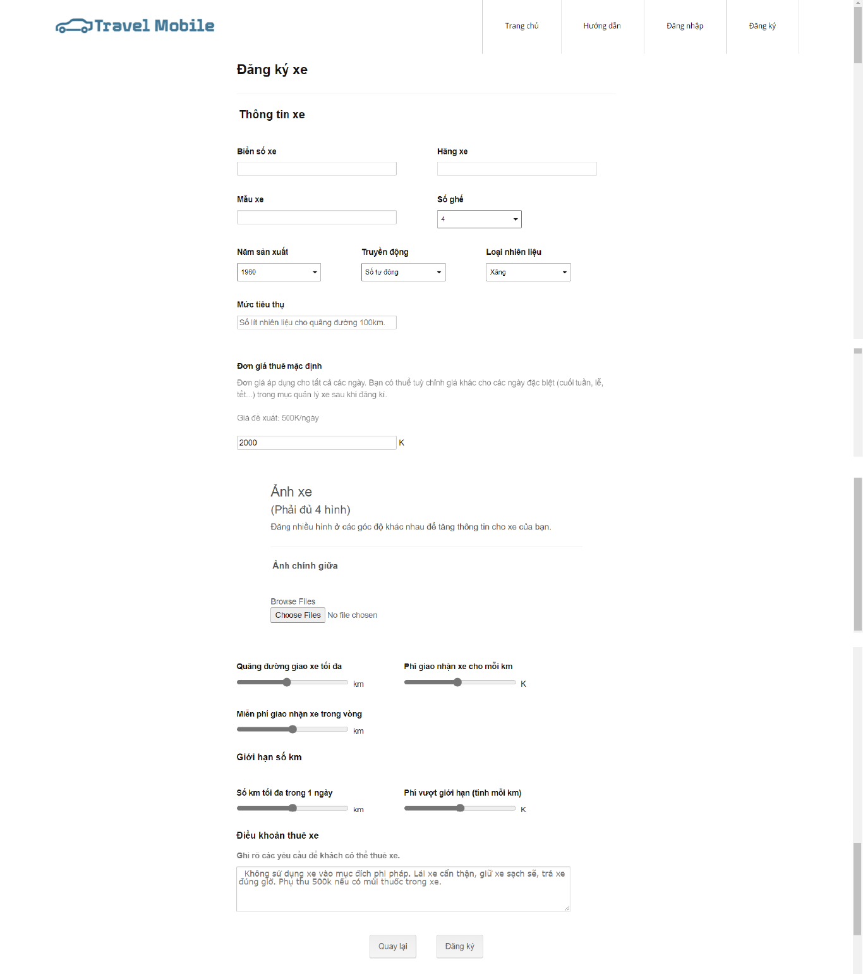

Car register page

Description: register car after login as user, the form is shared with updating car from back end.

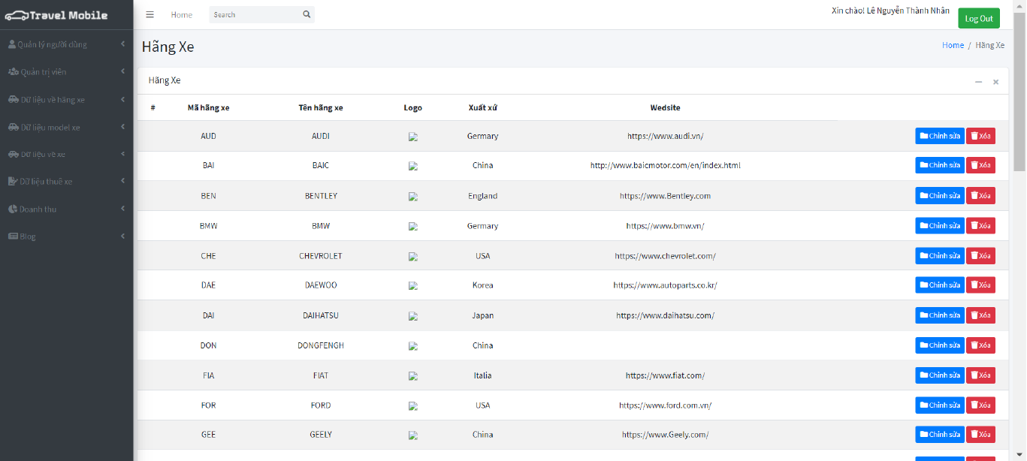

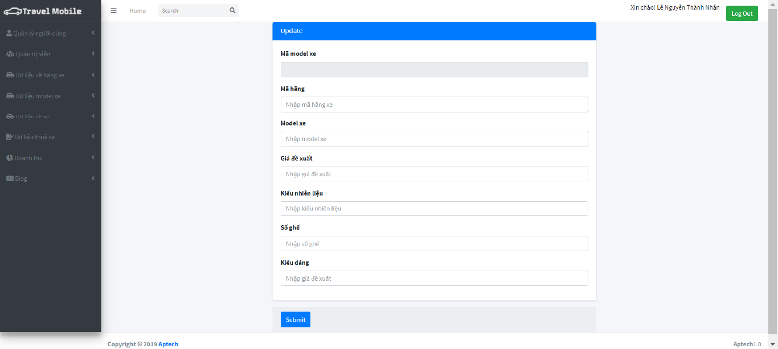

Manufacturer control panel backend

Description: Viewing by login as admin

Car profile page

Description: open by choosing car from ‘Search for car’ page

# Final checklist

|  |  |  |  |  |  |
| --- | --- | --- | --- | --- | --- |
| **No.** | **Features tested** | **Yes** | **No** | **N/A** | **Remarks** |
| 1 | Logo is on top left corner of the page | ✔ |  |  |  |
| 2 | Consistent layout | ✔ |  |  |  |
| 3 | Social login functioning | ✔ |  |  |  |
| 4 | Content is useful and relevant to audience | ✔ |  |  |  |
| 5 | Functionality adheres to user requirement | ✔ |  |  |  |
| 6 | Hyperlinks inside content are used to point to other relevant content | ✔ |  |  |  |
| 7 | All content has been spell-checked, grammatically correct | ✔ |  |  |  |

# Task Sheet