ZamNexus
Product Suite: Website Content
Connecting Intelligence. Enabling Action.
ZNXERP · ZNXePOS · ZNXEdu · ZNXCare
Each product page below includes a short overview and a Request a Demo call-to-action.

Our Products
Systems built for how each part of your business runs
Every ZNX product — ZNXERP, ZNXePOS, ZNXEdu and ZNXCare — is purpose-built for the operation it serves, yet shares the same intelligence, reliability and support behind it. Whichever team you're equipping, you get a system designed for that job, and a business that stays connected across all of them.
Explore Our Products→
URL: /Products



ZNXERP: Enterprise Resource Planning System
Run every part of your business on one intelligent platform.
ZNXERP is a full-scale Enterprise Resource Planning platform built for medium and large organizations that need to move fast without losing control. It unifies finance, HR, procurement, inventory, production, sales and quality control into one collaborative network, so every department and every customer, supplier and partner, works from the same accurate, real-time data.
From batch costing and formulation on the production floor to purchase orders, warehouse stock and profit-and-loss reporting in the boardroom, ZNXERP keeps the whole business connected and accountable. A dedicated MIS dashboard gives leadership a single window into sales, costs, losses and pending decisions, while built-in SMS alerts keep teams informed as things happen.
Trusted by manufacturers, pharmaceutical producers and service organizations including Grays Pharmaceutical, Lotus Pharmaceuticals, Panacea Pharmaceuticals, Khyber Textile Mills and the National Tariff Commission, ZNXERP deploys quickly and starts paying for itself fast.

Request a ZNXERP Demo

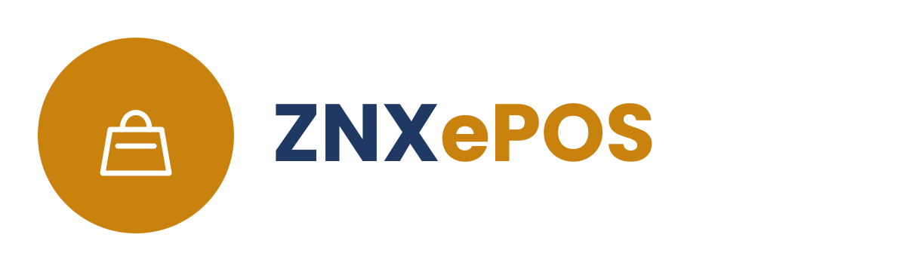

ZNXePOS: Point of Sale
Complete visibility of your retail or wholesale business, in a single click.
ZNXePOS, is a complete point-of-sale and business management system for retail and wholesale operations of any size. It brings sales, purchasing, stock, accounts, expenses and banking together in one place, so you always know exactly where your business stands, down to the profit or loss on a single item, invoice or customer.
Built-in ledgers track every supplier and client balance, credit limit and outstanding invoice automatically, while flexible discounting, barcode scanning and multi-terminal support keep the counter moving quickly. An optional mobile and web dashboard lets owners check sales, stock and cash position from anywhere, and an unlimited report writer turns daily transactions into the trends that matter.
More than 750 businesses already run on ZNXePOS.

Request a ZNXePOS Demo



ZNXEdu: Education System Manager
One system for every campus, classroom and conversation.
ZNXEdu is a complete education management system for schools, colleges, institutes and universities, covering everything from admissions to graduation in one platform. It manages student registration, fees, attendance, examinations and timetables alongside library, hostel, transport and HR administration, so academic and administrative teams work from the same up-to-date records.
A web and mobile portal keeps parents, students and teachers connected in real time, with progress, attendance, homework and fee status available at a glance, while an integrated SMS and chat system keeps the whole school community informed. Behind the scenes, built-in accounting, inventory and procurement systems give management full financial visibility across every campus.

Request a ZNXEdu Demo



ZNXCare: Patient Management Solution
The right information, for the right decision, at the right time.
ZNXCare is a patient management solution built for clinics, hospitals and health panels that need a complete, real-time view of every patient. It manages registration, admissions, billing, laboratory, pharmacy, X-ray and consultancy records in one connected system, with doctor information and prescriptions tied in throughout so nothing falls between departments.
Panel and corporate treatment records are handled automatically, payments and expenses are tracked as they happen, and a drill-down dashboard with Excel export gives management instant answers instead of end-of-month surprises. With full administrative controls for backup, user rights and data security, ZNXCare helps healthcare teams spend less time on paperwork and more time on patients.

Request a ZNXCare Demo

