ASP.NET Core Web API — Master-Details Exam Guide

Requirements Covered
- ASP.NET Core Web API tested from Postman
- EF Core — Code First
- Model classes with Data Annotations
- Custom authentication: Register + Login endpoints, ASP.NET Identity + hand-issued JWT
- [Authorize] protected endpoints (authorization)
- Student – Subject master-details CRUD, fully async
- Seeded Department relational data
- Data types: text, number, boolean, date, image, relational data
- Image upload from Postman using IFormFile

Final Files To Memorize
- Controllers/AccountController.cs
- Controllers/StudentsController.cs
- Data/SchoolDbContext.cs
- DTO/Dtos.cs
- Models/DbModels.cs
- Program.cs
- appsettings.json

Step 1 — NuGet Packages (install first)
NuGet Package Manager ▸ Manage NuGet Packages for Solution
Install-Package Microsoft.EntityFrameworkCore
Install-Package Microsoft.EntityFrameworkCore.SqlServer
Install-Package Microsoft.EntityFrameworkCore.Tools
Install-Package Microsoft.AspNetCore.Identity.EntityFrameworkCore
Install-Package Microsoft.AspNetCore.Authentication.JwtBearer

Step 2 — appsettings.json
"ConnectionStrings": {
"DefaultConnection": "Data Source=(LocalDB)\\MSSQLLocalDB; Initial Catalog=StudentExamCoreDB; Integrated Security=True; TrustServerCertificate=True"
},
"JWT": {
"Issuer": "StudentExamAPI",
"Audience": "StudentExamAPI",
"SigningKey": "ThisIsASecretExamSigningKey2026!"
}

Step 3 — Models/DbModels.cs
using Microsoft.AspNetCore.Identity;
using System.ComponentModel.DataAnnotations;

namespace StudentManagementSystemWebApi.Models;

public class ApiUser : IdentityUser { }

public class Department
{
public int Id { get; set; }

[Required, StringLength(50)]
public string Name { get; set; } = "";
}

public class Student
{
public int Id { get; set; }

[Required, StringLength(50)]
public string Name { get; set; } = "";

public DateTime Date { get; set; } = DateTime.Now;
public bool Activity { get; set; } = true;
public string? Image { get; set; }
public int DepartmentId { get; set; }

public Department? Department { get; set; }
public List<Subject> Subjects { get; set; } = [];
}

public class Subject
{
public int Id { get; set; }

[Required, StringLength(100)]
public string Course { get; set; } = "";

public int Credit { get; set; }
public int StudentId { get; set; }
}

Step 4 — Data/SchoolDbContext.cs
Base class changes from DbContext to IdentityDbContext<ApiUser> — that's what creates the AspNetUsers table. base.OnModelCreating(modelBuilder) must be called first or Identity's own table mappings never get built.
using Microsoft.AspNetCore.Identity.EntityFrameworkCore;
using Microsoft.EntityFrameworkCore;
using StudentManagementSystemWebApi.Models;

namespace StudentManagementSystemWebApi.Data;

public class SchoolDbContext(DbContextOptions<SchoolDbContext> options)
: IdentityDbContext<ApiUser>(options)
{
public DbSet<Department> Departments => Set<Department>();
public DbSet<Student> Students => Set<Student>();
public DbSet<Subject> Subjects => Set<Subject>();

protected override void OnModelCreating(ModelBuilder modelBuilder)
{
base.OnModelCreating(modelBuilder);

modelBuilder.Entity<Department>().HasData(
new Department { Id = 1, Name = "CSE" },
new Department { Id = 2, Name = "BBA" },
new Department { Id = 3, Name = "English" });
}
}

Step 5 — DTO/Dtos.cs
using System.ComponentModel.DataAnnotations;

namespace StudentManagementSystemWebApi.DTO;

public class RegisterDto
{
[Required]
public string UserName { get; set; } = "";

[Required, EmailAddress]
public string Email { get; set; } = "";

[Required]
public string Password { get; set; } = "";
}

public class LoginDto
{
[Required]
public string UserName { get; set; } = "";

[Required]
public string Password { get; set; } = "";
}

Step 6 — Program.cs
Adding Identity gives you UserManager<ApiUser>; Adding Authentication.JwtBearer makes [Authorize] understand Bearer tokens. app.UseAuthentication() must come before app.UseAuthorization().
using Microsoft.AspNetCore.Authentication.JwtBearer;
using Microsoft.AspNetCore.Identity;
using Microsoft.EntityFrameworkCore;
using Microsoft.IdentityModel.Tokens;
using StudentManagementSystemWebApi.Data;
using StudentManagementSystemWebApi.Models;
using System.Text;

var builder = WebApplication.CreateBuilder(args);

builder.Services.AddDbContext<SchoolDbContext>(options =>
options.UseSqlServer(
builder.Configuration.GetConnectionString("DefaultConnection")));

builder.Services.AddIdentity<ApiUser, IdentityRole>()
.AddEntityFrameworkStores<SchoolDbContext>();

builder.Services.AddAuthentication(options =>
{
options.DefaultAuthenticateScheme = JwtBearerDefaults.AuthenticationScheme;
options.DefaultChallengeScheme = JwtBearerDefaults.AuthenticationScheme;
options.DefaultScheme = JwtBearerDefaults.AuthenticationScheme;
})
.AddJwtBearer(options =>
{
options.TokenValidationParameters = new TokenValidationParameters
{
ValidateIssuer = true,
ValidIssuer = builder.Configuration["JWT:Issuer"],
ValidateAudience = true,
ValidAudience = builder.Configuration["JWT:Audience"],
ValidateIssuerSigningKey = true,
IssuerSigningKey = new SymmetricSecurityKey(
Encoding.UTF8.GetBytes(builder.Configuration["JWT:SigningKey"]!))
};
});

builder.Services.AddControllers();

var app = builder.Build();

if (app.Environment.WebRootPath == null) { app.Environment.WebRootPath = Path.Combine(app.Environment.ContentRootPath, "wwwroot"); }

Directory.CreateDirectory(Path.Combine(app.Environment.WebRootPath!, "images"));

app.UseStaticFiles();
app.UseAuthentication();
app.UseAuthorization();
app.MapControllers();

app.Run();

Step 7 — Controllers/AccountController.cs
Register creates a user through Identity; Login checks the password and hands back a signed JWT. Both actions are async — no manual ModelState check needed, [ApiController] already returns 400 automatically for invalid input.
using Microsoft.AspNetCore.Identity;
using Microsoft.AspNetCore.Mvc;
using Microsoft.IdentityModel.Tokens;
using StudentManagementSystemWebApi.DTO;
using StudentManagementSystemWebApi.Models;
using System.IdentityModel.Tokens.Jwt;
using System.Linq;
using System.Security.Claims;
using System.Text;

namespace StudentManagementSystemWebApi.Controllers;

[Route("api/[controller]")]
[ApiController]
public class AccountController(
UserManager<ApiUser> userManager, IConfiguration configuration) : ControllerBase
{
[HttpPost("register")]
public async Task<IActionResult> Register(RegisterDto dto)
{
var user = new ApiUser { UserName = dto.UserName, Email = dto.Email };
var result = await userManager.CreateAsync(user, dto.Password);

if (!result.Succeeded)
return BadRequest(result.Errors.Select(e => e.Description));

return StatusCode(201, $"User '{user.UserName}' created.");
}

[HttpPost("login")]
public async Task<IActionResult> Login(LoginDto dto)
{
var user = await userManager.FindByNameAsync(dto.UserName);
if (user == null || !await userManager.CheckPasswordAsync(user, dto.Password))
return Unauthorized("Invalid username or password");

var claims = new[] { new Claim(ClaimTypes.Name, user.UserName!) };
var key = new SymmetricSecurityKey(
Encoding.UTF8.GetBytes(configuration["JWT:SigningKey"]!));
var creds = new SigningCredentials(key, SecurityAlgorithms.HmacSha256);

var token = new JwtSecurityToken(
issuer: configuration["JWT:Issuer"],
audience: configuration["JWT:Audience"],
claims: claims,
expires: DateTime.UtcNow.AddHours(3),
signingCredentials: creds);

return Ok(new { token = new JwtSecurityTokenHandler().WriteToken(token) });
}
}

Step 8 — Controllers/StudentsController.cs
using Microsoft.AspNetCore.Authorization;
using Microsoft.AspNetCore.Mvc;
using Microsoft.EntityFrameworkCore;
using StudentManagementSystemWebApi.Data;
using StudentManagementSystemWebApi.Models;

namespace StudentManagementSystemWebApi.Controllers;

[Authorize]
[Route("api/[controller]")]
[ApiController]
public class StudentsController(
SchoolDbContext db, IWebHostEnvironment env) : ControllerBase
{
[HttpGet]
public async Task<IActionResult> Get() => Ok(await db.Students
.Include(s => s.Department)
.Include(s => s.Subjects)
.ToListAsync());

[HttpGet("{id}")]
public async Task<IActionResult> Get(int id)
{
var student = await db.Students
.Include(s => s.Department)
.Include(s => s.Subjects)
.FirstOrDefaultAsync(s => s.Id == id);

return student == null ? NotFound() : Ok(student);
}

[HttpPost]
public async Task<IActionResult> Post(Student student)
{
student.Id = 0;
student.Image = null;
student.Subjects.ForEach(s => s.Id = 0);

db.Students.Add(student);
await db.SaveChangesAsync();
return Ok(student);
}

[HttpPut("{id}")]
public async Task<IActionResult> Put(int id, Student model)
{
var student = await db.Students
.Include(s => s.Subjects)
.FirstOrDefaultAsync(s => s.Id == id);

if (student == null) return NotFound();

student.Name = model.Name;
student.Date = model.Date;
student.Activity = model.Activity;
student.DepartmentId = model.DepartmentId;

db.Subjects.RemoveRange(student.Subjects);
student.Subjects = model.Subjects;
student.Subjects.ForEach(s => s.Id = 0);

await db.SaveChangesAsync();
return Ok(student);
}

[HttpDelete("{id}")]
public async Task<IActionResult> Delete(int id)
{
var student = await db.Students.FindAsync(id);
if (student == null) return NotFound();

db.Students.Remove(student);
await db.SaveChangesAsync();
return NoContent();
}

[HttpPost("{id}/images")]
public async Task<IActionResult> UploadImage(int id, IFormFile file)
{
var student = await db.Students.FindAsync(id);
if (student == null) return NotFound();
if (file == null || file.Length == 0) return BadRequest("No file uploaded");

var fileName = $"{id}_{Guid.NewGuid()}{Path.GetExtension(file.FileName)}";
var path = Path.Combine(env.WebRootPath!, "images", fileName);

using var stream = System.IO.File.Create(path);
await file.CopyToAsync(stream);

student.Image = fileName;
await db.SaveChangesAsync();

return Ok(new { image = fileName });
}
}

Migration
Package Manager Console:
Add-Migration Initial
Update-Database

Because SchoolDbContext is now an IdentityDbContext, this migration creates the Identity tables too: AspNetUsers, AspNetRoles, AspNetUserRoles, AspNetUserClaims, AspNetUserLogins, AspNetUserTokens, AspNetRoleClaims, Departments, Students, Subjects

Postman Walkthrough

Run the project and find the port
Press F5 (or Dotnet run). Check the console output or Properties/launchSettings.json (make “launchBrowser” : true) for the actual port.

1. Register an account
POST {{baseUrl}}/api/account/register
{
"userName": "admin",
"email": "admin@test.com",
"password": "Admin@123"
}

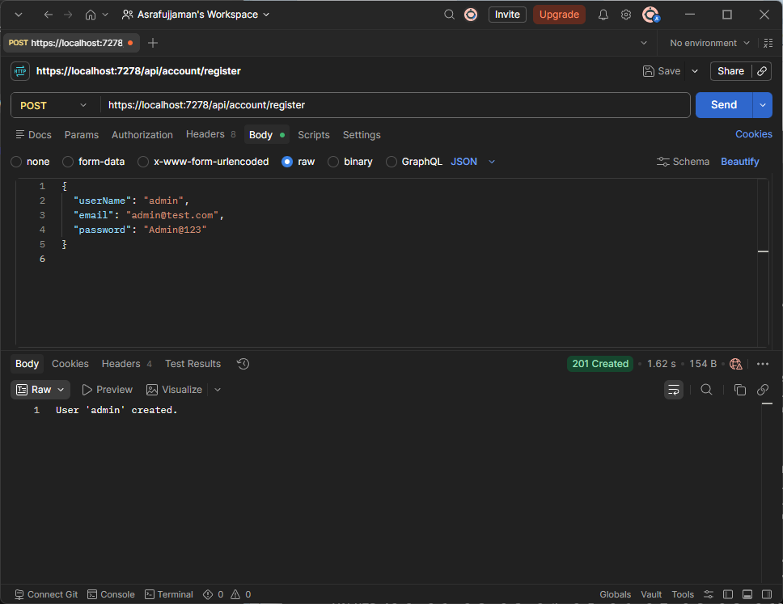

Response:
201 Created
User 'admin' created.
Password must satisfy ASP.NET Identity's default rules: 1 uppercase, 1 lowercase, 1 digit, 1 non-alphanumeric, 6+ characters. "Admin@123" passes; "123456" will not pass.

2. Log in
POST {{baseUrl}}/api/account/login
{
"userName": "admin",
"password": "Admin@123"
}

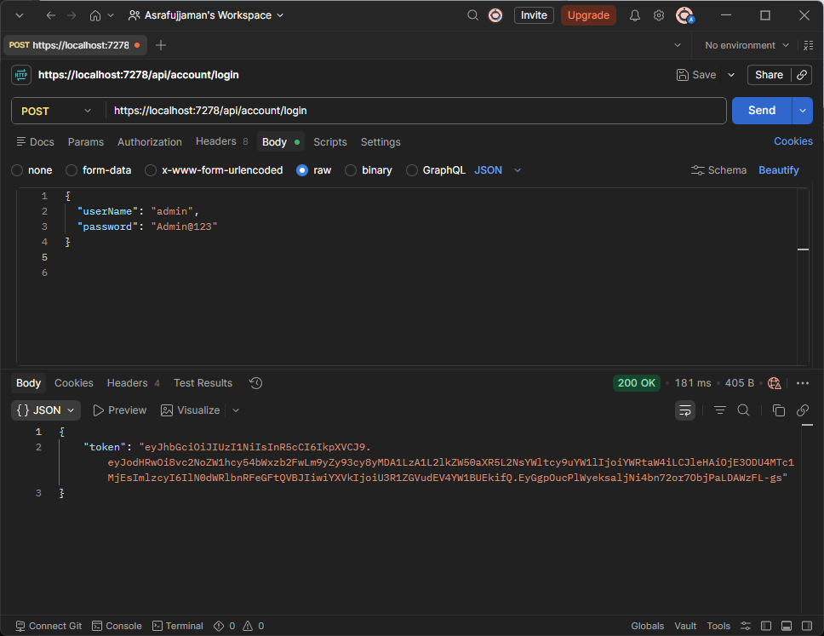
Response:
{
"token": "eyJhbGciOiJIUzI1NiIs...(much longer)..."
}
Copy the full token string. In Postman: open the Authorization tab on the collection or each request, type = Bearer Token, paste the token (without the word "Bearer" — Postman adds it for you).
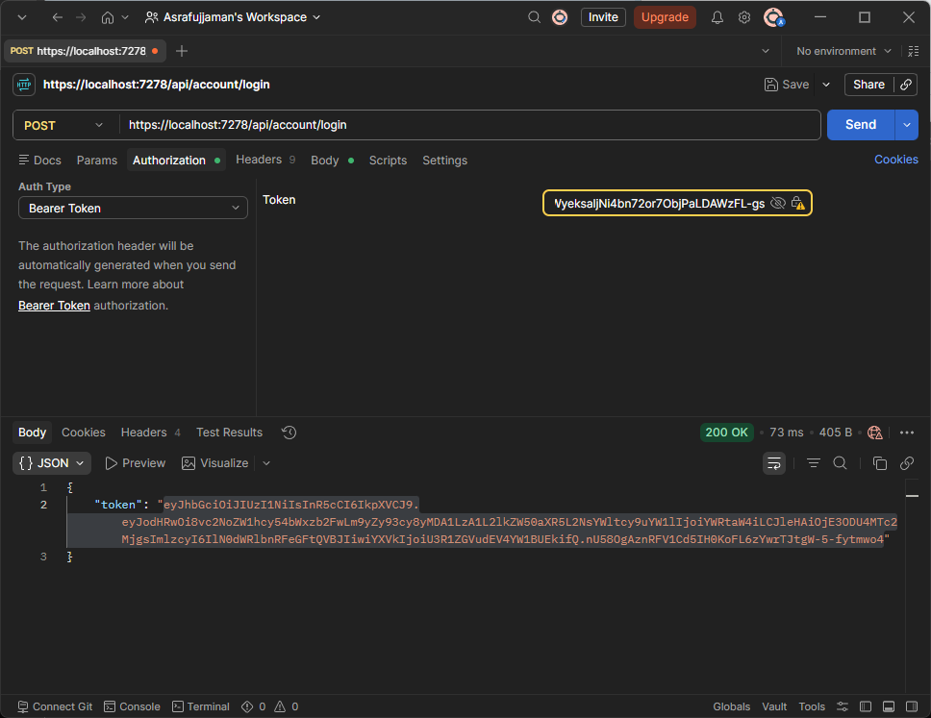

3. Create a student with subjects
POST {{baseUrl}}/api/students
Authorization: Bearer <token>
{
"name": "Rina",
"date": "2026-02-10",
"activity": true,
"departmentId": 1,
"subjects": [
{ "course": "SQL", "credit": 3 },
{ "course": "C#", "credit": 4 }
]
}
departmentId 1/2/3 = CSE/BBA/English (seeded in SchoolDbContext).
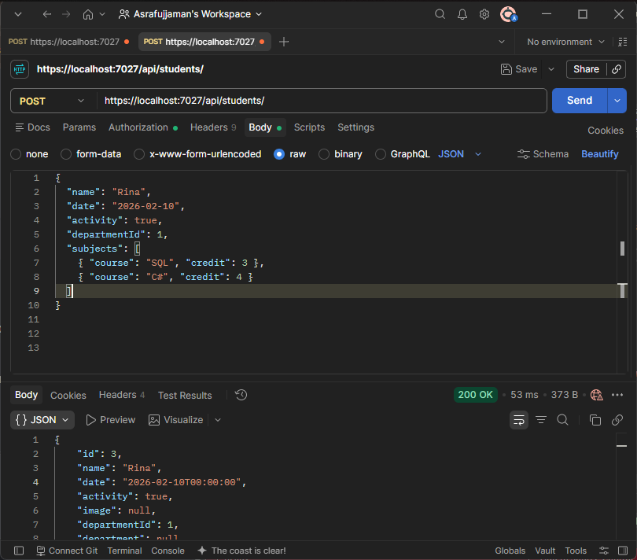

4. Get all students / get one
GET {{baseUrl}}/api/students and {{baseUrl}}/api/students/3
Authorization: Bearer <token>
Returns each student with Department and Subjects included.
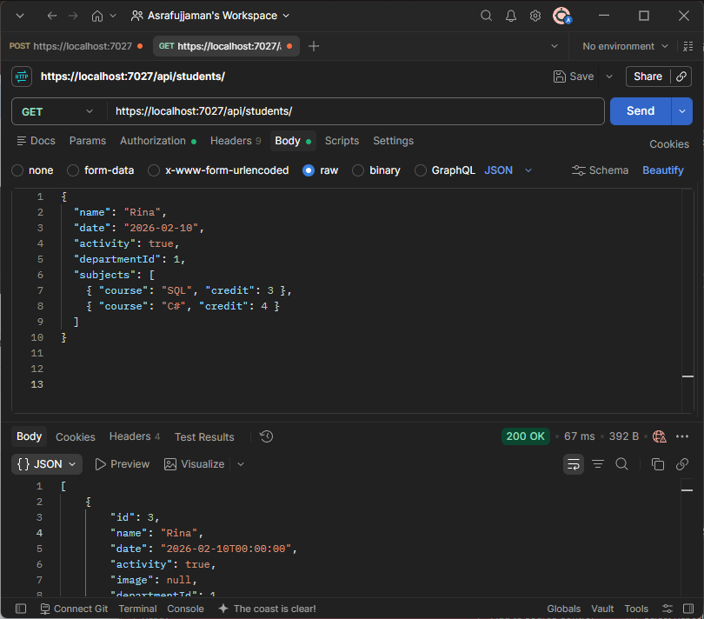

5. Update a student and replace their subjects
PUT {{baseUrl}}/api/students/3
Authorization: Bearer <token>
{
"name": "Rina Updated",
"date": "2026-03-15",
"activity": false,
"departmentId": 2,
"subjects": [
{ "course": "ASP.NET Core", "credit": 4 },
{ "course": "Web API", "credit": 3 }
]
}
The old subject rows for this student are deleted and replaced with the new array — that's the master-details update.
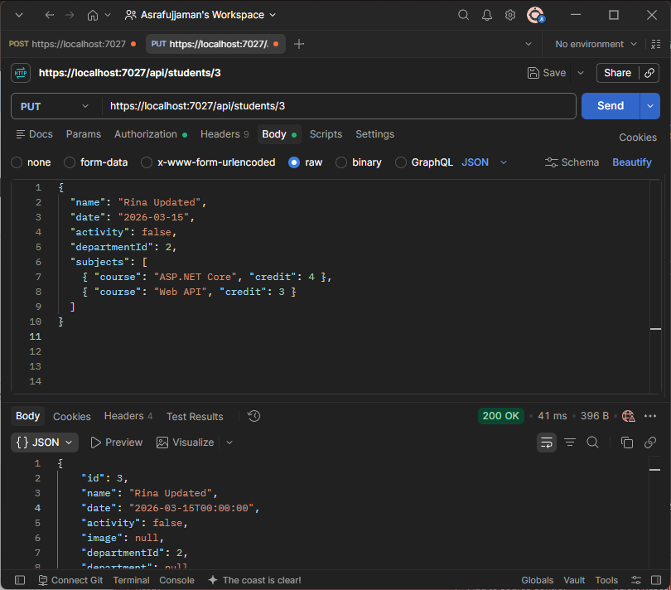

6. Upload an image
POST {{baseUrl}}/api/students/3/images
Authorization: Bearer <token>
Body: form-data

Field | Value
Key | file
Type | File
Value | choose an image

Response:
{
"image": "1_9c2f0a3e-....jpg"
}
View it in a browser at {{baseUrl}}/images/1_9c2f0a3e-....jpg — app.UseStaticFiles() is what makes that URL work.
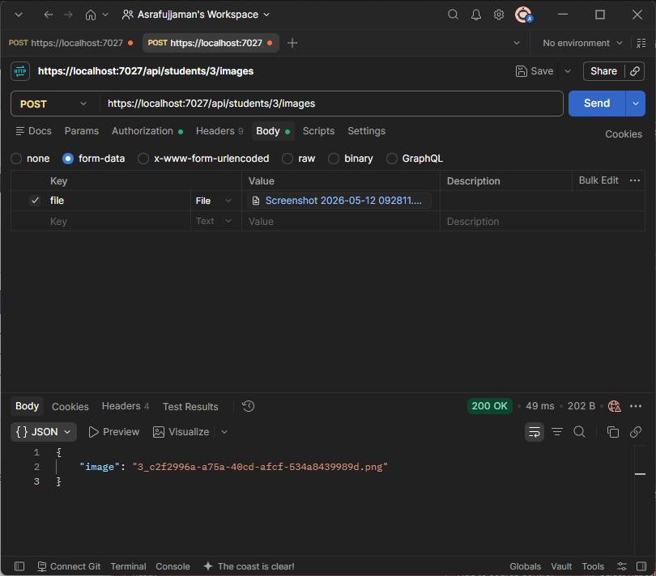

7. Delete a student
DELETE {{baseUrl}}/api/students/3
Authorization: Bearer <token>

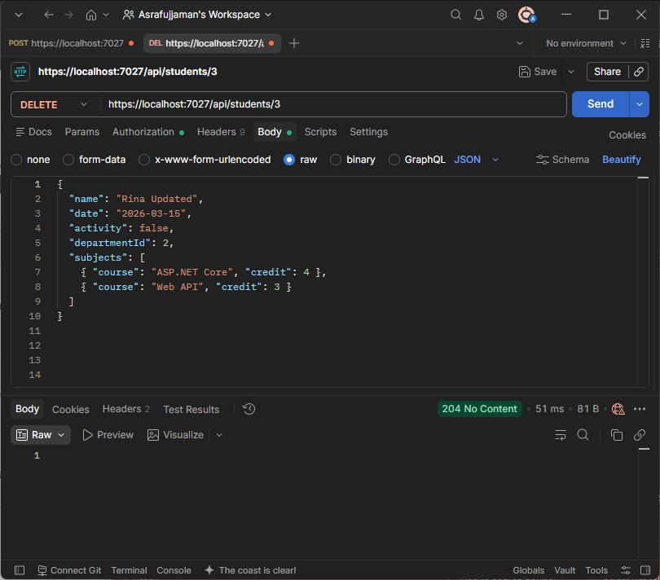

Shortest Memory Order
- Department, Student, Subject, ApiUser (Models/DbModels.cs)
- SchoolDbContext — IdentityDbContext<ApiUser>, seeded Departments
- DTO/Dtos.cs — RegisterDto, LoginDto
- Program.cs — DbContext → Identity → JWT auth → Controllers → middleware order
- AccountController — Register, Login
- StudentsController — CRUD + image upload, all async, [Authorize]
- Migration commands
- Postman: Register → Login → paste token → CRUD → image upload

