**1.Развертывание Среды Python**

I use IDE: Visual Studio Code

For Create VirtualEnV

Windows!

create: python -m venv venv

activate: venv\Scripts\activate.bat

deactivate: deactivate

Ubuntu!

create: python3 -m venv venv

activate: source venv/bin/activate

deactivate: deactivate

In my case:

I created on ubuntu with existing system packages:

python3 -m venv venv --system-site-packages

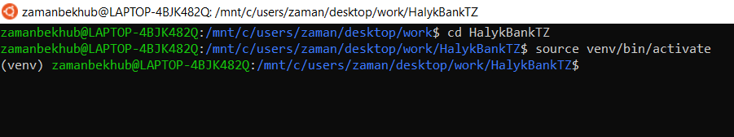

**2.Чтение данных из PDF файла Python**

I used for read pdf Python Fitz Package

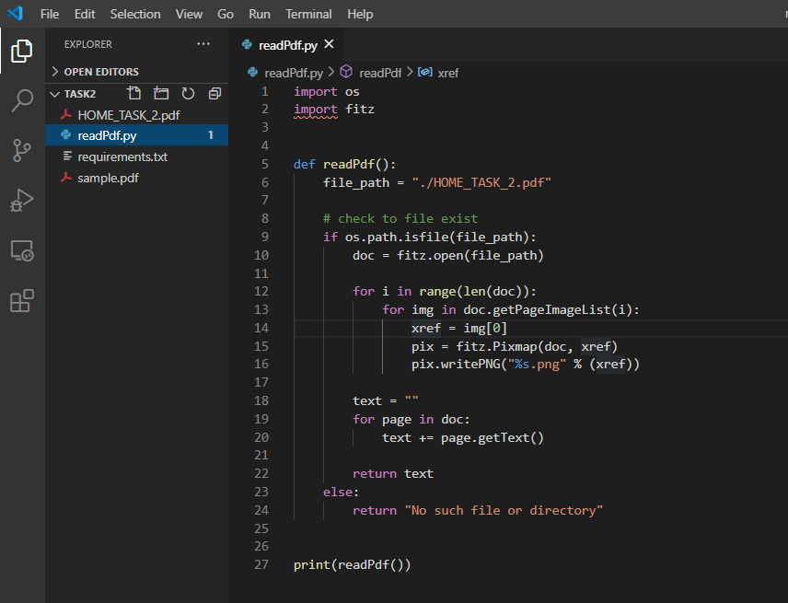

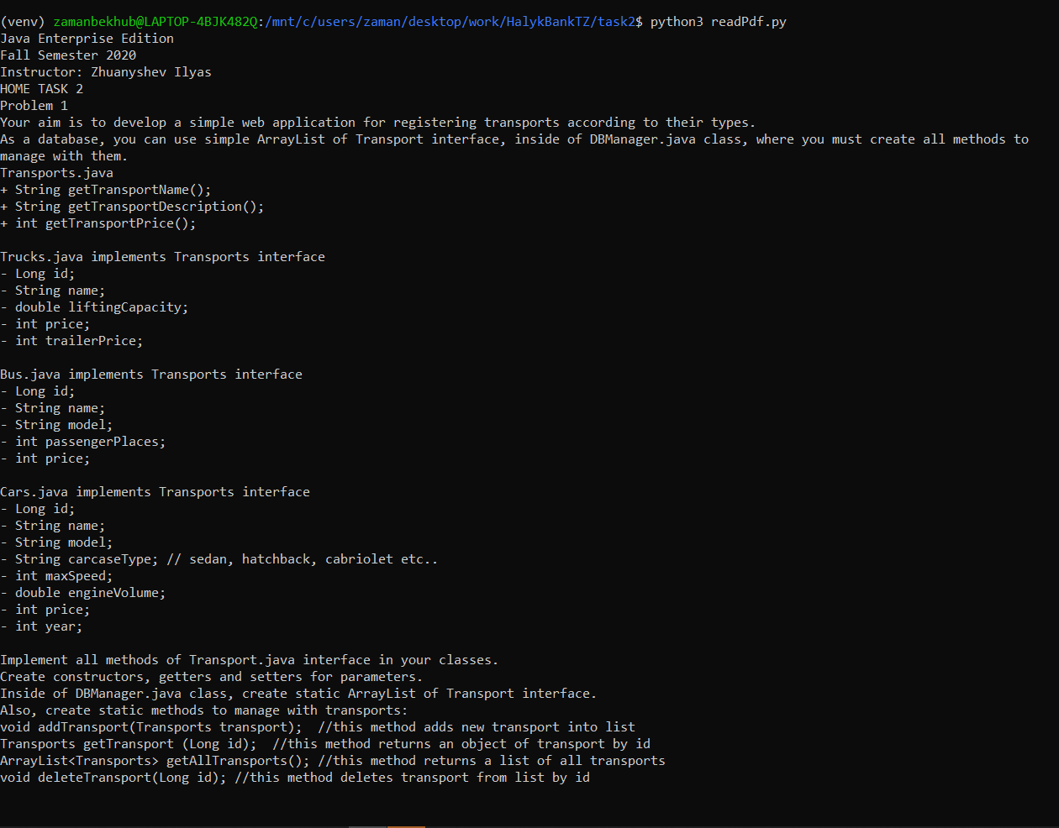

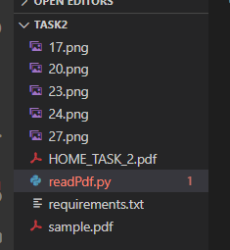

**3. Мини-приложение на C# (simple app input output)**

To make it more interesting, I completed the task from Абрамян

Code: you can find ./Task3/SimmleApp/SimmleApp/Program.cs

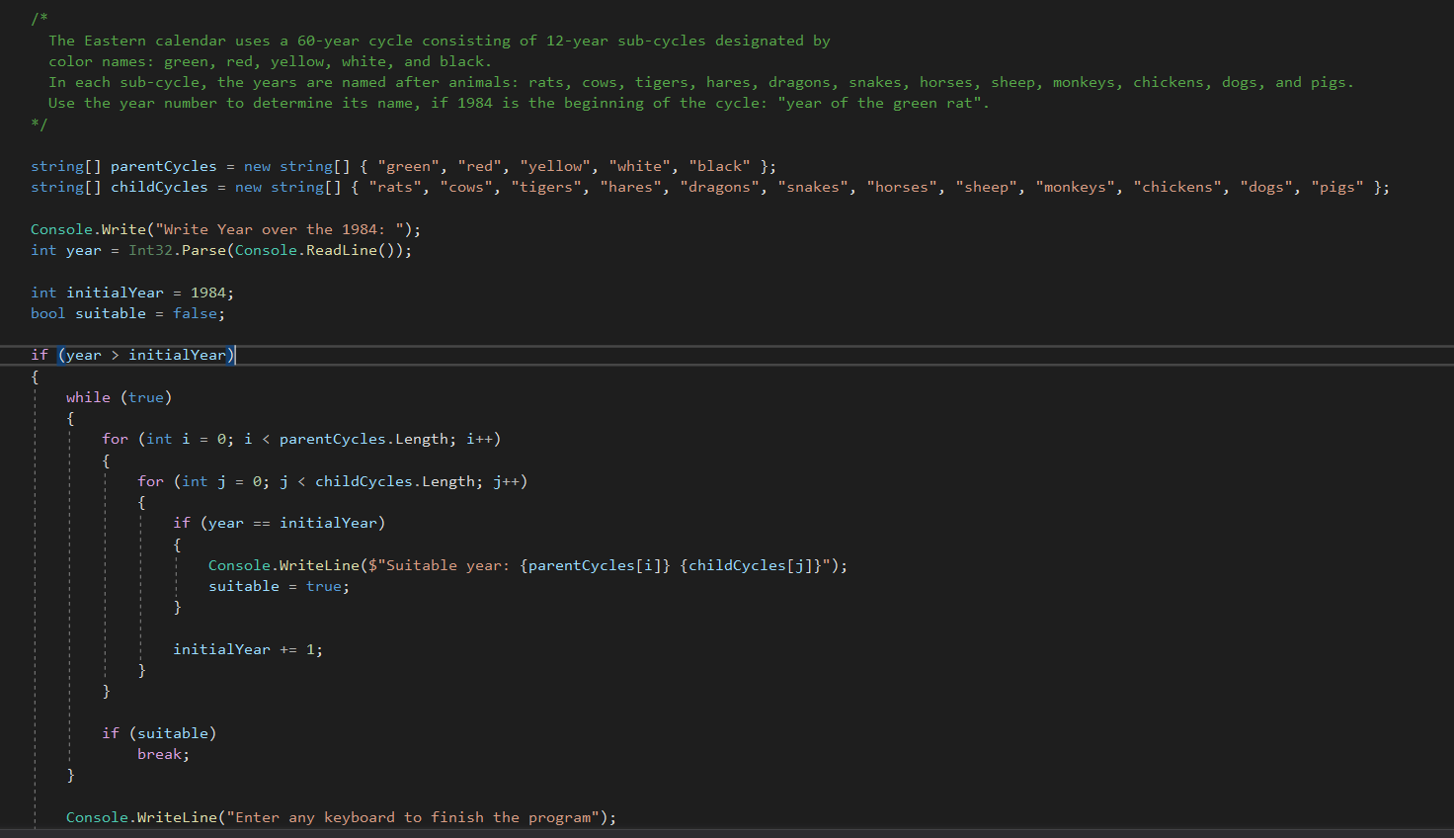

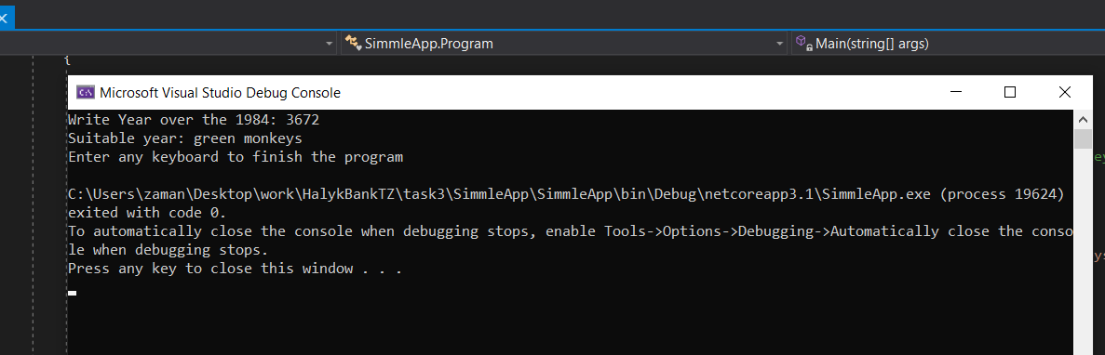

**4.  Парсинг текста на SQL (MSSQL)**

Code: you can see on ./Task4/SQLQueryParserFunction.sql

In this example I make function for parse text consists profiles

dbo.HandleProfiles(@Data, @Delimeter, @RowDelimeter)

@Delimeter = for define columns (default ‘,’)

@RowDelimeter = for define rows (default ‘;’)

