American International University-Bangladesh



**Paper Submission**

**A study on the challenges faced by remote teams to manage software projects in Bangladesh**

**Submitted By:**

|  |  |
| --- | --- |
| **Name** | **ID** |
| **Md. Reaz Uddin Chowdhury** | **21-92155-3** |
| **Ummey Soaiba Yeasmin** | **21-92158-3** |
| **Akibur Rahman Akib** | **22-92573-2** |
| **Sheuly Akter** | **22-92609-2** |
| **Md. Rifat-Uz-Zaman** | **22-92610-2** |
| **Md. Tanvir Rahman** | **22-92418-1** |

**Course:** Software Project Management **Course Teacher:** Mohammad Samawat Ullah **Section:** [MScCS] A

**Semester:** Summer 2021-2022

**Date of submitting:** 01, August, 2022

**A study on the challenges faced by remote teams to manage software projects in Bangladesh**

# *Abstract*

***Over the years the challenges faced during software project management has made software companies to adopt agile based iterative approach for software development. Agile emphasizes constant collaboration with stakeholders, an iterative approach to software development instead of doing everything in one go and working software over extensive documentation. Because of the covid-19 pandemic, many software firms were forced to operate online and they had to adapt their practices so that they are effective at managing software projects remotely. Following the best practices of an agile framework is challenging in itself in a country like Bangladesh. Doing it when the entire team is working remotely adds an additional layer of complexity to project management. After doing extensive surveys and interviews with remote workers our results show that employees believe working remotely has increased their productivity and reduced distractions. But Communication with colleagues and getting support from them has become more difficult. Agile has continued to be used effectively used in a remote setting in most firms in Bangladesh.***

**Keywords**

Agile, Software Project management, Remote work, remote project management.

# Introduction

The increasing scope and complexity of software projects over the past two decades has placed greater pressure on software companies to come with management techniques to help them face

those challenges. Traditional methods of software development like waterfall doesn’t allow teams to deal with the increasing complexity of software and rapid changes that are required in modern software development. Based on different studies [1] the primary reasons for the failure of a software project are the following.

* Rapid changes in requirement
* Lack of user involvement
* Unrealistic expectations by stakeholders
* Poor communication and planning

In the early days of software development methodologies like waterfall and the spiral method were acceptable but they are not suitable to deal with issues frequent changes to requirements and rapid delivery to market.

Those who practice agile methodologies claim that they that these challenges outlined above can be solved [2]. Over the years more and more companies have adopted agile in their project management workflow.

The covid pandemic created a great challenge for software companies all over the world including Bangladesh to adapt to the new realities. Although remote work has been more common for the software industry than any other industry but because of the lockdowns all physical offices had to be shut and entire teams had to work remotely overnight. There are no studies that demonstrate how the companies Bangladesh have adjusted to this new reality.

# Research Questions

The following issues will be covered in this article:

* What are the challenges that teams have faced after switching to remote work?
* How teams have adapted to remote work?
* Have agile methodologies been useful in a fully remote setting?

# Background

At present people live in digital world, so there the Digital world means the inter connection through the digital devices, media or socializing. There the digital devices all the time with the help of internet. Using internet, the world become advanced full of ideas, opinions, learning and opportunities smoothly. Therefore, most of the company or organization are tried to find a new approaches or innovation way to become more and more competitive and efficient. So, it is hardly surprising that the company or organization are trying and want to convert their work into remotely rather than physically by using new technologies. [K. A. Johnston](https://ieeexplore.ieee.org/author/38057986800), and [K. Rosin](https://ieeexplore.ieee.org/author/38076814400) named two author gives a paper named, “Global Virtual Teams: How to Manage Them”,[3] where they mentioned that organizations creates new opportunities based on the Global Virtual Teams (GVTs). Using this Global Virtual Teams (GVTs) they work on many complex virtual projects, and that are remain competitive. At the beginning they faced different challenges and difficulties for over 7 months. The communication was the core challenge, then trust, cultural differences, team cohesion, software maintains, collaboration, lacking of internet and environment are faced by them. In the “Process and technology challenges in swift-starting virtual teams” [4], paper Biorn Erik Munkvold and Ilze Zigures outlined some challenges that remote teams have to face. Maintaining a tight schedule is the most challenging. Time trackers can be used to keep teams accountable but managing everything adds a layer of complexity to operations. Teams also face obstacles if certain members have an unreliable internet or electricity connection.

In 2021, Gaye Kiely, Tom Butler and Patrick Finnegan commit a research paper named, the “Global virtual teams coordination mechanisms: building theory from research in software development” [5] where they analyses the impact of the Global Virtual Teams (GVTs) for software development and the aforementioned problem was determined that project team face issues during the coordination mechanisms. After that they develop a refined conceptual model for guiding future work for team on the global virtual software development. Mainly their findings are about coordination mechanisms theory not regarding issues and challenges.

Chris Kimble name of a researcher who wrote a paper titled, “Building effective virtual teams: How to overcome the problems of trust and identity in virtual teams” [6], where he said that people and organization faced some challenges when they manage virtual teams. They identify the main the challenges such as, trust and identity role in virtual team. They also mentioned that as remote teams are becoming more valuable, so they discussed two broad classes solution named, technical, and organizational which proposes to solve some of the challenges. The “Virtual Teams and Management Challenges” [7] paper are given by three researcher of Malaysia named Nader Ale, Shamsuddin Ahmed and Zahari Taha. There they defined the virtual team with its characteristics, addressing and relationship with different challenges that the organization faced during the virtual period. They point that the manager of that organization should invest less in tangible assets but the virtual team generate knowledge and employee are creatively increments their innovations and working procedure.

# In the “Challenges In Managing Virtual Teams” [8] paper, Rudy Nydegger and Liesl Nydegger author describe that managing virtual team is very challenging but those challenges can be overcome proper leadership, clear communication, leveraging technology and effective HR and organizational policy.

# Methodology

We have used google forms to create paperless questionnaires for software engineers, project managers, business analysts and testers in different companies to take their opinion on how remote work have impacted them and their team. Fig-1 is the breakdown of the different roles that respondents work in different software companies. We have had 50 respondents the majority of them 44% are software engineers, 12 % Business analysts and Project managers and 4 % of them were technical leads. We have discarded 7 responses as their roles are not relevant

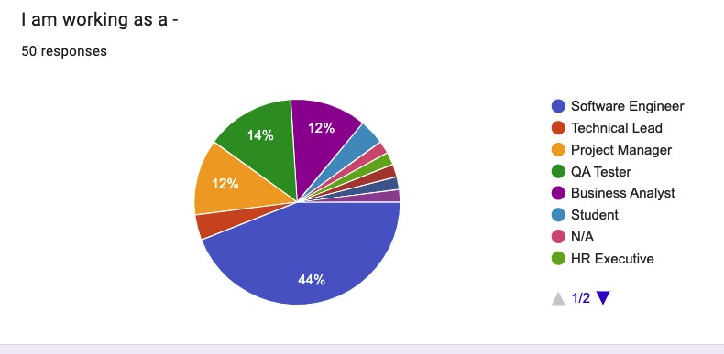

**Fig-1** What role id the respondent working as.

Apart from that we have also conducted one-to-one interviews with 5 software engineers to get more detailed information on how remote teams are managed and how agile frameworks are practiced in a remote setting in Bangladesh. We have queried about the best practices that their teams have employed to manage projects in an effective manner. And the advantages and challenges that they have faced since going fully remote

# Results and Discussion

**Productivity and Time management**

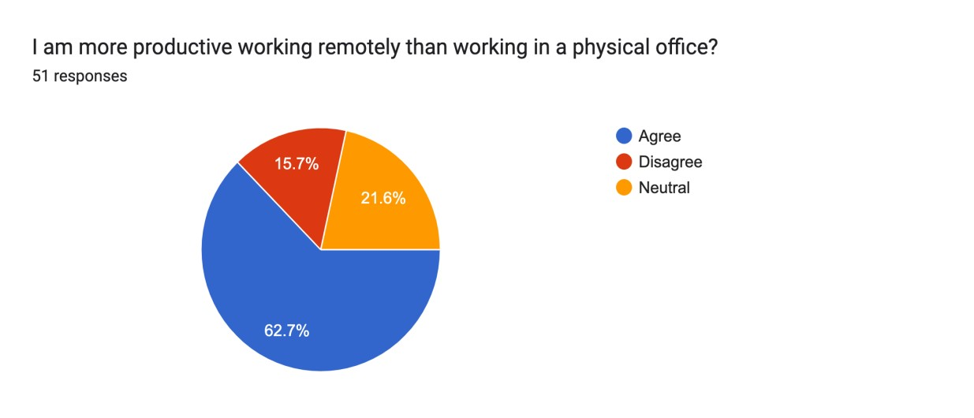

**Fig- 2** Productivity in the office vs remote work

Remote work has increased productivity for most knowledge workers as time and energy spent on traffic has been greatly reduced. 62.7% of the respondents agreed that they have become more productive because of working remotely compared to 15.7% of the respondents who disagree. 21.6% decided to stay neutral and don’t think there has been any increase or decrease in productivity. During interviews respondents said the biggest benefit of remote work is the time and energy saved while commuting to the office especially considering the traffic of Dhaka.

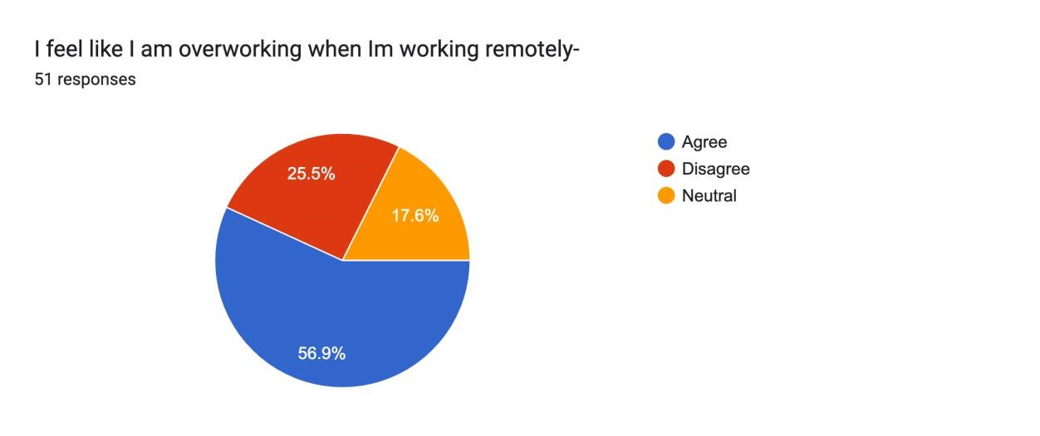

**Fig- 3** Overworking in the office vs remote work

While productivity has increased most respondents, 56.9% said they feel like they are overworking since going fully remote. During interviews respondents mentioned they have difficulty switching from work to home life while doing remote work as they are in the same physical space. Previously they used to stop working when they got out of the office.

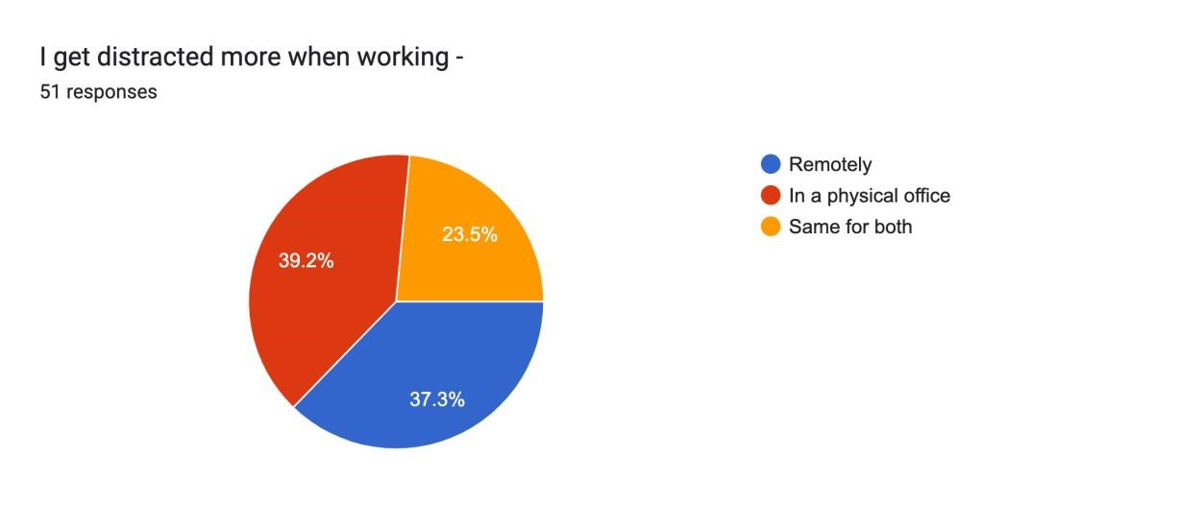

**Fig- 4** Getting distracted in the office vs remote work

37.3% of the respondents they get distracted while working remotely while 39.2% get more distracted in a physical office. The primary reason given during the interviews for being distracted at home working remotely was kids or family members disturbing the work flow. Most have managed to deal with this by asking family members not to disturb them during working hours and setting up a dedicated work space in their home. While in the office other colleagues calling them is the main source of distraction.

# Communication and Support

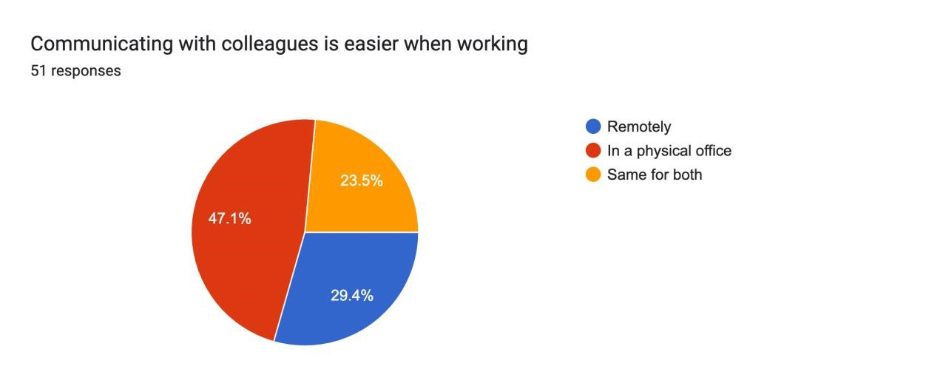

**Fig- 5** Communication in the office vs remote work

Most respondents said it is easier to communicate with colleagues inside a physical office compared to 29.4%% who said its easier in a remote setting.

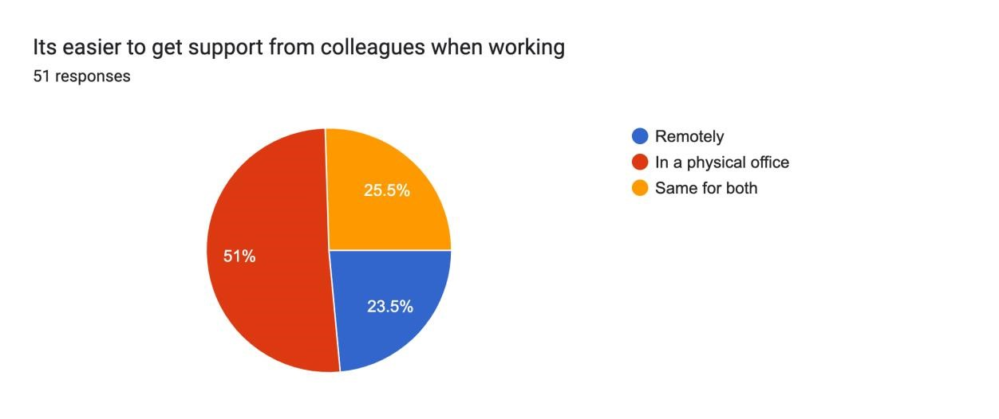

**Fig- 6** Getting support in the office vs remote work

51% of the respondents said it was easier for them to get support from their colleague’ in a physical setting while 23.5% said it is easier in a remote setting. While getting instant support has be more difficult in a remote setting asynchronous support through messages has been the default way to get support from seniors [9].

# Working environment and setting

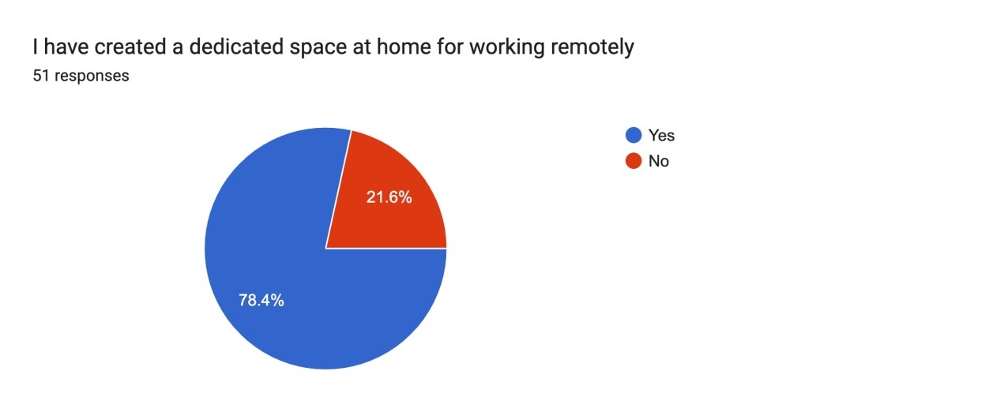

**Fig- 7** Dedicated space for remote work

Most respondents 78.4% have created their own dedicated environment for remote work. During interviews they have mentioned that they have done this to reduce distractions.

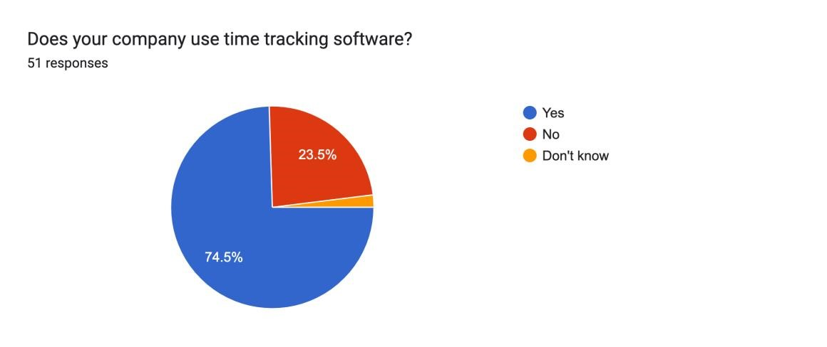

**Fig- 8** Time tracking software for remote work

74.5 % of the respondents mentioned they have to use a time tracking software for their company. During interviews most agreed that this keeps them accountable and don’t have a problem with it.

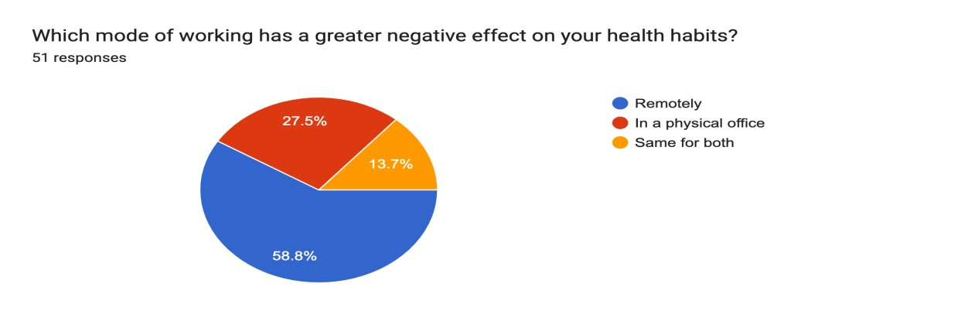

**Fig- 9** Mode of work which has an effect on health

58.8% of the respondents said remote work has a negative effect on their health compared to

27.5% of the people who said working in the physical office has a worse health impact.

# Agile and project management

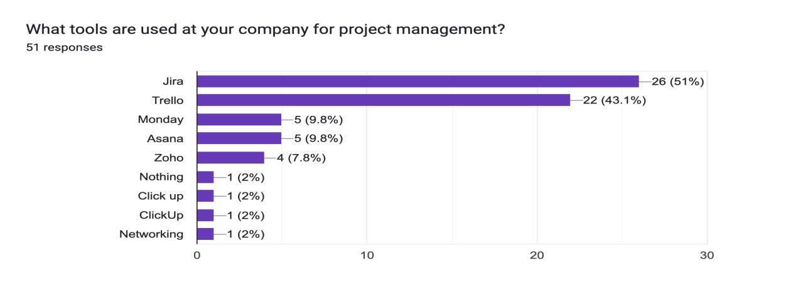

**Fig- 10** Time tracking software for remote work

Most respondents said Jira and trello are the most common software that their companies use to manage projects in their teams. 51% and 43.1% respectively. [10]

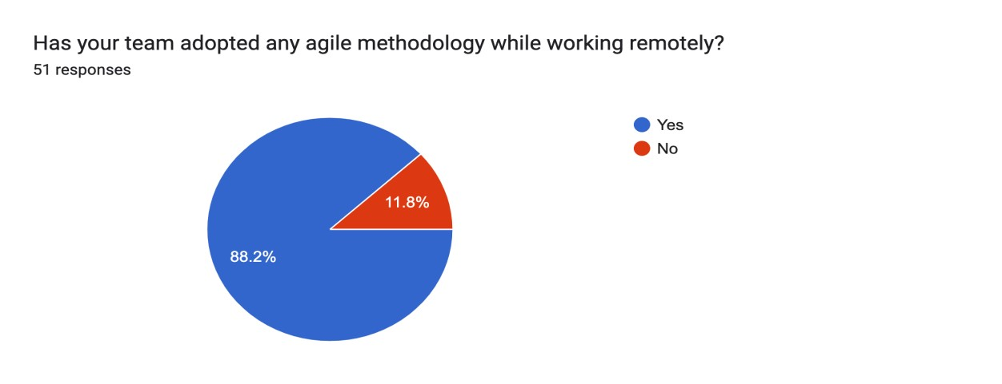

**Fig- 11** Is your team following an agile methodology?

An overwhelming majority 82.2% say their team is following an agile methodology which demonstrates the popularity and effectiveness of agile as a project management methodology. [11]

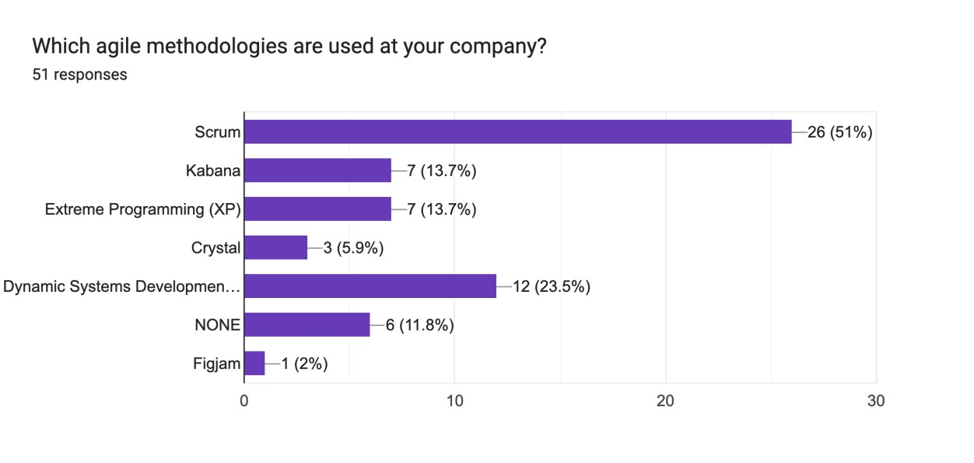

**Fig- 12** Agile methodology my popularity

According to our respondents the most widely used agile framework is Scrum with 51% of the respondents saying they follow scrum in their teams.

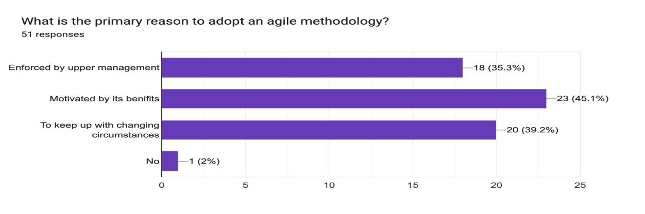

**Fig- 13** Why adopt agile

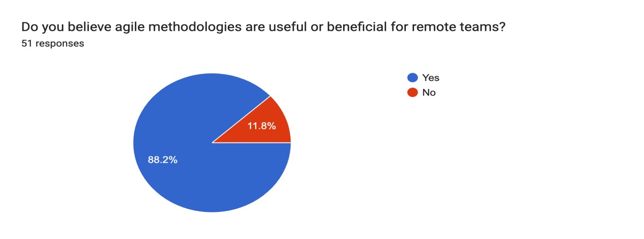

**Fig- 14** Is agile useful for remote teams

Most respondents 88.2% believe agile is beneficial for remote teams. During interviews most respondents mentioned they had to adjust during the initial days but after a couple of weeks teams became highly efficient in using agile frameworks in a remote setting.

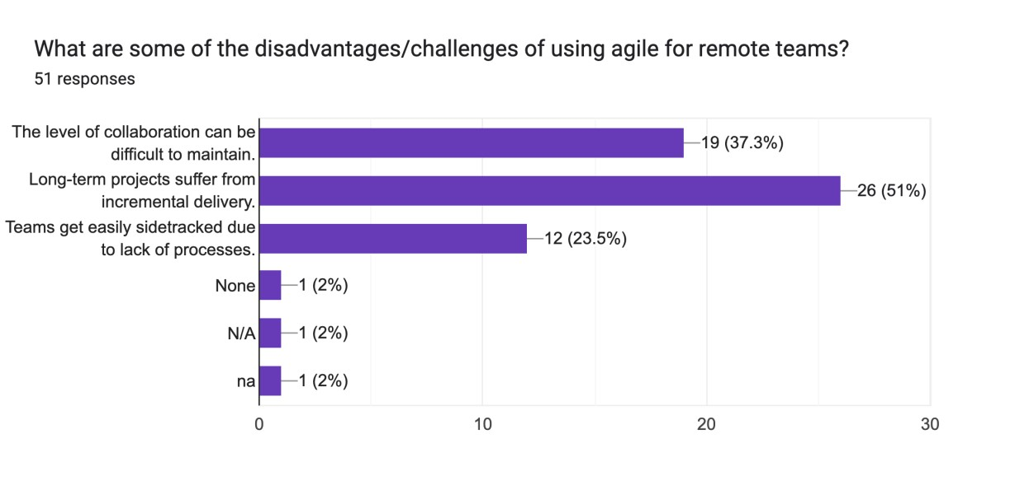

**Fig- 15** Disadvantages of using agile

# Conclusion

Based on the survey and interviews with remote software development teams our results show that employees believe working remotely has increased their productivity and reduced distractions. Most respondents have their own setting for remote work to maximize productivity and reduce distractions. But Communication with colleagues and getting support from them has become more difficult. The Agile has continued to be used effectively used in a remote setting in most software firms in Bangladesh even though there were some difficulties in the initial phase of remote work.

**References**

***[1]*** *R. N. Charette, Why Software Fails [Software Failure], pp. 42–49. [Online]. You may get it at: 10.1109/MSPEC.2005.1502528: IEEE Spectrum, vol. 42, no. 9, September 2005.*

|  |
| --- |
| ***[2]*** *A. B. a. N. Nagappan, Usage and Perceptions of Agile Software Development in an Industrial Context: An Exploratory Study, In Empirical Software Engineering and Measurement, First International Symposium on ESEM 2007, pp. 255–264, in 2007.* |
| ***[3]*** *G. V. T. H. t. M. Them, K. A. Johnston, K. Rosin, Electronic ISBN:978-1-4244-9283-1: 2011 International Conference on Computer and Management (CAMAN), IEEE, 19-21 May 2011.* |
| ***[4]*** *I. Bjørn Erik Munkvolda, Process and technology challenges in swift-starting virtual teams, Information & Management, Volume 44, Issue 3, April 2007, Pages 287-299.* |
| ***[5]*** *T. B. &. F. Gaye Kiely, Global virtual teams coordination mechanisms: building theory from research in software development, IEEE, 06 Apr 2021.* |
| ***[6]*** *C. Kimble, Building effective virtual teams: How to overcome the problems of trust and identity in virtual teams, Wiley Online Library, 10 December 2010.* |
| ***[7]*** *S. A. a. Z. T. Nader Ale Ebrahim, Virtual Teams and Management Challenges, IEEE, January 2009.* |
| ***[8]*** *L. N. Rudy Nydegger, Challenges In Managing Virtual Teams, Journal of Business & Economics Research , March, 2010 Volume 8, Number 3.* |
| ***[9]*** *C. L. a. V. R. Basili, Iterative and Incremental Development: A Brief History Agile software development: The Cooperative Game, by A. Cockburn. Agile methodology, vol. 36, no. 6, June 2003, pp. 47–56.* |
|  |
| ***[10]*** *D. M. A. D. C. W. M. S. D. K. J. M. a. T. K. M. Lindvall, Agile software development in Large Organizations, In Computer, vol. 37, pp. 26–34, 2004.* |
| ***[11]*** *B. a. T. R. Boehm, Balancing Agility and Discipline: Evaluating and Integrating Agile and Plan-Driven Methods, 26th International Conference on Software Engineering, pp. 718–719.6, 2004.* |