LINUX LOG FILE
ANALYSIS
Manual investigation, Python automation and SIEM visualization

PROJECT REPORT

Project detail | Description
Focus | Reviewing Linux authentication events and identifying patterns that warrant investigation
Dataset | Linux_2k.log — 2,000 log lines
Tools | Python 3, CSV/Excel, Splunk Enterprise
Automation scope | Lines 200–500 of the sample log
Report date | 25 October 2026

A hands-on SOC-style lab using a sample dataset. The findings are indicators for review, not a confirmed security incident.

1. Executive Summary
This project examines a sample Linux log file using three complementary approaches: manual review, a small Python script, and Splunk Enterprise searches and visualizations. The goal was to turn raw log messages into evidence that can be reviewed and explained, rather than to label every unusual event as an attack.
The Python script reviewed the requested section of the dataset (lines 200–500) and exported 140 matching entries to suspicious_logs.csv. The exported rows contain 114 authentication-failure entries and 26 unknown/invalid-user entries. No “Failed Login” rows were exported by this run because the script did not find the exact “failed password” phrase in the selected range.
In Splunk, the authentication-failure search returned 490 events in the uploaded source. The timechart visualization showed activity at different times, including a noticeable spike. A separate grouped statistics view showed repeated counts associated with source hosts and usernames. These results support further triage, but they do not by themselves establish whether an event was malicious or whether access succeeded.

Project objectives
- Recognize authentication failures, unknown-user messages and other events that may need follow-up.
- Record observations in a structured findings workbook.
- Automate keyword-based triage for a bounded range of log lines and export the results to CSV.
- Use Splunk to search, group and visualize authentication-failure events.
- Document evidence, limitations and sensible next steps.

At a glance
Measure | Result | What it means
Source log size | 2,000 lines | The supplied Linux sample contains 2,000 log entries.
Python scan range | Lines 200–500 | 301 lines were checked by the script.
CSV matches | 140 | Keyword matches exported for analyst review.
Authentication failures | 114 | Exact keyword category assigned by the script.
Unknown/invalid user | 26 | Entries matching the unknown/invalid-user keywords.
Splunk authentication search | 490 events | Result displayed in the provided Splunk screenshots.

2. Scope and Method
The analysis uses the supplied Linux_2k.log sample, the log_analysis.py script, its suspicious_logs.csv output, the Excel findings workbook, and the provided Splunk statistics screenshot. The dataset is a sample for learning; it is not evidence from a currently monitored production system.

Workflow followed
- Review representative log entries and note timestamps, process names, remote hosts and messages.
- Record initial observations in the Excel findings workbook.
- Run the Python script against lines 200–500 and export keyword matches to CSV.
- Search the indexed log source in Splunk for authentication-failure events.
- Use Statistics and Visualization views to compare event counts and inspect activity over time.
- Interpret the results cautiously and identify what still needs validation.

Tools and files
Artifact | Role in the project
Linux_2k.log | Original sample log dataset; retained as the source of evidence.
log_analysis.py | Checks selected lines for authentication-related keywords and writes CSV output.
suspicious_logs.csv | Structured output containing line number, event type and original log entry.
Linux_Log_Analysis_Findings.xlsx | Workbook for initial findings and analyst notes.
Splunk Enterprise | Searches and summarizes indexed events; provides statistics and time-based visualization.

3. Observations from the Log File
The sample contains repeated SSH authentication failures and messages indicating that a requested user was unknown. The examples below are taken from the supplied log. They show why repetition and context matter when deciding what to investigate.
Evidence in the sample | Observation | Initial assessment
Lines 200–221 | Repeated authentication failures associated with rhost=n219076184117.netvigator.com and user=root; several entries occur within seconds on Jun 22. | A concentrated series of failed attempts against a privileged account deserves review. It is consistent with repeated login attempts, but is not proof of a successful compromise.
Lines 227–246 | Repeated “user unknown” and authentication-failure messages associated with ip-216-69-169-168.ip.secureserver.net around Jun 22 04:30:55. | Could indicate attempts using unknown usernames. Correlate with surrounding events and other sources before classifying it as account enumeration.
Lines 1–3 | The log records an unknown-user check and authentication failures involving rhost=218.188.2.4 on Jun 14. | A useful example of a remote source associated with failed authentication; investigate repetition and context.
Other sample entries | The log also includes service activity and logrotate messages such as “ALERT exited abnormally”. | Keep these separate from authentication findings; they may reflect a system issue and need their own context.

What the evidence does and does not say
- Observed: the log contains repeated authentication-failure messages and unknown-user messages.
- Reasonable interpretation: clustered attempts against root or repeated unknown-user checks warrant further investigation.
- Not established: the sample alone does not prove an attacker gained access, identify the person behind a source, or establish malicious intent.
- Validation needed: compare timestamps with successful authentication events, host context, expected administrative activity and any additional logs available.

4. Python Automation
The script reads Linux_2k.log, selects the requested range, checks each line for three keyword groups, prints matching entries and exports the matches to suspicious_logs.csv. It preserves the original log message so that the result can be checked against the source.

Detection logic
subset_logs = logs[199:500]
for line_number, line in enumerate(subset_logs, start=200):
text = line.lower()
if "failed password" in text:
event_type = "Failed Login"
elif "authentication failure" in text:
event_type = "Authentication Failure"
elif "user unknown" in text or "invalid user" in text:
event_type = "Unknown/Invalid User"
else:
continue

Results from the supplied CSV
Event type | Rows exported
Authentication Failure | 114
Unknown/Invalid User | 26
Failed Login | 0
Total | 140

The output currently covers matching lines 200 through 495. This is the range of matching rows in the CSV, not the full range scanned. The script checked lines 200–500.

Limitations of the script
- Detection is based on exact keywords. A relevant event written in different words may be missed.
- A keyword match is not automatically malicious; false positives are possible.
- The if/elif structure assigns only the first matching category to a line. A line containing both “user unknown” and “authentication failure” is classified as Authentication Failure.
- The script does not parse timestamps, IP addresses or usernames into separate fields. Those values remain inside the original log text.
- The analysis is restricted to a small section of the file, so its CSV totals should not be compared directly with full-source Splunk totals.

5. Splunk Search and Visualization
The supplied Splunk screenshots show searches against source=\"Linux_2k.log\". The authentication-failure search returned 490 events. The statistics search grouped results by extracted source host and username, and the timechart view plotted authentication failures in hourly buckets.

Search examples used
source="Linux_2k.log" "authentication failure"
| stats count by host
The screenshot of the grouped analysis uses a more detailed query:
source="Linux_2k.log" "authentication failure"
| rex "rhost=(?<source_host>\S+)"
| rex "user=(?<username>\S+)"
| stats count by source_host username
| sort - count
The timeline query shown during the lab was:
source="Linux_2k.log" "authentication failure"
| timechart span=1h count

Statistics screenshot
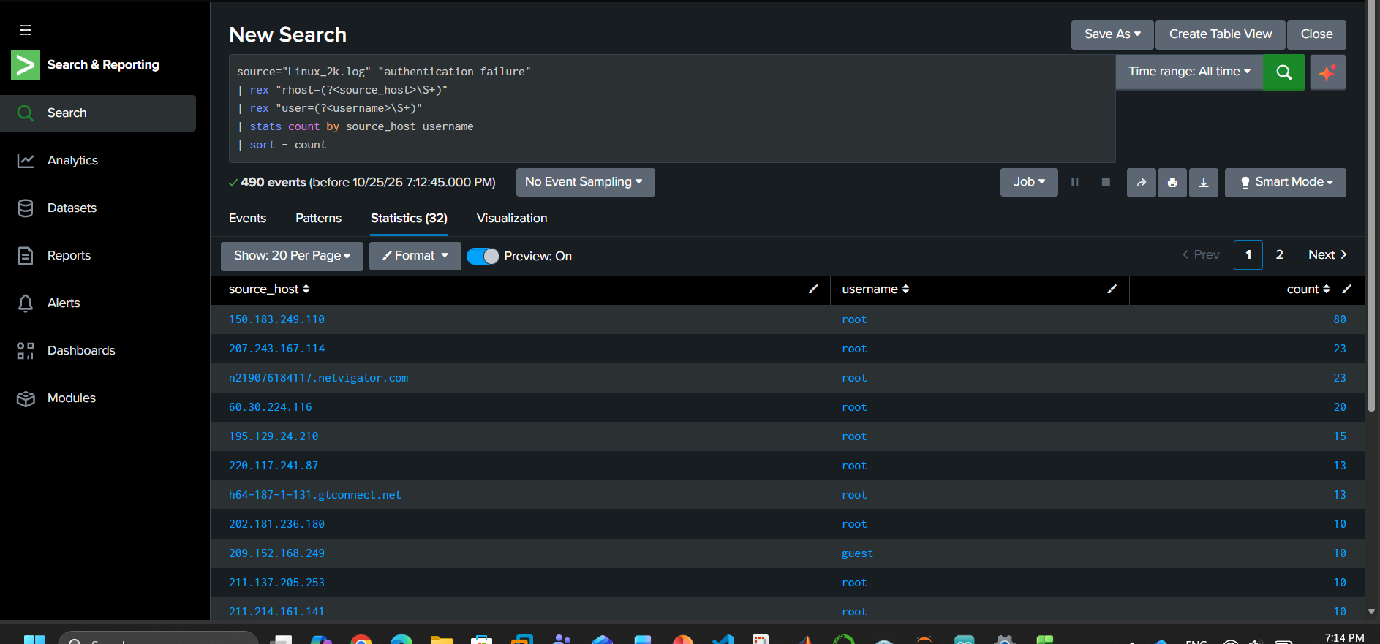
Figure 1. Splunk Statistics view from the lab session. The table groups authentication-failure events by source host and username.

Reading the Splunk results
- The broad authentication-failure search returned 490 events in the screenshot.
- The grouped statistics screenshot displays 32 result rows across two pages. The first displayed row shows source 150.183.249.110, username root, count 80.
- The timechart showed event activity at different times, including a visible spike. Spikes help prioritize review but do not prove an attack on their own.
- A separate search for the exact phrases “Accepted password” or “Accepted publickey” returned 0 events in the screenshot. This means the search found no matches for those phrases in the selected source and time range; it does not prove that successful logins were impossible or that every relevant success message was searched correctly.

Important query checks
Before treating counts as final, confirm the selected time range, source name and field extraction. In the grouped query, the username extraction depends on the text containing user=. Events without that field may not be grouped as expected. For a more complete investigation, search both failure and success indicators and inspect the raw events around the same timestamps.

6. Conclusion
The lab demonstrates a practical first-pass SOC workflow: inspect raw logs, use a small script to reduce repetitive searching, and use Splunk to summarize and visualize the results. The most useful observation is the presence of repeated authentication failures and unknown-user messages in the sample. These patterns are worth investigating, especially when attempts cluster around a privileged account, but the evidence in this exercise is not enough to declare a confirmed incident.

Recommended next steps
- Extend the Python script to extract timestamp, remote host/IP, username and event type into separate CSV columns.
- Add tests for variations such as “Failed password”, “authentication failure”, “invalid user” and “user unknown”.
- Compare Python results with Splunk using the same source, time range and keyword definitions.
- Investigate whether successful logins occurred near the repeated failures, and document the exact search used.
- If using this in a portfolio, include screenshots of the Python output, CSV, Splunk timeline and statistics table, while removing any personal or machine-specific details that should not be public.

7. Reproduction Notes
Keep the following files together in the project folder:
Linux_2k.log
log_analysis.py
suspicious_logs.csv
Linux_Log_Analysis_Findings.xlsx
Linux_Log_Analysis_Project_Report.docx
Run the script from that folder with:
python log_analysis.py
If Python is installed through the Windows launcher, use py log_analysis.py. Run the script on a copy of the sample if you plan to modify the data.

References
LogHub — Log Datasets for AI-powered Log Analytics: https://github.com/logpai/loghub
Splunk Enterprise downloads: https://www.splunk.com/en_us/download.html

End of report

