Note: the square brackets are not actually in the message. Explanations in square brackets outside the <> are not part of the message. The <>, however, should be included.

User changeable:

<SFTP:> [soft stop]

<EFMD:[Boolean on/off]> [Efficient mode on/off]

<JOGR: [integer 0-360]> [Rotational jog in degrees]

<JOGV: [integer 0-1500]> [vertical jog in mm, approximate max 1500 mm]

<DIPR:[integer number of dips per revolution]>

Admin changeable:

*Dip profile:*A set of time and depth pairs

The suggested format for dip profile is <[dip location 1 in integer mm:time in ms], [dip location 2:time], [dip location 3:time] >

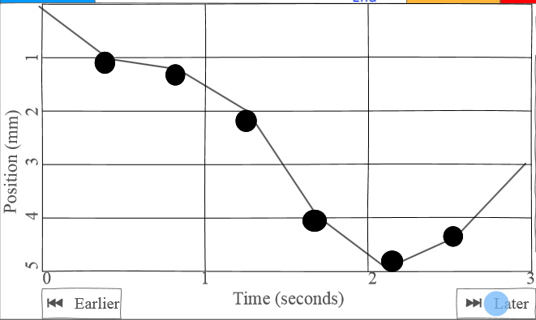

*Candle Program:* A candle program is a series of dip profiles and/or setting changes i.e.

[set max acceleration]

[set max depth]

[set certain acceleration]

[set dips per profile]

[dip profile 1]

[time delay]

[perhaps change acceleration etc between profiles]

[dip profile 2]

<TMDY:[time in seconds]> [generic time delay]

<ACMR:[mm/s/s]> [max revolution acceleration]

<ACMV:[mm/s/s]> [max vertical acceleration]

<JGSV:[integer mm/s]> [vertical jog speed set]

<JGSR: [integer mm/s]> [horizontal jog speed set]

<MAXL:[integer millimeters]> [Maximum length. We actually aren’t using this one anymore, but replacing it with a “select program” button]

<ESRR:> [soft pause]

Messages from the Arduino:

<ESRV:[Boolean, 1 up, 0 down]>

<LOGM:[happy message from Arduino “I’ve completed my program etc.]>

<ERRM: ”Error message i.e. Lowered in bucket, unable to rotate”>