* **Title Bar**: The title bar is located at the top of the Excel window and displays the name of the current workbook.
* **Ribbon**: The ribbon is a tabbed toolbar that runs across the top of the Excel window. It contains multiple tabs, such as Home, Insert, Page Layout, Formulas, Data, Review, and View, each with a set of related commands and functions.
* **Quick Access Toolbar**: This is a customizable toolbar located above the ribbon or below the ribbon, depending on your configuration.
* **Formula Bar**: The formula bar is situated below the ribbon and displays the contents of the active cell.
* **Worksheet Area**: The largest area of the Excel interface is the worksheet area, where you enter, edit, and format data.
* Financial modeling and analysis.
* Budgeting and forecasting.Top of Form
* Inventory management and demand forecasting.
* Supplier and vendor management.

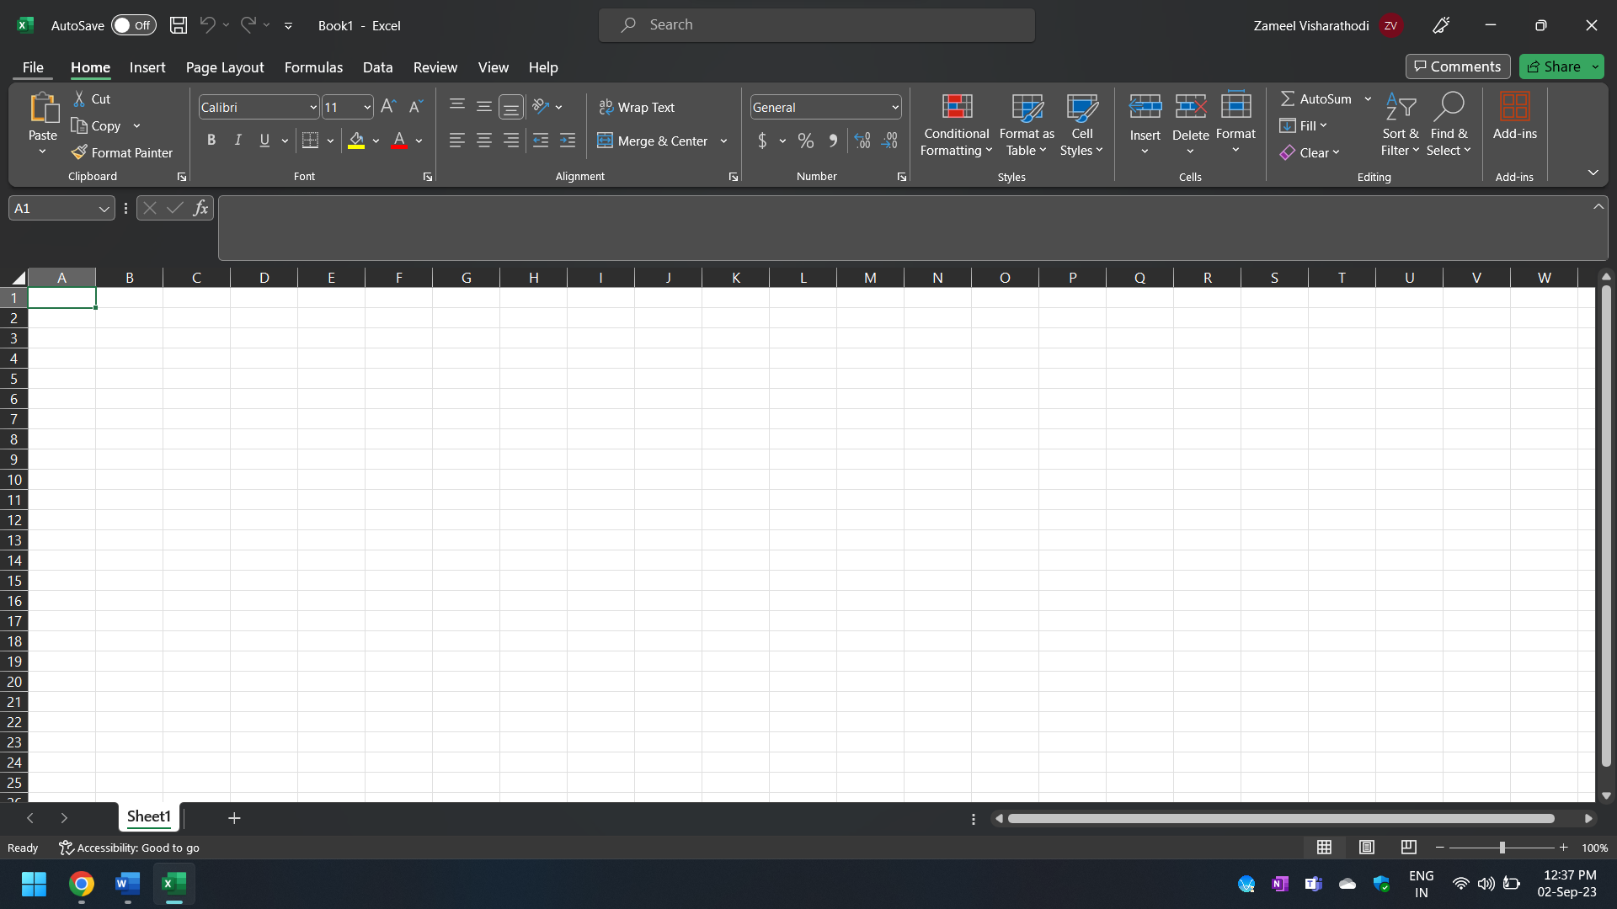

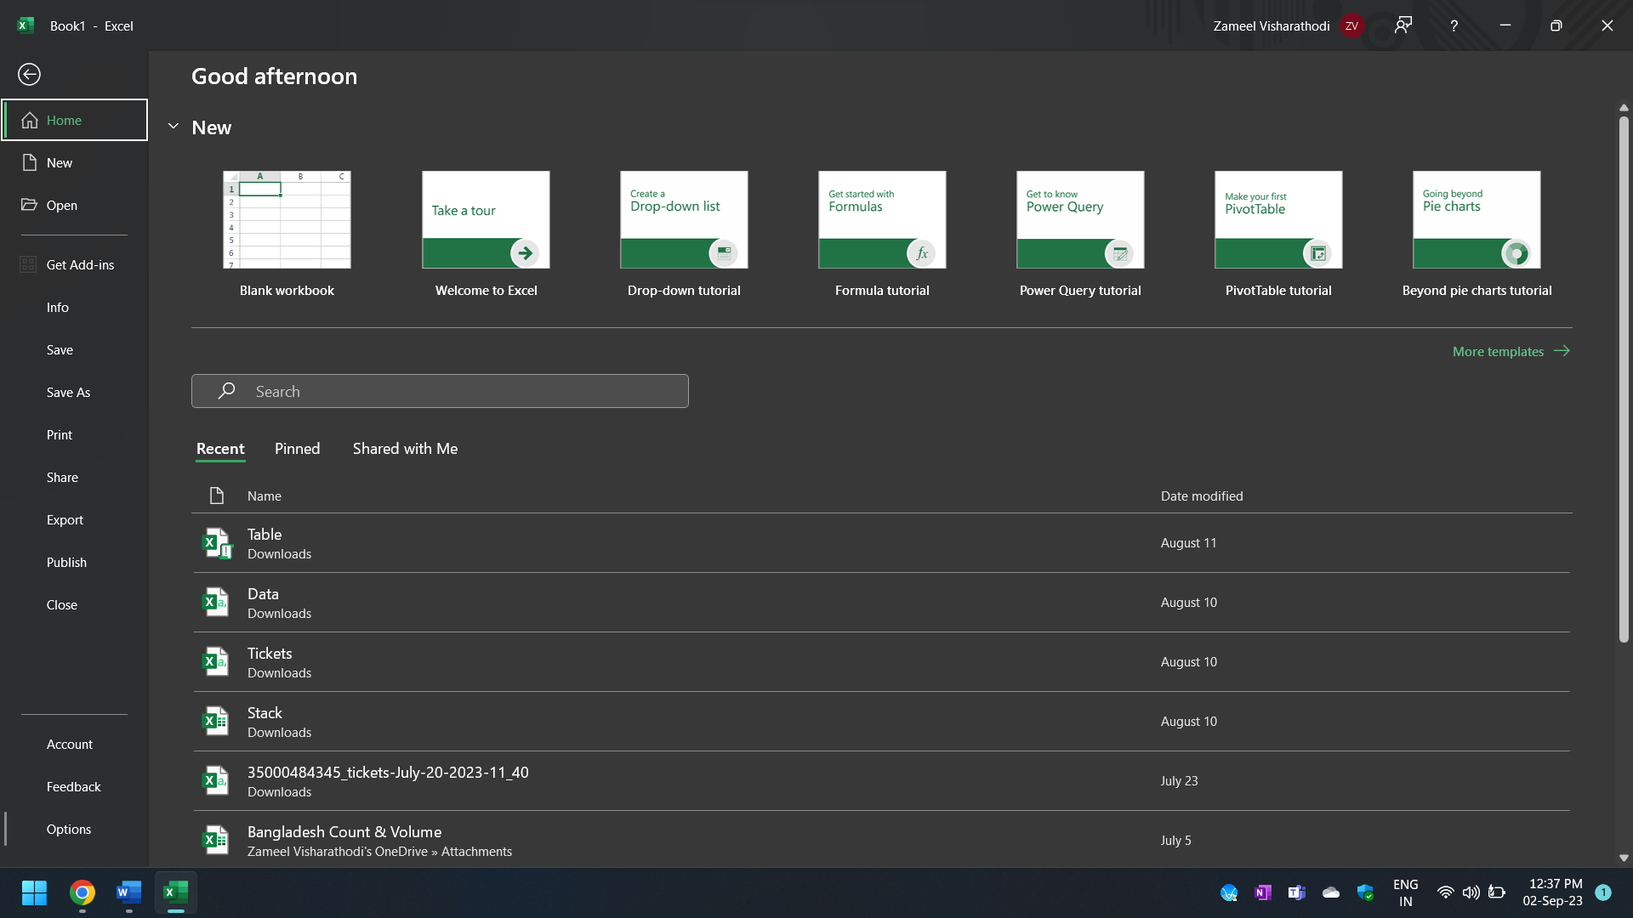

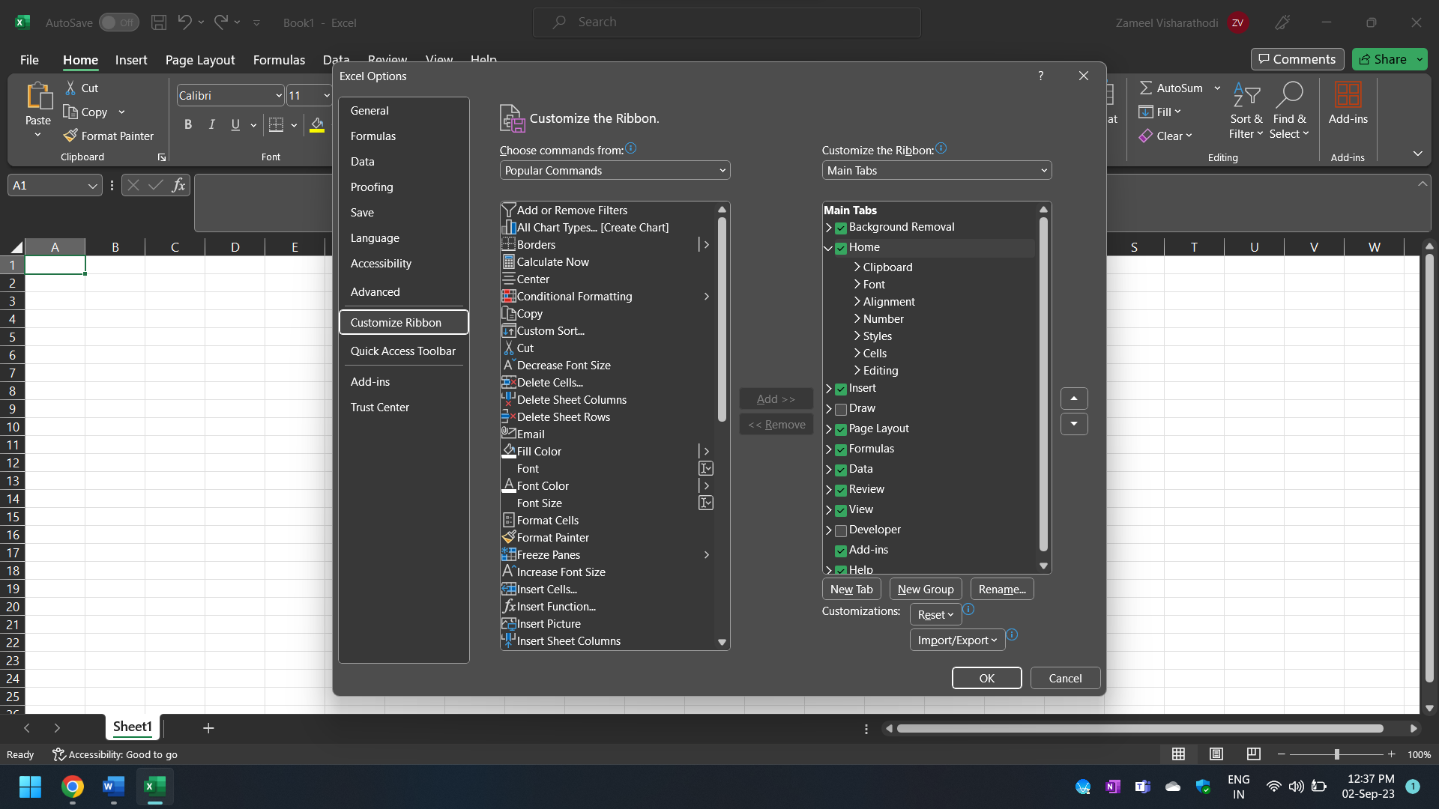

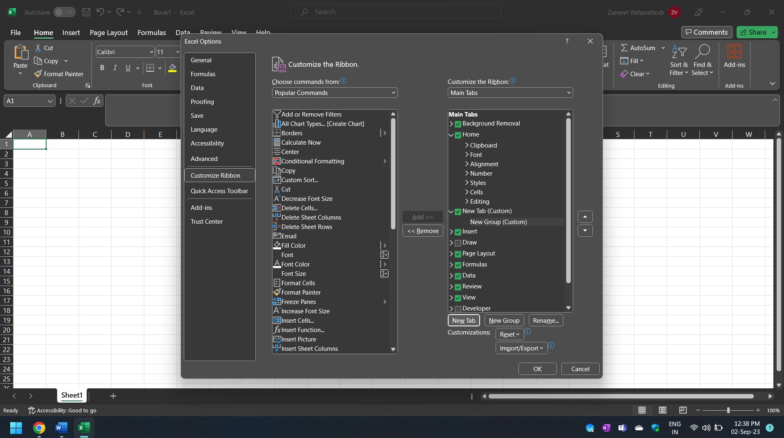

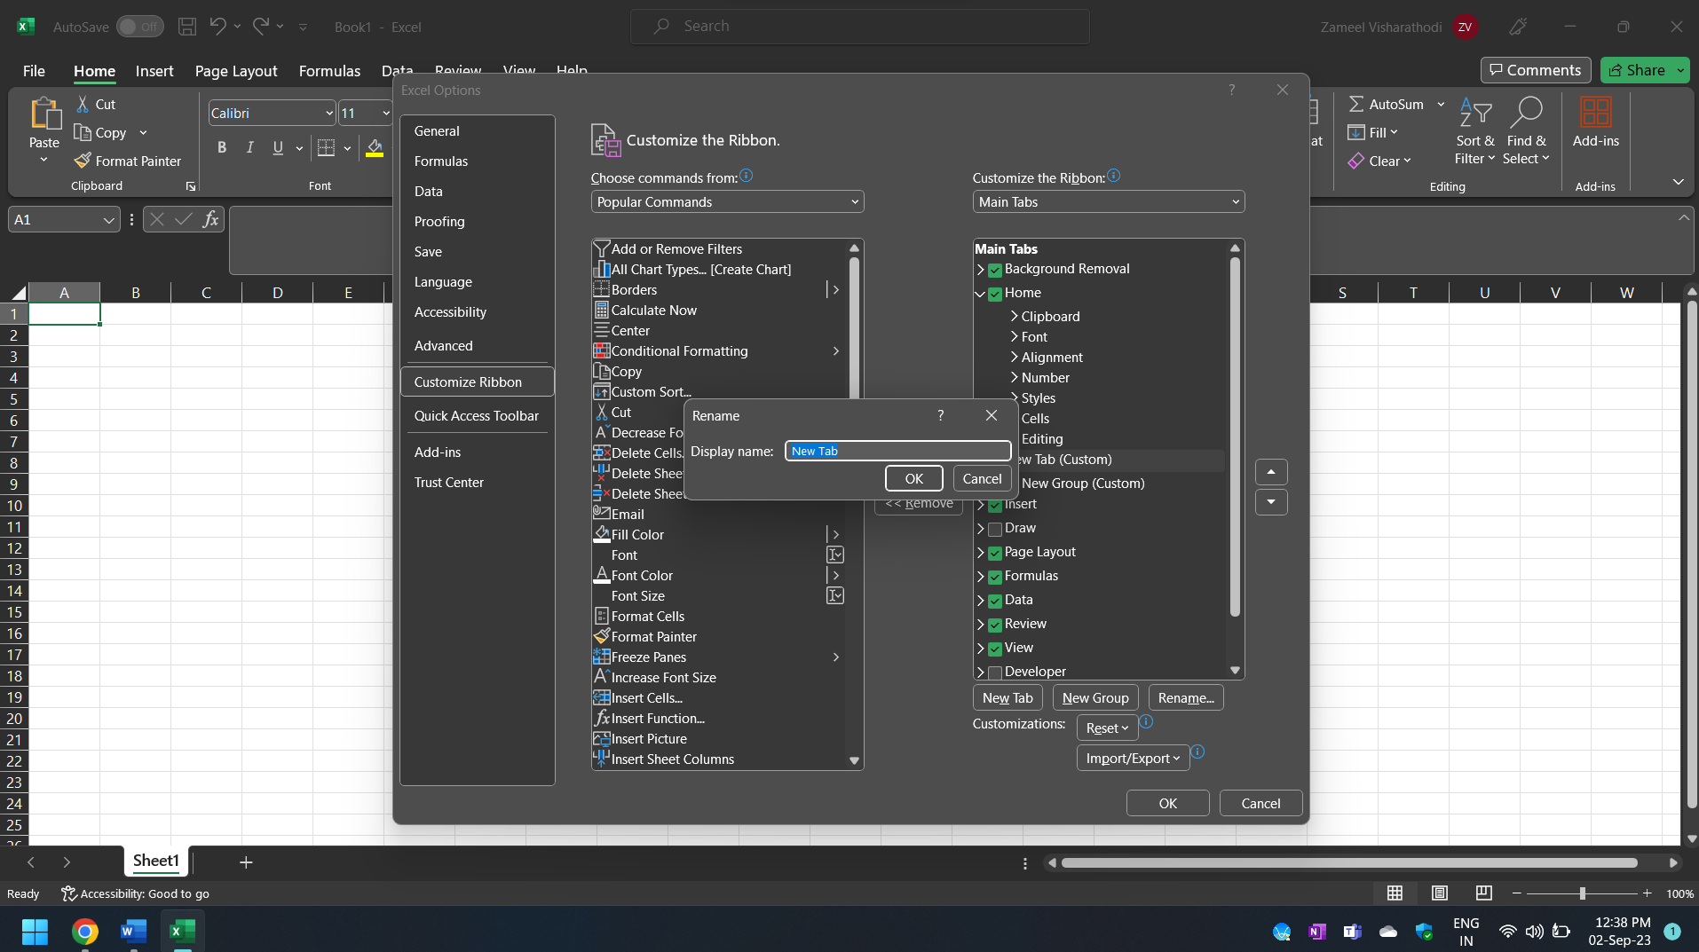

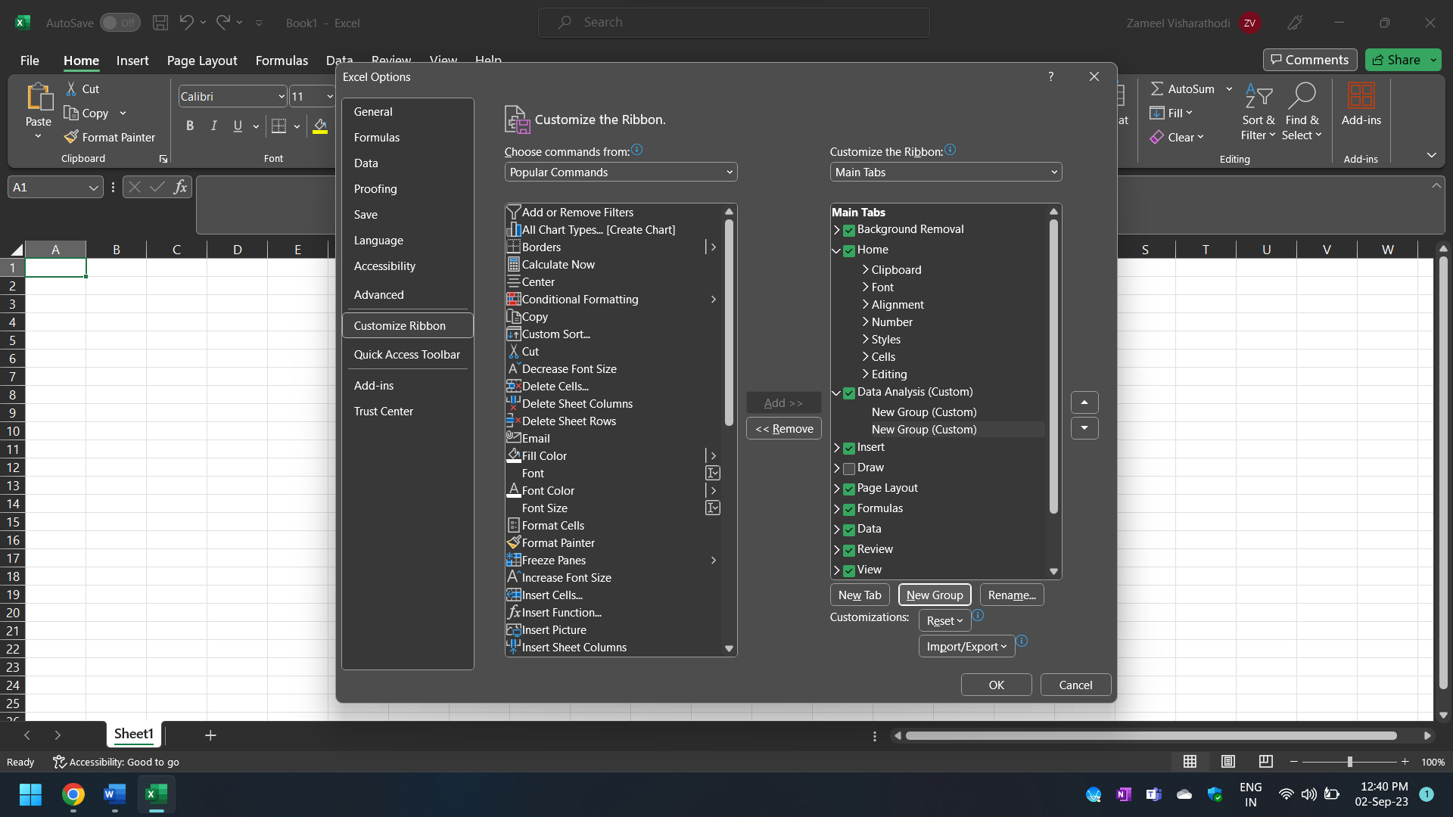

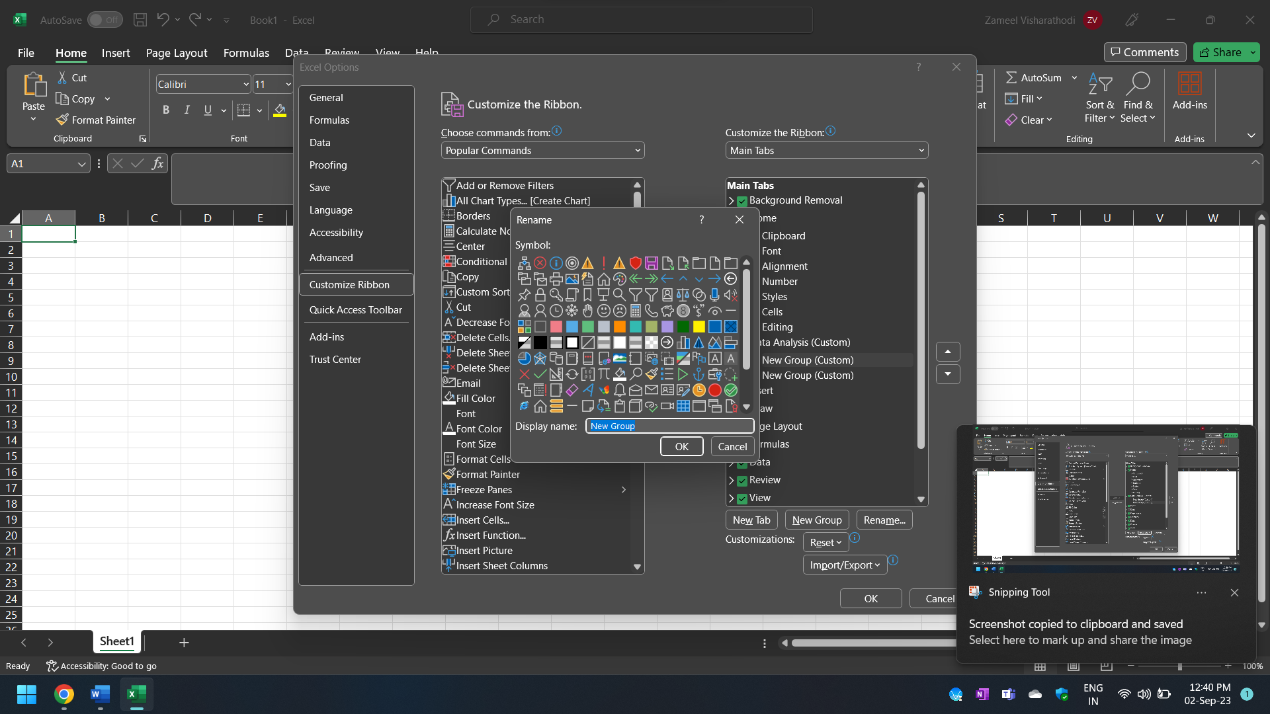

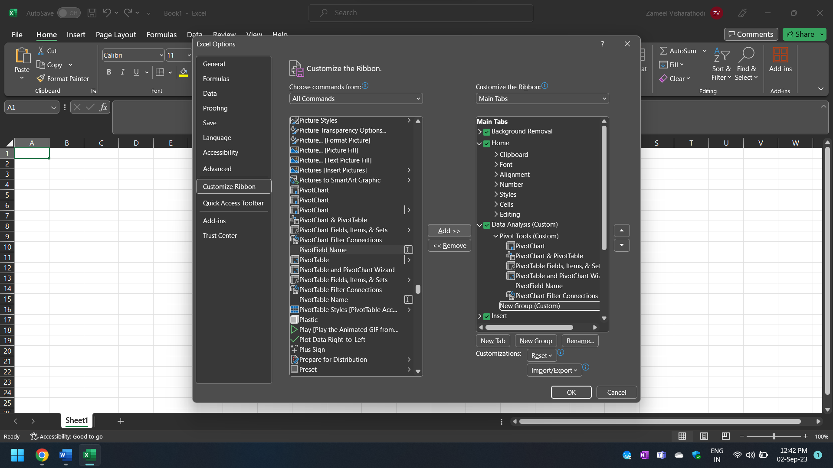

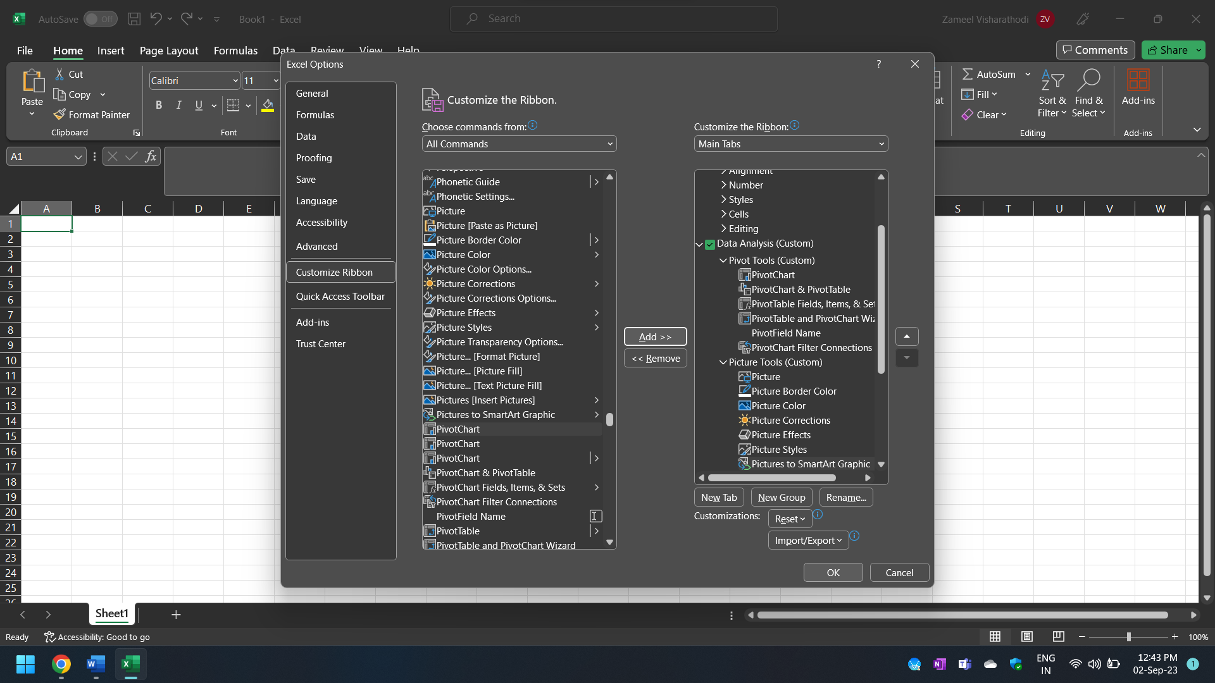

* **Ctrl+B**: This shortcut toggles text between bold and normal formatting.
* **Ctrl+I**: It toggles text between italic and normal formatting.
* **Ctrl+U**: It underlines or removes the underline from selected text.
* **Ctrl+1**: Opens the Format Cells dialog box, allowing you to customize various formatting options, such as font, number format, border, and more.
* **Ctrl+5**: Adds or removes a strikethrough line from selected text.
* Unlike some web-based analytical tools, Excel can be used offline, making it suitable for situations with limited or no internet access.
* Excel is often more cost-effective than specialized analytical tools, especially for small and medium-sized businesses.
* PivotTables are a powerful feature in Excel for data summarization, filtering, and analysis, allowing users to quickly gain insights from large datasets.
* Users can create custom functions and automate tasks using Visual Basic for Applications (VBA). This allows for tailored solutions to specific analytical needs.
* Excel is known for its user-friendly interface, making it accessible to users with varying levels of technical expertise. It doesn't require extensive programming skills to get started.
  + Select the data range you want to convert into a table.
* Go to the "Insert" tab in the Excel ribbon.
* Click on the "Table" button. A "Create Table" dialog box will appear.
* Ensure the "My table has headers" option is checked if your table has headers in the first row.
* Click "OK" to create the table.
* Click on the "File" tab in the Excel ribbon
* Select "Print" from the left-hand menu. You'll see a preview of your worksheet on the right side.
* In the center of the screen, under "Settings," you'll find options for customizing the header and footer.
* Click on "Header & Footer." This will open the "Header & Footer Tools" tab on the ribbon.
* In the "Header" box, you can type your custom header text. This will appear at the top of each printed page.
* In the "Footer" box, you can type your custom footer text. This will appear at the bottom of each printed page.
* Use the "Format Picture" and "Format Text" buttons on the ribbon to further customize the appearance of your header and footer.
* Click on "Apply to Sheets" to choose which sheets in your workbook should have this header and footer. You can select specific sheets or apply it to all sheets.
* Click "OK" to apply it.
* After customizing your header and footer, you can return to the Print Preview by clicking the "Back" button in the upper-left corner of the "Header & Footer" dialog box.
* Review how your worksheet will look when printed.
* To print, click on the "Print" button in the Backstage view.