1.

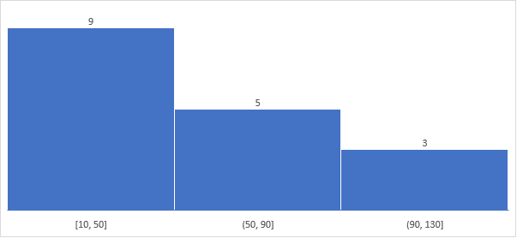2. The 80% confidence interval about the mean is (494.4, 545.6).

3. a)

* Null Hypothesis (H0): The percentage of citizens in city ABC who own a vehicle is 60% or less.
* Alternate Hypothesis (H1): The percentage of citizens in city ABC who own a vehicle is greater than 60%.

b)

Since the calculated z-score (1.96) is greater than the critical z-value (1.28), we have enough evidence to reject the null hypothesis. That is, there is enough evidence to support the idea that the percentage of citizens in city ABC who own a vehicle is greater than 60% at the 10% significance level.

4. The value of the 99th percentile in the dataset is 12.

5.

In left skewed graph, Mean < Median < Mode

In right skewed graph, Mode < Median < Mean

