Freight Rate Prediction Report

Executive summary
I promoted the fold-local 0.4/2.5 target-ratio screen after the review showed consistent gains across three seeds. The final run selected the log-target CatBoost by pooled May-September CV MAE. Its current seed-42 run scored $116.26 CV MAE and $110.93 October MAE. Five chronological folds are the primary evidence because October results were also considered during the cleaning review and October is no longer a fully untouched holdout.
The 48,000 labeled rows span January through October. The screen retained 47,387 rows and flagged 613 (1.28%). It is a heuristic for unusually large or small rate-per-mile ratios relative to leave-one-out training references. In the out-of-fold residual analysis, unusual ratios form low and high satellites around a central group: approximately 0.18-0.40x and 2.5-5.3x. Of the 290 bucket-flagged rows covered by May-September CV OOF predictions, 284 (97.93%) also crossed the OOF satellite cutoffs; nine additional OOF satellites were not bucket-flagged. The other 323 flags are outside that OOF scope. A tested feature-only tree scored ROC AUC 0.4741, so the available features did not predict the flags reliably. The screen improves average evaluation error, but it cannot establish that every flagged row is erroneous.

Data quality and cleaning
I normalized city strings, converted invalid and nonpositive weights to missing, and kept numeric preprocessing within each training fold. Coordinates for validation and the December lane are looked up from labeled training data. Feature generation does not calculate lane counts, target means, or other validation-frame aggregates.
For each fit fold, the cleaning code computes a row's expected rate-per-mile using leave-one-out medians from that fold's training rows only. It first looks within equipment and distance bucket, then falls back to equipment, then the same fold's global reference. Rows with actual/expected below 0.4 or above 2.5 are removed from model and baseline fitting. Scored rows and the unlabeled validation file are not passed to the flagger or fit calls. The cutoff is heuristic; it can remove legitimate loads and can miss corrupted labels.

Validation design and results
The five expanding-window folds score May through September using only earlier dates for fitting. This matches the future-prediction setting and avoids mixing later market conditions into earlier folds. Model selection uses pooled CV MAE. October is shown as a chronological check, with the caveat that it influenced the cleaning decision and is not an untouched final test.
Model | Pooled CV MAE | Pooled CV RMSE | October MAE | October RMSE
Log-target CatBoost, cleaned | $116.26 | $627.45 | $110.93 | $647.08
Raw-target MAE CatBoost, cleaned | $123.08 | $629.78 | $117.01 | $647.27
Linear regression, cleaned fit rows | $171.09 | $640.86 | $138.02 | $649.72
Median rate-per-mile, cleaned fit rows | $248.68 | $673.54 | $253.86 | $695.05

The three-seed paired experiment from the preceding review found pooled CV MAE of $124.44 +/- $2.43 for the all-row log model and $115.28 +/- $1.12 for the cleaned log model. October was $115.98 +/- $1.13 versus $110.80 +/- $0.19. These seed results support the cleaning choice; the final run above uses the configured seed 42 and both CatBoost candidates remain in the CV comparison.
The log target reduced the effect of the right-skewed rate scale during fitting. The raw-target MAE model did not beat it on pooled CV, although model rankings can vary by individual month. The model is selected by CV, not by October alone.

December chart
The final December series has 31 predictions, with minimum $798.41, median $807.98, and maximum $810.53. All rows are Dry Van loads over 360 miles on the Lexington-to-Fort-Wayne lane. The scorer accepted the required validation and December schemas and created the chart below. The scorer checks output validity; it does not measure model accuracy.
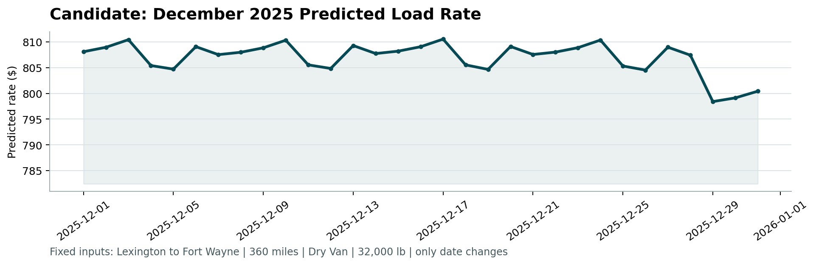
December 2025 predicted load rates

Limitations
The validation file has no labels, so its November-December accuracy cannot be measured here. Its labels may contain the same kind of target corruption; no model can repair unknown ground truth. Market-index shifts, unseen cities and lanes, and only ten months of labeled history limit how confidently the model can generalize. The screen itself is a rule based on observed training targets, not a verified data correction. October has contributed to the cleaning decision, so the main performance evidence is the five-fold CV.

Reproduction
From the repository root in PowerShell:
python -m src.train --config configs/config.yaml python score.py --predictions validation_predictions.csv --december-predictions data/december_chart_inputs.csv python -m compileall -q src scripts tests python -m unittest discover -s tests -v
The default configuration enables the 0.4/2.5 screen and compares both CatBoost candidates using CV MAE. Training and prediction outputs are reproducible with the configured seed.

