## OBJECTIVE



To join an organization where I can apply my knowledge of object-oriented programming, web technologies, and database systems.

Work with a variety of clients to build their back-end and front-end interfaces. My main aim is to be professional in Software Engineer, working in Software House to improve my Software Engineering skills and developing Web applications.

SUMAIR ALI MALLAH

Junior PHP developer

**CONTACT**

# Phone:

0305 1076865

**Email:** [sumairali8181@gmail.c](mailto:sumairali8181@gmail.c) om

# Address:

Block-no 02 Madhoo Ghot near Kala Board bus stop Gulshen-e-Iqbal Karachi

# Language:

* English
* Urdu
* SIndhi

**EXPIRIENCE**

Feb-2022 to May-23 **Web Development (**PHP with MYSQLI**)** Frontend and Backend.

At Hidaya Institute Science and Technology Jamshoro Sindh Pakistan.

1. June-23 to present **PHP developer**

Dow Medical University in IT department in Ojha Campus Karachi.

## EDUCATION

2018-2021 **Information Technology**

BS - Information Technology with **(3.29) CGPA**

At Sindh University Jamshoro.

2014-2016 **Intermediate**

Intermediate (Pre-Engineering) with ‘**B’** grade HSC Sukkur Sindh.

## SKILLS

**Web development**

* Laravel basic Level
* Front-end (HTML, CSS, JavaScript, AJAX, Bootstrap)
* Back-end (PHP, MySQL).
* Other languages (C++, Java).
* Database ( MySQL )
* Tool and Technologies ( SQLYog , PHP My Admin, Sublime , VS-code , Bootstrap )

**PROJECTS**

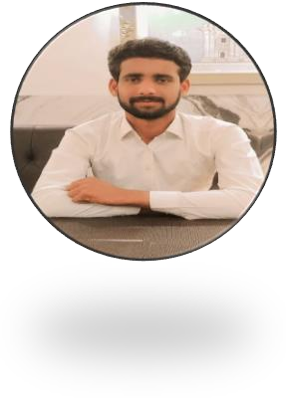

* 1. **Online Blogging System** (PHP, MySQL, AJAX, JavaScript and Bootstrap)
  2. **CURD System** (Using Laravel)
  3. **Group Chat System** (JavaScript, Ajax, PHP, MySQL database)
  4. **CRUD System** (PHP, JavaScript, AJAX, Bootstrap and MySQL Database).