**CSE3209 - Lecture 01**

**Introduction to Systems Analysis and Design**

**What are system analysis and design?**

System analysis and design deal with planning the development of information systems through understanding and specifying in detail what a system should do and how the components of the system should be implemented and work together.

Systems Analysis: understanding and specifying in detail what an information system should do.

System Design: specifying in detail how the parts of an information system should be implemented.

**The three main things system analysis and design focus on.**

Systems: complete knowledge required for the makeup of the system which in turn requires knowledge about the functioning of an organization for which the system is being designed

Processes:

Technology: Thus, a system is a way of thinking about an organization and their problems which involves techniques that helps in solving those problems.

**Characteristics of a system**

1. Organization: structure and order

Example: Hierarchical organization in a company.

Computer system: organization of various components like input devices, output devices, CPU and storage devices

1. Interaction: Between sub systems or the components

Example: the main memory holds the data that has to be operated by the ALU.

1. Interdependence: Component linkage, Component dependence.
2. Integration: How subsystems are tied together to achieve the system objective.
3. Central Objective: Should be known in early phases of analysis.

**Elements of a system.**

A system is a set of components working together to achieve some goal. The basic elements of the system may be listed as:

**1.** Resources: h/w, s/w and liveware (human), Example: Banking system- computers, trained staff.

**2.** Procedures: Set of rules to accomplish the goal of the system. Example: Banking systems have their predefined rules for providing interest at different rates for different types of accounts.

**3.** Data/Information: inputs/outputs.

**4.** Intermediate Data: Intermediate transformation of data before final output, Output depends on it

**5.** Processes: Operational elements to convert i/p into o/p. Example: the processing of a cheque as a process.

**6.** Environment: System should adapt to the environment.

**7.** Feed Back: Compares the output against a performance standard.

**8.** Boundaries and Interfaces: Every system has defined boundaries within which it operates. Beyond these limits the system has to interact with the other systems.

**Types of systems**

**1.** Physical or Abstract Systems: Physical systems are tangible entities that may be static or dynamic in operation. Abstract systems are not physical entities. They may be formulas, representation or model of a real system.

**2.** Open or Closed Systems: An open system continually interacts with its environments. It receives inputs from and delivers output to the outside. A closed system is isolated from environmental influences.

**3.** Deterministic or Probabilistic Systems: A deterministic system is one in which the occurrence of all events is perfectly predictable.

**4.** Man-made Information Systems: It is generally believed that information reduces uncertainty about a state or event. Main purpose of Man-made Information Systems is managing data for a particular organization.

Further Categorized as:

* + 1. Formal Information Systems: Responsible for flow of information from top management to lower management.
    2. Informal Information Systems: Informal systems are employee based. These are made to solve the day to day work related problems.
    3. Computer-Based Information Systems: This class of systems depends on the use of computer for managing business applications.

**Management information system**

* These systems assist lower management in problem solving and making decisions.
* They use the results of transaction processing and some other information also.
* An important element of MIS system is database.
* And the information is accessed through DBMS.

**The three sub-components:**

1. System emphasizing a fair degree of integration and a holistic view.
2. Information stressing on processed data in the context in which it is used by end users
3. Management focusing on the ultimate use of such information systems for managerial decision making.

**The five components:**

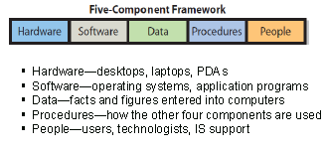

**The concept of MIS:**

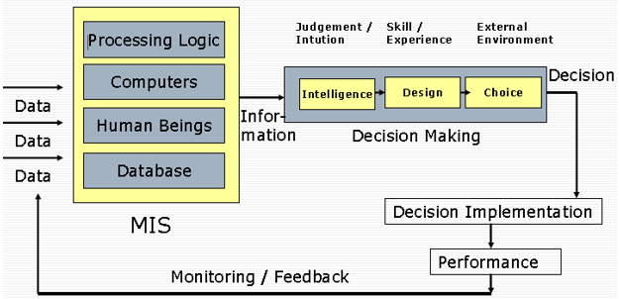

**Types of decision support system**

Using the relationship with the user as the criterion

1. A passive DSS is a system that aids the process of decision making, but that cannot bring out explicit decision suggestions or solutions.
2. An active DSScan bring out such decision suggestions or solutions.
3. A cooperative DSSallows the decision maker (or its advisor) to modify, complete, or refine the decision suggestions provided by the system, before sending them back to the system for validation.

**Common components of an automated system.**

1. Computer hardware: CPUs, disks, terminals, and so on.
2. Computer software: system programs such as operating systems, database systems, and so on.
3. People: those who operate the system, those who provide its inputs and consume its outputs, and those who provide manual processing activities in a system.
4. Data: the information that the system remembers over a period of time.
5. Procedures: formal policies and instructions for operating the system.

**Advantages of Distributed Systems**

1. Economics: cost effective way to increase computing power.
2. Speed: a distributed system may have more total computing power than a mainframe.
3. Reliability: If one machine crashes, the system as a whole can still survive. Higher availability and improved reliability.
4. Incremental growth: Computing power can be added in small increments. Modular expandability.
5. Data sharing: allow many users to access to a common data base
6. Resource Sharing: expensive peripherals like color printers
7. Communication: enhance human-to-human communication, e.g., email, chat
8. Flexibility: spread the workload over the available machines.

**Disadvantages of Distributed Systems**

1. Software:difficult to develop software for distributed systems.
2. Network:saturation, lossy transmissions.
3. Security:easy access also applies to secrete data.