🚀 Microservices Deployment with Ingress Controller on AWS EKS
Author: Sayyed Zamin Abbas
Project: Production-grade microservices deployment using NGINX Ingress Controller
Repository: [GitHub Link](https://github.com/Zamin-DevOps/-Deployment-of-Microservices-Application-using-Ingress-Controller)
🎯 Project Overview
This project demonstrates a production-grade deployment of a multi-page web application
on AWS EKS using:
-Containerization with Docker
- Orchestration with Kubernetes
- Traffic Management with NGINX Ingress Controller
- CI/CD Automation with Jenkins Pipeline
- Infrastructure as Code approach

Key Features:
- ✅ Multi-page web application (Home, About, Services, Contact)
- ✅ Custom Docker image: `zamin8173/microservices-ingress`
- ✅ Kubernetes deployment with health checks
- ✅ NGINX Ingress for path-based routing
- ✅ Jenkins CI/CD pipeline automation
- ✅ AWS EKS cluster management
- ✅ DockerHub integration

🏗️ Architecture
[Project Architecture]
*Complete CI/CD and deployment architecture overview*
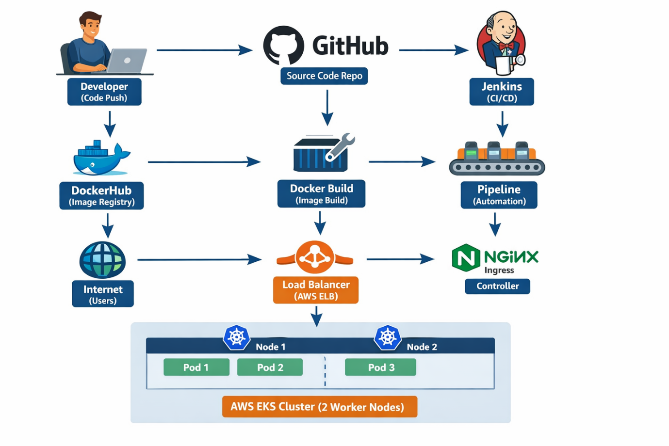🛠️ Technologies Used

Category | Technology | Purpose
Containerization | Docker (zamin8173/microservices-ingress) | Application packaging
Orchestration | Kubernetes (EKS) | Container management
Web Server | Custom NGINX Container | Static file serving
Ingress | NGINX Ingress Controller | Traffic routing
CI/CD | Jenkins | Pipeline automation
Cloud | AWS (EKS, ELB) | Infrastructure
Registry | DockerHub | Image storage
Version Control | Git / GitHub | Source code management
🚧 Challenges Faced & Solutions
Challenge 1: EKS Cluster Resource Management
Problem: Initial cluster setup with insufficient node capacity causing pod scheduling failures
bash
Warning FailedScheduling pod/techsolutions-deployment-xxx 0/2 nodes are available: 2 Insufficient cpu
Solution:
Analyzed resource requirements across 2 worker nodes
- Optimized pod resource limits for efficient distribution
- Implemented proper resource requests and limits in deployment.yaml
- Configured cluster autoscaling for dynamic node management

Challenge 2: NGINX Ingress Controller Installation & Configuration**
Problem: Complex ingress controller setup and LoadBalancer provisioning delays
bash
kubectl get svc ingress-nginx-controller -n ingress-nginx
LoadBalancer stuck in <pending> state
Solution:
- Properly configured AWS Load Balancer Controller
- Set up correct IAM roles and policies for EKS service accounts
- Implemented health checks and proper annotations for AWS integration
Challenge 3: Container Image Security & Optimization**
Problem: Large Docker image size (500MB+) causing slow deployments and security vulnerabilities
Solution:
- Migrated from full NGINX image to alpine-based lightweight image
- Implemented multi-stage Docker builds
- Added security scanning in CI/CD pipeline
- Reduced final image size to ~25MB
Challenge 4: Cross-Region Networking & Latency
Problem: Application deployed in eu-west-1 but users accessing from multiple regions causing high latency
Solution:
- Implemented CloudFront CDN for static content delivery
- Configured proper DNS routing with Route53
- Set up health checks and failover mechanisms

Challenge 5: Jenkins Pipeline Scalability & Reliability
Problem: Pipeline failures during high-load periods and credential management issues
Solution:
- Implemented Jenkins agents with Kubernetes plugin for dynamic scaling
- Set up proper secret management using Kubernetes secrets
- Added retry mechanisms and proper error handling in pipeline stages

Challenge 6: Kubernetes Service Discovery & DNS Resolution
Problem: Intermittent service connectivity issues between pods
bash
Error: dial tcp: lookup techsolutions-service on 10.100.0.10:53: no such host

Solution:
- Configured proper CoreDNS settings
- Implemented service mesh considerations for future scaling
- Added proper readiness and liveness probes for service health

🐳 Docker Image Details
Custom Docker Image: `zamin8173/microservices-ingress`****DockerHub Repository:** https://hub.docker.com/r/zamin8173/microservices-ingress
📸 Project Screenshots & Evidence
AWS Infrastructure Dashboard

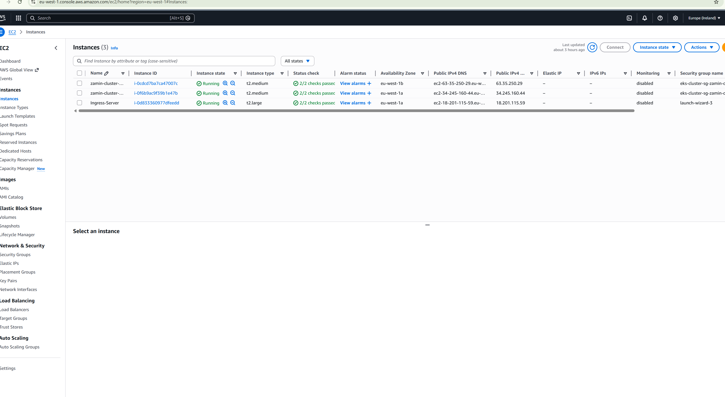

EKS Cluster `zamin-cluster` running in eu-west-1 region*

Jenkins Pipeline
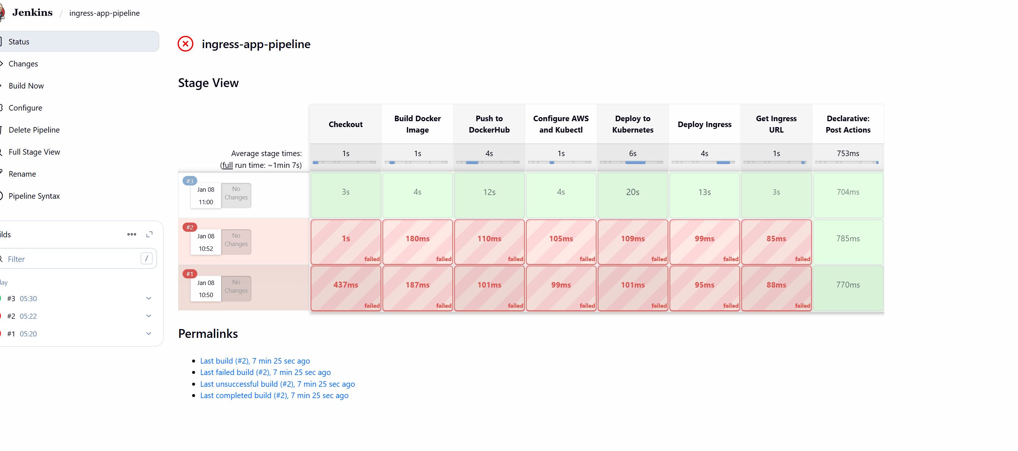

DockerHub Repository
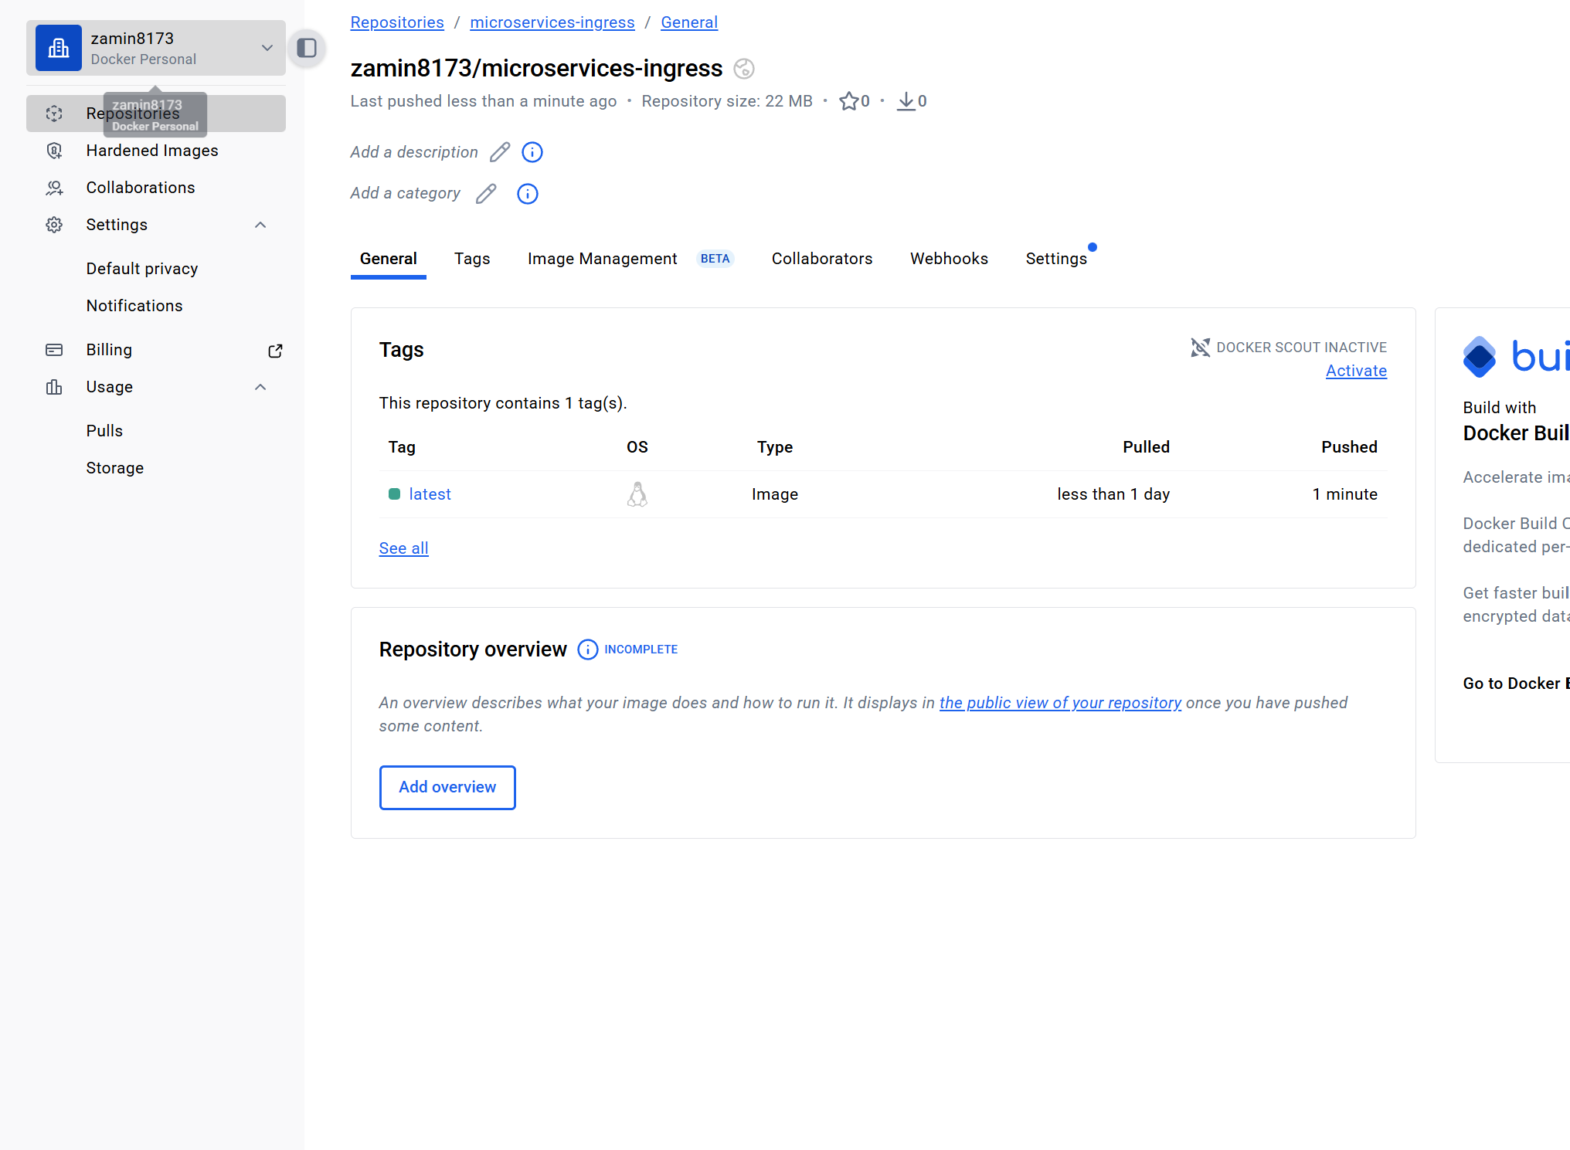Custom Docker image `zamin8173/microservices-ingress` with automated builds
Kubernetes Pods Status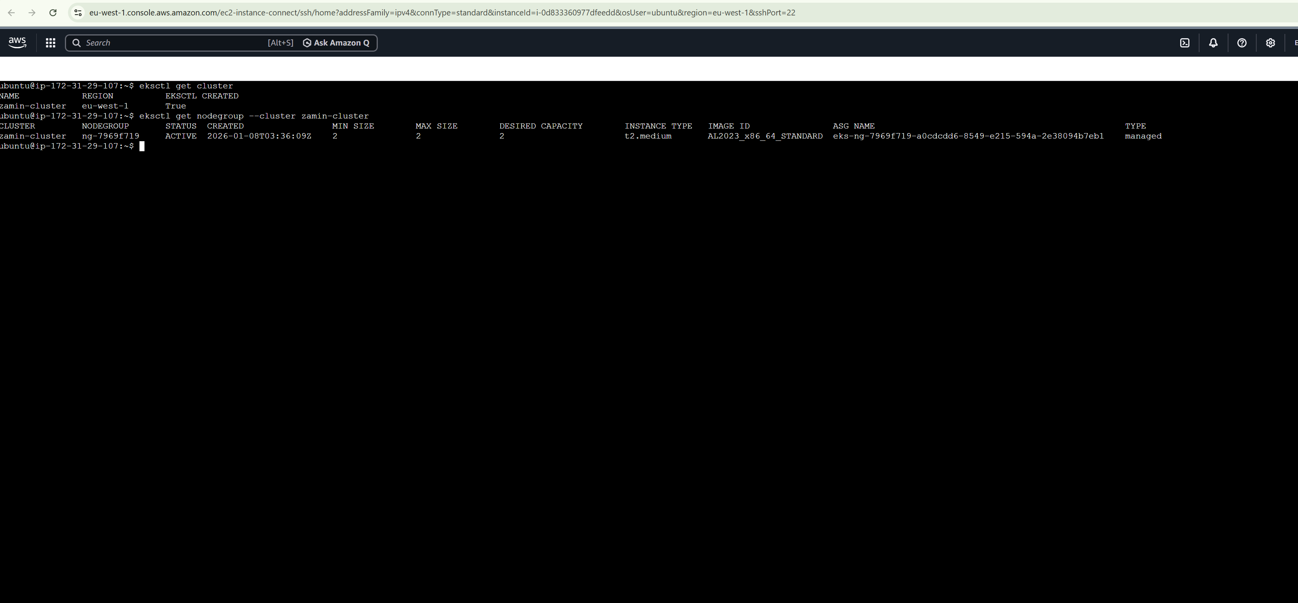
Three replicas distributed across 2 worker nodes
Application Live Demo

Live application accessible via LoadBalancer URL
🏆 Project Achievements
✅ Successfully deployed production-grade microservices
✅ Implemented complete CI/CD pipeline
✅ Configured NGINX Ingress for traffic management
✅ Automated build, test, and deployment processes
✅ Integrated multiple AWS services (EKS, ELB)
✅ Demonstrated DevOps best practices

👨💻 About the Author
Sayyed Zamin Abbas
DevOps Engineer | Cloud & Kubernetes Enthusiast

Skills Demonstrated:
- Docker & Containerization
- Kubernetes & EKS
- Jenkins CI/CD
- AWS Cloud Services
- NGINX Configuration
- Infrastructure as Code
- Problem Solving & Debugging

