6. Prototype: Unified Operations Dashboard
6.1 Introduction
As part of the EIS research project, my responsibility was to design and implement a working prototype that demonstrates how multiple enterprise systems (ERP, CRM, HRMS, WMS, and Digital Wallet) can be unified into a single operational view. The goal was to address the integration challenges identified from stakeholder interviews and show how a consolidated dashboard can support data-driven decision-making.
The prototype was developed using a React-based frontend and a Spring Boot backend API, following the architecture principles outlined in the proposed future-state EIS model.
The dashboard visually integrates KPIs from multiple enterprise systems and presents them in a clear and actionable format for operations managers.

6.2 Objectives of the Prototype
Based on interview insights, the prototype was designed to solve the following pain points:
Pain Points Addressed
- Lack of a single shared view across HR, CRM, warehouse, and operations data.
- Manual tracking of performance metrics through siloed tools (Excel, emails, separate systems).
- No ability to correlate workforce utilisation, service quality, and warehouse throughput.
- Delayed visibility into operational bottlenecks due to the absence of real-time updates.
- Fragmented system landscape with limited cross-system reporting.
Prototype Objectives
- Create a unified dashboard showing critical KPIs from HRMS, CRM, WMS, and ERP.
- Provide a real-time operational snapshot for decision-makers.
- Demonstrate how an EIS integration layer can feed consolidated data to a modern UI.
- Deliver an interactive and visually appealing proof-of-concept for presentation.

6.3 System Architecture
The prototype follows a modular and integration-ready architecture.
Below is the PlantUML architecture diagram:
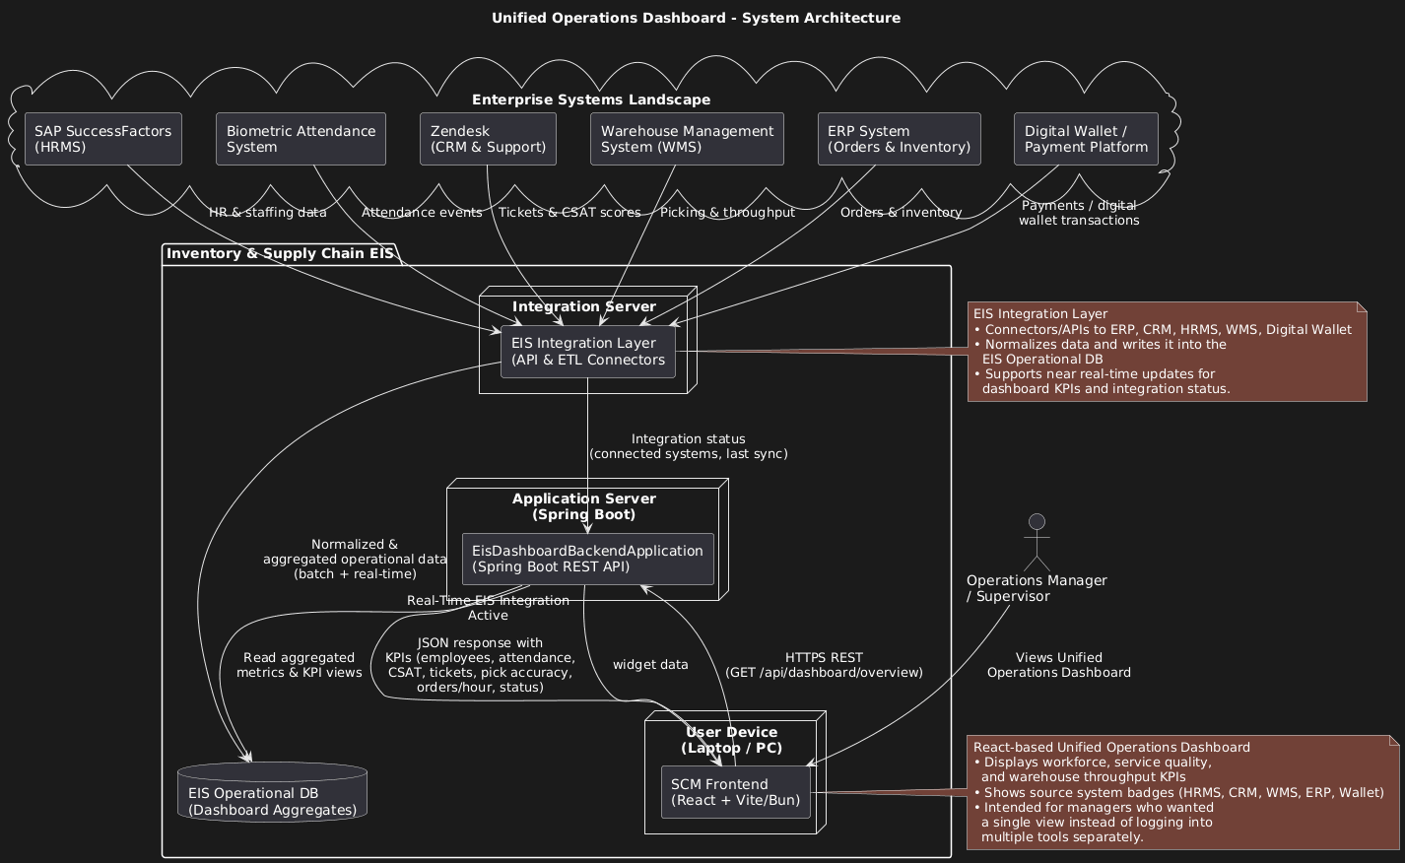

Architecture Description
The system architecture consists of:
1. Enterprise Systems Layer
- HRMS (SAP SuccessFactors) → Employee & attendance data
- CRM (Zendesk) → Customer satisfaction & ticket resolution
- WMS (Warehouse Management System) → Pick accuracy
- ERP → Orders processed per hour
- Digital Wallet → (Future extension)
2. Integration Layer
A unified service layer acts as a middleware to normalize data from multiple systems.
3. Backend API (Spring Boot)
- Provides endpoint: /api/dashboard/overview
- Aggregates simulated or real-time values
- Returns consolidated KPI object to frontend
4. Frontend (React / Vite)
- Renders workforce, service, and throughput KPIs
- Includes EIS integration health indicators
- Fully responsive and styled for executive dashboards
You will include the PNG of the architecture diagram in your documentation and GitHub README.

6.4 Prototype Features
Workforce & Service Health
- Total Employees
Source: HRMS
Displays total active staff across all operations.
- Average Attendance
Source: HRMS + Biometric system
Shows daily/monthly attendance rate vs. target values.
- Average CSAT (Customer Satisfaction)
Source: CRM
Consolidated satisfaction rating (1–5 scale).
- Tickets Resolved
Source: CRM
Count of support tickets closed during current period.

Warehouse Throughput
- Pick Accuracy (%)
Source: WMS
Measures order picking quality compared to target.
- Orders per Hour
Source: ERP / WMS
Reflects throughput of warehouse operations.

EIS Integration Health
- Number of systems connected
- Data sources currently active
- Last sync status
- Overall integration operational status

6.5 Screenshots of the Prototype
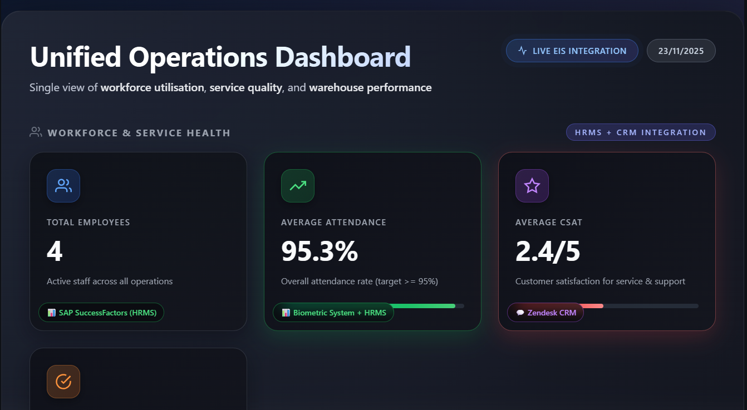
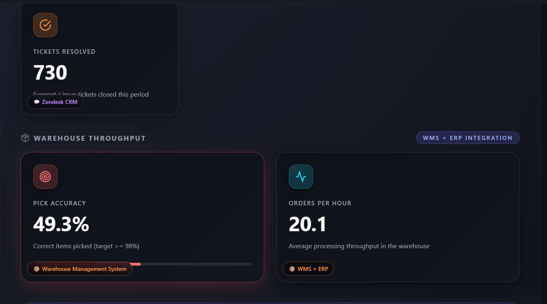
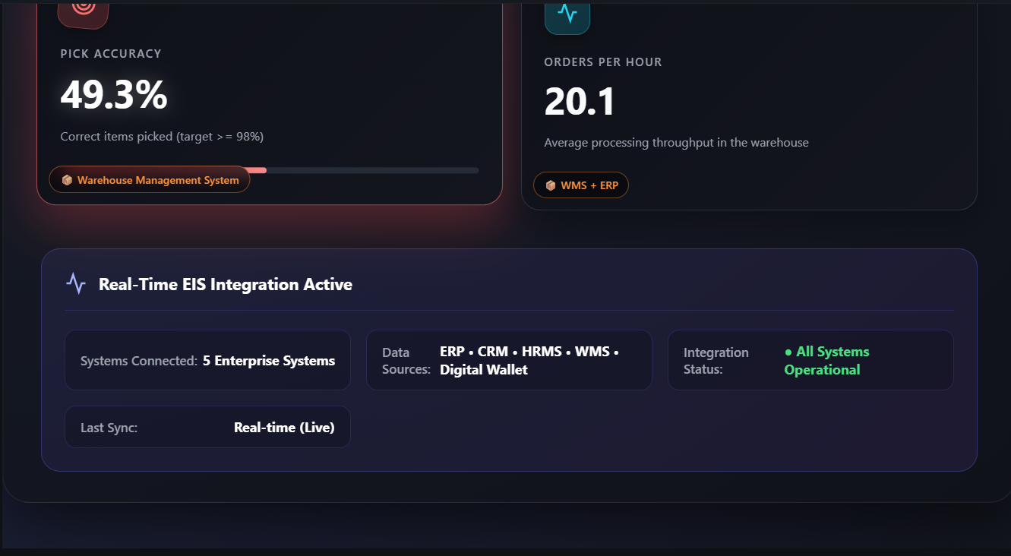

6.6 Technology Stack
Layer | Technology
Frontend | React (Vite), Tailwind CSS / Custom CSS
Backend | Spring Boot (Java)
Architecture Modeling | PlantUML
Version Control | Git + GitHub
Deployment | Local demo (for presentation)

6.7 How the Prototype Demonstrates EIS Integration
The prototype simulates real enterprise integrations by:
- Combining workforce, service quality, and warehouse KPIs into a single screen.
- Displaying standardized metrics regardless of the source system.
- Demonstrating how an EIS layer simplifies data consumption for operational teams.
- Showing a future-ready interface where real APIs can replace simulated data with minimal modification.
This meets the Phase 3 requirement:
A working prototype demonstrating an EIS component.

6.8 Limitations (for academic transparency)
- Backend uses simulated data instead of actual APIs due to access restrictions.
- Limited filters/drilldowns (future enhancement).
- Not deployed to cloud, run locally for prototype demonstration.

6.9 Conclusion
The prototype successfully addresses key interview pain points and shows how enterprise systems can be unified into a single operational snapshot. It provides a practical demonstration of Phase 3 and Phase 4 deliverables and lays the foundation for a scalable EIS integration dashboard.

