AWS Assignment Report
Course Name & Code: AWS
Instructor: Nitha

Assignment Details
Assignment Title: Automated Database Backup to Amazon S3 using IAM Role
Date: April 13, 2026

Student Information
Name: Sameer Malik
Email: sameermalik.dev@gmail

Objective
The objective of this assignment is to implement a secure and automated database backup system using AWS services. This includes configuring IAM roles, setting up MariaDB, writing a backup script, and storing backups in Amazon S3.

Implementation Steps
- Created IAM Policy (S3BackupPolicy) with required permissions (PutObject, GetObject, ListBucket).
- Created IAM Role (EC2-S3-Backup-Role) and attached the policy.
- Attached IAM Role to EC2 instance for secure access.
- Installed and configured MariaDB on EC2 instance.
- Created backup shell script to dump databases and sync with S3.
- Configured AWS CLI and executed backup script.
- Verified backups in S3 bucket.

Screenshots
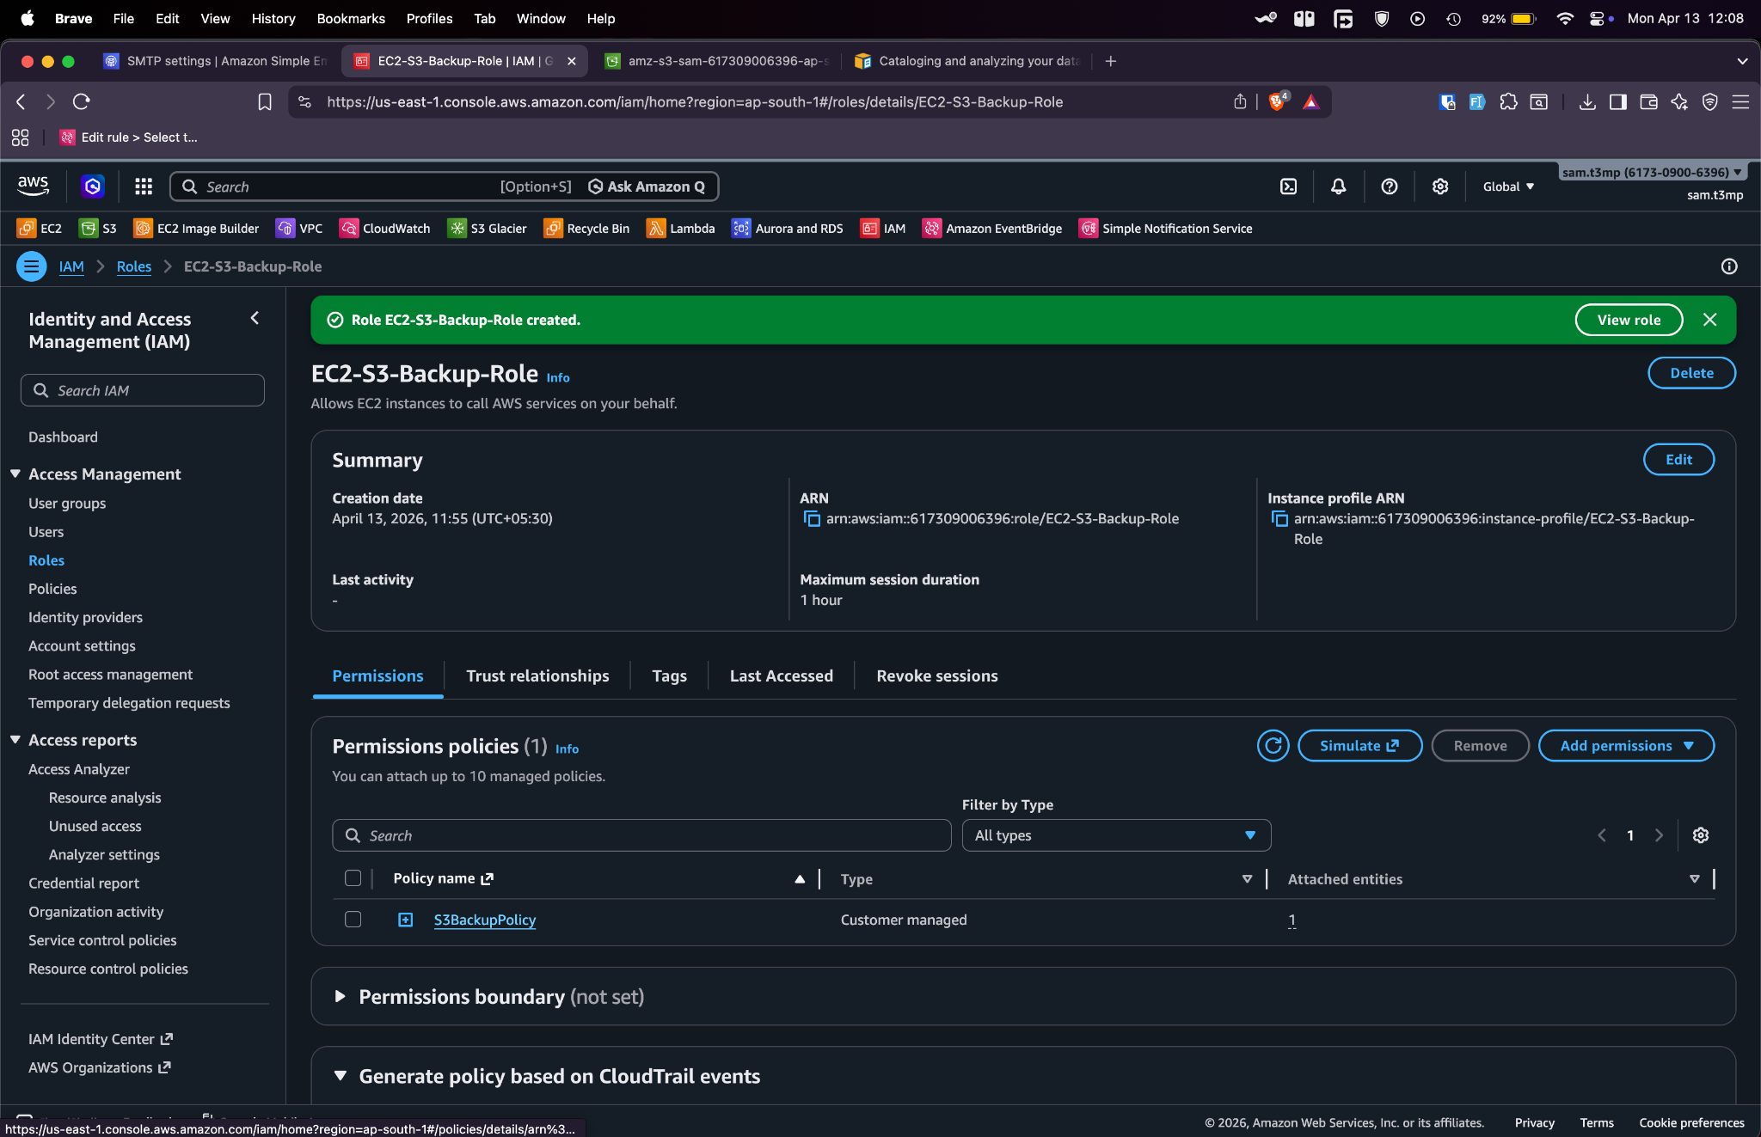
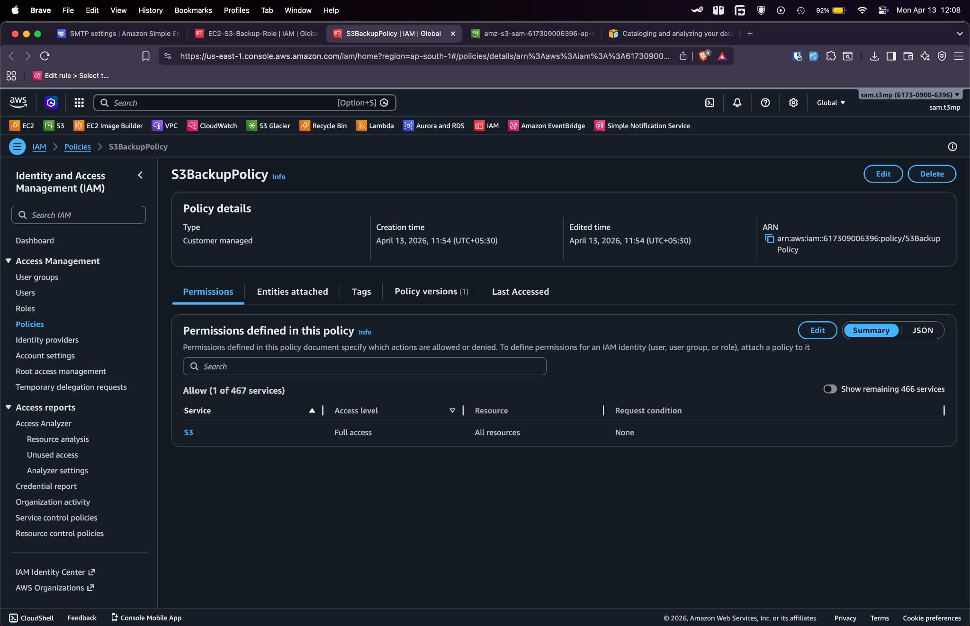
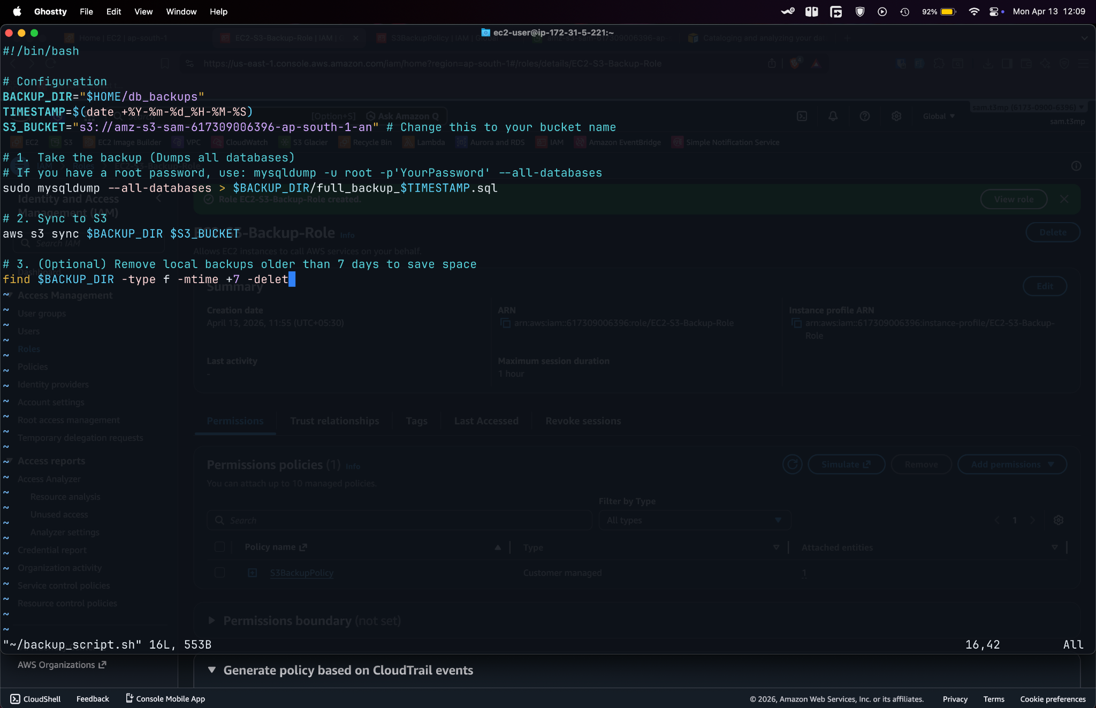
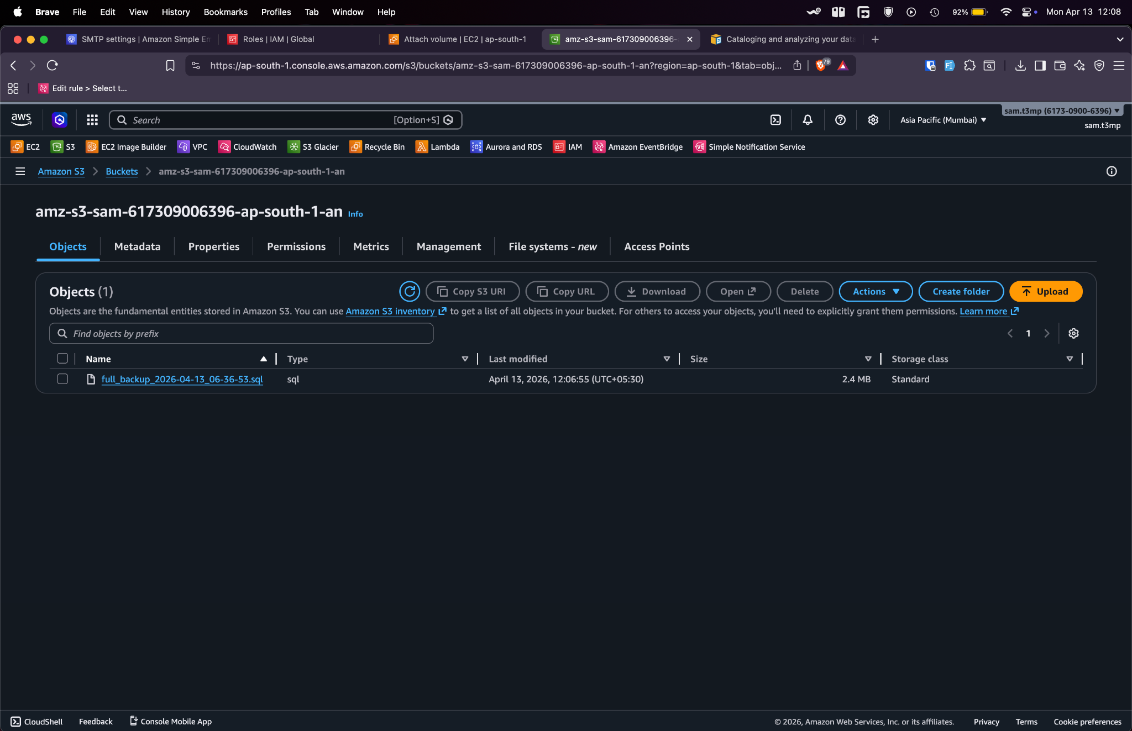

Result
Successfully implemented an automated and secure backup solution. Database backups are generated and stored in Amazon S3 with proper IAM role-based access.

