ASSIGNMENT REPORT
Course | Amazon Web Services (AWS)
Instructor | Nitha
Task ID | Task #48780
Assignment Title | Jenkins Basics
Student Name | Sameer Malik
Student Email | sameermalik.dev@gmail.com

Objectives
This assignment covers three core learning goals:
- Learn the basics of the Jenkins Automation Server and understand its core concepts.
- Learn about the CI/CD deployment methods commonly used with Jenkins.
- Install Jenkins on an AWS EC2 instance running RHEL 10 and verify the setup.

Part 1: Installing Jenkins on AWS EC2 (RHEL 10)

Create an instance and ssh into it
- An AWS EC2 instance running RHEL 10 (t2.micro).
- Security Group must allow inbound TCP on port 8080 (Jenkins UI) and port 22 (SSH).

Connect to the instance over SSH using your key pair:
ssh -i your-key.pem ec2-user@<PUBLIC_IP>
Update the system:
sudo dnf update -y

Check Available Java Versions
search to see what versions are available in the repository:
sudo dnf search openjdk

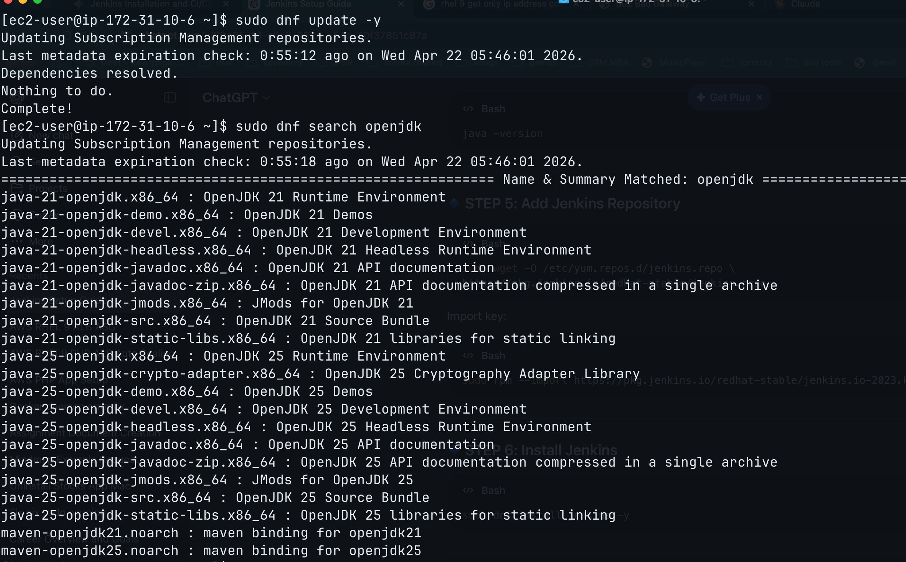
dnf update completes successfully; dnf search openjdk lists available Java versions

Install Java 25 (OpenJDK)
From the search results, Java 25 (LTS) is the recommended version for Jenkins 2.55. Install it with:
sudo dnf install -y java-25-openjdk.x86_64

Verify the installation:
java -version

Add the Jenkins YUM/DNF Repository
Jenkins is not in the default RHEL repositories. You must add the official Jenkins repository. Download the .repo file:
sudo wget -O /etc/yum.repos.d/jenkins.repo \
https://pkg.jenkins.io/redhat-stable/jenkins.repo
The wget command fetches the repository configuration file and saves it to /etc/yum.repos.d/jenkins.repo. You will see a 301 redirect followed by a 200 OK and a download progress bar.

Import the Jenkins GPG Signing Key
Import the Jenkins GPG key to authenticate packages from the Jenkins repository:
sudo rpm --import https://pkg.jenkins.io/redhat-stable/jenkins.io-2023.key

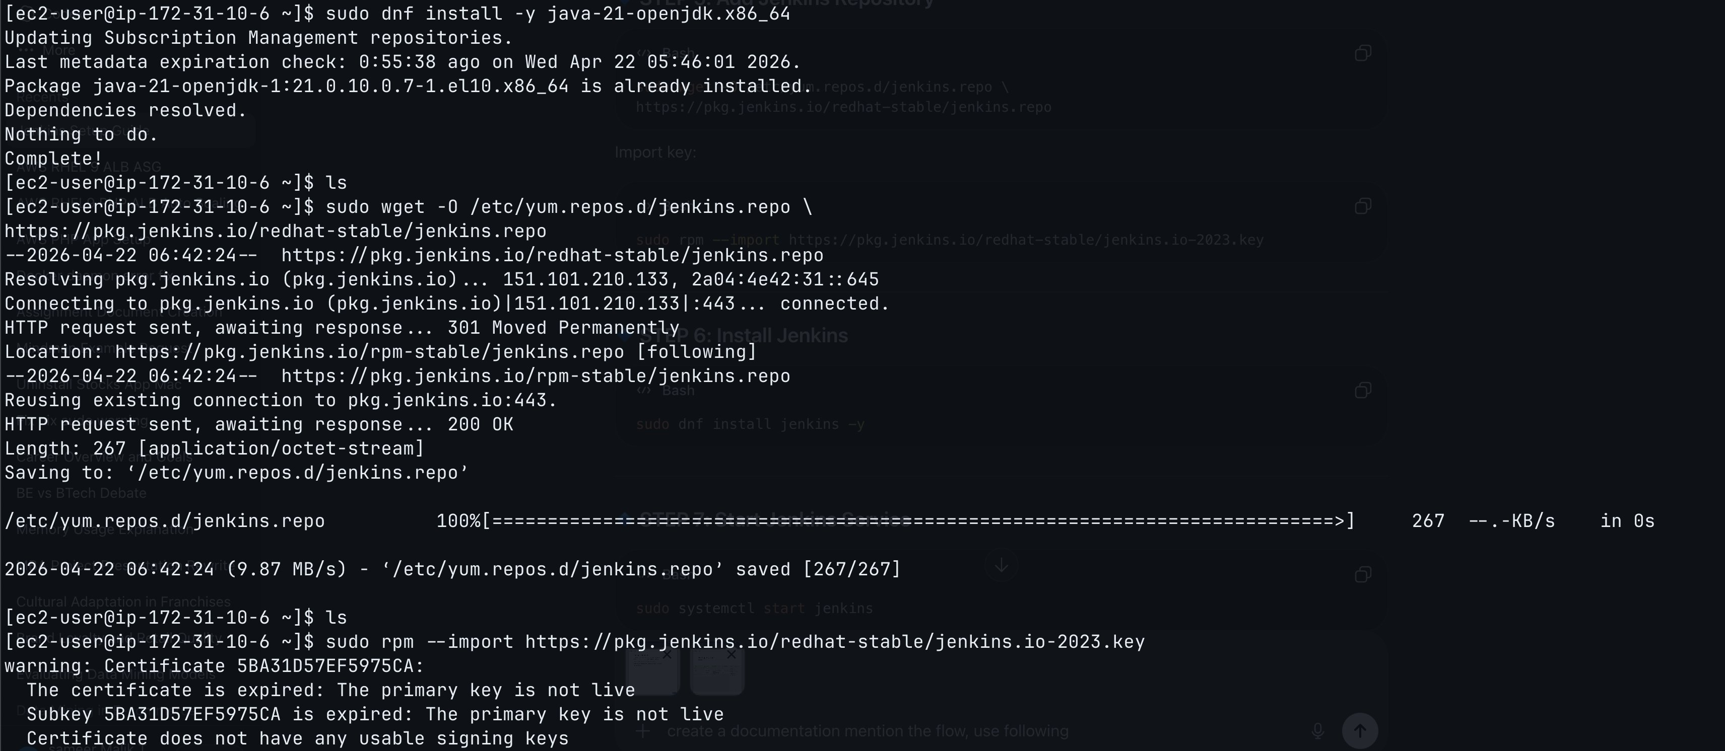
Java 25 already installed; Jenkins repo file downloaded successfully to /etc/yum.repos.d/jenkins.repo; GPG key import shows a certificate warning (key expired) but proceeds normally

Install Jenkins
With the repository and key in place, install Jenkins using dnf:
sudo dnf install jenkins -y
If Jenkins is already installed, dnf will report 'Package jenkins-2.555.1-1.noarch is already installed. Nothing to do. Complete!'

Enable and Start Jenkins Service
Enable Jenkins to start automatically on boot and start it immediately:
sudo systemctl enable --now jenkins
This single command both enables the service (start on boot) and starts it right now. You can verify the status with:
sudo systemctl status jenkins

Step 9: Retrieve the Initial Admin Password
On first launch, Jenkins generates a one-time Administrator password stored in a file. Retrieve it with:
sudo cat /var/lib/jenkins/secrets/initialAdminPassword
Copy the alphanumeric string that is printed. You will need it in the next step to unlock Jenkins.

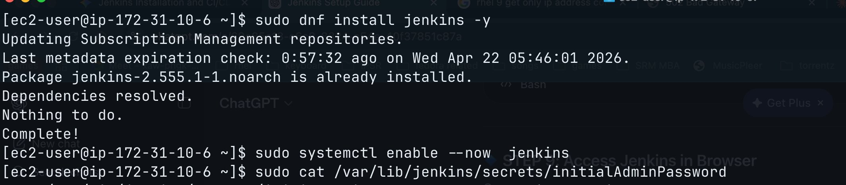
cat retrieves the initialAdminPassword

Open Port 8080 in EC2 Security Group
In the AWS console, navigate to EC2 > Security Groups > your instance's security group. Add an inbound rule:
- Type: Custom TCP
- Port: 8080
- Source: 0.0.0.0/0 (or your IP for security)
- Description: Jenkins-port

Access Jenkins in the Browser
Open a web browser and navigate to:
http://<EC2_PUBLIC_IP>:8080
Replace <EC2_PUBLIC_IP> with the public IP address of your EC2 instance (visible in the AWS console, e.g., 13.203.103.138).

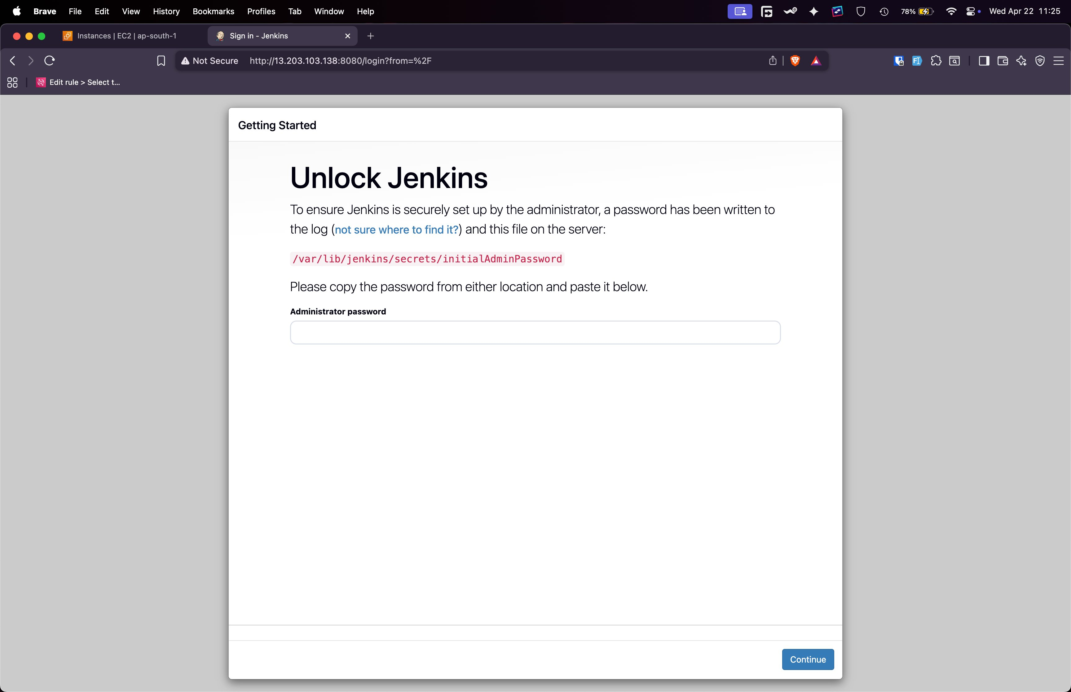
Jenkins 'Unlock Jenkins' screen at http://13.203.103.138:8080. Paste the initialAdminPassword copied and click Continue.

Complete the Setup Wizard
After entering the initial admin password:
- Install Suggested Plugins – Click 'Install suggested plugins'. Jenkins will automatically install the most commonly used plugins (Git, Pipeline, Credentials Binding, Matrix Authorization Strategy, etc.). A progress screen shows each plugin being installed.
- Create Admin User – After plugin installation, set up your permanent admin username, password, and email address.
- Configure Jenkins URL – Confirm the Jenkins URL (the public IP:8080 address) and click 'Save and Finish'.
- Start Using Jenkins – Click 'Start using Jenkins' to enter the Jenkins dashboard.

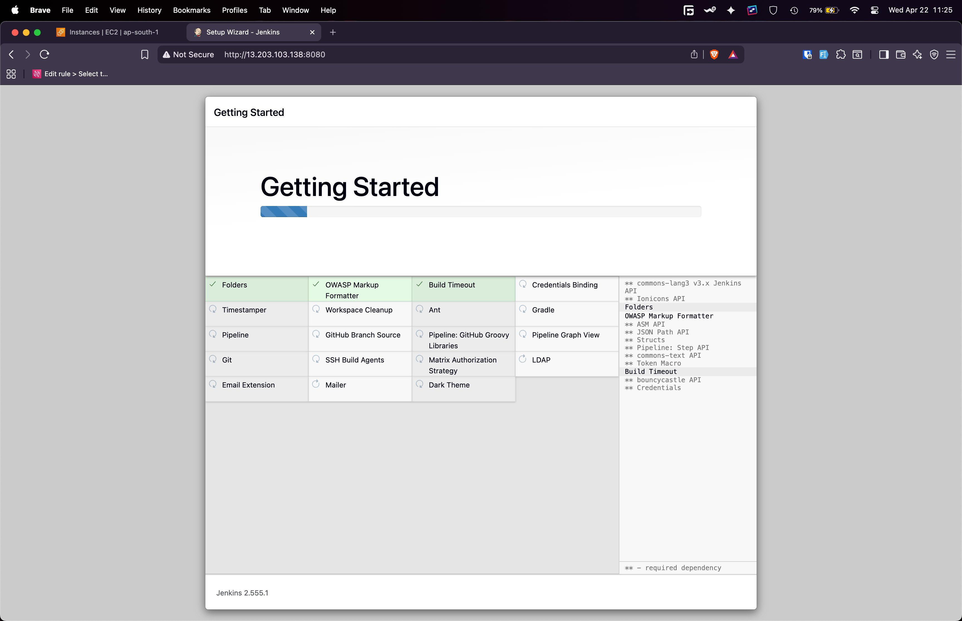
Jenkins Setup Wizard installing suggested plugins, Jenkins version 2.555.1 shown at the bottom.

