AWS ASSIGNMENT
Automating MariaDB Backups to Amazon S3
Course Name & Code | AWS
Instructor | Nitha
Assignment Title | Automating MariaDB Backups to Amazon S3
Date | April 13, 2026
Student Name | Sameer Malik
Student Email | sameermalik.dev@gmail.com

Objective
This assignment demonstrates how to automate MariaDB database backups on an Amazon EC2 instance and securely sync them to an Amazon S3 bucket using IAM roles (without static credentials), AWS CLI, and a custom shell script.

Steps Performed

Step 1: Create and Attach the IAM Role
Instead of manually entering access keys on the server, an IAM Role was used. This approach is more secure because it provides temporary, automatically-rotating credentials to the EC2 instance.

1.1 Create the IAM Policy
- Navigate to IAM > Policies > Create Policy in the AWS Console.
- Select S3 as the service and enable permissions: PutObject, ListBucket, GetObject.
- Name the policy S3BackupPolicy.

1.2 Create the IAM Role
- Go to Roles > Create Role.
- Select AWS Service and choose EC2 as the use case.
- Attach the S3BackupPolicy created above.
- Name the role EC2-S3-Backup-Role.

1.3 Attach Role to EC2 Instance
- Go to EC2 Dashboard > Select your instance.
- Click Actions > Security > Modify IAM role.
- Select EC2-S3-Backup-Role and click Update IAM role.
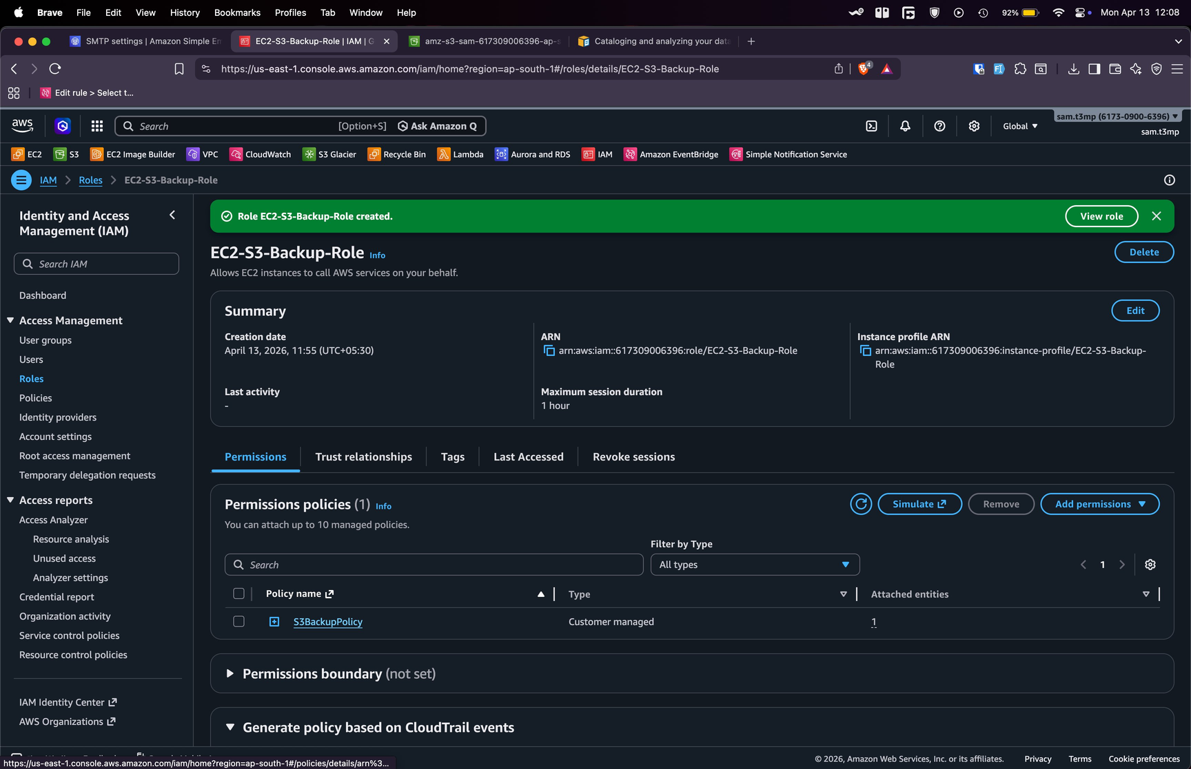
Figure 1: IAM Role EC2-S3-Backup-Role created successfully
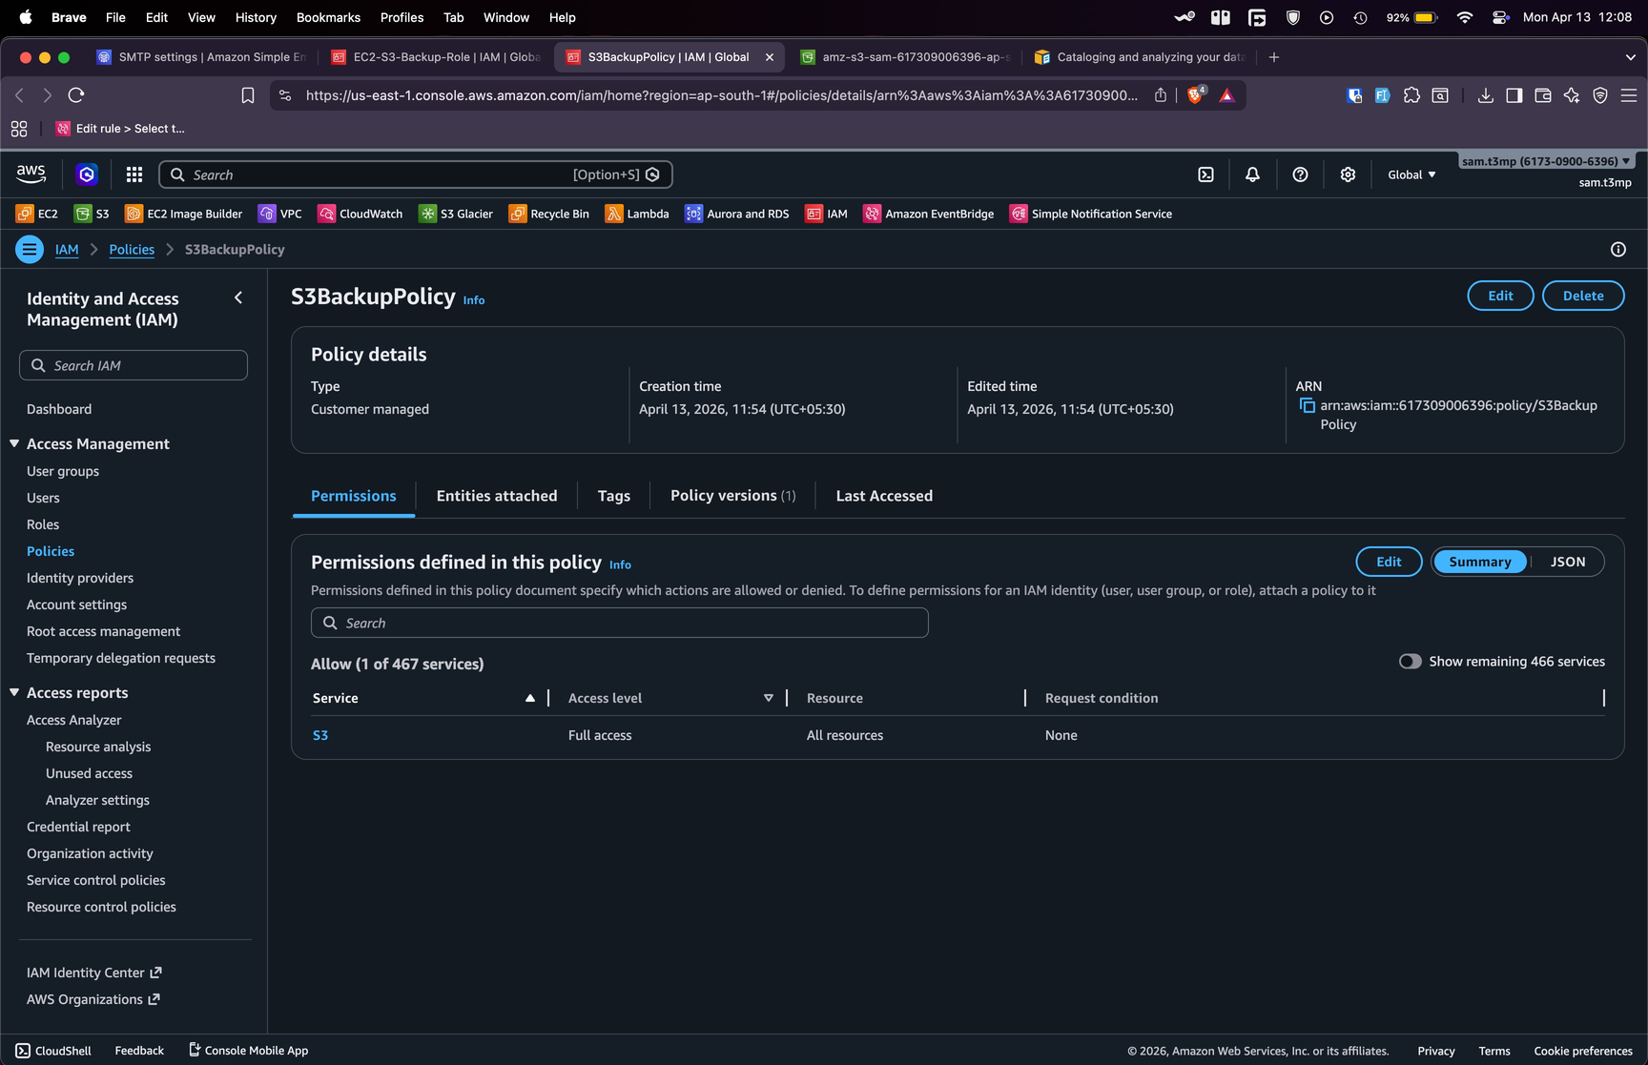
Figure 2: S3BackupPolicy showing Full Access to S3 for all resources

Step 2: Configure MariaDB on the Server
Logged in to the EC2 instance via SSH. Using a Red Hat-based (Amazon Linux) environment, the following commands were run:

Install MariaDB
sudo dnf install mariadb-server -y

Start and Enable the Service
sudo systemctl enable --now mariadb

Initial Secure Setup
sudo mariadb-secure-installation
Set a root password and answered 'Y' to all security prompts to harden the installation.

Step 3: Write the Backup Shell Script
A shell script was written to dump all databases and sync the backup file to S3 automatically.

Create Backup Directory
mkdir -p ~/db_backups

Create the Script
vim ~/backup_script.sh

Script Contents
#!/bin/bash

# Configuration
BACKUP_DIR="$HOME/db_backups"
TIMESTAMP=$(date +%Y-%m-%d_%H-%M-%S)
S3_BUCKET="s3://amz-s3-sam-617309006396-ap-south-1-an"

# 1. Take the backup (Dumps all databases)
sudo mysqldump --all-databases > $BACKUP_DIR/full_backup_$TIMESTAMP.sql

# 2. Sync to S3
aws s3 sync $BACKUP_DIR $S3_BUCKET

# 3. Remove local backups older than 7 days
find $BACKUP_DIR -type f -mtime +7 -delete

Make Executable
chmod +x ~/backup_script.sh
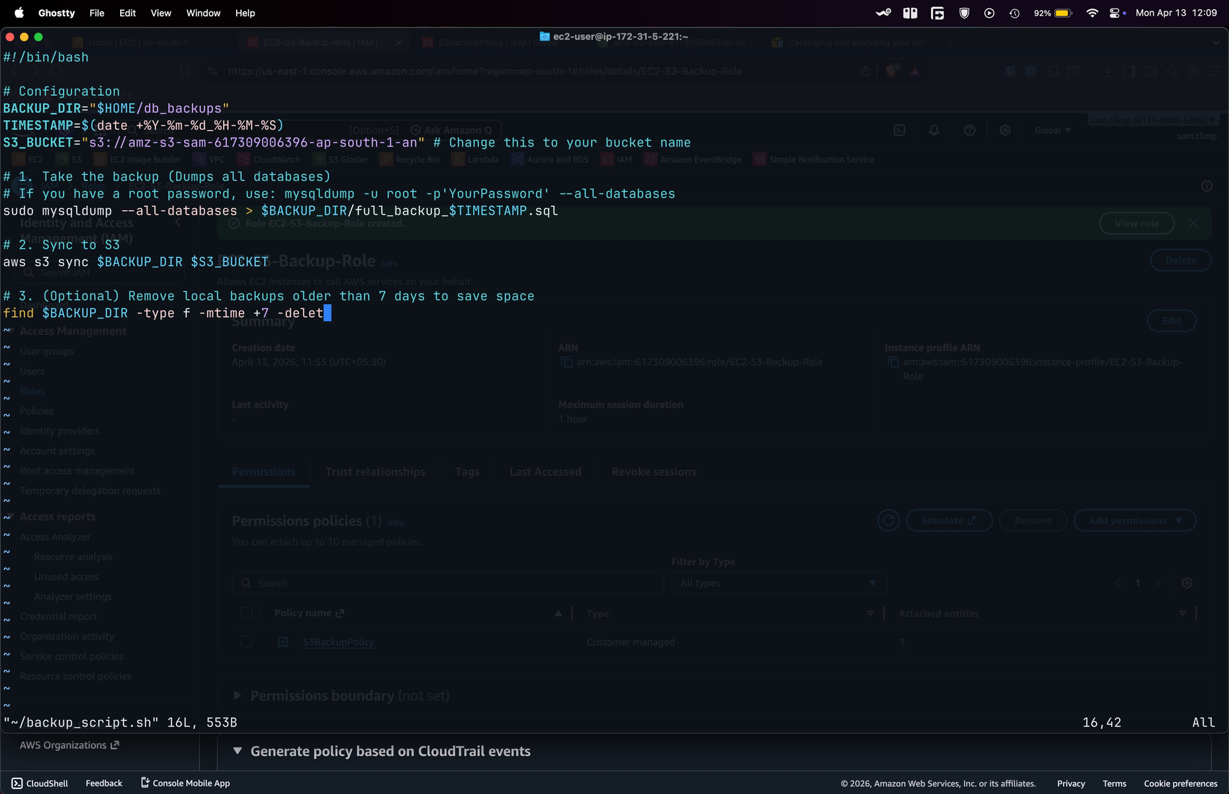
Figure 3: backup_script.sh open in Vim editor on EC2 instance

Step 4: Configure AWS CLI & Run the Sync
Because an IAM Role was attached in Step 1, the CLI already had the necessary permissions. Only the region and output format needed to be configured.

Configure AWS CLI
aws configure
Settings used:
- AWS Access Key ID: (left blank — role provides credentials)
- AWS Secret Access Key: (left blank — role provides credentials)
- Default region name: ap-south-1
- Default output format: json

Run the Backup Script
./backup_script.sh
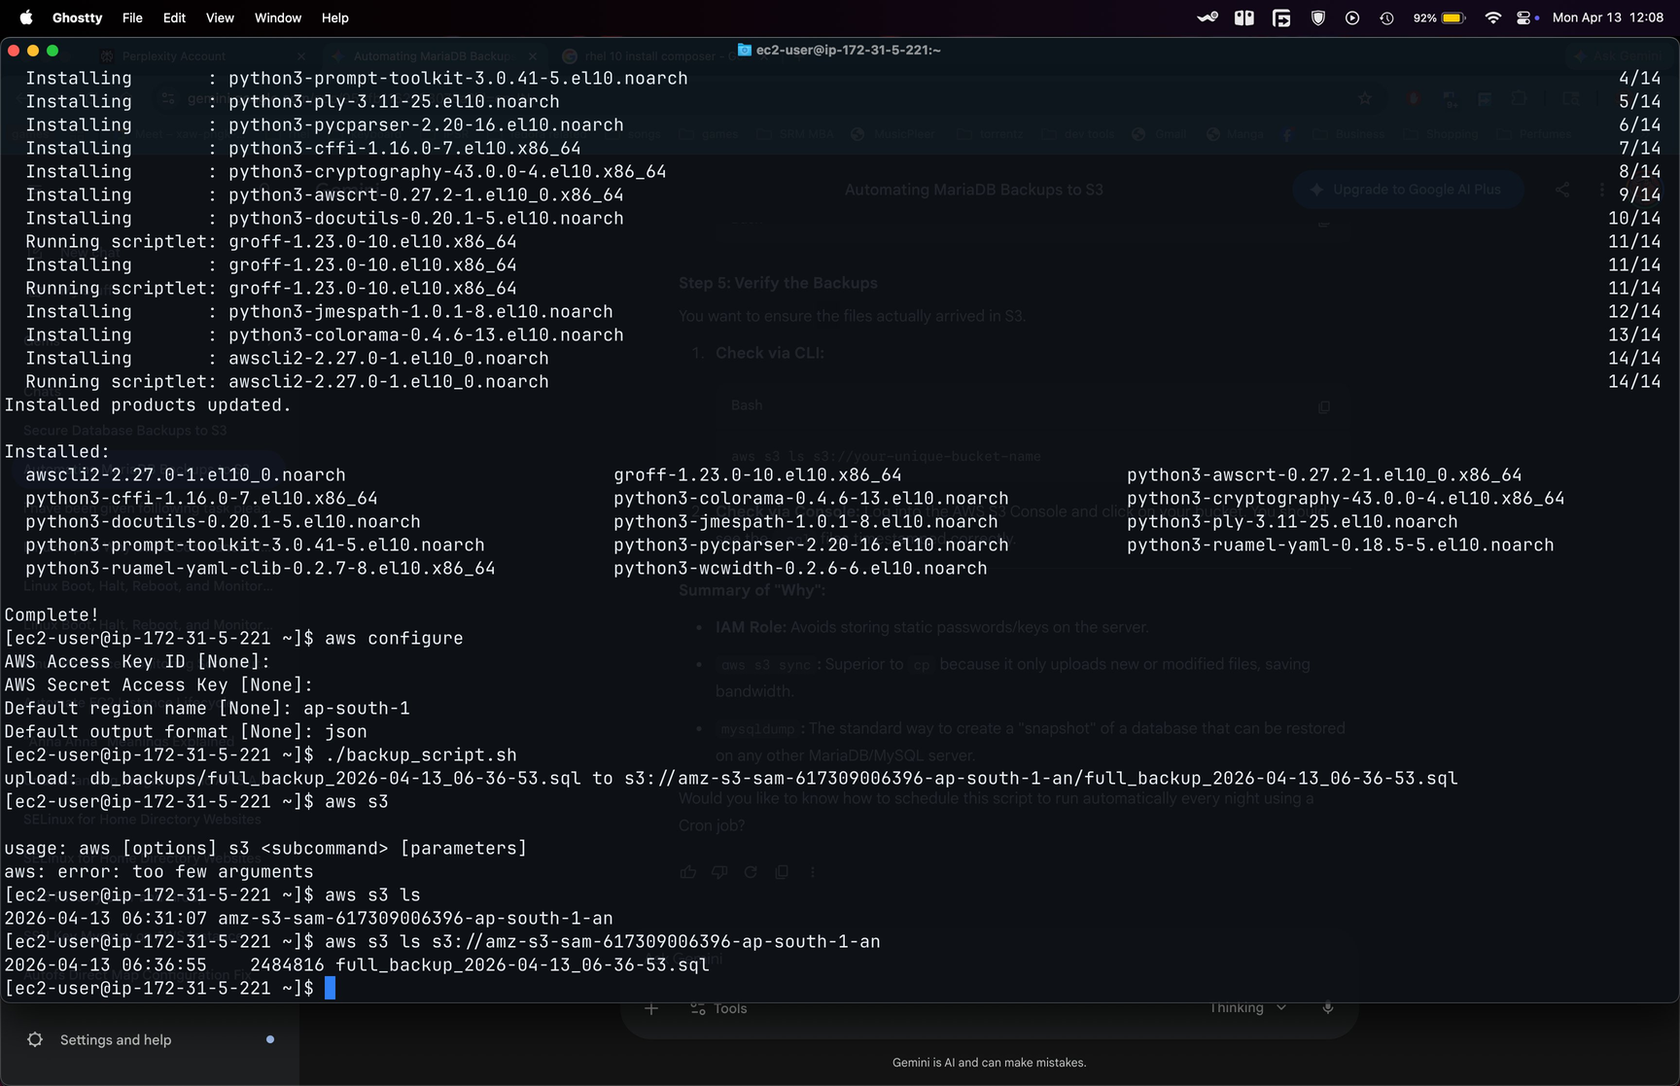
Figure 4: Terminal showing AWS CLI installation, aws configure, script execution, and successful S3 upload

Step 5: Verify the Backups
After running the script, the backup was verified both via CLI and the AWS S3 Console.

Verify via CLI
aws s3 ls s3://amz-s3-sam-617309006396-ap-south-1-an
Output confirmed the backup file was present:
2026-04-13 06:36:55 2484816 full_backup_2026-04-13_06-36-53.sql

Verify via AWS Console
Logged into the AWS S3 Console and confirmed the backup file was visible in the bucket with the correct timestamp and size (2.4 MB).
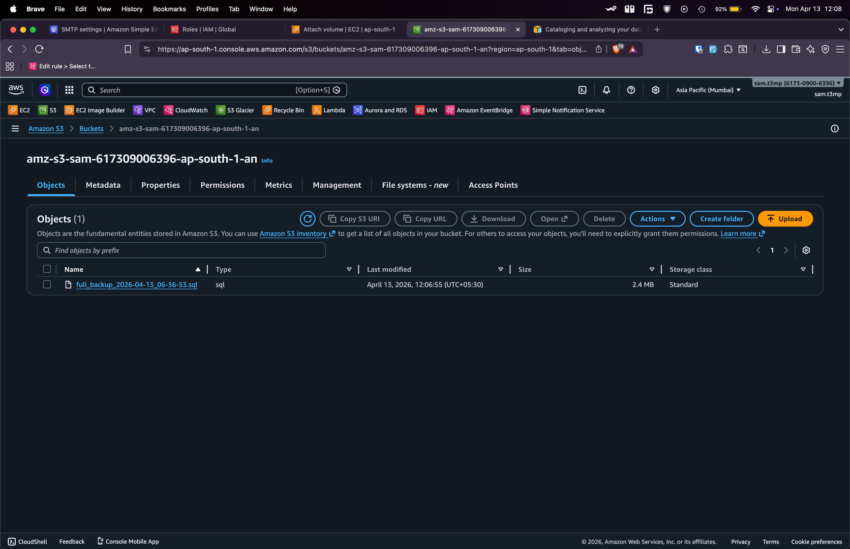
Figure 5: AWS S3 Console showing full_backup_2026-04-13_06-36-53.sql (2.4 MB) uploaded successfully

Result & Summary

What Was Achieved
- Successfully installed and configured MariaDB on an Amazon EC2 instance.
- Created an IAM policy (S3BackupPolicy) and role (EC2-S3-Backup-Role) for secure, credential-free S3 access.
- Wrote a shell script to dump all databases and sync backups to an S3 bucket.
- Verified the backup file was uploaded correctly via both CLI and the AWS Console.

Why This Approach Is Best Practice
IAM Role: Avoids storing static passwords or access keys on the server. Credentials rotate automatically and never appear in scripts.
aws s3 sync: Superior to aws s3 cp because it only uploads new or modified files, saving bandwidth and storage costs.
mysqldump: The standard method for creating a portable database snapshot that can be restored on any MariaDB or MySQL server.
Automated cleanup: The find command removes local backups older than 7 days, preventing disk space exhaustion on the instance.

Submitted by Sameer Malik | sameermalik.dev@gmail.com | AWS | April 13, 2026

