EECS 2021E

Zamir Lalji

212779997

September 25, 2018

Lab B

ORG 96

DD 15, 6, -5, 12, 3, 11,0

addi x1, x0, 96

ld x2, 0(x1) // Y=15

ld x3, 8(x1) // Z=6

ld x4, 16(x1) // C=-5

ld x5, 24(x1) // D=12

ld x6, 32(x1) // L=3

ld x7, 40(x1) // M=11

ld x14, 48(x1) // X=0

add x8,x2,x7 // (Y+M)

sub x9, x6, x5 // (L-D)

add x10, x3, x4 // (Z+C)

sub x14, x8,x9 //(Y+M)-(L-D)

add x14, x14, x10 //(Y+M)-(L-D)+(Z+C)

sub x14, x14, x5 // Final

sd x14, 48(x1) // stored 24 into memory

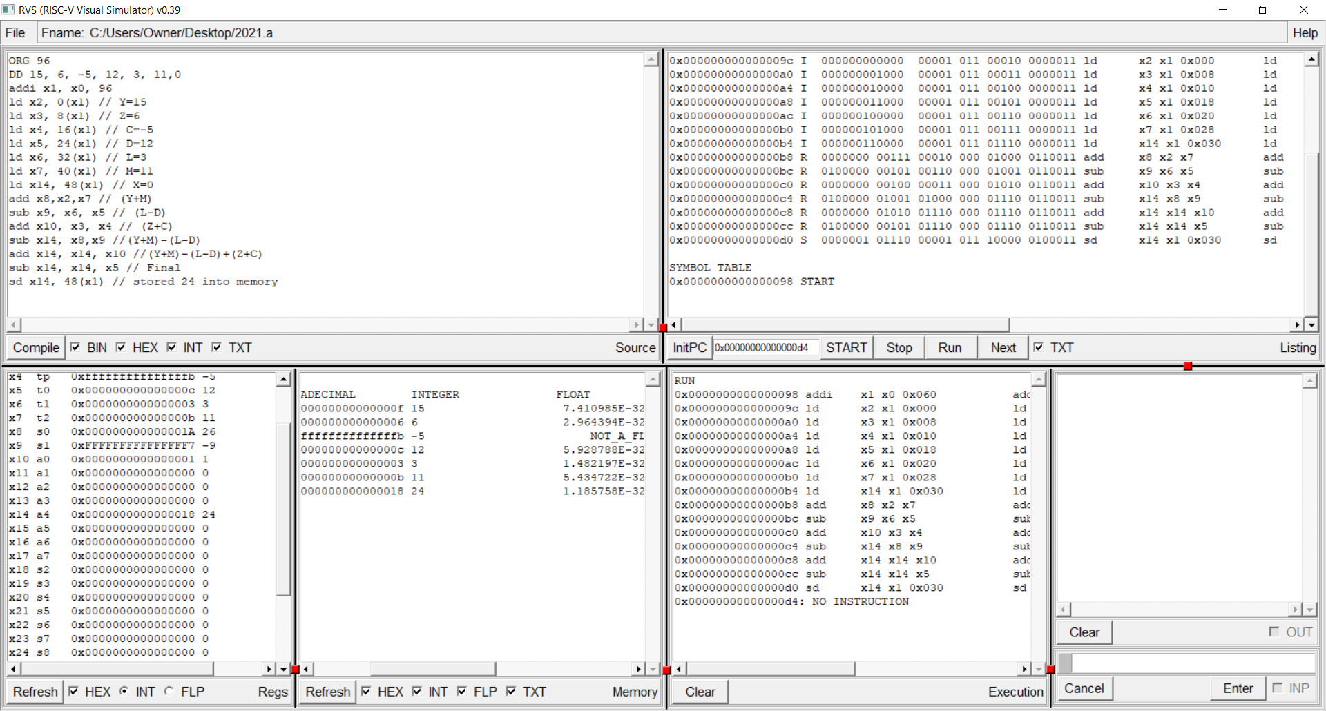

ORG 96

DD 12, 3, 11,0

addi x1, x0, 96

addi x2, x0, 15// Y=15

addi x3, x0, 6 // Z=6

addi x4, x0, -5 // C=-5

ld x5, 0(x1) // D=12

ld x6, 8(x1) // L=3

ld x7, 16(x1) // M=11

ld x14, 24(x1) // X=0

add x8,x2,x7 // (Y+M)

sub x9, x6, x5 // (L-D)

add x10, x3, x4 // (Z+C)

sub x14, x8,x9 //(Y+M)-(L-D)

add x14, x14, x10 //(Y+M)-(L-D)+(Z+C)

sub x14, x14, x5 // Final

sd x14, 24(x1) // stored 24 into memory

