EECS 2021E

Zamir Lalji

Student #212779997

LabD

addi x2,x0,1600 // stack pointer

addi x7,x0,3 // x7 = 3

addi x17,x0,2 // x17 = 2

ecall x6,x0,5 // environmental call int put it to x6

add x10,x6,x0 // store x6 in x10

addi x2,x2,-8 // two vacancies for the stack

sd x6,0(x2) // store x2 in x6

jal x1, not_really_fac // call recursive function

ld x6,0(x2) // restore x6 argument

addi x2,x2,8 // restored the stack

ecall x0,x10,0 // ecall to the prompt

ORG 96

not_really_fac:

addi x2,x2,-16 // x2 stack pointer 2 vacancies

sd x1,8(x2) // stored x1

sd x10,0(x2) // stored x10

bge x7,x10,L1 // 3 > input go to L1

addi x10,x10,-2 // (i-2)

addi x6,x10,0 // stored i-2 in x6

jal x1,not_really_fac // call the recursion

sd x6,0(x2) // stored x6

ld x1,8(x2) // stored return address

addi x2,x2,16 // pop the stack

mul x10,x10,x17 // 2(i-2)

addi x10,x10,1 // 2(i-2)+1

jalr x0,0(x1) // returned back to caller

L1:

addi x10,x0,1 //made x10 1

addi x2,x2,16 //pop the stack

jalr x0,0(x1) // return to caller

Before run:

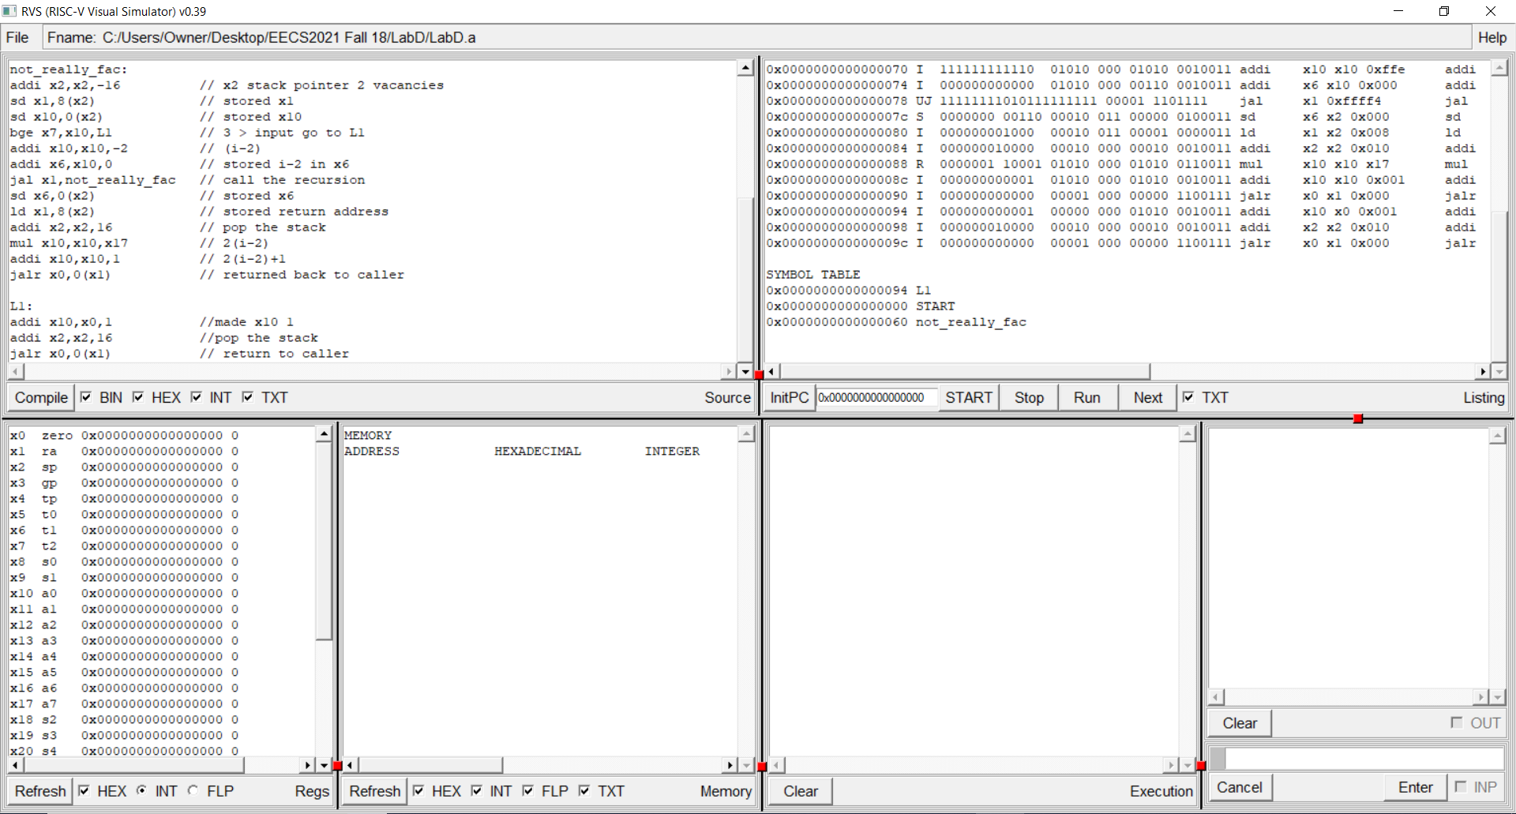

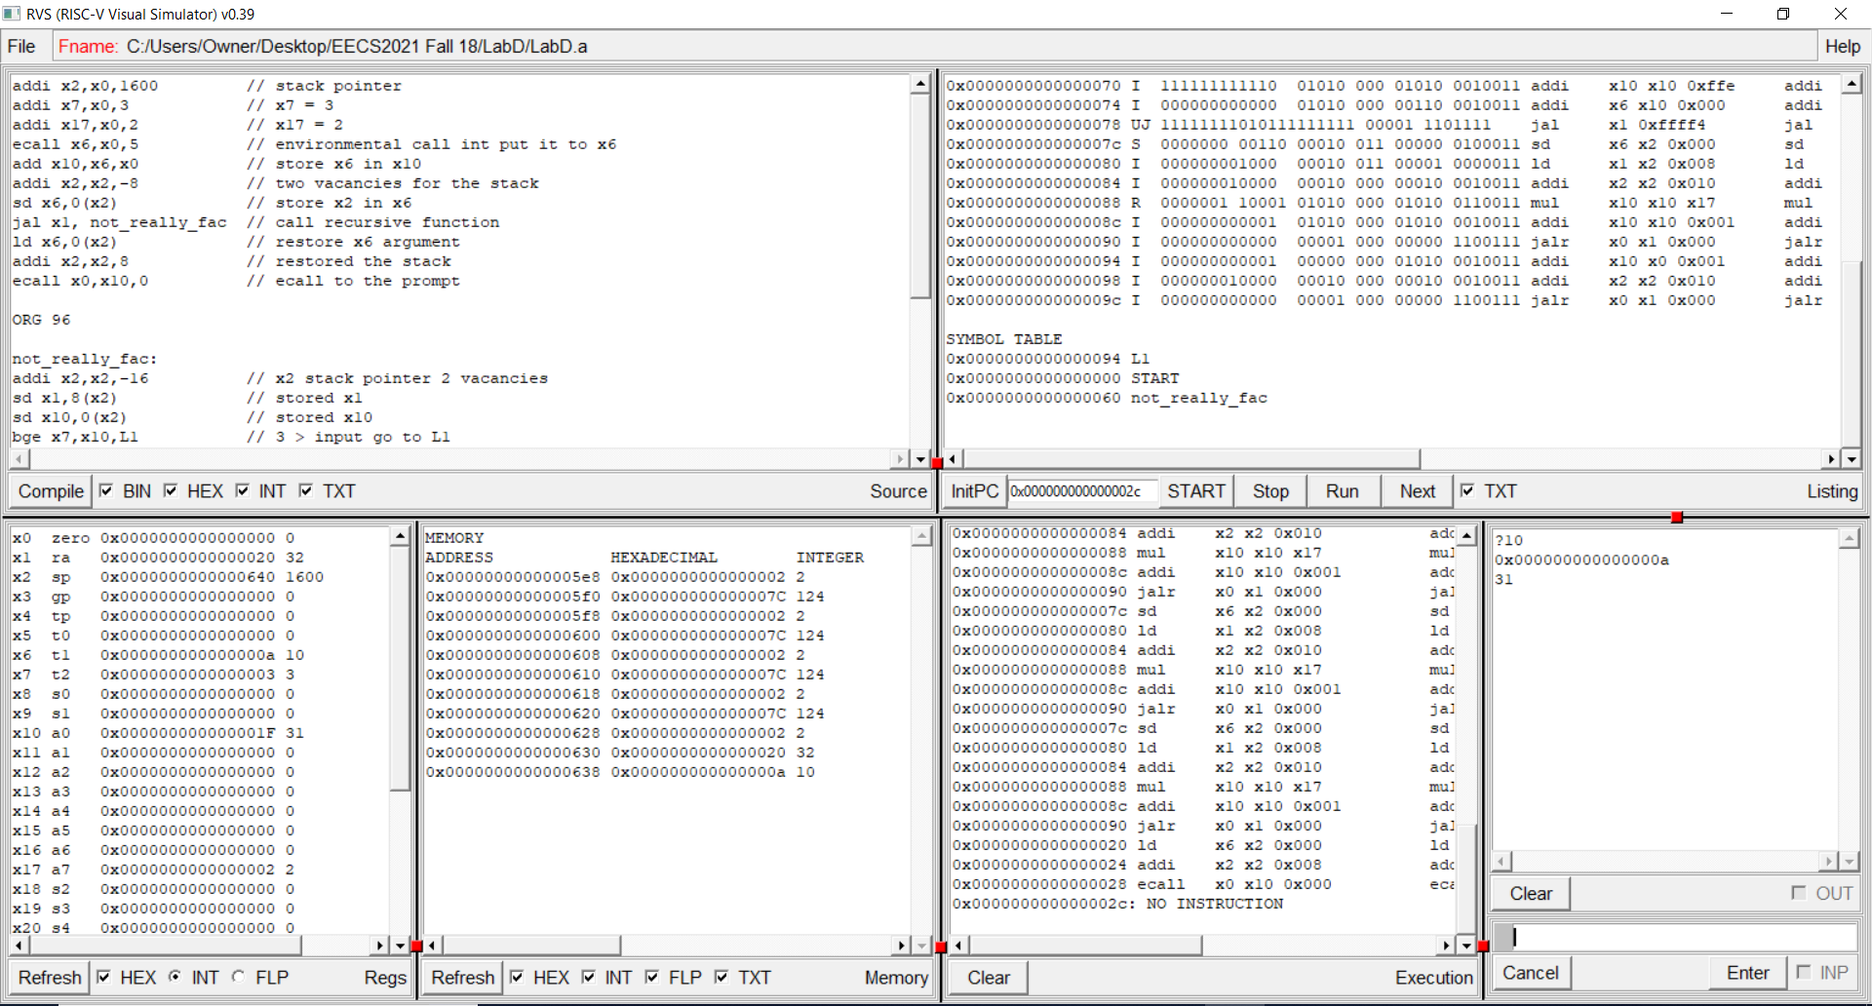After Compile and Run with the output: