**Data Science & Machine Learning: Lab Cycle 3**

**Mathplotlib**

**Demonstrate creating various types of charts and plots using functions in mathplotlib library**

1. Sarah bought a new car in 2001 for $24,000. The dollar value of her car changed each year as shown in the table below.

**Value of Sarah's Car**

**Year Value**

**2001 $24,000**

**2002 $22,500**

**2003 $19,700**

**2004 $17,500**

**2005 $14,500**

**2006 $10,000**

**2007 $ 5,800**

Represent the following information using a line graph with following style properties

* **X- axis - Year**

**Y –axis - Car Value**

* **title –Value Depreciation (left Aligned)**
* **Line Style dashdot and Line-color should be red**
* **point using * symbol with green color and size 20**

Subplot() provides multiple plots in one figure.

*import matplotlib.pyplot as plt*

*import numpy as np*

*xpoints = np.array([2001, 2002, 2003, 2004, 2005, 2006, 2007])*

*ypoints = np.array([24000, 22500, 19700, 17500, 14500, 10000, 5800])*

*plt.title("Value Depreciation", loc = 'left')*

*plt.plot(xpoints, ypoints, 'o-.r', marker = '*',ms = 20,mec = 'g', mfc = 'g')*

*plt.show()*

*output*

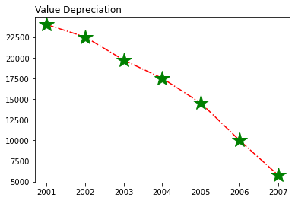

1. Following table gives the daily sales of the following items in a shop

|  |  |  |  |  |  |
| --- | --- | --- | --- | --- | --- |
| Day | Mon | Tues | Wed | Thurs | Fri |
| Drinks | 300 | 450 | 150 | 400 | 650 |
| Food | 400 | 500 | 350 | 300 | 500 |

Use subplot function to draw the line graphs with **grids(color as blue** and line style dotted) for the above information as 2 separate graphs in two rows

1. Properties for the Graph 1:

* X label- Days of week
* Y label-Sale of Drinks
* Title-Sales Data1 (right aligned)
* Line –dotted with cyan color
* Points- hexagon shape with color magenta and outline black

1. Properties for the Graph 2:

* X label- Days of Week
* Y label-Sale of Food
* Title-Sales Data2 ( center aligned)
* Line –dashed with yellow color
* Points- diamond shape with color green and outline red

*import matplotlib.pyplot as plt*

*import numpy as np*

*#plot 1:*

*x = np.array(['Mon', 'Tues', 'Wed', 'Thurs', 'Fri'])*

*y = np.array([300, 450, 150, 400, 650])*

*plt.subplot(2, 1, 1)*

*plt.title("sales data 1", loc ='right')*

*plt.xlabel("Days of week")*

*plt.ylabel("sales of drink")*

*plt.plot(x,y,'o:',color = 'cyan', marker ='H', mec = 'k', mfc ='m')*

*plt.grid(color = 'blue', linestyle = '--')*

*#plot 2:*

*x = np.array(['Mon', 'Tues', 'Wed', 'Thurs', 'Fri'])*

*y = np.array([400, 500, 350, 300, 500])*

*plt.subplot(2, 1, 2)*

*plt.title("sales data 2")*

*plt.xlabel("Days of week")*

*plt.ylabel("sales of food")*

*plt.plot(x,y,'o--',color = 'y', marker ='D', mec = 'r', mfc ='g')*

*plt.grid(color = 'blue', linestyle = '--')*

*plt.subplots_adjust(top=2.5, bottom=1.5, wspace=0.4, hspace=0.4)*

*plt.show()*

*output*

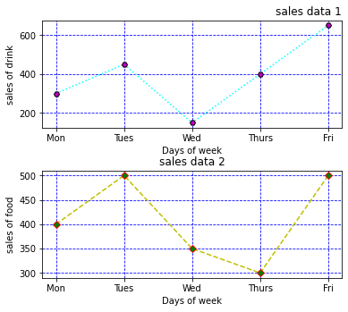

1. Create scatter plot for the below data:(use Scatter function)

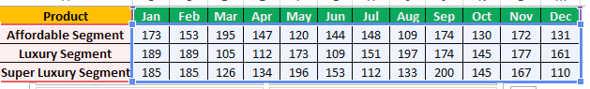

Create scatter plot for each Segment with following properties within one graph

* X Label- Months of Year with font size 18
* Y-Label- Sales of Segments
* Title –Sales Data
* Color for Affordable segment- pink
* Color for Luxury Segment- Yellow
* Color for Super luxury segment-blue

*import matplotlib.pyplot as plt*

*import numpy as np*

*m = np.array(['jan','feb','mar','apr','may','jun','jul','aug','sep','oct','nov','dec'])*

*x = np.array([173, 153, 195, 147, 120, 144, 148, 109, 174, 130, 172, 131])*

*plt.scatter(m, x, color = 'hotpink')*

*m = np.array(['jan','feb','mar','apr','may','jun','jul','aug','sep','oct','nov','dec'])*

*y = np.array([189, 189, 105, 112, 173, 109, 151, 197, 174, 145, 177, 161])*

*plt.scatter(m, y, color = 'y')*

*m = np.array(['jan','feb','mar','apr','may','jun','jul','aug','sep','oct','nov','dec'])*

*z = np.array([185, 185, 126, 134, 196, 153, 112, 133, 200, 145, 167, 110])*

*plt.scatter(m, z, color = 'b')*

*plt.title("sales data")*

*plt.xlabel("Months")*

*plt.ylabel("sales of segments")*

*plt.show()*

*output*

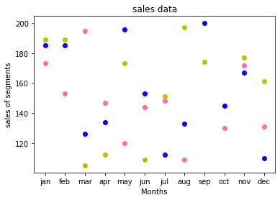

1. Display the above data using multiline plot( 3 different lines in same graph)

* Display the description of the graph in upper right corner(**use legend())**
* Use different colors and line styles for 3 different lines

i*mport matplotlib.pyplot as plt*

*x1 = ['jan','feb','mar','apr','may','jun','jul','aug','sep','oct','nov','dec']*

*x2 = [173, 153, 195, 147, 120, 144, 148, 109, 174, 130, 172, 131]*

*plt.plot(x1, x2, color = 'hotpink', label = 'line 1', ls = '-.')*

*y1 = ['jan','feb','mar','apr','may','jun','jul','aug','sep','oct','nov','dec']*

*y2 = [189, 189, 105, 112, 173, 109, 151, 197, 174, 145, 177, 161]*

*plt.plot(y1, y2, color = 'y', label = 'line 2', linestyle = 'dashed')*

*z1 = ['jan','feb','mar','apr','may','jun','jul','aug','sep','oct','nov','dec']*

*z2 = [185, 185, 126, 134, 196, 153, 112, 133, 200, 145, 167, 110]*

*plt.plot(z1, z2, color = 'blue', label = 'line 3',linestyle = 'dotted')*

*plt.title("sales data")*

*plt.xlabel("Months")*

*plt.ylabel("sales of segments")*

*plt.legend()*

*plt.show()*

*output*

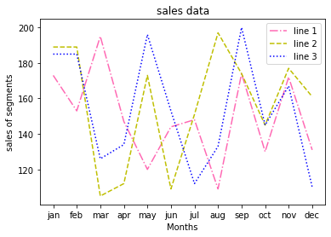

1. 100 students were asked what their primary mode of transport for getting to school was. The results of this survey are recorded in the table below. Construct a bar graph representing this information.

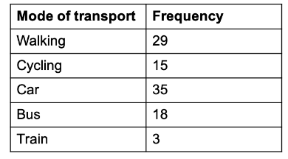

Create a bar graph with

* X axis -mode of Transport and Y axis ‘frequency’
* Provide appropriate labels and title
* Width .1, color green

*import matplotlib.pyplot as plt*

*import numpy as np*

*x = np.array(["Walking", "Cycling", "Car", "Bus", "Train"])*

*y = np.array([29, 15, 35, 18, 3])*

*plt.xlabel("mode of transport")*

*plt.ylabel("frequency")*

*plt.bar(x,y, color ="#4CAF50", width = 0.1)*

*plt.show()*

*output*

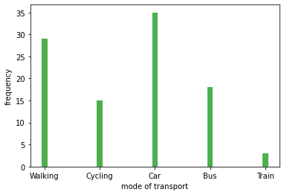

1. We are provided with the height of 30 cherry trees.

The height of the trees (in inches): 61, 63, 64, 66, 68, 69, 71, 71.5, 72, 72.5, 73, 73.5, 74, 74.5, 76, 76.2, 76.5, 77, 77.5, 78, 78.5, 79, 79.2, 80, 81, 82, 83, 84, 85, 87.Create a histogram with a bin size of 5

*import matplotlib.pyplot as plt*

*x = [61, 63, 64, 66, 68, 69, 71, 71.5,*

*72, 72.5, 73, 73.5, 74, 74.5, 76,*

*76.2,76.5, 77, 77.5, 78, 78.5, 79,*

*79.2, 80, 81, 82, 83, 84, 85, 87]*

*plt.hist(x,bins=5)*

*plt.show()*

*output*

