CYCLE-2

1. Create 2 activity from the first activity on button click move to second activity

activity_main.xml

<LinearLayout android:layout_width="match_parent"
android:layout_height="wrap_content"
android:orientation="vertical"
xmlns:android="http://schemas.android.com/apk/res/android">
<Button
android:id="@+id/button"
android:layout_width="match_parent"
android:layout_height="wrap_content"
android:layout_marginLeft="150dp"
android:layout_marginTop="150dp"
android:layout_marginRight="150dp"
android:text="CLICK" />
</LinearLayout>
MainActivity.java

package com.example.sjcet.activity;
import android.support.v7.app.AppCompatActivity;
import android.os.Bundle;
import android.widget.Button;
import android.view.View;
import android.content.Intent;
public class MainActivity extends AppCompatActivity {
@Override
protected void onCreate(Bundle savedInstanceState) {
super.onCreate(savedInstanceState);
setContentView(R.layout.activity_main);
Button button = (Button) findViewById(R.id.button);
button.setOnClickListener(new View.OnClickListener() {
@Override
public void onClick(View v) {
openActivity2();
}
});
}
public void openActivity2() {
Intent intent = new Intent(this, Main2Activity.class);
startActivity(intent);
}
}
content_main2.xml

<?xml version="1.0" encoding="utf-8"?>
<android.support.constraint.ConstraintLayout xmlns:android="http://schemas.android.com/apk/res/android"
xmlns:app="http://schemas.android.com/apk/res-auto"
xmlns:tools="http://schemas.android.com/tools"
android:layout_width="match_parent"
android:layout_height="match_parent"
app:layout_behavior="@string/appbar_scrolling_view_behavior"
tools:context=".Main2Activity"
tools:showIn="@layout/activity_main2">
<TextView
android:layout_width="357dp"
android:layout_height="96dp"
android:gravity="center"
android:text="Welcome..."
android:textColor="@color/colorPrimary"
android:textSize="40dp"
android:textStyle="bold|italic"
android:typeface="monospace"
tools:layout_editor_absoluteX="16dp"
tools:layout_editor_absoluteY="16dp" />
</android.support.constraint.ConstraintLayout>
Main2Activity.java

package com.example.sjcet.activity;
import android.os.Bundle;
import android.support.design.widget.FloatingActionButton;
import android.support.design.widget.Snackbar;
import android.support.v7.app.AppCompatActivity;
import android.support.v7.widget.Toolbar;
import android.view.View;
public class Main2Activity extends AppCompatActivity {
@Override
protected void onCreate(Bundle savedInstanceState) {
super.onCreate(savedInstanceState);
setContentView(R.layout.activity_main2);
Toolbar toolbar = (Toolbar) findViewById(R.id.toolbar);
setSupportActionBar(toolbar);
FloatingActionButton fab = (FloatingActionButton) findViewById(R.id.fab);
fab.setOnClickListener(new View.OnClickListener() {
@Override
public void onClick(View view) {
Snackbar.make(view, "Replace with your own action", Snackbar.LENGTH_LONG)
.setAction("Action", null).show();
}
});
}
}
Output
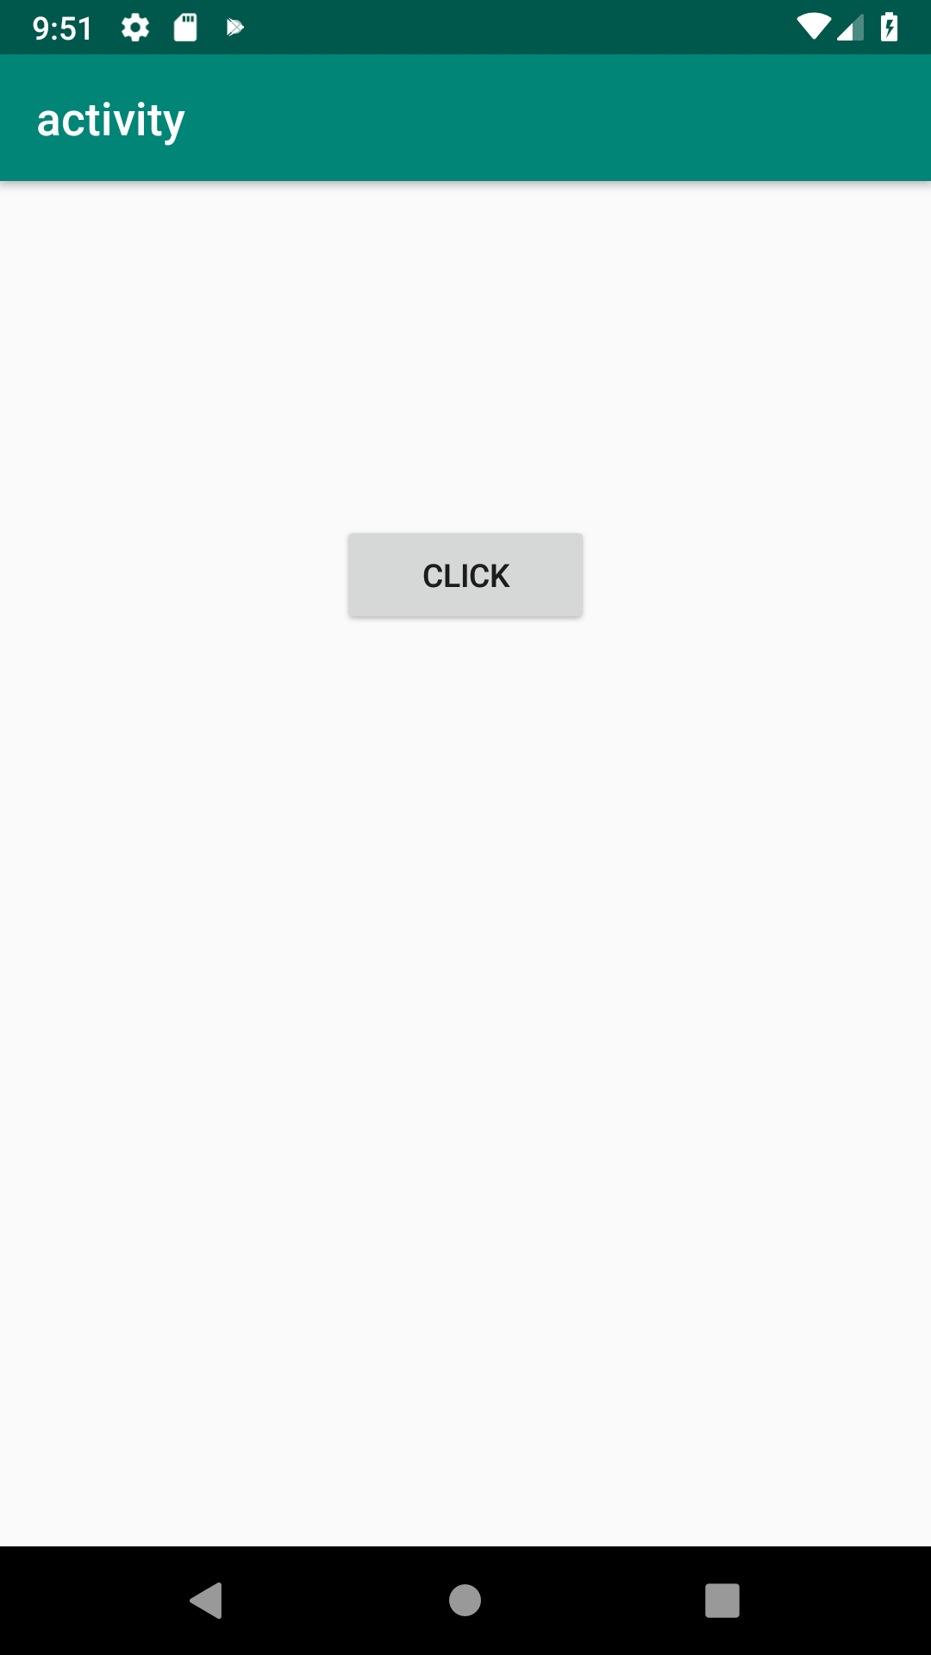
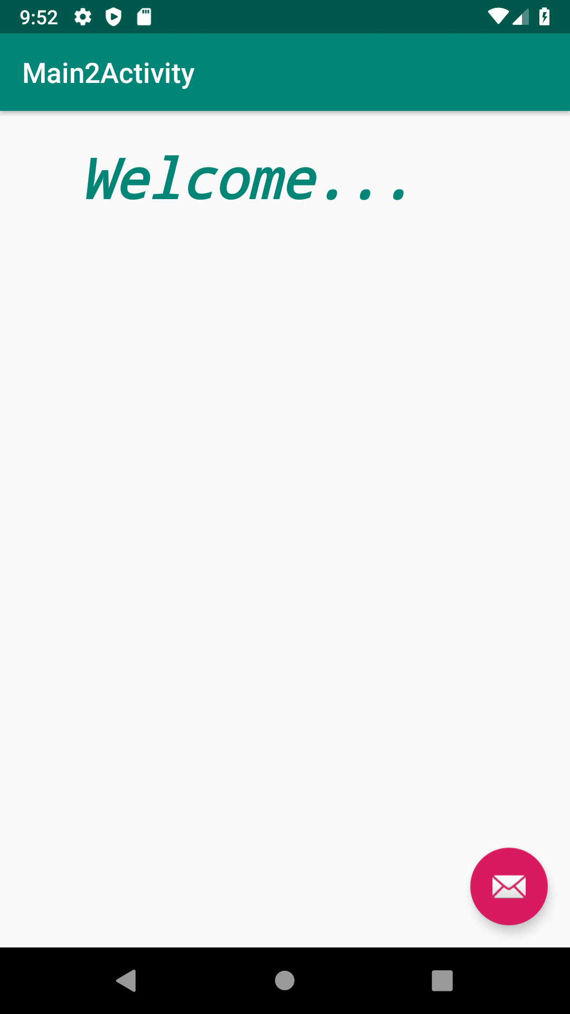

2. Create an activity and move to facebook login page on button click.

activity_main.xml
<LinearLayout android:layout_width="match_parent"
android:layout_height="wrap_content"
android:orientation="vertical"
xmlns:android="http://schemas.android.com/apk/res/android">
<Button
android:id="@+id/button"
android:layout_width="match_parent"
android:layout_height="match_parent"
android:text="facebook"
android:textAlignment="gravity"
android:onClick="click"/>
</LinearLayout>
MainActivity.java
package com.example.sjcet.fb;
import android.content.Intent;
import android.net.Uri;
import android.support.v7.app.AppCompatActivity;
import android.os.Bundle;
import android.view.View;
public class MainActivity extends AppCompatActivity {
@Override
protected void onCreate(Bundle savedInstanceState) {
super.onCreate(savedInstanceState);
setContentView(R.layout.activity_main);
}
public void click(View view) {
String url = "https://www.facebook.com";
Intent i = new Intent(Intent.ACTION_VIEW);
i.setData(Uri.parse(url));
startActivity(i);
}
}

Output
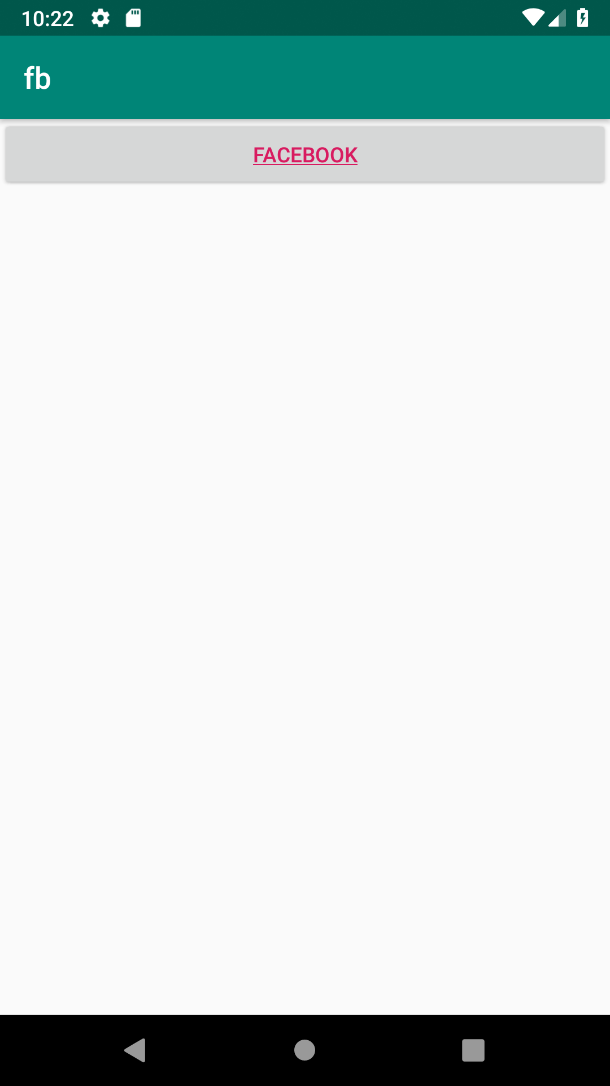
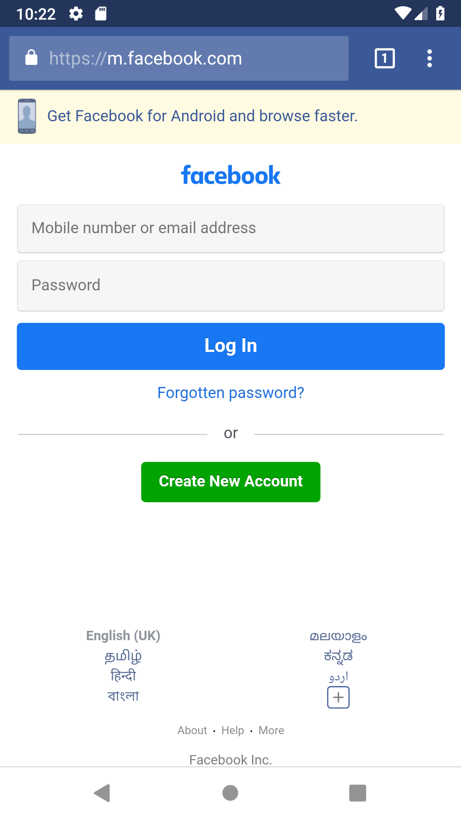

3. Read msg from first activity and pass to second activity.

activity_main.xml
<LinearLayout android:layout_width="match_parent"
android:layout_height="wrap_content"
android:orientation="vertical"
xmlns:android="http://schemas.android.com/apk/res/android">
<EditText
android:id="@+id/text"
android:layout_width="match_parent"
android:layout_height="wrap_content"
android:ems="10"
android:inputType="textPersonName"
android:hint="Enter a message" />
<Button
android:id="@+id/button"
android:layout_width="match_parent"
android:layout_height="wrap_content"
android:text="view" />
</LinearLayout>

MainActivity.java
package com.example.sjcet.c2pgm3;
import android.content.Intent;
import android.support.v7.app.AppCompatActivity;
import android.os.Bundle;
import android.view.View;
import android.widget.Button;
import android.widget.EditText;
public class MainActivity extends AppCompatActivity {
Button button;
EditText text;
@Override
protected void onCreate(Bundle savedInstanceState) {
super.onCreate(savedInstanceState);
setContentView(R.layout.activity_main);
button = (Button) findViewById(R.id.button);
text = (EditText)findViewById(R.id.text);
button.setOnClickListener(new View.OnClickListener() {
@Override
public void onClick(View v) {
String str = text.getText().toString();
Intent intent = new Intent(getApplicationContext(), Second_activity.class);
intent.putExtra("message_key", str);
startActivity(intent);
}
});
}
}

Second_activity.java
package com.example.sjcet.c2pgm3;
import android.content.Intent;
import android.os.Bundle;
import android.support.design.widget.FloatingActionButton;
import android.support.design.widget.Snackbar;
import android.support.v7.app.AppCompatActivity;
import android.support.v7.widget.Toolbar;
import android.view.View;
import android.widget.TextView;
public class Second_activity extends AppCompatActivity {
TextView rmsg;
@Override
protected void onCreate(Bundle savedInstanceState) {
super.onCreate(savedInstanceState);
setContentView(R.layout.activity_second_activity);
rmsg = (TextView)findViewById(R.id.textView);
Intent intent = getIntent();
String str = intent.getStringExtra("message_key");
rmsg.setText(str);
}
}
Content_second_activity.xml
<LinearLayout android:layout_width="match_parent"
android:layout_height="wrap_content"
android:orientation="vertical"
xmlns:android="http://schemas.android.com/apk/res/android">
<TextView
android:id="@+id/textView"
android:layout_width="match_parent"
android:layout_height="664dp"
android:paddingTop="250dp"
android:textSize="30dp"
android:textAlignment="center"
android:text="msg"
android:textColor="@android:color/holo_green_dark"
android:textStyle="bold" />
</LinearLayout>
output
